59th jpoint meeting of the CIDOC CRM SIG and ISO/TC46/SC4/WG9

24-27 September 2024

Hotel Imperial Plovdiv – 6 Lev Tolstoy Str., Plovdiv, Bulgaria

Participants
Alejandro Peña, dedalo.dev; Aleksandra Mitiukova, Researcher; Alessia Vaccariello, Sapienza Università di Roma; Alliyya Mo, University of Guelph; Anais Guillem, ; Athanasios Velios, English Heritage; Athina Kritsotaki, ICS-FORTH; César Huiza Romero, Museo de Arqueología y Antropología de la Universidad Nacional Mayor de San; Chiara Giovannetti, Sapienza University of Rome; Crhyssoula Bekiari, ICS-FORTH; Dani Metilli, University of Guelph; Daria Hookk, The State Hermitage Museum; Denitsa Nenova, Takin.solutions Ltd.; Dimitris Angelakis, ICS-FORTH; Dominic Oldman, Kartography; Edurne Uriarte Santillán, DGRU-UNAM; Eleni Tsouloucha, ICS-FORTH ; Elias Tzortzakakis, ICS-FORTH; Elisabeth Reuhl, Department for Digital Humanities, University of Cologne; Francesco Beretta, LARHRA CNRS; George Bruseker, Takin.solutions; Gerald Hiebel, University of Innsbruck; Gerhard Rampl, University of Innsbruck; Hedren, Sum, Nanyang Technological University; Janneke van Hoeve, Carleton University; Juan Francisco, dedalo.dev; Maliheh Dorkhosh, University of Tehran; Maribel Hidalgo-Urbaneja, University of the Arts London and Carleton University; Markos Katsianis, University of Patras; Martin Doerr, ICS-FORTH; Mélanie ROCHE, Bibliothèque Nationale de France; Michaël Meersmans, Digipolis (City of Antwerp); Michalis Mountantonakis, ICS-FORTH; Milena Peralta Friedburg, University of Innsbruck; Muriel van Ruymbeke, UniLu; Nils Geißler, CCeH / FID Philosophie (University of Cologne); Oikonomakis Iosif, ICS-FORT; Puyu Wang, University of Oxford; Ron Van den Branden, Letterenhuis; Sarantos Kapidakis, University of West Attica; Sjoerd Siebinga, Delving B.V.; Stephen Hart, Unibe; Stephen Stead, Paveprime Ltd; Susan Brown, University of Guelph; Thomas Wikman, Delving BV; Tiako Djomatchoua Murielle Sandra, Princeton University; Trang Dang, Canadian Heritage Information Network (CHIN); Veselina Kalkandzhieva, Takin.Solutions; Vincent Alamercery, LARHRA

Table of Contents
59th jpoint meeting of the CIDOC CRM SIG and ISO/TC46/SC4/WG9 1
24-27 September 2024 1
Hotel Imperial Plovdiv – 6 Lev Tolstoy Str., Plovdiv, Bulgaria 1
Participants 1
Tuesday, 24 September 2024 4
Issue 587: Principles for Modelling Ontologies: A Short Reference Guide [introduction and examples for didactic purposes] 4
Issue 672: Quantifiers of P140, P141, P177 5
Schedule the 60th CIDOC CRM & 53rd LRMoo SIG Meeting in Bern (31 March – 4 April 2025) 6
Issue 682: List externally maintained CRM Compatible Extensions on New Section of CRM Site 6
CRMinf update (see Issues 614, 663, 646 below). 6
Issue 614: Definition of I4 Proposition Set and what an instance of I2 Belief is about 9
Issue 663: Define Ixx Singleton Proposition Set 9
Issue 602: determine the interface btw CRMsci and CRMinf 10
Issue 556: Content of the minimal vocabularies for restricting the CIDOC CRM Types 10
Wednesday, 25 September 2024 11
CRMsoc, CRMaaa, SDSS, CRMinfluence – a critical appraisal 11
Issue 628: Update the modelling constructs found under The Model\Use&Learn\Functional Overview 13
NEW ISSUE (687): Review the textual descriptions to diagrams in the functional overview 14
Archaeological Excavation Semantic Modelling Workgroup; scope and activities 15
LRMoo: Update on the Official (IFLA approved) release (V1.0) 15
Issue 684: Modelling of Series in LRMoo 15
Issue 685: FOL Statements for LRMoo 15
CIDOC CRM Russian translation 16
Why we need Ontology-Specific Data Portals: A case study for CIDOC-CRM 16
Utlilizing CIDOC-CRM, CRMsci, and CRMinf to model Modern and Historical Earthquakes 16
Thursday, 26 September 2024 16
OntoME – Ontology Management Environment 16
Zellij – the semantic pattern library; supporting sustainable semantic data management 16
3M – Ontology and Semantic Modelling Documentation and ETL Software 16
SIP-Creator visual mapping tool 17
Ontop 17
Arches; A Data Management, Discovery, Integration, and Visualization Platform for Cultural Heritage 17
Wisski 17
Research Space 17
Geovistory 17
Criteria 17
Drawio2triples 17
Onto Match Game 17
Exploring CIDOC CRM datasets with A-Qub 17
Roundtable discussion 17
Friday, 27 September 2024 18
Issue 672: Quantifiers of P140, P141, P177 (continuation) 18
Teaching CIDOC CRM 19
Issue 628: Update the modelling constructs found under The Model\Use&Learn\Functional Overview (continuation) 19
Appendices 21
Appendix I: List of abbreviated names 21
Appendix II: Scope note reformulations -model updates 22
CRMinf Update 22
Issue 614: 23
Issue 663: 28
Issue 602: 35
Issue 556: 36
Issue 628: 38
Issue 684: 49

Tuesday, 24 September 2024

Issue 587: Principles for Modelling Ontologies: A Short Reference Guide [introduction and examples for didactic purposes]
CEO gave a brief outline of the issue.
It is an old issue that started as an effort to update the CM Principles v0.1.2 document –editorial feedback mentioned the need to make the document’s purpose clear, better contextualize the examples found therein, consistently use a normal register throughout the text rather than mix it with dense academic prose, etc.
Lack of contextualization of the principles listed through use cases was considered a major flaw, which resulted in a new proposal for a procedure whereby to license new modeling constructs (for CIDOC CRM or an extension), or for issuing a new extension to CIDOC CRM. The proposal was put forth at the 53rd CIDOC CRM SIG meeting, by MD & DO. It was accepted in principle, but more work is required to finalize the document.
Following the approval of the document describing the procedure followed when it comes to admitting new modeling constructs/extensions to the CIDOC CRM, it was understood that the SIG should supply use cases that support it.
To this end, the SIG identified a number of resources that could be put to use to illustrate how modeling decisions were grounded in (a) available project data, and (b) the research questions that said projects set out to provide answers to. These were: the research questions and data from the projects SeaLiT and the Restauration of Notre Dame de Paris, plus an example of how to disambiguate polysemous concepts into distinct classes from CRMtex. These resources have been reviewed multiple times (at different stages in their development).

Current state of the issue:
What the SIG had to decide at this meeting then, was how to proceed with making these resources available (as they form valuable educational material demonstrating this group’s modus operandi), and especially whether to collate all the documents into one or to figure out another way to reference one from the other, where necessary. Furthermore, the SIG was presented with an updated version of FORTH’s HW (SEALIT: executive summary, research questions, graphical representation of the queries, sparql endpoints) for approval.
All the documents can be found here.
CEO was in charge of making a proposal on how to continue with this and what he suggested was the following:
Proposal:
- Use the first 29 pages of the last known version of the Principles for Modeling Ontologies document (namely 0.2 –the one that he and EC had thoroughly edited) as a reference point. Appoint someone to have another go at editing it –preferably resulting in a shorter version.
- Have MD and DO provide some insight with respect to how they intended the introductory bit to be integrated with the checklist they provided.
- Stop editing the use cases as a group, consider them done and also make sure that they are featured on the website.
Decisions:
The SIG accepted CEO’s proposal and appointed
- MR to deal with point (1) –with the help of CEO& EC;
- DO & MD to deal with point (2);
- and FORTH to deal with point (3) –making the resources identified accessible on the site.
The final version of the introduction will be presented either as HW at the next SIG meeting or prior to that (as an evote).

Issue 672: Quantifiers of P140, P141, P177
CEO gave an update on the issue, namely that the decision to change the property quantifiers of P140 & P141 from “many to many (0,n:0,n)” and P177 from “many to many, necessary (1,n:0,n)” to “many to one, necessary (1.1:0,n)” (which, in its turn, was motivated by the inability to discern which property type assignment (P177:E55) was connected to which instance of E13) has consequences for the quantifiers of the subproperties of P140/P141: they cannot be less restrictive than the ones used for P140-P141.
The SIG was presented with two alternatives concerning the relevant set of properties for the subclasses of E13 Attribute Assignment listed below: either change the cardinalities of their subproperties to “many to one, necessary (1,1:0,n)” or disengage them from P140 and P141 altogether.
- E14 Condition Assessment
  - P34 concerned (was assessed by): E18 Physical Thing (ISA P140)
  - P35 has identified (was identified by): E3 Condition State (ISA P141)
- E15 Identifier Assignment
  - P37 assigned (was assigned by): E42 Identifier (ISA P141)
  - P38 deassigned (was deassigned by): E42 Identifier (ISA P141)
- E16 Measurement
  - P39 measured (was measured by): E18 Physical Thing (ISA P140)
  - P40 observed dimension (was observed in): E54 Dimension (ISA P141)
- E17 Type Assignment
  - P41 classified (was classified by): E1 CRM Entity (ISA P140)
  - P42 assigned (was assigned by): E55 Type (IsA P141)
N.b. Changing the cardinalities does not entail having to redraft the scope notes, seeing as they explicitly mention connecting one instance of the E13 subclasses in their domain, to their range.
An implication of implementing the new cardinalities for the set of properties would be that (as far as the subclasses of E13 are concerned) each activity type will only be applied to/ affect exactly one thing. For instance, when documenting the measurement of the volume of an object, CIDOC CRM users would have to document measuring the height, the length, and the width of an object as distinct E16 Measurement events. Taking each of these measurements would become part of an overarching activity (i.e., “calculating the volume of object x”).
Also, seeing as the issue has implications for CRMsci (where the model for Observations is undergoing a major reorganization) and CRMarchaeo (properties dependent on subclasses of S4 Observation), there was the question of how to proceed –either resolve the issue for CRMbase and then have CRM extensions harmonize with base or wait for the new model for observations be accepted and harmonized with E13 Attribute Assignment before the relevant structures be updated in CRMbase.
- In terms of procedure, the SIG decided that CRMbase always takes precedence compared to CRM extensions –so they proceeded with examining the proposed changes.

Discussion points:
Some interesting points were raised that essentially lead the SIG to refrain from reaching a decision at this meeting. Specifically:
- If E13 Attribute Assignment is only meant to be used for reification constructs, then its properties should only be used for this purpose –it doesn’t make sense that they have subproperties of themselves.
- E14 Condition Assessment and E16 Measurement in particular are inherently different to E13 Attribute Assignment, insofar as they involve objectively true situations that are observed and documented, whereas E13 is purely declarational (i.e., E14 and E16 are uncovering facts about the world, whereas E13 is just stating them –thereby creating them).
- The properties of E15 Identifier Assignment are not so different from one another (contrary to what is mentioned in the scope note).

The SIG decided to review the issue on the last day of the meeting.

Schedule the 60th CIDOC CRM & 53rd LRMoo SIG Meeting in Bern (31 March – 4 April 2025)
S.H. shared with the SIG a document containing information on how to get to Bern, and also accommodations etc.
They have blocked the whole week for the meeting, but it is possible that it starts on April 1st instead.

Issue 682: List externally maintained CRM Compatible Extensions on New Section of CRM Site
GB presented the current state of the issue. The slide deck of his presentation can be found here. The document it references can be found here.
Discussion points:
- Participants were in favor of the proposed hierarchy of extensions being dependent on the SIG’s commitment to maintain them.
- For project ontologies, whose goal was never to become part of the harmonized CRM extensions, the SIG must determine what the requirements for them to be referenced from the site are. Namely, there should be a definition file and an implementation file. If they are not interested in maintaining a site after the project has terminated, then they should be advised to share a DOI on Zenodo or some other open access resource.
- The terms suggested to distinguish between project ontologies augmenting some part of the CRM on the one hand, and family models maintained by the CRM SIG on the other –namely: CRM compatible vs. fully harmonized models, respectively –were not to their liking. Alternatives presented were official/unofficial, maintained by the SIG/CRM compatible ontologies, etc.
- The LRMoo group registered their willingness and ability to continue working towards harmonizing LRMoo with any major updates on CIDOC CRM. They agreed that project ontologies (like DOREMUS) that are no longer maintained because the projects they evolved out of have long terminated, should be referenced from a central point of the CIDOC CRM site –after all they do form proof of concept as well as an important resource showcasing the kind of use that CRM and family models have been put to use or extended. But the way they are presented should reflect the commitment of the maintaining group to continue with harmonizing them.
  - Regarding PRESSoo, it forms an interesting case, because at the time it was created it was fully harmonized with CIDOC CRM v5.0.4 and FRBRoo v2.4 and other existing family models.
  - Since it was heavily dependent on FRBRoo v2.4, no work could be done to it until LRMoo had reached a more or less stable form, and in the meantime, there is no group to push forward with its harmonization now. The SIG needs to determine how to flag that PRESSoo no longer forms part of the models harmonized with the current CIDOC CRM Community Official version –whereas up to CIDOC CRM v5.0.4 it did.
- Regarding the group’s practices when it comes to declaring a model as compatible with CIDOC CRM. In the past, the SIG attributed the label “CRM Compatible” to any model it had the intention of working towards developing. This was completely unwarranted and from now on the SIG will only talk about harmonized (or CRM SIG maintained models) when they’re almost ready to be issued –not at the very beginning of the process. CRMsoc is such a model.
- Conservation Process Modeling Ontology is almost ready to be submitted as a CRM compatible model, they need to be very clear on the process they will be following.
Decision:
The SIG voted to streamline the document describing how to maintain CRM compatible extensions. Among the things that will be considered before the document gets resubmitted to the SIG, is the terms used for the two types of compatible extensions, the metadata that should be provided for an extension that is not maintained by the SIG to be referenced on the site.
HW assigned to: GB, MD, SH, DO, PM, MP, CEO, PR.

CRMinf update (see Issues 614, 663, 646 below).
The diagrams found here are relevant for the update of CRMinf –they do not fall under any one particular issue. The same holds for the usage that are briefly mentioned and explicated in the introduction section of CRMinf (see appendix).

CRMinf Belief Adoption modelling construct
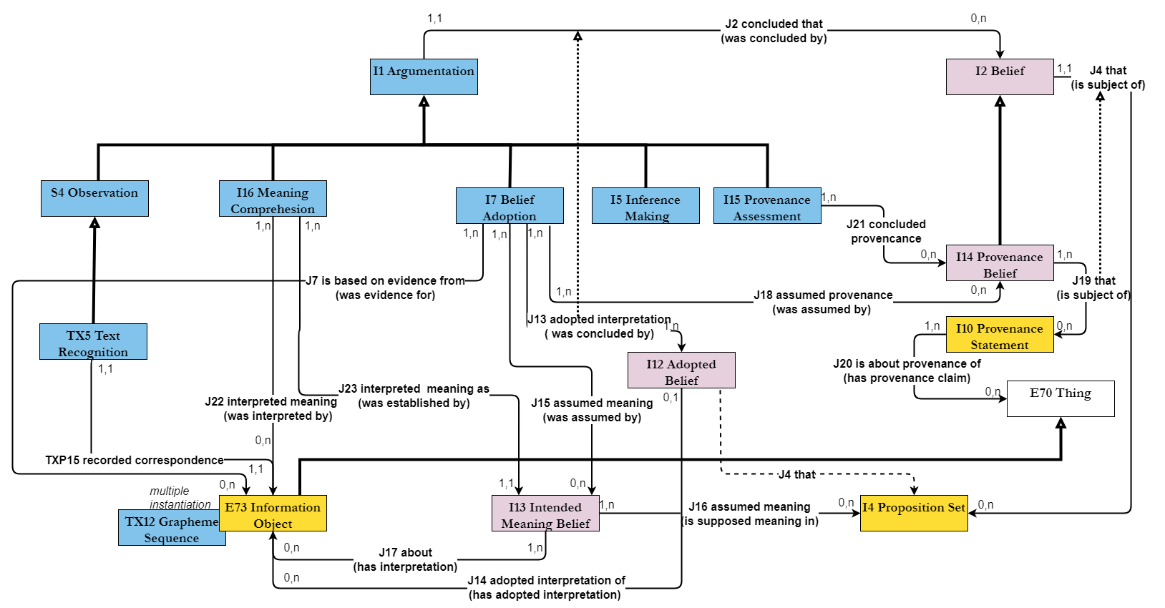

Proposition Sets and E13 Attribute Assignment
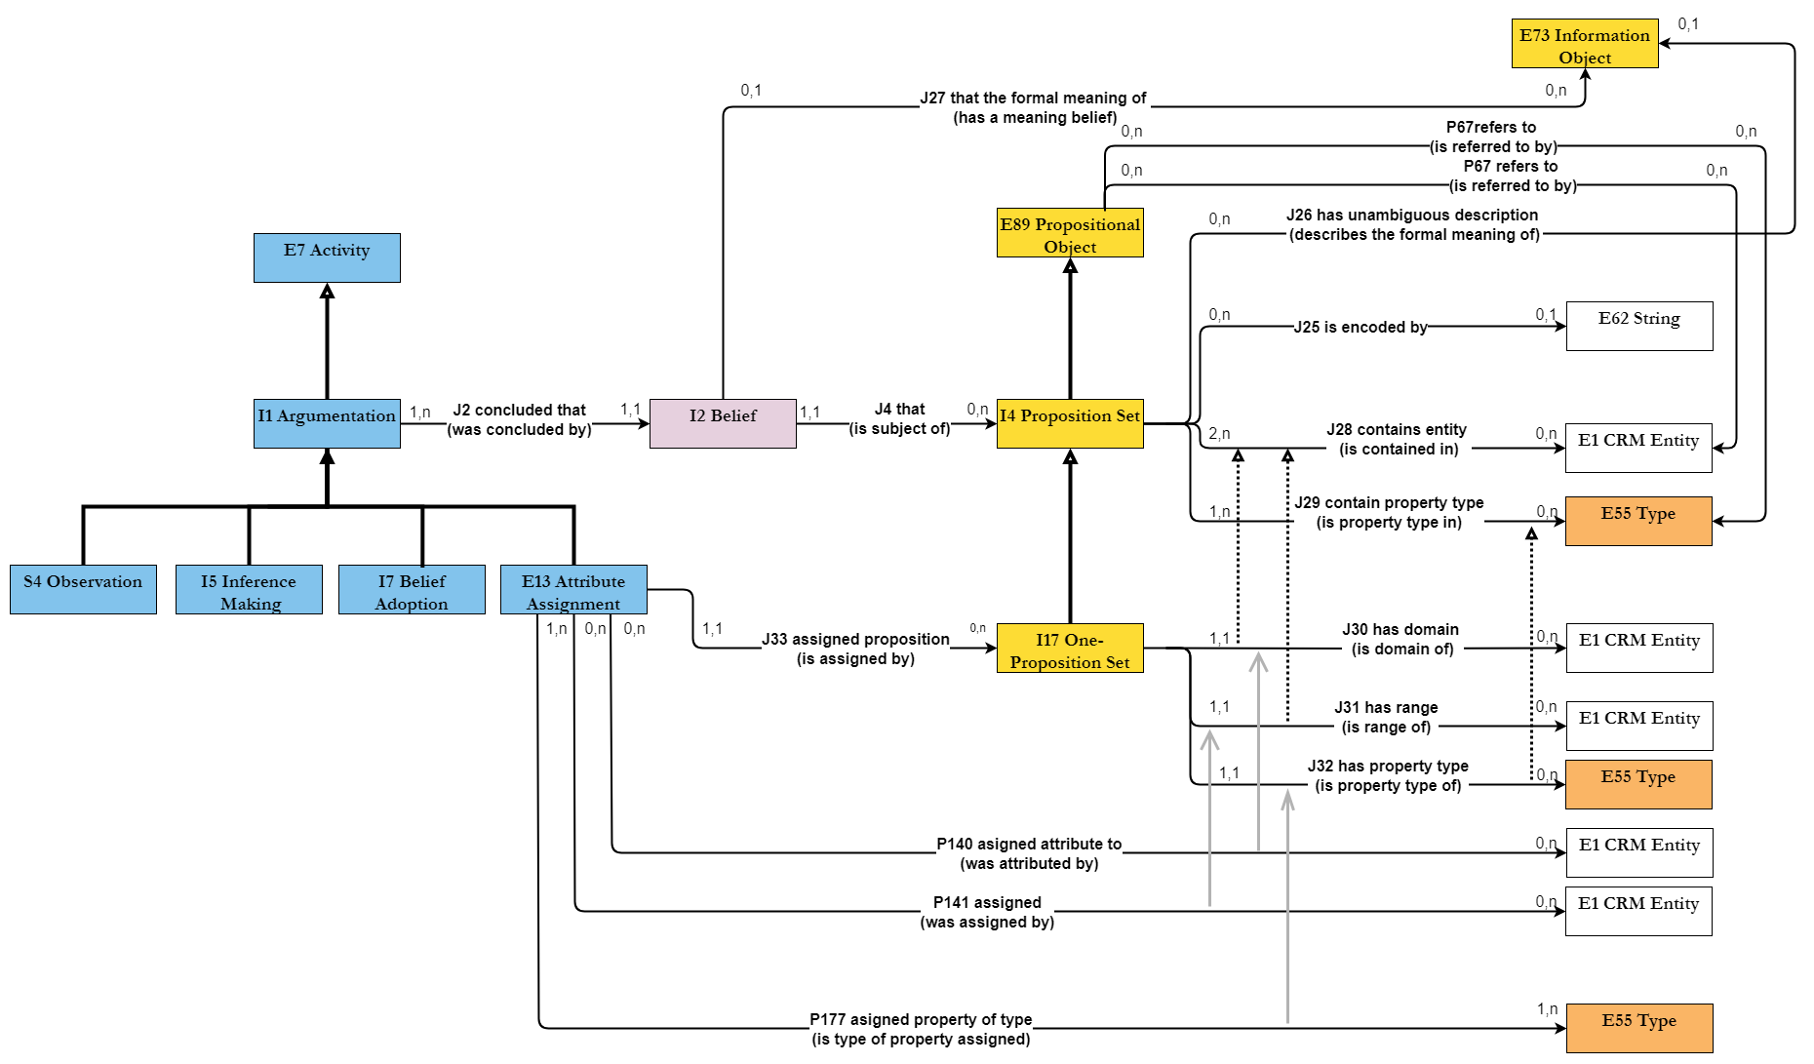

Issue 614: Definition of I4 Proposition Set and what an instance of I2 Belief is about
The SIG reviewed the proposal by MD & PF to redefine I4 Proposition Set, i.e., introduce a set of related properties.
- Jxx1 is encoded by
- Jxx2 has unambiguous description (describes the formal meaning of)
- Jxx3 that the formal meaning of (has a meaning belief)
- Jxx4 contains entity (is contained in)
- Jxx5 contains property type (is property type in)
Plus, add new examples for I2 Belief
The proposed definitions can be found in the Appendix.
Discussion points:
- Jxx has unambiguous representation: the label will have to change unless compelling evidence as to why it shouldn’t change are provided. It is not a question of it not reading nicely; rather, it is because it forms too strong a statement when in reality it is used to make claims about what goes on in people's heads. N.b.: The scope note does hypothesize an absolute lack of ambiguity independently of a context, but still the SIG was very vocal about wanting the label to change.
  - Proposed alternatives: has contextual description, has intended interpretation (something along these lines).
- Jxx that the formal meaning of (has a meaning belief): the “that” part on the label makes it hard to read and parse the property in the paths it appears. CRMinf is known to refer to beliefs in this fashion, “the instance of I2 Belief that … (rest of property name)”, but knowing that, does not make labels easier to read.
- Jxx contains entity (is contained in) AND Jxx contains property type (is property type in): the properties mix levels of representation. The instance of I4 Proposition Set, does not contain an instance of E1 CRM Entity; rather it references it. Given that they are declared superproperties of P67 refers to, they are probably intended as a means to reference an entity or property (not to contain them).
The SIG has decided that the property scope notes in question need to undergo further editing.
  - If anything, a long path could form like I4 Proposition Set. P148 has component (is component of): E89 Propositional Object. P67 refers to (is referred to by): E1 CRM Entity
  - HW: MD & CEO to discuss it among themselves.

The SIG voted in favor of accepting the proposed changes in principle, with the caveat of MD, PF having to adjust the proposed definitions and labels as suggested and then put them to an evote; rather than wait for them to be approved at the next meeting.
HW: MD, PF, with the help of CEO.

HW: PF will be deploying some rdf data to demonstrate how these data points can be graphically represented using the CRMinf, plus how to query them.

Issue 663: Define Ixx Singleton Proposition Set
The SIG reviewed the model proposed by MD & PF (see figures above, as well as the class and properties definitions in the appendix). What the proposed modelling construct aims to do is provide a CRM compatible method to implement reification and connect to E13 Attribute Assignment and properties.
Discussion points:
- For the modelling to work, the property quantifiers of P140, P141, and P177 need to be set to “many to one, necessary (1.1:0,n)”, but there seems to be no consensus on that (at least for the moment).
It is something that MD, CEO, WS, and PF will have to reconsider for issue 672.
- The proposed modeling construct provides a CRM compatible method to implement reification and connect to E13. It allows modelling one’s data as a knowledge graph (in the case that one is dealing with instances of I4 Proposition Set) or explicitly marking the truth value to statements connecting an instance of E13 Attribute Assignment to a I17 One Proposition Set. This cannot be done only relying on CRMbase –even after declaring E13 to be a subclass of I1 Argumentation –because P140/P141 implicitly take the content of the assignment to be true. The proposed modeling allows to document a knowledge revision process, during which the original E13 (represented through P140/P141/P177) will be augmented using the full path through J2 concluded that (was concluded by): I2 Belief. J4 that (is subject of): I4 Proposition Set. J5 holds to be: I6 Belief Value
- DH will be sharing relevant examples from archaeological excavation data with PF.
Decisions:
- The proposed definition for One-Proposition Set and its properties were accepted in principle.
- The properties were OK, but I17 One-Proposition Set needs some editing, in terms of making clear what its relation to reification is.
HW: GB will be contacting PF & MD to work on the scope note for I17 One-Proposition Set

Issue 602: determine the interface btw CRMsci and CRMinf
PF walked the SIG through the proposed generalized model for Observation interfacing CRMinf –see appendix.
The SIG’s feedback was along the following lines:
- Sxx3 Observable Proposition was not met with enthusiasm. The critique was that the modelling there mixes up levels of representation (If propositions can be observed, then the inferences should be about the propositions themselves, not the world).
  - Alternatively, what the diagram seems to be missing is that the thing contained in a proposition set is what got observed (not the proposition set itself).
  - Maybe change the label to "assigned something"
- the position of S5 Inference Making & S6 Data Evaluation is not made clear from the diagram.
- That E13 Attribute Assignment could be considered a subclass of EI1 Argumentation, was not met with enthusiasm in the sense that E13 is used to make a statement, especially to register difference of opinion with the maintainers of the knowledge base.
  - An instance of I1 Argumentation is primarily used to document the process whereby Actors (E39) arrive at conclusions that they believe in.
  - That the E13 is primarily used to document somebody else’s opinion neither justifies it to be construed as part of the Argumentation (I1) process, nor does it block this interpretation.
  - What seems to sanction the E13 IsA I1 relation, is that Beliefs (I2) can be adopted in an impressionistic manner (the line of argumentation being “because I said so”)
Decision:
The SIG wants this line of reasoning to be further pursued and discussed in depth.

Issue 556: Content of the minimal vocabularies for restricting the CIDOC CRM Types
The SIG reviewed the proposal
- to provide a list of recommendations
- (concerning deprecated CIDOC CRM class E40 Legal Body) from AAT –besides corporations, and corporate bodies –namely, advise to use relevant/appropriate terms listed under
  - AAT ID: 300024980 <people by occupation>
  - AAT ID: 300025825 <people by activity>
- (concerning the deprecated CIDOC CRM class E82 Actor Appellation) from AAT –besides personal names –toponyms and also actor types
  - AAT: ID: 300404655 place names
  - AAT: ID: 300025825 <people by activity>
- (concerning deprecated CIDOC CRM class E46 Section Definition) from BBT –namely, advise to use terms
  - BBT ID: 0000049 geometric extents
  - BBT ID: 0000050 points
  - BBT ID: 0000053 linear extents
  - BBT ID: 0000051 surface areas
  - BBT ID: 0000052 d-volumes
- to provide a definition for “preferred identifier assignment” (in order to specify E15 Identifier Assignment):
  - CRM Thesaurus term:
Scope note: the process of assigning an identifier which is to be preferred for use within a context, such as an organisation or a project.

Decisions:
For point (A):
- The SIG accepted the proposal for item (ii): type restrictions from BBT for deprecated CRM Class E46 Section Definition –the scope notes for the relevant set of terms can be found at the appendix.
- The SIG rejected the proposal for items (i) and (ii): type restrictions from AAT relating to <a> ID: 300024980 <people by occupation>, and <b> ID: 300025825 <people by activity> for deprecated classes E40 and E82 –they didn’t see the relevance and they claimed the proposed terms were a far worse fit than the original proposals –namely: ID: 300025969 corporations & ID: 300386361 corporate bodies for E40, and ID: 300266386 personal names for E82.
  - Coroporate bodies are not people, so then people by activity and people by occupation are not groups.
  - The AAT hierarchies are also not relevant for E82.
For point (B):
- The motivation to create a term for “preferred identifier assignment” comes from the fact that the scope note of E15 explicitly mentions that one can express the concept better through assigning a type to E15 via P2 has type: E55 Type (“preferred identifier assignment”).
- The SIG was not OK with that, instead they suggested that we do not make a recommendation and that this clause in the scope note of E15 is deleted. To be dealt with through a new issue.
  - […] The fact that an identifier is a preferred one for an organisation can be expressed by using the property E1 CRM Entity. P48 has preferred identifier (is preferred identifier of): E42 Identifier. It can better be expressed in a context independent form by assigning a suitable E55 Type, such as “preferred identifier assignment”, to the respective instance of E15 Identifier Assignment via the P2 has type property.

Wednesday, 25 September 2024

CRMsoc, CRMaaa, SDSS, CRMinfluence – a critical appraisal
CEO contrastively presented some of the assumptions found in each of the models supporting social documentation. A substantial part of the modeling invokes states of mind/ collective intentionalities etc. and ties in with constructs in CRMinf, concepts that are hard to model based on the partial evidence accessible to us through indirect means. Furthermore, the proposed models draw on intradisciplinary practices and, in that sense, they are not bound by reality, but by theory internal notions.
His take was that the SIG should refrain from collectively maintaining models for social science, but instead, it should provide a place for CRM compatible models dealing with aspects of social life to be displayed. As a corollary, the tiles for CRMsoc & CRMact should be removed from the CRM compatible models (in the sense of models collectively maintained by the SIG). The slide deck of his presentation can be found here.
Discussion points:
The ensuing discussion revolved around 4 major points, namely (i) whether the SIG should collectively undertake the responsibility of maintaining models for social phenomena, (ii) if the proposed models for documenting social phenomena comply to the principles for modeling ontologies, (iii) if and where the existing models fit with the 3-tier system that was proposed earlier and how developments in these models should be represented on the site, and (iv) how to proceed from now on.

Concerning point (i)
The SIG should be very clear on what the purpose that every model it collectively maintains is. What it is intended to do. The reply to which is that museum documentation practices are evolving, encompassing socially grounded viewpoints etc. Many projects need to document historically bound conditions conditional social facts, relative to the groups that abided to them, for as long as they did so.

Concerning point (ii)
Some concerns were voiced regarding social ontology’s lack of grounding in empirical data. The top-down approach assumed is to a large extent theory-driven and will probably clash with different approaches to social evolution.
Especially historical data calls for interpretation, in view of it being fragmentary at best. So, bottom-up approaches based on empirical observation are difficult to obtain.

Concerning point (iii)
The conversation around CRM-extension types is particularly relevant when it comes to CRMsoc. Unlike what was the case with CRMsoc, from now on, the SIG should only label a model CRM-compatible, if it has undergone harmonization with CIDOC CRM (at least). The label CRM-compatible should not be an indication of the SIG’s willingness to develop such a model.
For the moment, CRMsoc should be referenced on the site, but not as a fully harmonized model; rather as something that the SIG has invested time and effort on, but has not panned out. Because from the way it’s presented, people get the impression that it’s a fully harmonized model, when it’s really just an outdated draft. The same should apply to CRMact, in the sense that it was created to form an alternative to the model for Plans in CRMsoc v.01.
However, all the progress and issues raised etc., should be recoverable despite said models losing their status as CRM harmonized models.
On the other hand, models such as CRMaaa, SDSS, CRM-Influence, that form independent developments, compatible with the CIDOC CRM and useful for historical documentation and artistic influence should, too be referenced on the site, but on the designated part for models that are compatible with CIDOC CRM (i.e., not fully harmonized).
If the SIG appoints a subgroup towards creating a model that works well with all three independently developed models for social phenomena as well as with the entire CRM family of models, then the ensuing model would ultimately get its own tile under “CRM Harmonized Models” (or however we decide to call them).

Concerning point (iv)
There’s consensus among the SIG members that the draft version currently found on the site does not reflect the developments in any of the models for social phenomena. If anything, it’s misleading and creates a lot of confusion. Therefore, keeping it on the site indefinitely, is not an option –at least not until a better option presents itself.
A proposal was formally made to deprecate this from the CRM harmonized (formerly known as CRM compatible) models. Given the rule of not making proposals for the first time and voting on them on the same meeting, CEO said that he’ll be raising an issue to do just that.
The SIG decided to put together a task force to reinstate the CRMsoc, as a CRM compatible model that’s fully harmonized with the communally maintained CRM extensions and works well with CRMaaa, SDSS, CRM Influence, the model for Bonds, CRMact.
It’s no small task, there’s grounds for broader collaborations, maybe workshops etc.
Decision:
- The following people will work towards bringing something to the next SIG meeting (in terms of a high-level extension of CIDOC CRM that works well with CRMaaa, SDSS, CRM-Influence, CRMact, CRMbiz:
FB, GB, MP, SH

Issue 628: Update the modelling constructs found under The Model\Use&Learn\Functional Overview
Decisions per diagram –details in the appendix

Taxonomic Discourse diagram
The diagram documents how types are created in order to classify things
The following things need editing:
- Add P136.1 in the taxonomic role to P136 was based on (supported type creation)

Subject Information
- Substitute E21 Person for E39 Actor (could be a picture of E74 Group f.i.)
- Add the indirect IsA to E5 Event in the list of subclasses of E1.
- Change the label to “Subject Information” rather than “Subject Depicted Information” –it’s not limited to visual information (at least not in terms of what appears on the diagram)

Time-Span Information
- Do not disengage P10 falls within (contains) from E4 Period, but make sure to mark the property with a dashed line (as it is inherited from E92 Spacetime Volume). E92 Spacetime Volume is not critical information for this particular diagram.

Spatial-Temporal Relations
- The updated diagram looks very dense; it encodes too much information, unsure whether it’s extremely commonsensical.
  - There should be some textual description attached to it, to ensure that the information therein can be easily unpacked. We need to appoint someone to do that.
  - Especially in view of the fact that the website does not mention any STV-related pedagogical information.
- The diagram has been implemented with the previous (not universally agreed upon) version of the CHIN library. It needs to be updated.
- The information around E2 Temporal Entity could be split from the STV diagram and should probably get linked to “time-related” notions. Maybe reference some bits across diagrams. Or just create smaller bits for Temporal Entities and for Places and give a general overview for the STVs in this diagram.
  - HW: WS to do just that.

Reproduction Rights Information
- Change the label to “Rights Information” –it’s not only about reproduction rights.
- The following nodes are intended to document that one can always classify a right, and also add a textual description to it (of a particular type). It is one of the things where a short description of what the diagram is about and what the modeling is supposed to be doing can prove helpful.
  - P2 has type: E55 Type, and
  - P3 has note: E62 String (P3.1 has type: E55 Type):
- Add subclasses of E72 Legal Object that can be subject to a Right (E18 Physical Thing and E28 Conceptual Object).
- Delete P129 is about (is subject of)
- Delete E70 Thing

Reference Information
- E24 Physical Human-Made Thing. P62 depicts (is depicted by): E1 CRM Entity
  - The left-hand side should be aligned under E28/E89/E31, in the sense that it, too, is a class that can refer (in one way or another) to E1 CRM Entity.

Planned Actitivity (design, purpose, use) 1
- The diagram lacks a clear-cut purpose.
- If anything, the diagram should be relabeled “Intentional Activities” –its current name means that it’s future oriented.
- Mark the IsA between P33 used specific technique (was used by) and P16 used specific object (was used for)
- Delete the occurrence of E7 Activity at the bottom right corner of the diagram (done).
- Add P134 continued (was continued by) on E7 Activity.

Planned Activity (design, purpose, use) 2
- Rename the diagram “Intentional Activities 2”.
- Lose E1 CRM Entity. P2 has type (is type of): E55 Type link, to avoid duplicating the class in the diagram. Since the indirect ISA to E1 CRM Entity has been declared (through E70 Thing and E7 Activity), we assume that all relevant classes inherit P2.
- Use ETs copy of the slide, it only references E55 Type once, and the ISA relations show alright. The link between E1 CRM Entity and E55 Type remains implicit, but it can be inferred.

Recorder Information
- Make sure that P67 refers to (is referred to by) and P70 documents (is documented in) point to the E1 CRM Entity box on the top of the diagram.
- Add P177 assigned property of type (is type of property assigned) to the diagram.

How to proceed:
- HW: ETz to check all the diagrams for mislabeled things, other kinds of typos etc.
- HW: GB, CEO, PM & WS to continue working on the diagrams.
This group will be working offline to edit the diagrams or generate new ones and will present them at the next SIG meeting (when they will be incorporated in the Functional Overview section of the website).

The SIG voted for the diagrams that have already been revised to be uploaded on the site -with a disclaimer that only a subset is revised (it’s going to be a work in progress).
Decisions applying to all diagrams:
- We try to keep the subproperty/subclass relation pointing upwards, where possible, but in cases where they become over encumbered, we don’t have to worry too much about it.
- The indirect IsA for classes does not really show the dashed line –needs to change so that readers can easily identify the specified kind of relation
- Take out the dashed lines surrounding the main class represented in a diagram, it’s underinformative and possibly creates ambiguities
- Come back to representing the E55 Type for .1 properties. They will appear more often, and should not mess up the diagrams completely. Maybe standardize a different representation for them. Maybe a smaller box, or different colour…
- Start a new issue about adding short descriptions to each diagram explaining what they are about etc.

NEW ISSUE (687): Review the textual descriptions to diagrams in the functional overview
The SIG resolved to start a new issue, where to document the textual descriptions of the diagrams found under Functional Overview, thereby increasing their readability. The ones we now offer are underinformative/underspecific to a great extent.

Archaeological Excavation Semantic Modelling Workgroup; scope and activities
Presentation by Markos Katsianis (University of Patras)
Link to slide-deck summarizing the activities of the WG and the document advertising the scope and aims of the WG, and inviting participation here.
MK asked on behalf of the AESMWG that the SIG host the materials issued by the WG on the site of CIDOC CRM –as there is substantial overlap among the two groups (in particular when it comes to maintaining CRMarchaeo)

Discussion points:
- CRMarchaeo covers mainly stratigraphic analysis and reconstruction, but post excavation practices are not part of it. These are the things that the working group has been predominantly trying to model.
- The SIG agreed to hosting datasets, tutorials and other teaching materials (webinars etc.) provided by the AESMWG. The specifics will be worked out among MK & FORTH.

LRMoo: Update on the Official (IFLA approved) release (V1.0)
In April 2024 IFLA approved the LRMoo V1.0 version, the RDF file for it was produced and was uploaded on the CRMsite. It has been published through OntoME as well. The landing page (scope) for the model was reworked.
Publications and advertisement on the part of IFLA has been slower, but adoption is encouraged.
In the time that followed the approval, the LRMoo team have been identifying and trying to resolve remaining issues.

Issue 684: Modelling of Series in LRMoo
PR gave an outline of the issue –for more details see the slide deck of the presentation she put together.
The proposal was to introduce a new class in LRMoo F56 Container Manifestation and a set of properties to link it with F3 Manifestation, E39 Actor (through a creator and an editor role), to other instances of Container Manifestation.
The definitions for the class and properties can be found in the appendix.
The proposal aspires to implement the link to PRESSoo not as F18 Serial Work (to be deprecated in LRMoo) but through the new class.

Discussion points:
- Why declare the new class (Container Manifestation) a subclass of E28 Conceptual Object andE99 Product Type, instead of E73 Information Object andE99 Product Type? Especially if it won’t be documented unless “at least one manifestation has become a member of it, although it may have been initiated as a proposal”.
  - The rationale was that the works to be incorporated in an instance of F56 do not have to have been created for the F56 to come about. But it is open to debate. It’s about broader issues, not instances of F3 Manifestation.
  - The decision is motivated by the discussions on R10 is member of, which involved associating an instance of F1 Work to a generalized concept (i.e., a superwork), which was described as an instance of E28 Conceptual Object –in the sense that it explores a common topic or form rather than be part of the same instance of F1 Work.
- Aggregating Expressions and Aggregating Works is a useful concept to have. But it is necessary to tease apart this notion from the newly proposed class (F56).
Decision:
The proposal is not complete yet, its purpose was to get the SIG’s feedback on the usefulness of the concept. The LRMoo group will revise and come back with a definitive proposal at the next SIG meeting.

Issue 685: FOL Statements for LRMoo
LRMoo V1.0 was released without any FOL representations in it. The LRMoo group have been working on them since.
PR shared the file of the proposed FOL for classes and properties with the SIG, to get feedback and help with long path axioms, or complex restrictions due to property quantification.
The document can be accessed here.
N.b.: Anything that is mentioned in italic fonts has not been addressed in terms of FOL.

Decision:
HW: CEO and WS will go through them and comment by the next SIG meeting.

CIDOC CRM Russian translation
Presentation by Daria Hookk (The State Hermitage Museum).
Link to the slide deck here, link to the Russian translation of CIDOC CRM v7.1 here

Why we need Ontology-Specific Data Portals: A case study for CIDOC-CRM
Presentation by Mike Mountantonakis (Foundation for Research and Technology – Hellas)
Link to the slide deck here, link to portal here.

Discussion points:
- This work definitely has to be embedded in a central part of the CIDOC CRM site, it addresses the question of how many datasets are using the CIDOC CRM. It also offers interesting statistics on the use of CRM classes and properties, or patterns in use by different groups. They form examples that new users can consult when modeling similar data (or for similar reasons).
- Most frequently used properties in a given dataset would typically be a part of longer paths that the dataset in question deploys. Which means that they can serve as examples of how to use a particular construct. Could be demonstrated at the next SIG meeting, Michalis has been working on it.
- Sharing new datasets through the portal presents a great option for institutions. It requires a sparql endpoint to compute the statistics, but there are workarounds even if it’s not available.
N.b.: Geovistory offers a very large CIDOC CRM dataset on its SPARQL access point, they would love to see it featured.

Utlilizing CIDOC-CRM, CRMsci, and CRMinf to model Modern and Historical Earthquakes
Presentation by Sifis Oikonomakis (Computer Science Department -University of Crete)
Link to the slide deck here.

Discussion points:
- The presentation is highly relevant to the modeling constructs that have been in the focus of CRMinf. They form valuable examples that illustrate the concepts and properties in point.
- Modal properties of the sort “has documented possible (epicenter)|(magnitude)|(timespan)|(…)” have not been modelled as a named using exclusively CRMinf because they are represented just as data values. In case of historical earthquakes that have been properly documented, CRMinf is extremely efficient. Still, given that the modal properties are essentially shortcut properties, using them instead is less costly in terms of querying (compared to the long paths) –simply by using their superproperty.

Thursday, 26 September 2024

OntoME – Ontology Management Environment
Presentation by Stephen Hart (University of Bern) & Vincent Alamercery (ENS de Lyon, LAHRA)
Link to the slide deck here.

Zellij – the semantic pattern library; supporting sustainable semantic data management
Presentation by George Bruseker (Takin.solutions).
Link to the slide deck here.

3M – Ontology and Semantic Modelling Documentation and ETL Software
Presentation by Yannis Marketakis (Foundation for Research and Technology –Hellas; Institute of Computer Science).
Link to the slide deck here.

SIP-Creator visual mapping tool
Presentation by Sjoerd Siebinga (Delving)
Link to the slide deck here.

Ontop
Presentation by Florian Hivert (Centre National de la Recherche Scientifique –CNRS)
Link to the slide deck here.

Arches; A Data Management, Discovery, Integration, and Visualization Platform for Cultural Heritage
Presentation by Dennis Wuthrich (Farallon Geographics)
Link to the slide deck here

Wisski
Presentation by Mark Ficthner (German National Museum)
Slide-deck pending.

Research Space
Presentation by Domini Oldman (Kartography)
Link to the slide deck here.

Geovistory
Presentation by Stephen Hart (University of Bern)
Link to the slide deck here.

Criteria
Presentation by Trang Dang (Canadian Heritage Information Network)
Link to the slide deck here

Drawio2triples
Presentation by Elias Tzortzakakis (Foundation for Research and Technology – Hellas)
Link to the slide deck here

Onto Match Game
Presentation by Anaïs Guillem
Link to the slide deck here

Exploring CIDOC CRM datasets with A-Qub
Presentation by Pavlos Fafalios (Foundation for Research and Technology – Hellas)
Link to the slide deck here

Roundtable discussion
An open-ended discussion followed the presentations session, its main points revolved around the following:
What kind of resources does the SIG think would be beneficial to have (i), whether the observed overlap among systems that have been developed independently by SIG members is desirable or if it replicates previous efforts for no obvious reason (ii).

- What kind of resources does the SIG think would be beneficial to have
  - Doing development work for museums and cultural heritage institutions has become increasingly difficult on account of the structural changes that such organizations have undergone, together with how research funding works. There have been too many independently working systems developed that do not favor integration. This problem is best understood when we’re talking about legacy data, that have been documented with a completely different mindset. And despite developers being enthusiastic about a Linked Open Data approach, the people who would be generating the data in question do not see any benefit in putting in the time and effort. It’s not just about producing an ontology or the systems/services, but it’s essentially about convincing curators to give it a go.
  - To achieve that, one has to make sure that use case examples covering an extreme breadth are easily accessible to people outside this group. Unless the examples feel relevant to one’s research, then they wouldn’t be keen on using them.
  - Mapping legacy data to CIDOC CRM is a very long process, but it’s necessary.
  - One of the great impediments to using the CIDOC CRM is the specification document itself. It is hard to read and it should be redrafted in a more user-friendly way. That would be a major improvement, also a huge task to undertake. That’s how the CIDOC CRM game was created in the first place, to overcome the impediments that the documentation created for newcomers.
  - We should not assume that people with no background in computer science can use the CRM in its full potential. They will typically not be able to draw a budget that will allow them to do data integration in the course of their projects. As a starting point, we can all agree that the part of the CIDOC CRM site that explains how it can be put to use is weak. The existing resources need to be updated with clear descriptions on how to use them and to what end. The SIG should come up with a way to showcase how the examples can be put to use. There should be a structure to each folder, consisting of data, an rdf, and an explanation of what can be done (or what has been done in each instance).
- There’s substantial overlap among the systems presented today. Should the SIG take on a technical coordination rule to focus different groups to different types of effort?
  - The overlap is to be expected given how funding and research frameworks operate. They almost always require some development work, and in that sense, who’s to say that given any number of research groups and/or projects that have gotten funding for similar development work, one should proceed with it and the other(s) shouldn’t?
  - The SIG however isn’t invested in infinitely developing tools that do the exact same thing. The truth is, that outside the SIG there’s not too much awareness in terms of projects generating, querying, and managing CIDOC CRM data. Sharing an updated list of projects, datasets, etc. that SIG members have developed with a broader community would favor reuse over an infinite replication of such resources.
Decisions:

The SIG decided to start a new issue about how to best document what is available in terms of resources (datasets, software, etc.).

The SIG decided to start a new issue about how to bring people and groups doing similar development work in contact with one another. It could become a permanent feature in SIG meetings.

Friday, 27 September 2024

Issue 672: Quantifiers of P140, P141, P177 (continuation)
The SIG postponed reaching a decision on the original proposal on the grounds that
- if E13 Attribute Assignment is only to be used for reification constructs then it forms a very special case, and so do its properties. In that sense, they cannot have subproperties of their own, and
- P177 assigned property of type (is type of property assigned) is superfluous with respect to the subclasses of E13 Attribute Assignment.
Whether E13 Attribute Assignment should be disengaged from its current subclasses (E14 Condition Assessment, E15 Identifier Assignment, E16 Measurement, and E17 Type Classification) was discussed anew.
Evidence that we might not have to do that came from CRMaaa, where the constructs of ZE1 Institutional Fact resemble an E13 Attribute Assignment.
- It’s a temporal entity; but unlike E3 Condition State that exists independently of observation –only to become relevant once it’s been observed –ZE1 Institutional Fact only exists because society/ some group has collectively decided that it is the case.
- It connects two entities and ascribes a type of relation to them much like the E13 and P140, P141, P177 modeling construct in CRMbase. And it also allows to ascribe temporal and other information (actor, location, whatnots) to the institutional fact.

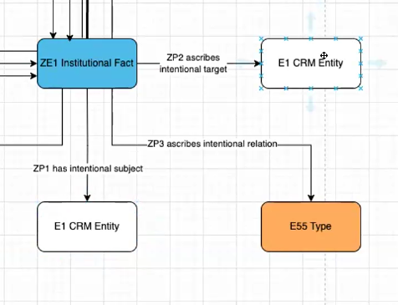
Still, the SIG could not reach a decision at that point. Whether P177 is used as in E13 (to reference the name of the property) or in a direct analogy to ZP3 ascribes intentional relation, its scope note will have to change. The same thing applies to the scope notes for E14, E15, E16, E17 and their properties, if they are disengaged from E13.
How to proceed:
HW: CEO, MD, WS to discuss this ahead of the next meeting. Come up with a concrete proposal by that time.

Teaching CIDOC CRM
Presentation by Sarantos Kapidakis (University of West Attica)
Link to the slide deck here.

Discussion points:
- It helps students if they are given explicit information on what the purpose of a description is.
- Small exercises should take less than an hour to complete, but takehome exams would be more substantial than the ones presented.
- The diagrams and collection of errata should serve as use cases for teaching the CRM
- More of the work undertaken by SK and his group should be shown at the 60th SIG meeting, where we’re planning to hold a day of activities designated to collecting/presenting material on teaching the CRM.

Issue 628: Update the modelling constructs found under The Model\Use&Learn\Functional Overview (continuation)

Person Nationality Information
Discussion points:
- The diagram needs massive reorganization. The connection between E21 Person and an E74 Group is not particularly convincing, in the sense that not all national subjects of a given state act collectively or in a similar way. The information could be relayed through a
  - P2 has type. E55 Type {“a given nationality”} on E21 Person
  - P98i was born (brought into life): E67 Birth. P7 took place at (witnessed). E53 Place
- The P10 falls within (contains) property to be replaced by P9 consists of (forms part of): E4 Period
- E41 Appellation should be used for E21 Person, E74 Group, E53 Place, E4 Period as well –although maybe geospatial data can serve as what used to be Place Appellations, if that’s considered useful.
  - Alternatively, P172 contains or P168 place is defined by (defines place) could be used for E53 Place in particular.
These points should be part of the textual description of the diagram
HW: GB to do that.

Part and component information
Discussion points:
- Proposal to add P110 augmented (was augmented by), P112 diminished (was diminished by)
- Consider adding the superproperty of P110 and P112 (namely P31 has modified (was modified by) –Domain: E11 Modification, Range: E18 Physical Thing.
Overall comment:
Pointers from diagram to diagram in order to enhance the available information. Maybe instead of using draw.io, we could use Criteria diagrams.

Appendices

Appendix I: List of abbreviated names
CEO - Christian-Emil Ore
DH - Daria Hookk
DO - Dominic Oldman
EC - Erin Canning
ETz -Elias Tzortzakakis
FB - Francesco Beretta
GB - George Bruseker
MD - Martin Doerr
MK - Markos Katsianis
MP - Milena Peralta,
MR - Melanie Roche
PF - Pavlos Fafalios
PR - Pat Riva
SH - Stephen Hart
SK - Sarantos Kapidakis
WS - Wolfgang Schmidle

Appendix II: Scope note reformulations -model updates

CRMinf Update

Class and property usage examples

The first running example is about an important archaeological discovery, initially announced in the press, and subsequently in proper scientific archaeological publications. It covers two simple events of observation, a simple example of an inference based on a legitimate plausibility argument, and a rare published example of knowledge revision by the same author:

The skeleton found on the left bench of La Tomba dell'Aryballos sospeso, Doganaccia di Tarquinia, Tuscany, Italy, by Prof. Alessandro Mandolesi on the 21th of September 2013, was initially estimated by Prof. Mandolesi to be the remains of a male person, due to the lance found next to it, and published in the press as such. Soon after, osteological analysis carried out by the team revealed that it was of a female person, as published in the academic papers afterwards. This is a good example for a simple inference and scientific knowledge revision. We refer to this skeleton in these examples of propositions as “The skeleton on the left bench in La Tomba dell'Aryballos sospeso” and as “The burial arrangement on the left bench in La Tomba dell'Aryballos sospeso” respectively, meaning any unique identifier for the same real object.]

The second running example is the text by Francesca Bologna about Nero, in particular about the whereabouts of Nero during the Great Fire of Rome. (Bologna 2021). It contains a clear published example of understanding and citing two contradictory historical sources without implicitly believing them, and then a nice scholarly argument for trusting the one and disbelieving the other, based on plausibility, the provenance of the information the author of the source had, and contextually justified bias.

Citation:

“On 19 July AD 64, a fire started close to the Circus Maximus. The flames soon encompassed the entire city of Rome and the fire raged for nine days. Only four of the 14 districts of the capital were spared, while three were completely destroyed.
Rome had already been razed by flames – and would be again in its long history – but this event was so severe it came to be known as the Great Fire of Rome.
Later historians blamed Nero for the event, claiming that he set the capital ablaze in order to clear land for the construction of a vast new palace. According to Suetonius and Cassius Dio, Nero took in the view of the burning city from the imperial residence while playing the lyre and singing about the fall of Troy. This story, however, is fictional.
Tacitus, the only historian who was actually alive at the time of the Great Fire of Rome (although only 8 years old), wrote that Nero was not even in Rome when the fire started, but returned to the capital and led the relief efforts.”

“Most of what we know about Nero comes from the surviving works of three historians – Tacitus, Suetonius and Cassius Dio. All written decades after Nero's death, their accounts have long shaped our understanding of this emperor's rule. However, far from being impartial narrators presenting objective accounts of past events, these authors and their sources wrote with a very clear agenda in mind. Nero's demise brought forward a period of chaos and civil war – one that ended only when a new dynasty seized power, the Flavians. Authors writing under the Flavians all had an interest in legitimising the new ruling family by portraying the last of the Julio-Claudians in the worst possible light, turning history into propaganda. These accounts became the 'historical' sources used by later historians, therefore perpetuating a fabricated image of Nero, which has survived all the way to the present.”

Issue 614:

J25 is encoded by
Domain:
I4 Proposition Set
Range:
E62 String
Subproperty of:
<???>
Superproperty of:
<???>
Quantification:
one to many (0,n:0,1)
Scope note:
This property associates an instance of I4 Proposition Set with a “serialization” of its content in the format of a knowledge representation language. There may be more than one ontologically equivalent formal encodings of the same propositions.
In a Knowledge Base implementation, the content of an instance of I4 Proposition Set may be represented by the content of a Named Graph, but only if the propositions are encoded in the data model of the Knowledge Base and held to be true by the maintainers of a Knowledge Base because they become part of the stated knowledge. In this case, the platform-internal relation between the URI of the Named Graph and its content are regarded as equivalent to J25 is encoded by, and the property should formally not be instantiated.
<Fully developed path??>
Examples:
- {The skeleton on the left bench in La Tomba dell'Aryballos sospeso (E20 Biological Object) P2 has type ‘male’ (E55 Type)} (I17)
is encoded by
“<crm:E20_Biological_Object rdf:about=" https://cidoc-crm.org/crminf/examples/ Aryballos_Skeleton">
<rdfs:label xml:lang="en"> The skeleton on the left bench in La Tomba dell'Aryballos sospeso </rdfs:label>
<crm:P2_has_type>
<crm:E55_Type rdf:about="http://vocab.getty.edu/aat/300025928">
<rdfs:label xml:lang="en">men (male humans)</rdfs:label>
</crm:E55_Type>
</crm:P2_has_type>
</crm: E20_Biological_Object>” (E62). (Squires, 2013)
In First Order Logic:
J25(x,y) ⇒ I4(x)
J25(x,y) ⇒ E62(y)

J26 has unambiguous description (describes the formal meaning of)
Domain:
I4 Proposition Set
Range:
E73 Information Object
Subproperty of:
E1 CRM Entity. P129i is subject of (is about): E89 Propositional Object
Superproperty of:

Quantification:
one to many (0,n:0,1)
Scope note:
This property associates an instance of I4 Proposition Set with an instance of E73 Information Object that expresses the content of the former as propositions that are or could, in principle be, encoded in a knowledge representation language.
These propositions should be unambiguous at least within the context of provenance of the information object and the context of documenting them as the content of the instance of I4 Proposition Set. For a textual representation, rules of a normal scholarly consensus should be applied.
<Fully developed path??>
Examples:
- The proposition set with content:
{The skeleton on the left bench in La Tomba dell'Aryballos sospeso (E20 Biological Object) P2 has type ‘male’ (E55 Type)} (I17)
has unambiguous description
“The skeleton found on the left bench of La Tomba dell'Aryballos sospeso, Doganaccia di Tarquinia, Tuscany, Italy, by Prof. Alessandro Mandolesi on the 21th of September 2013 belongs to the remains of a male person” (E73). (Squires, 2013)
- The proposition set with content:
{Nero July 19, 64 AD (E93 Presence)
P164 is temporally specified by: July 19, 64 AD (E52 Timespan)
P195 was a presence of: Nero Claudius Caesar Drusus Germanicus (E21 Person)
P167 was within Rome in 64AD, Italy (E53 Place)
P10 falls within (contains): Nero Singing (E7 Activity)
P2 has type: Singing (E55 Type)
P14 carried out by: Nero Claudius Caesar Drusus Germanicus (E21)
P4 has timespan: July 19, 64 AD (E52 Timespan)
P7 took place at: Rome in 64AD, Italy (E53 Place)
P132 spatiotemporally overlaps with: The Great Fire of Rome (E5 Event)
P1 is identified by: incendium magnum Romae (E41 Appellation)
P4 has timespan: July 19-27, 64 AD (E52 Timespan)
P7 took place at: Rome in 64AD, Italy (E53 Place)
}
has unambiguous description
“Nero Claudius Caesar Drusus Germanicus was singing in Rome while it was burning from July 19 in 64 AD” (E73). (Bologna, 2021)
In First Order Logic:
J26(x,y) ⇒ I4(x)
J26(x,y) ⇒ E78(y)
J26(x,y) ⇒ P129(y,x)

J27 that the formal meaning of (has a meaning belief)
*comment by MD: The label “a formal meaning” is not adequate, because the link should only be used if the meaning is not ambiguous. Otherwise, J4 must be used!*
Domain:
I2 Belief
Range:
E73 Information Object
Subproperty of:
<??>
Superproperty of:
<??>
Quantification:
many to one (0,1:0,n)
Scope note:
This property associates an instance of I2 Belief with an instance of E73 Information Object that expresses the believed propositions in a form that are or could, in principle be, encoded in a knowledge representation language.
This property is a strong shortcut of the fully developed path from I2 Belief, J4 that (is subject of), I4 Proposition Set, J26 has unambiguous description (describes the formal meaning of) to E73 Information Object. It is introduced into this model for the convenience of the user, when the implied instance of I4 Proposition Set appears not to be a separate object of discourse within this documentation context.
<Fully developed path??>
Examples:
- The belief of Prof. Alessandro Mandolesi in the gender of the skeleton on the left bench in La Tomba dell'Aryballos sospeso as provided to the press on the 21th of September 2013 (I2)
that the formal meaning of
“The skeleton found on the left bench of La Tomba dell'Aryballos sospeso, Doganaccia di Tarquinia, Tuscany, Italy, by Prof. Alessandro Mandolesi on the 21th of September 2013 belongs to the remains of a male person” (E73)
[“holds to be True (I6)”, see examples for J5].
(Squires, 2013)
In First Order Logic:
*comment by MD: J27 is a strong shortcut of J4 –J26*
J27(x,y) ⇒ I2(x)
J27(x,y) ⇒ E78(y)
J27(x,y) ⇔ (∃u) [I4(u) ˄ J4(x,u) ˄ J26(u,y)

J28 contains entity (is contained in)
*comment by PF: “element of one or more propositions”, refers to the domain or range class of an instance of a property in a proposition set, i.e., the subject or object of a statement in a triple.*
Domain:
I4 Proposition Set
Range:
E1 CRM Entity
Subproperty of:
E89 Propositional Object. P67 refers to (is referred to by): E1 CRM Entity
Superproperty of:
I10 Provenance Statement. J20 is about the provenance of (has provenance claim): E70 Thing
I17 One-Proposition Set. J30 has domain (is domain of): E1 CRM Entity
I17 One-Proposition Set. J31 has range (is range of): E1 CRM Entity
Quantification:
many to many, necessary (2,n:0,n)
Scope note:
This property associates an instance of I4 Proposition Set with an instance of E1 CRM Entity that appears as an element of one or more propositions in the content of the former.
This property serves on one side to relate an instance of I4 Proposition Set to other contexts of interest, in particular when its content is or cannot be represented as a Named Graph in the same knowledge base. On the other hand, it plays an important structural role in this model for expressing constraints to the content of an instance of I4 Proposition Set or one of its subclasses.
<Fully developed path??>
Examples:
- The proposition set with content:
{Nero in July 19, 64 AD (E93 Presence)
P164 is temporally specified by: July 19, 64 AD (E52 Timespan)
P195 was a presence of: Nero Claudius Caesar Drusus Germanicus (E21 Person)
P167 was within Antium in 64AD, Italy (E53 Place)
P133 is spatiotemporally separated from: The Great Fire of Rome (E5 Event)
P1 is identified by: incendium magnum Romae (E41 Appellation)
P4 has timespan: July 19-27, 64 AD (E52 Timespan)
P7 took place at: Rome in 64AD, Italy (E53 Place)
}
contains entity Antium in 64AD, Italy (E53 Place)
(Bologna 2021)
In First Order Logic:
J28(x,y) ⇒ I4(x)
J28(x,y) ⇒ E1(y)
J28(x,y) ⇒ P67(x,y)

J29 contains property type (is property type in)
Domain:
I4 Proposition Set
Range:
E55 Type
Subproperty of:
E89 Propositional Object. P67 refers to (is referred to by): E1 CRM Entity
Superproperty of:
I17 One-Proposition Set. J32 has property type (is property type of): E55 Type
Quantification:
many to many, necessary (1,n:0,n)
Scope note:
This property associates an instance of I4 Proposition Set with an instance of E55 Type that appears as property type in one or more propositions in the content of the former.
This property plays an important structural role in this model for expressing constraints to the content of an instance of I4 Proposition Set or one of its subclasses.
<Fully developed path??>
Examples:
- The proposition set with content:
{Nero in July 19, 64 AD (E93 Presence)
P164 is temporally specified by: July 19, 64 AD (E52 Timespan)
P195 was a presence of: Nero Claudius Caesar Drusus Germanicus (E21 Person)
P167 was within Antium in 64AD, Italy (E53 Place)
P133 is spatiotemporally separated from: The Great Fire of Rome (E5 Event)
P1 is identified by: incendium magnum Romae (E41 Appellation)
P4 has timespan: July 19-27, 64 AD (E52 Timespan)
P7 took place at: Rome in 64AD, Italy (E53 Place)
}
contains property type P195 was a presence of (E55 Type)
(Bologna, 2021)
In First Order Logic:
J29(x,y) ⇒ I4(x)
J29(x,y) ⇒ E55(y)
J29(x,y) ⇒ P67(x,y)

New examples for I2 Belief
- One lance being in the burial arrangement on the left bench in La Tomba dell'Aryballos sospeso following Prof. Alessandro Mandolesi’s observation (I2) (Squires, 2013) (Mandolesi, 2013) [An observed fact, be it by many people, still constitutes a belief in the most general sense]
- The belief of Prof. Alessandro Mandolesi in the gender of the skeleton on the left bench in La Tomba dell'Aryballos sospeso as provided to the press on the 21th of September 2013 (I2) (Squires, 2013)

Issue 663:

I17 One-Proposition Set
Subclass of:
I4 Proposition Set
Superclass of:

Scope note:
This class comprises proposition sets containing exactly one binary proposition which is or could, in principle be, encoded in a knowledge representation language. The identity of an instance of I17 One-Proposition Set is given by the total of its content, regardless equivalent encodings.
A property linking to an instance of I17 One-Proposition Set in a Knowledge Base may alternatively be implemented by a “reification” construct, and is regarded as logically equivalent in this model. Similarly, all triples of properties declared for one class to denote the domain, type and range of another property, such as the properties of E13 Attribute Assignment and its subclasses, can be interpreted as shortcuts to an instance of I17 One-Proposition Set and its properties J30 has domain (is domain of), J31 has range (is range of), J32 has property type (is property type of), or as a “reification” implicit to the declaring class.
As such, the class I17 One-Proposition Set plays the role of an important logical interface between different ways to document a discourse about propositions within a Knowledge Base in different ways. It is particularly relevant for implementing effective queries. For documentation, the use of simpler shortcut properties will, typically, be the preferred approach.
Examples:
- The proposition set with content:
{The skeleton in La Tomba dell'Aryballos sospeso on the left bench (E20 Biological Object) P2 has type ‘male’ (E55 Type)} (I17) (Squires, 2013)
- The proposition set with content:
{The skeleton in La Tomba dell'Aryballos sospeso on the left bench (E20 Biological Object) P2 has type ‘female’ (E55 Type)} (I17) (Mandolesi, 2013)
- The proposition set with content:
{The burial arrangement in La Tomba dell'Aryballos sospeso on the left bench (E22 Human-Made Object) is composed of The spear found in La Tomba dell'Aryballos sospeso (E22 Human-Made Object)} (I17) (Mandolesi, 2013)
- The proposition set with content:
{The skeleton in La Tomba dell'Aryballos sospeso on the left bench (E20 Biological Object) forms part of The burial arrangement in La Tomba dell'Aryballos sospeso on the left bench (E22 Human-Made Object)} (I17) (Mandolesi, 2013)
[The skeleton found on the left bench of La Tomba dell'Aryballos sospeso, Doganaccia di Tarquinia, Tuscany, Italy, by Prof. Alessandro Mandolesi on the 21th of September 2013, was initially estimated by Prof. Mandolesi to be the remains of a male person, due to the lance found next to it, and published in the press as such. Soon after, osteological analysis carried out by the team revealed that it was of a female person, as published in the academic papers afterwards. This is a good example for a simple inference and scientific knowledge revision. We refer to this skeleton in these examples of propositions as “The skeleton on the left bench in La Tomba dell'Aryballos sospeso” and as “The burial arrangement on the left bench in La Tomba dell'Aryballos sospeso” respectively, meaning any unique identifier for the same real object.]
- The proposition set with content:
{The book MS Sinai Greek 418 (E22 Human-Made Object) has binding structure ‘unsupported’ (E55 Type) } (Honey & Pickwoad, 2010)
[‘has binding structure’ refers to a property, external to the CIDOC CRM, which connects a book (E22 Human-Made Object) to the type of its binding structure (E55 Type)]
In First Order Logic:
I17(x) ⇒ I4(x)
I17(x) ⇒ (∃uvw) [E1(u) ˄ J30(x,u) ˄ E1(v) ˄ J31(x,v) ˄ E55(w) ˄ J32(x,w)]

Properties:
J30 has domain (is domain of): E1 CRM Entity
J31 has range (is range of): E1 CRM Entity
J32 has property type (is property type of): E55 Type

J30 has domain (is domain of)
Domain:
I17 One-Proposition Set
Range:
E1 CRM Entity
Subproperty of:
I4 Proposition Set. J28 contains entity (is contained in): E1 CRM Entity
Superproperty of:

Quantification:
many to one, necessary (1,1:0,n)
Scope note:
This property associates an instance of I17 One-Proposition Set with an instance of E1 CRM Entity that must appear as the only domain instance of the proposition in the content of the former.
This property is part of the fully developed path from E13 Attribute Assignment through J33 assigned proposition (is assigned by), I17 One-Proposition Set, J30 has domain (is domain of) E1 CRM Entity, which is shortcut by P140 assigned attribute to (was attributed by).
Examples:
- The proposition set with content:
{The skeleton on the left bench in La Tomba dell'Aryballos sospeso (E20 Biological Object) P2 has type ‘male’ (E55 Type)} (I17) has domain The skeleton in La Tomba dell'Aryballos sospeso on the left bench (E20) (Squires 2013)
- The proposition set with content:
{The skeleton on the left bench in La Tomba dell'Aryballos sospeso (E20 Biological Object) P2 has type ‘female’ (E55 Type)} (I17) has domain The skeleton in La Tomba dell'Aryballos sospeso on the left bench (E20) (Mandolesi 2013)
- The proposition set with content:
{The burial arrangement on the left bench in La Tomba dell'Aryballos sospeso (E22 Human-Made Object) is composed of the spear found in La Tomba dell'Aryballos sospeso (E22 Human-Made Object)} (I17) has domain The burial arrangement in La Tomba dell'Aryballos sospeso on the left bench (E22) (Mandolesi 2013)
- The proposition set with content:
{The skeleton on the left bench in La Tomba dell'Aryballos sospeso (E20 Biological Object) forms part of The burial arrangement on the left bench in La Tomba dell'Aryballos sospeso (E22 Human-Made Object)} (I17) has domain The skeleton on the left bench in La Tomba dell'Aryballos sospeso (E20) (Mandolesi 2013)
- The proposition set with content:
{The book MS Sinai Greek 418 (E22 Human-Made Object) has binding structure ‘unsupported’ (E55 Type)} (I17) has domain The book MS Sinai Greek 418 (E22) (Honey & Pickwoad, 2010)

[See comments for examples of I17]
In First Order Logic:
J30(x,y) ⇒ I17(x)
J30(x,y) ⇒ E1(y)
J30(x,y) ⇒ J28(x,y)
J28(x,y) ) ˄ I17(x) ⇒ J30(x,y) OR J31(x,y)

J31 has range (is range of)
Domain:
I17 One-Proposition Set
Range:
E1 CRM Entity
Subproperty of:
I4 Proposition Set. J28 contains entity (is contained in): E1 CRM Entity
Superproperty of:

Quantification:
many to one, necessary (1,1:0,n)
Scope note:
This property associates an instance of I17 One-Proposition Set with an instance of E1 CRM Entity that must appear as the range of the proposition in the content of the former.
This property is part of the fully developed path from E13 Attribute Assignment through J33 assigned proposition (is assigned by), I17 One-Proposition Set, J31 has range (is range of) E1 CRM Entity, which is shortcut by P141 assigned (was assigned by).

Examples:
- The proposition set with content:
{The skeleton on the left bench in La Tomba dell'Aryballos sospeso (E20 Biological Object) P2 has type ‘male’ (E55 Type)} (I17) has range ‘male’ (E55) (Squires 2013)
- The proposition set with content:
{The burial arrangement on the left bench in La Tomba dell'Aryballos sospeso (E22 Human-Made Object) is composed of The spear found in La Tomba dell'Aryballos sospeso (E22 Human-Made Object)} (I17) has range The spear found in La Tomba dell'Aryballos sospeso (E22) (Mandolesi 2013)
- The proposition set with content:
{The skeleton on the left bench in La Tomba dell'Aryballos sospeso (E20 Biological Object) forms part of The burial arrangement on the left bench in La Tomba dell'Aryballos sospeso (E22 Human-Made Object)} (I17) has range The burial arrangement on the left bench in La Tomba dell'Aryballos sospeso (E22) (Mandolesi 2013)
- The proposition set with content:
{The book MS Sinai Greek 418 (E22 Human-Made Object) has binding structure ‘unsupported’ (E55 Type)} (I17) has range ‘unsupported’ (E55 Type) (Honey & Pickwoad, 2010)

[See comments for examples of I17]

In First Order Logic:
J31(x,y) ⇒ I17(x)
J31(x,y) ⇒ E1(y)
J31(x,y) ⇒ J28(x,y)

J32 has property type (is property type of)
Domain:
I17 One-Proposition Set
Range:
E55 Type
Subproperty of:
I4 Proposition Set. J29 contains property type (is property type in): E55 Type
Superproperty of:

Quantification:
many to one, necessary (1,1:0,n)
Scope note:
This property associates an instance of I17 One-Proposition Set with an instance of E55 Type that must appear as the only property type of the proposition in the content of the former.
This property is part of the fully developed path from E13 Attribute Assignment through J33 assigned proposition (is assigned by), I17 One-Proposition Set, J32 has property type (is property type of) E1 CRM Entity, which is shortcut by P177 assigned property of type (is type of property assigned).

Examples:
- The proposition set with content:
{The skeleton on the left bench in La Tomba dell'Aryballos sospeso (E20 Biological Object) P2 has type ‘male’ (E55 Type)} (I17) has property type ‘P2 has type’ (E55). (Squires 2013)
- The proposition set with content:
{The skeleton on the left bench in La Tomba dell'Aryballos sospeso (E20 Biological Object) P2 has type ‘female’ (E55 Type)} (I17) has property type ‘P2 has type’ (E55). (Mandolesi 2013)
- The proposition set with content:
{The burial arrangement on the left bench in La Tomba dell'Aryballos sospeso (E22 Human-Made Object) is composed of The spear found in La Tomba dell'Aryballos sospeso (E22 Human-Made Object)} (I17) has property type ‘P46 is composed of’ (E55). (Mandolesi 2013)
- The proposition set with content:
{The skeleton on the left bench in La Tomba dell'Aryballos sospeso (E20 Biological Object) forms part of The burial arrangement on the left bench in La Tomba dell'Aryballos sospeso (E22 Human-Made Object)} (I17) has property type ‘P46i forms part of’ (E55). (Mandolesi 2013)
- The proposition set with content:
{The book MS Sinai Greek 418 (E22 Human-Made Object) has binding structure ‘unsupported’ (E55 Type)} (I17) has property type ‘has binding structure’ (E55). (Honey & Pickwoad, 2010)

[See comments for examples of I17]

In First Order Logic:
J32(x,y) ⇒ I17(x)
J32(x,y) ⇒ E55(y)
J32(x,y) ⇒ J29(x,y)

J33 assigned proposition (is assigned by)
Domain:
E13 Attribute Assignment
Range:
I17 One-Proposition Set
Superproperty of:

Subproperty of:

Quantification:
many to one, necessary (1,1:0,n)
Scope note:
This property associates an instance of E13 Attribute Assignment with an instance of I17 One-Proposition Set that describes the proposition made and believed to be true.
This property constitutes a formal logical alternative to specifying the proposition made by an instance of E13 Attribute Assignment via P140 assigned attribute to (was attributed by), P141 assigned (was assigned by) and P177 assigned property of type (is type of property assigned). As such, it is of importance for querying knowledge bases compatible with either model.
This property forms part of the following three (3) fully developed paths from E13 Attribute Assignment through:
- J33 assigned proposition (is assigned by), I17 One-Proposition Set, J30 has domain (is domain of) to E1 CRM Entity, which is shortcut by P140 assigned attribute to (was attributed by).
- J33 assigned proposition (is assigned by), I17 One-Proposition Set, J31 has range (is range of) to E1 CRM Entity, which is shortcut by P141 assigned (was assigned by),
- J33 assigned proposition (is assigned by), I17 One-Proposition Set, J32 has property type (is property type of) to E1 CRM Entity, which is shortcut by P177 assigned property of type (is type of property assigned).
This property is a shortcut for the path from E13 Attribute Assignment through J2 concluded that (was concluded by), I2 Belief, J4 that (is subject of), I4 Proposition Set, J5 holds to be to I6 Belief Value (= “True”).
Full path:
<???>
Examples:
- The gender classification of the skeleton on the left bench in La Tomba dell'Aryballos sospeso provided to the press by Prof. Alessandro Mandolesi on the 21th of September 2013 (E17, I5) assigned proposition
The proposition set with content:
{The skeleton on the left bench in La Tomba dell'Aryballos sospeso (E20 Biological Object) P2 has type ‘male’ (E55 Type)} (I17) (Squires 2013)
- The gender analysis of the skeleton on the left bench in La Tomba dell'Aryballos sospeso provided to the press by Prof. Alessandro Mandolesi on the 18th of October and academically published in 2013 (E17, S4) assigned proposition
The proposition set with content:
{The skeleton on the left bench in La Tomba dell'Aryballos sospeso (E20 Biological Object) P2 has type ‘female’ (E55 Type)} (I17) (Mandolesi 2013)
- The examination of MS Sinai Greek 418 by Nicholas Pickwoad in November 2003 (E13) assigned proposition
The proposition set with content:
{The book MS Sinai Greek 418 (E22 Human-Made Object) has binding structure ‘unsupported’ (E55 Type)} (I17) (Honey & Pickwoad, 2010)

[See comments for examples of I17]
In First Order Logic:
J33(x,y) ⇒ E13(x)
J33(x,y) ⇒ I17(y)
J33(x,y) ⇒ P140(x,u) ˄ J30(y,u) ˄ P141(x,v) ˄ J31(y,v) ˄ P177(w) ˄ J32(y,w)
J33(x,y) ⇒ (∃u) [I2(u) ˄ J2(x,u) ˄ J4(u,y) ˄ J5(u,’TRUE’)] believed to be true!
E13(x) ⇒ (∃uvw) [E1(u) ˄ P140(x,u) ˄ E1(v) ˄ P141(x,v) ˄ E55(w) ˄ P177(x,w)]
J2(x,y) ˄ E13(x) ⇒ J33(x,y)
P140(x,y) ⇒ (∃u) [I17(u) ˄ J33(x,u) ˄ J30(u,y)]
P141(x,y) ⇒ (∃u) [I17(u) ˄ J33(x,u) ˄ J31(u,y)]
P177(x,y) ⇒ (∃u) [I17(u) ˄ J33(x,u) ˄ J32(u,y)]

Issue 602:
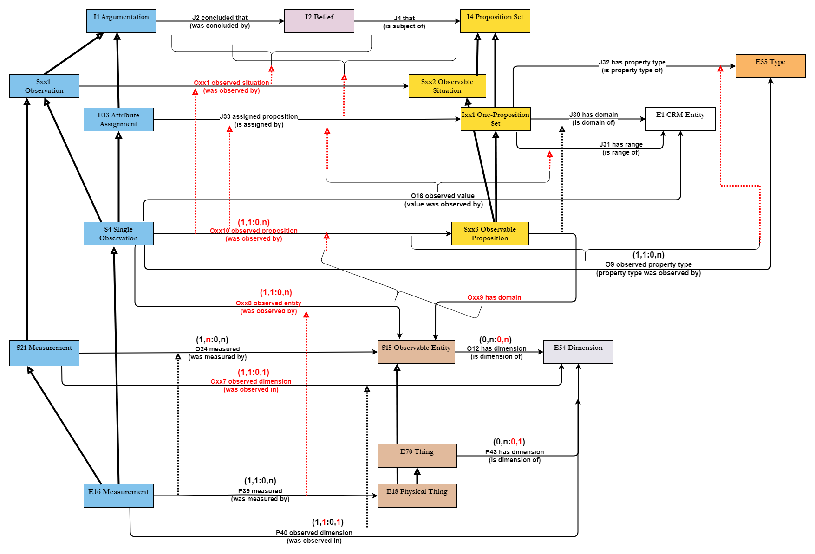

Issue 556:
E46 Section Definition | use E41 Appellation | ID: 0000049  Page Link: https://vocabs.dariah.eu/bbt/Concept/0000049  geometric extents (hierarchy name) | BBT Note: This term classifies kinds of designations and definitions of spatial extents based on either geometric expressions or spatial properties of observable features -like mountains, lakes, buildings, cities, etc. -and social constructs -referring to the spatial extent of territories that fall within the jurisdiction of some geopolitical or other administrative unit. NOTE: The terms listed as Geometric extents can be coordinated with the suitable type of phenomenal place, in the sense of CRMgeo, classified accordingly under Physical Features, Built Environment or Geopolitical Units.
E46 Section Definition | use E41 Appellation | ID: 0000050  Page Link: https://vocabs.dariah.eu/bbt/Concept/0000050  points (geometric extents (hierarchy name)) | BBT Note: This term classifies zero-dimensional geometric primitives, representing the position [1] of the centroid of a particular feature, on a given surface –irrespective of its actual spatial extent –depending on the scale of the representation (the smaller the scale, the more likely it is for a feature to be thus represented), convenience and the type of feature the points stand for [2]. [1] The OpenGIS; Abstract Specification; Topic 5: Features [2] https://docs.qgis.org/2.8/en/docs/gentle_gis_introduction/vector_data.html#figure-geometry-point NOTE: The terms listed as points can be coordinated with the suitable type of phenomenal place -in the sense of CRMgeo [1] -classified under the hierarchies of Physical Features, Built Environment or Geopolitical Units.
E46 Section Definition | use E41 Appellation | ID: 0000053  Page Link: https://vocabs.dariah.eu/bbt/Concept/0000053  linear extents (geometric extents (hierarchy name)) | BBT Note: This term classifies one-dimensional shapes on a surface that are either straight or curved and can be defined by a connected series of unique x,y coordinate pairs/points forming a continuous path. The said points are all contained in it [1], [2]. Linear extents can be used to show the geometry of linear features such as roads, rivers, contours, footpaths, flight paths and so on. NOTE: The kind of physical feature, built environment or geopolitical unit -or part thereof, f.i. a mountain range, a road, a border between two countries -providing the linear extent can be specified by coordinating this term with the suitable feature type, such as “linear extents of physical features/ built environments/ geopolitical units”. [1] https://docs.qgis.org/2.8/en/docs/gentle_gis_introduction/vector_data.html#figure-geometry-polyline [2] https://en.wikipedia.org/wiki/Line_(geometry)
E46 Section Definition | use E41 Appellation | ID: 0000051  Page Link: https://vocabs.dariah.eu/bbt/Concept/0000051  surface areas (geometric extents (hierarchy name)) | BBT Note: The term classifies quantities expressing the extent of a two-dimensional feature, figure or shape defined by a connected sequence of x,y coordinate pairs/points, where the first and last coordinate pair/points are the same and all others are unique, thus forming a polygon. The latter can have a shared geometry, i.e. boundaries that are in common with a neighboring polygon. Surface areas can be seen as contiguous projections onto some reference space. Examples of such areas are enclosed spaces like dams, islands, country boundaries and so on. NOTE: The kind of Physical feature, Built environment or Geopolitical unit providing the geometric extent -i.e. a lake, a stadium, a prefecture -can be specified by coordinating this term with the suitable feature type, such as “surface areas of Physical features/ Built environments/ Geopolitical units”.
E46 Section Definition | use E41 Appellation | ID: 0000052  Page Link: https://vocabs.dariah.eu/bbt/Concept/0000052  3d-volumes (geometric extents (hierarchy name)) | BBT Note: This term characterizes physical features or material objects extending in three dimensions/ defined along three axes of a Euclidean space . They can –but need not –be solid and can be reduced to three dimensional polyhedra. NOTE: The kind of Physical feature, Built environment or Geopolitical unit providing the geometric extent -i.e. the bed of a lake filled with water, the volume occupied by a building, or the Exclusive Economic Zone of a sovereign state represented in terms of a 3D volume -can be specified by coordinating this term with the suitable feature type, such as “surface areas of Physical features/ Built environments/ Geopolitical units”.

Issue 628:

Taxonomic Discourse
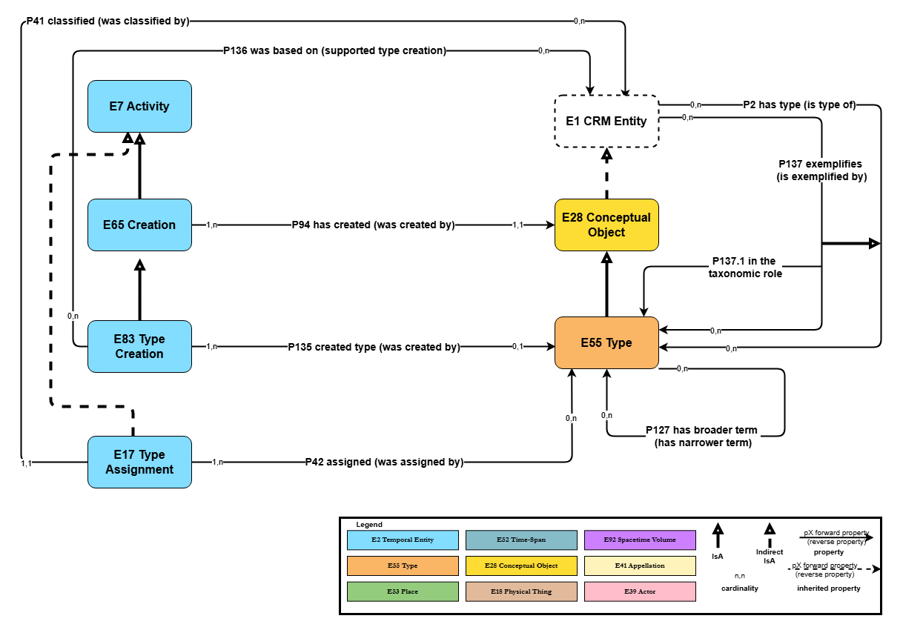

Subject Information
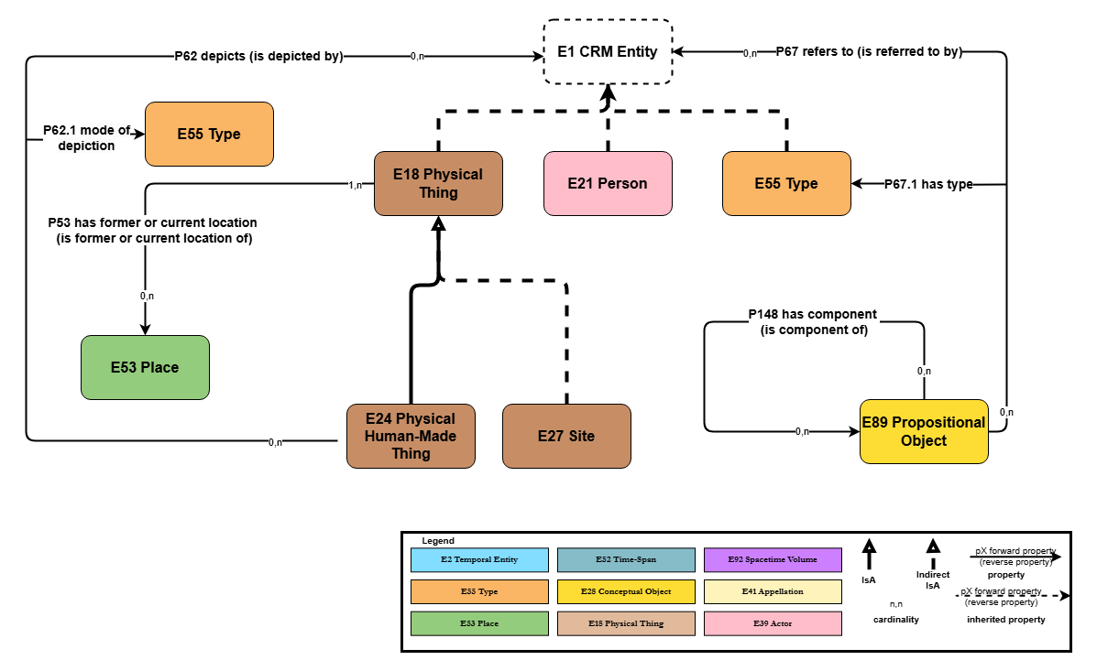

Time-Span Information
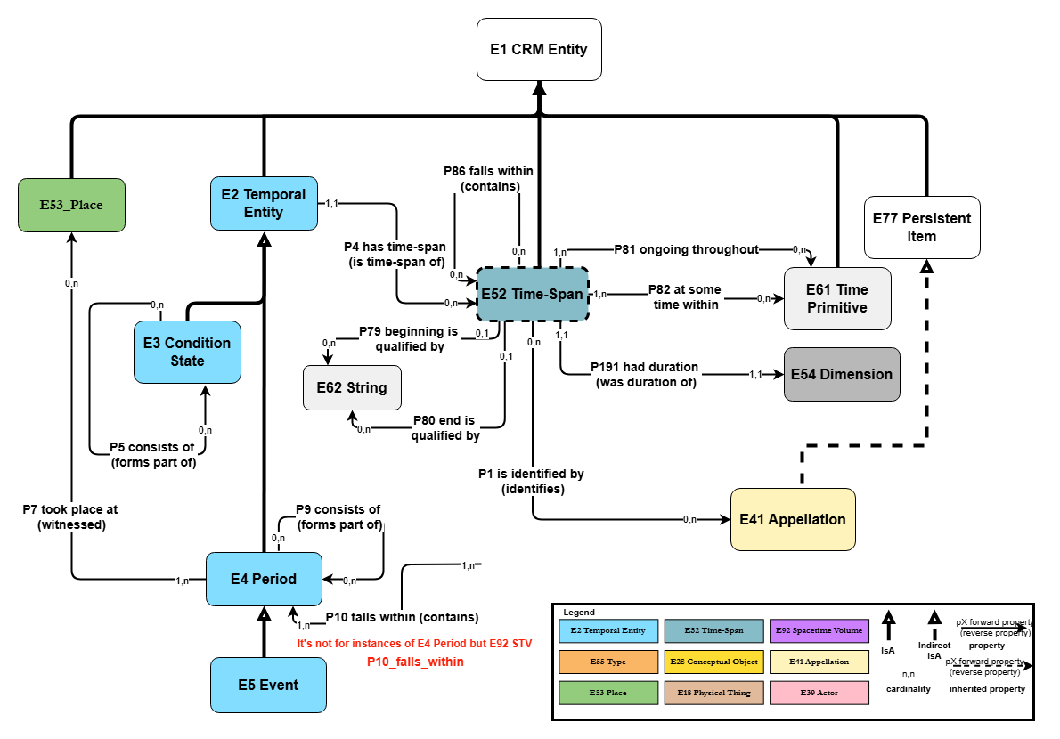

Spatial-Temporal Relations
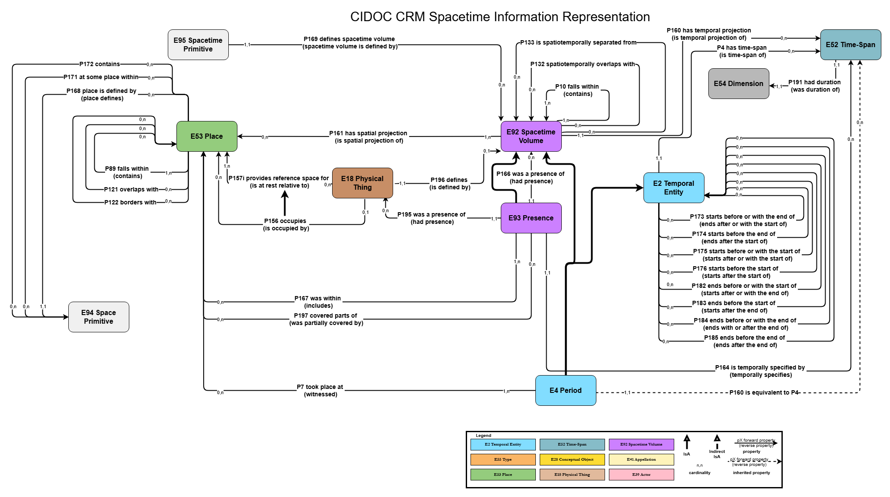

Reproduction Rights
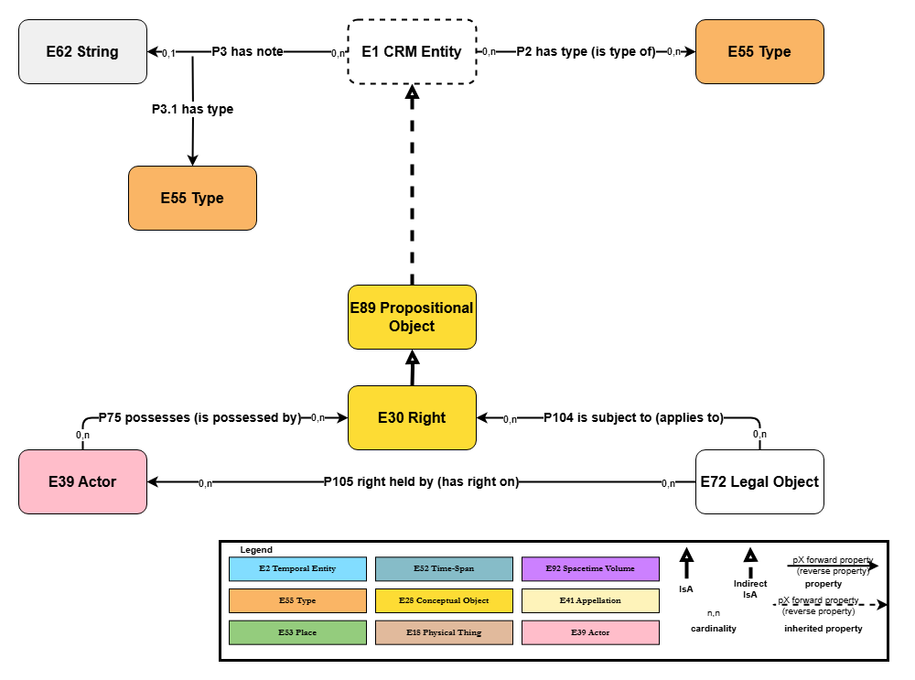

Reference Information
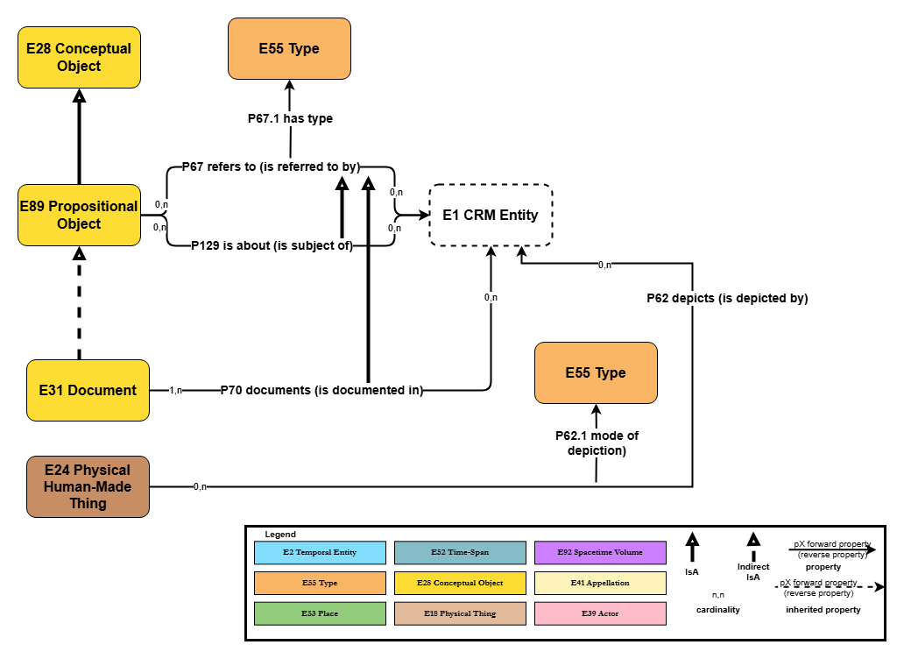

Planned Activities (design, purpose, use) 1
Nb. The diagram will be renamed “Intentional Activities 1”
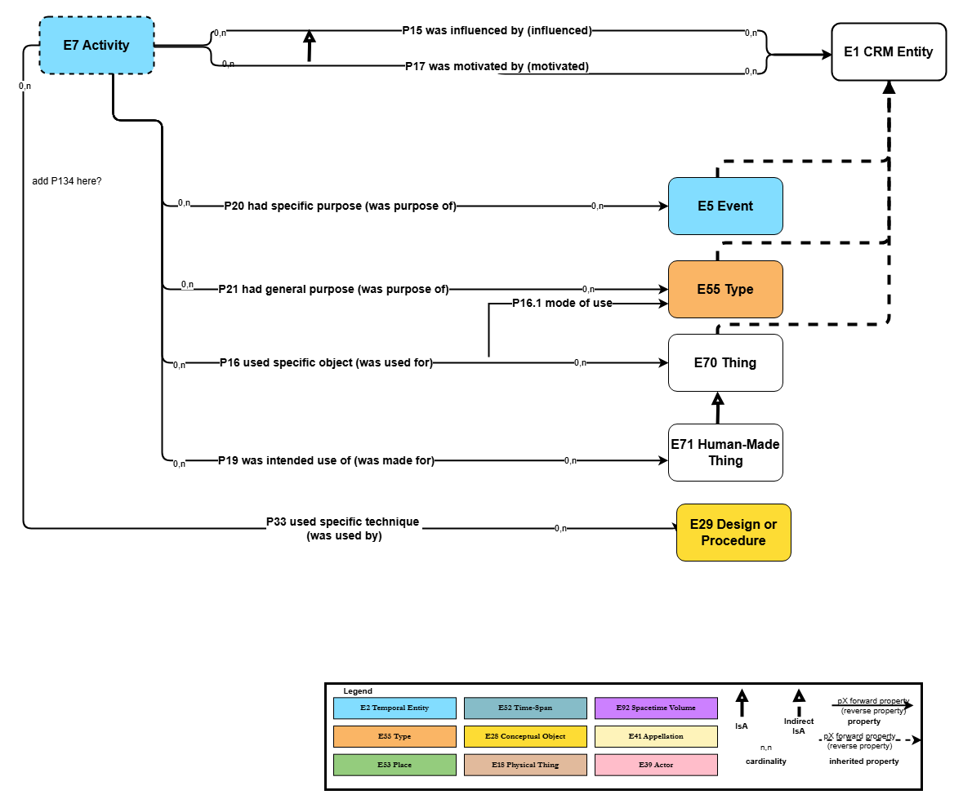

Planned Activities (design, purpose, use) 2
Nb. The diagram to be renamed “Intentional Activities 2”.
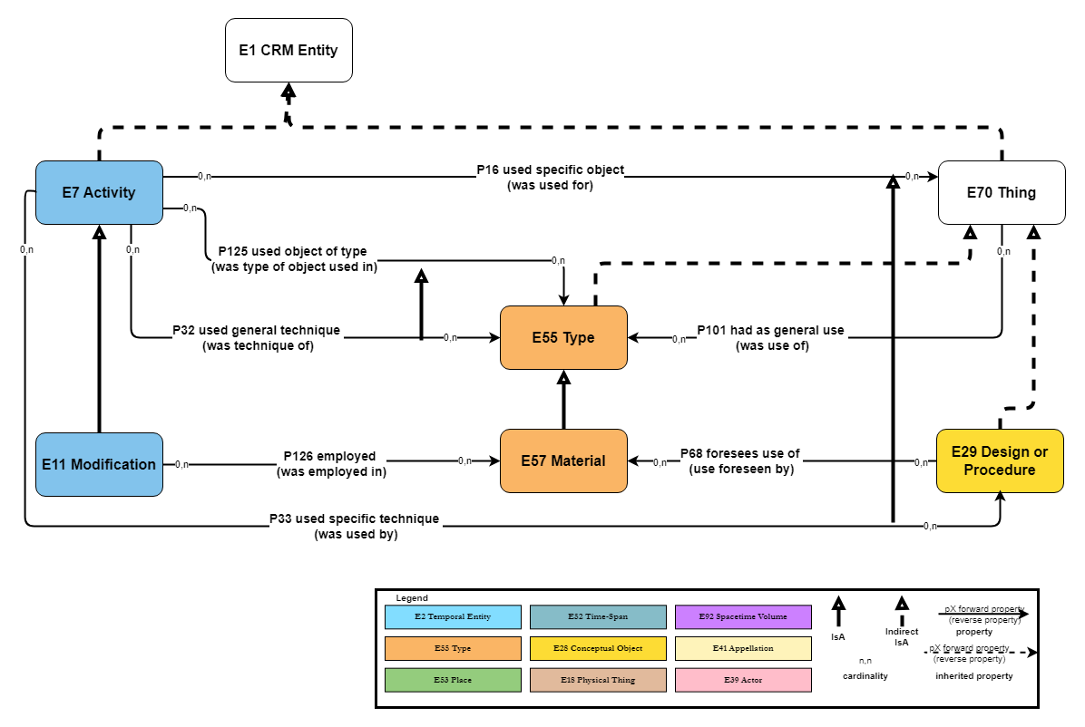

Recorder Information
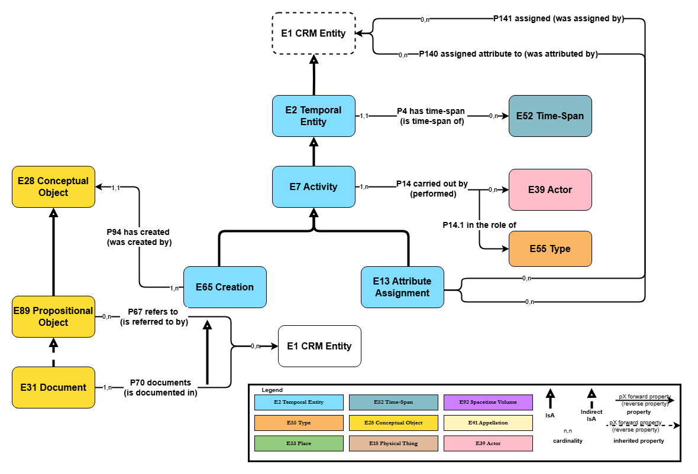

Person Nationality Information
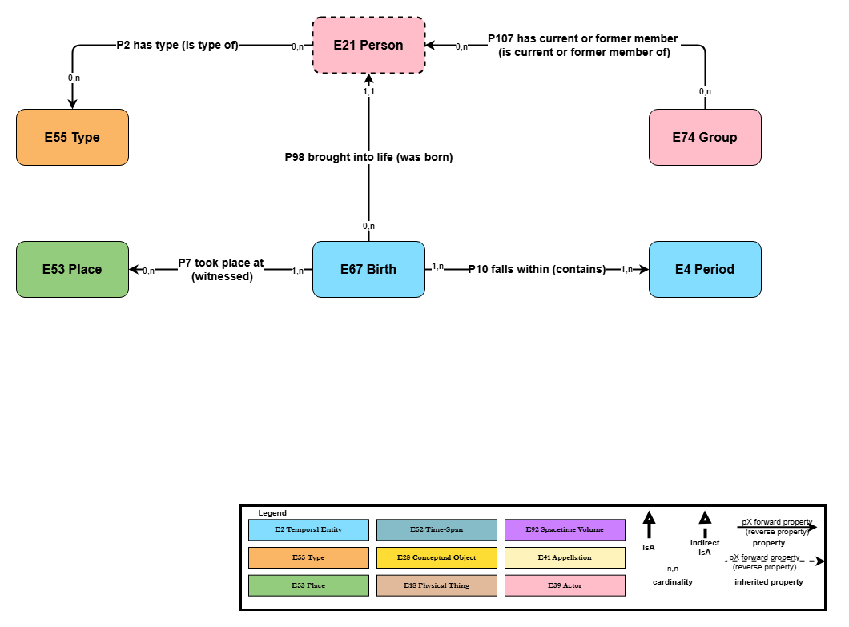

Part and Component Information
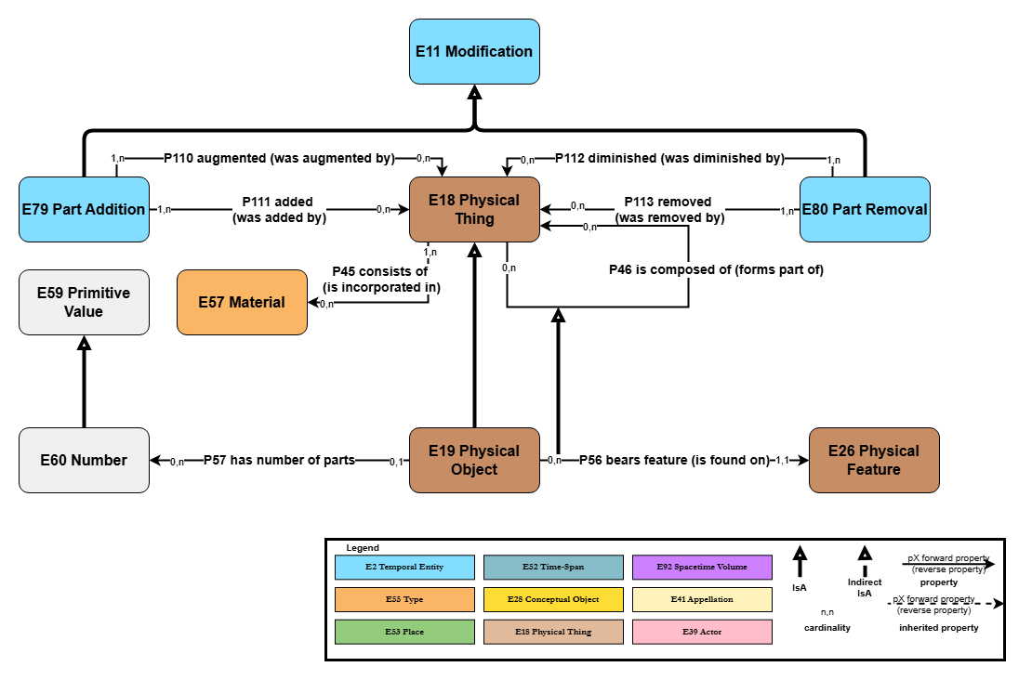

Issue 684:

F56 Container Manifestation
F56 Container Manifestation
Subclass of: E28 Conceptual Object
E99 Product Type
Superclass of: (none)
Scope note: This class comprises the instances of publisher created venues for issuing smaller manifestations of works that appear related by an overarching concept or theme. The container manifestations gain additional members over time with no predetermined end. The manifestations of works that will appear in an instance of container manifestation are not all known when the first member manifestation appears. These works may not even have been created yet.
An instance of container manifestation may have as member a single manifestation or several.

An instance of container manifestation is normally not documented until at least one manifestation has become a member of it, although it may have been initiated as a proposal.
Examples:
- the periodical entitled ‘The UNESCO Courier’, ISSN ‘0041-5278’
- the periodical entitled ‘Courrier de l’UNESCO’, ISSN ‘0304-3118’ [French edition of the periodical titled ‘The UNESCO Courier’, ISSN ‘0041-5278’]
- the series entitled ‘L’évolution de l’humanité’, ISSN ‘0755-1843’ [a monograph series comprising volumes that were published by La Renaissance du livre from 1920 on, and some of which were reprinted, with different physical features and rearranged in a different order, from 1968 on, in a distinct series published by Albin Michel also entitled ‘L’évolution de l’humanité’, ISSN ‘0755-1770’]
- the newspaper entitled ‘The Guardian’, ISSN 0261-3077
- the journal entitled ‘Cataloging and Classification Quarterly’, ISSN 0163-9374

Properties: R82 has member (is member of): F3 Manifestation
R83 has editor (is editor of): E39 Actor
R84 has creator (is creator of): E39 Actor
(R84.1 has type: E55 Type)
R85 is related to: F56 Container Manifestation
(R85.1 has type: E55 Type)

New Properties

R82 has member (is member of)
R82 has member (is member of)
Domain: F56 Container Manifestation
Range: F3 Manifestation
Subproperty of: Outside of CIDOC CRM Scope
Quantification: many to many (0,n:0,n)
Scope note: This property associates an instance of F3 Manifestation with an instance of F56 Container Manifestation that it appears in. The property groups instances of manifestations together into a single published container product. Examples include serials of all types, such as journals and newspapers, that contain articles, as well as monographic series.
An instance of F56 Container Manifestation is normally related to at least one instance of F3 Manifestation.
Examples:
- ‘Le langage’ by Joseph Vendryes, published in Paris in 1921 by La Renaissance du livre (F3) is member of the series entitled ‘L’évolution de l’humanité’, ISSN ‘0755-1843’. [a monograph series comprising volumes that were published from 1920 on, and some of which were reprinted, with different physical features and rearranged in a different order, from 1968 on, in a distinct series also entitled ‘L’évolution de l’humanité’, ISSN ‘0755-1770’ published by Albin Michel] [Vol. 3 in the series, https://fr.wikipedia.org/wiki/L%27%C3%89volution_de_l%27humanit%C3%A9]
- The 8 September 2024 issue of the newspaper ‘The Guardian’, ISSN 0261-3077 (F56) has member ‘Paris Paralympics 2024: A closer look – in pictures’ (F3). [https://www.theguardian.com/sport/gallery/2024/sep/08/paris-paralympics-2024-a-closer-look-in-pictures]
- ‘IFLA Series on Bibliographic Control’ (F56) has member ‘Functional Requirements for Authority Data’, published in 2009, ISBN 978-3-598-24282-3 (F3). [it is vol. 34 in the series]
- The article ‘Extending the LRM Model to Integrating Resources’ by Trond Aalberg, Edward O’Neill & Maja Žumer (F3) is member of ‘Cataloging and classification quarterly’, ISSN 0163-9374, a journal published by Taylor & Francis (F56). [In vol. 59, issue 1, pages 11–27. https://doi-org./10.1080/01639374.2021.1876802 ]

R83 has editor (is editor of)
R83 has editor (is editor of)
Domain: F56 Container Manifestation
Range: E39 Actor
Short-cut of: F56 Container Manifestation. P94i was created by: E65 Creation. P14 carried out by: E39 Actor (P14.1 has type)
Quantification: many to many (0,n:0,n)
Scope note: This property associates an instance of an E39 Actor with an instance of F56 Container Manifestation that is edited by that actor. An editor is an actor responsible for the selection and arrangement of the manifestations that appear in a Container Manifestation. That is, the editor selects/accepts and orders the articles in a journal or journal issue, or the articles in a newspaper, or the publications in a monographic series.
The actor or actors that edited a particular instance of F56 Container Manifestation may be unknown or unrecorded.
Examples:
- ‘Cataloging and classification quarterly’, ISSN 0163-9374, a journal published by Taylor & Francis (F56) has editor Sandra K. Roe (E21).

R84 has creator (is creator of)
R84 has creator (is creator of)
Domain: F56 Container Manifestation
Range: E39 Actor
Short-cut of: F56 Container Manifestation. P94i was created by: E65 Creation. P14 carried out by: E39 Actor (P14.1 has type)
Quantification: many to many (0,n:0,n)
Scope note: This property associates an instance of E39 Actor with an instance of F56 Container Manifestation that is created by that actor. Creators of Container Manifestations include publishers, issuing bodies, sponsoring associations. The creator(s) of the Container Manifestation are distinct from the creators of the works and expressions whose manifestations are members of the container manifestation.
The actor or actors that created a particular instance of F56 Container Manifestation may be unknown or unrecorded.

Properties: R84.1 has type: E55 Type
This property allows specifying the particular type of creation relationship (publisher, sponsoring association, issuing body) that holds between the Actor and the Container Manifestation.

Examples:
- ‘Cataloging and classification quarterly’, ISSN 0163-9374, a journal published by Taylor & Francis (F56) has creator Taylor & Francis (F11) with has type {Publisher} (E55).

R85 is related to
R85 is related to
Domain: F56 Container Manifestation
Range: F56 Container Manifestation
Subproperty of: ??
Quantification: many to many (0,n:0,n)
Scope note: This property associates an instance of F56 Container Manifestation with another instance that is related to it. This property can express that one serial may derive from another. Examples include language editions, earlier/later titles, splits, mergers, supplements and more generally borrowing of an idea.

This is a high-level property that captures the relationship between two instances of F56 Container Manifestation. It is expected that this property will be subtyped in applications. This property is transitive and irreflexive. It is generally not symmetric.

Properties: R85.1 has type: E55 Type
This property allows specifying the particular type of relationship between the two Container Manifestations, such as expressing the type of derivation. Most subtypes are asymmetric.

Examples:
- The periodical entitled ‘Colloids and surfaces’ (ISSN ‘0166-6622’) (F56) is related to the periodical entitled ‘Colloids and surfaces. A, Physicochemical and engineering aspects’ (ISSN ‘0927-7757’) (F56), with has type {split into} (E55).
- The periodical entitled ‘Colloids and surfaces’ (ISSN ‘0166-6622’) (F56) is related to the periodical entitled ‘Colloids and surfaces. B, Biointerfaces’ (ISSN ‘0927-7765’) (F56), with has type {split into} (E55).
- The periodical entitled ‘Animal research’ (ISSN ‘1627-3583’) (F56) is related to the periodical entitled ‘Animal’ (ISSN ‘1751-7311’) (F56), with has type {merged into} (E55).
- The periodical entitled ‘Animal science’ (ISSN ‘1357-7298’) (F56) is related to the periodical entitled ‘Animal’ (ISSN ‘1751-7311’) (F56), with has type {merged into} (E55).
- The periodical entitled ‘Reproduction nutrition development’ (ISSN ‘0926-5287’) (F56) is related to the periodical entitled ‘Animal’ (ISSN ‘1751-7311’) (F56), with has type {merged into} (E55).
- The periodical entitled ‘Animal research’ (ISSN ‘1627-3583’) (F56) is related to the periodical entitled ‘Animal science’ (ISSN ‘1357-7298’), with has type {merged together} (E55).
- The periodical entitled ‘Applied economics quarterly’ (ISSN ‘1611-6607’) (F56) is related to the periodical entitled ‘Applied economics quarterly. Supplement’ (ISSN ‘1612-2127’) (F56), with has type {supplement} (E55).

Note: distribution relationship is mapped with rights, nothing new needed

The scope note reads “the E1 CRM Entity that appears as an element of one or more propositions”.

