CRMarchaeo: the Excavation Model

An Extension of CIDOC CRM to support the archaeological excavation process

Produced by FORTH and collaborators

Maintained by PIN S.c.R.L.

Version 1.3 (draft)

May 2015

1. The Excavation Model

1.1. INTRODUCTION

1.1.1. SCOPE

This document presents CRMarchaeo, an extension of CIDOC CRM created to support the archaeological excavation process and all the various entities and activities related to it. The model has been created starting from standards and models already in use by national and international cultural heritage institutions, and has evolved through deep analysis of existing metadata from real archaeological documentation. It has been enriched by continuous collaboration with various communities of archaeologists from different countries and schools. Furthermore, it takes advantage of the concepts provided by CRMsci, from which it inherits most of the geological and stratigraphic principles that govern archaeological stratigraphy, extending these principles.

CRMarchaeo is intended to provide all necessary tools to manage and integrate existing documentation in order to formalise knowledge extracted from observations made by archaeologists, recorded in various ways and adopting different standards. In this sense, its purpose is to facilitate the semantic encoding, exchange, interoperability and access of existing archaeological documentation.

CRMarchaeo takes inspiration from the basic idea on which archaeology is based according to Harris [add reference], that the features of an archaeological site are to be found in the stratified context which is investigated by an archaeological excavation. It takes into consideration the physical arrangement of archaeological stratification and the events that led to the formation of a particular stratigraphic situation. The model comprises entities and properties for describing stratigraphic genesis and modifications and the natural phenomena or human intervention that led to their creation, the nature and shape of existing stratifications and surfaces, and the analysis of the human remains or artefacts found within the strata. This will enable archaeologists to determine the relative chronological order in which stratification was formed. The interpretation of the chronological sequences, also based on the space-time analysis of a specific site, provides all the elements needed for the reconstruction of the identity, life, beliefs, behaviour and activities of a given group of people in the past in that specific place.

Furthermore, the model documents, in a transparent way, the various aspects of archaeological excavation process, including the technical details concerning different methods of excavation, the reasons for their application and the observations made by archaeologists during their activities in the field. This approach allows the creation of an objective documentation that can guarantee the scientific validity of the results, making them revisable following further investigations and reusable in different research contexts, in order to answer further (and potentially different) research questions.

One of the most important goals of the model is to overcome the differences resulting from the application of different excavation techniques and procedures, e.g. from different traditions and schools of archaeology, revealing the common ways of thinking that characterise the stratigraphic excavation. This will serve to provide a unified view that can express the common concepts without imposing any specific recording or investigation technique, on stratigraphic activity, and will also provide a sound basis for the integration of various methods.
From a technical point of view, the model provides conceptual descriptions of classes and properties in an encoding-agnostic formalism, inherited from CIDOC CRM, allowing implementation of its concepts and relationships by the use of various languages and formal encodings (such as RDF and OWL), thereby providing maximum flexibility for operations of mapping and conversion and giving IT experts the freedom to implement it in the way they prefer.

1.1.2. STATUS

CRMarchaeo is the result of collaboration between many cultural heritage institutions and the unifying efforts of many European projects, including ARIADNE. The first need that the model attempts to meet is to create a common ground for the integration of archaeological records on every level, from raw excavation data to official documentation produced according to national and institutional standards. This document describes a community model which has been approved by CRM SIG to be formally and methodologically compatible with CIDOC CRM. In particular records encoded in EH-CRM preserve export compatibility with CRMarchaeo [add reference to EH-CRM]. However, in a broader sense, it is always open to any possible integration and addition that may become necessary as a result of its practical use on real archaeological problems on a large scale. The model is intended to be maintained and promoted as an international standard.

1.1.3. NAMING CONVENTIONS
All the classes declared were given both a name and an identifier constructed according to the conventions used in the CIDOC CRM model. For classes that identifier consists of the letter A followed by a number. Resulting properties were also given a name and an identifier, constructed according to the same conventions. That identifier consists of the letters AP followed by a number, which in turn is followed by the letter “i” every time the property is mentioned “backwards”, i.e., from target to domain (inverse link). “A” and “AP” do not have any other meaning. They correspond respectively to letters “E” and “P” in the CIDOC CRM naming conventions, where “E” originally meant “entity” (although the CIDOC CRM “entities” are now consistently called “classes”), and “P” means “property”. Whenever CIDOC CRM classes are used in our model, they are named by the name they have in the original CIDOC CRM. CRMsci classes and properties are referred with their respective names, classes denoted by S and properties by O.
Letters in red colour in CRM Classes and properties are additions/extensions coming by the scientific observation model.

1.2.CLASS AND PROPERTY HIERARCHIES
The CIDOC CRM model declares no “attributes” at all (except implicitly in its “scope notes” for classes), but regards any information element as a “property” (or “relationship”) between two classes. The semantics are therefore rendered as properties, according to the same principles as the CIDOC CRM model.
Although they do not provide comprehensive definitions, compact mono hierarchical presentations of the class and property IsA hierarchies have been found to significantly aid in the comprehension and navigation of the model, and are therefore provided below.
The class hierarchy presented below has the following format:
- Each line begins with a unique class identifier, consisting of a number preceded by the appropriate letter “E”, “A”, “S”
- A series of hyphens (“-”) follows the unique class identifier, indicating the hierarchical position of the class in the IsA hierarchy.
- The English name of the class appears to the right of the hyphens.
- The index is ordered by hierarchical level, in a “depth first” manner, from the smaller to the larger sub hierarchies.
- Classes that appear in more than one position in the class hierarchy as a result of multiple inheritance are shown in an italic typeface.

1.2.1. EXCAVATION MODEL CLASS HIERARCHY ALIGNED WITH (PART OF) CIDOC CRM AND CRMsci CLASS HIERARCHIES [Classes directly instantiated from CIDOC CRM and CRMsci. What is the percentage of CRM involved.]
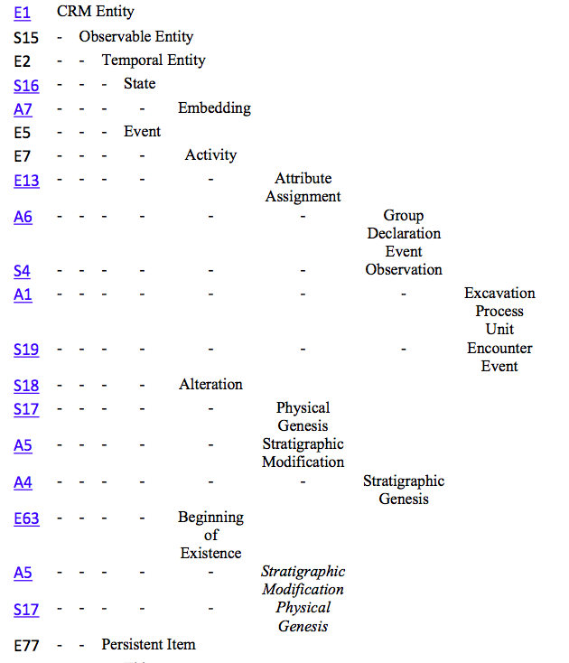

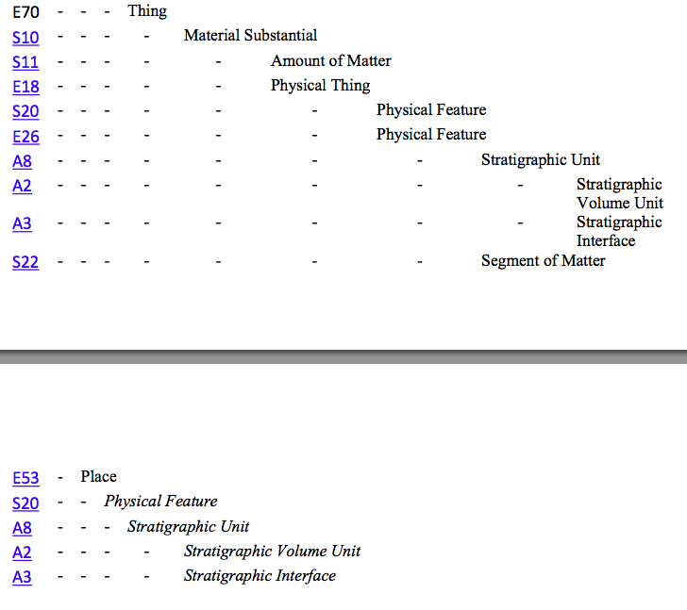

1.2.2. EXCAVATION MODEL PROPERTY HIERARCHY
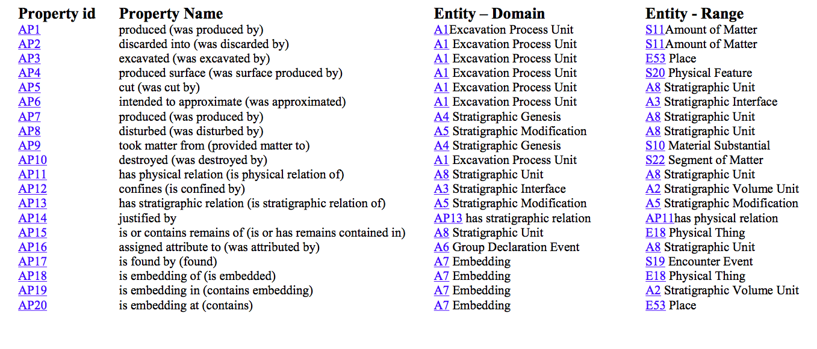

1.2.3. GRAPHICAL OVERVIEW

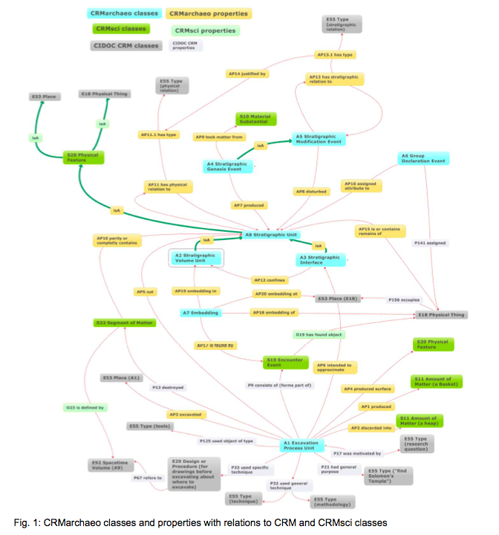

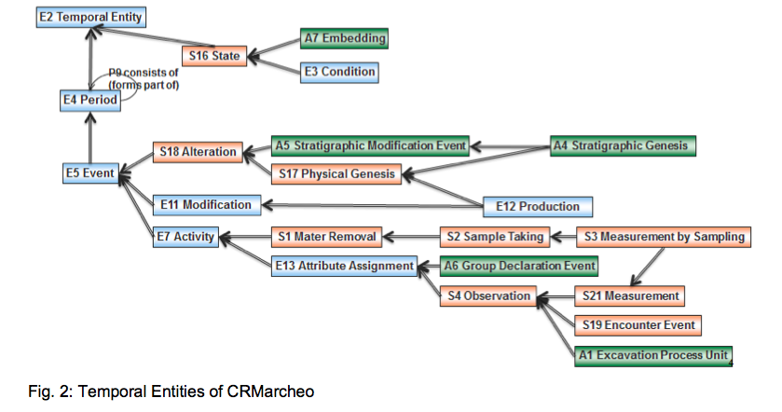

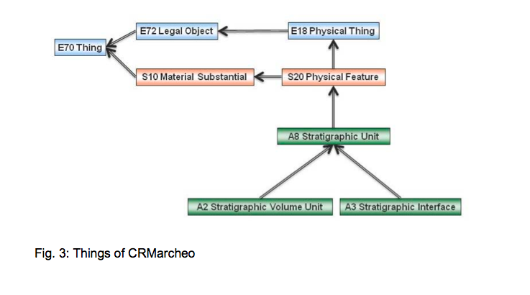

1.2.4. EXAMPLES TO ILLUSTRATE CLASS AND PROPERTY DEFINITIONS
The following examples are taken from the English Heritage Recording Manual (reference) and try to illustrate the use of classes and properties of CRMarchaeo to represent the entities and relations of documentation praxis in relation to Harris Matrix. The stratigraphic sequence explains how the site was formed. For this example, we’ll work backwards and explain how the site was formed to make determining the stratigraphic sequence easier. Focussing near the top of Figure 4, the post-hole [3] was dug and the post inserted, the hole was packed (18). Eventually the post rotted away, leaving a post-pipe [19], into which later material accumulated (2) (see Fig. 4).

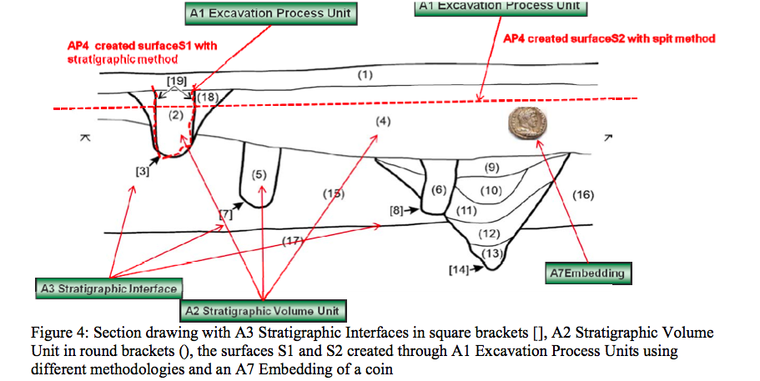

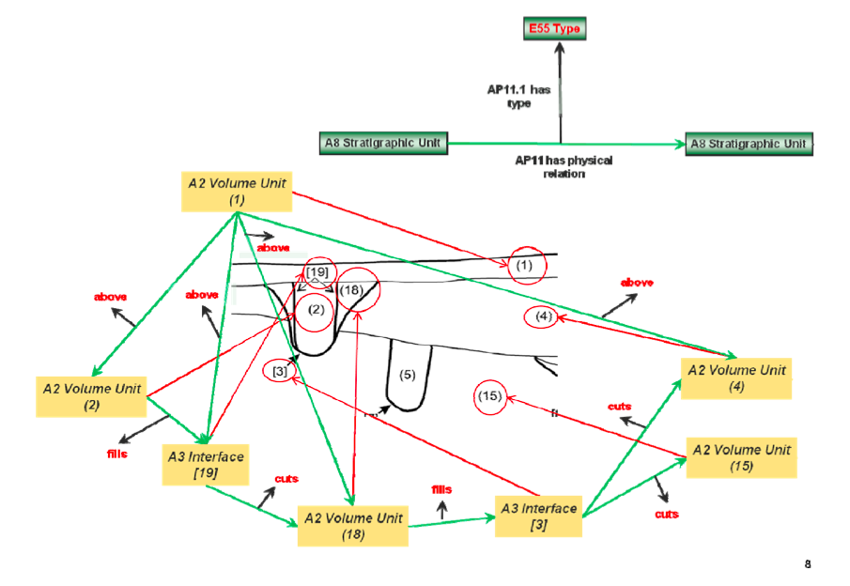

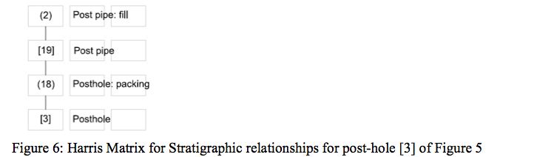

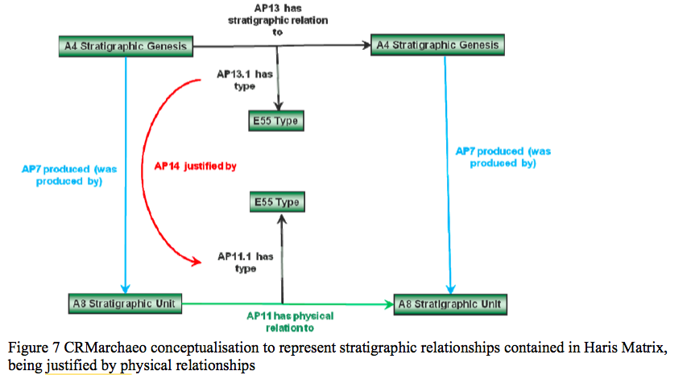

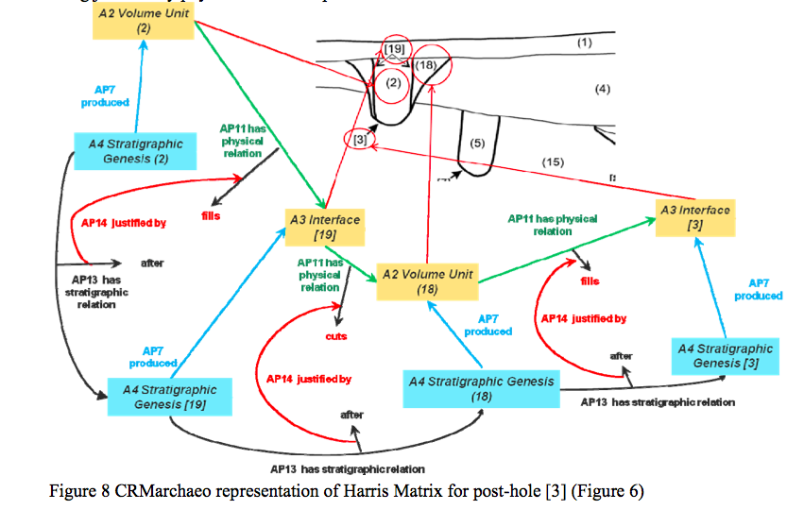
Figure 8 shows the close relationship existing between the events that led to the stratigraphic situation at the time of the excavation and the layers that were formed as a result of human activities and natural events. The investigation, observation and above all the documentation of the complex physical and stratigraphic relationships existing between the layers and interfaces, if properly executed, will contribute to the definition of the exact sequence of events and the reconstruction of what happened in that place in a given time frame.

1.3.EXCAVATION MODEL CLASS DECLARATION
The classes are comprehensively declared in this section using the following format:
- Class names are presented as headings in bold face, preceded by the class’s unique identifier;
- The line “Subclass of:” declares the superclass of the class from which it inherits properties;
- The line “Superclass of:” is a cross-reference to the subclasses of this class;
- The line “Scope note:” contains the textual definition of the concept the class represents;
- The line “Examples:” contains a bulleted list of examples of instances of this class.
- The line “Properties:” declares the list of the class’s properties;
- Each property is represented by its unique identifier, its forward name, and the range class that it links to, separated by colons;
- Inherited properties are not represented;
- Properties of properties, if they exist, are provided indented and in parentheses beneath their respective domain property.

1.4. CLASSES

A1 Excavation Process Unit

Subclass of: | S4 Observation
Superclass of:
Scope Note: | This class comprises activities of excavating in the sense of archaeology which are documented as a coherent set of actions of progressively recording and removing matter from a pre-specified location under specific rules. Typically, an excavation process unit would be terminated if significant discontinuities of substance or finds come to light, or if the activity should be interrupted due to external factors, such as end of a working day. In other cases, the termination would be based on predefined physical specifications, such as the boundaries of a maximal volume of matter intended to be excavated in one unit of excavation.  Depending on the methodology, an instance of A1 Excavation Process Unit may intend to remove matter only within the boundaries of a particular stratigraphic unit, or it may follow a pre-declared spatial extent such as a trench. It may only uncover, clean or expose a structure or parts of it.  The process of excavation results in the production of a set of recorded (documentation) data that should be sufficient to provide researchers enough information regarding the consistence and spatial distribution of the excavated Segment of Matter and things and features embedded in it. Some parts or all of the removed physical material (S11 Amount of Matter) may be dispersed, whereas others may be kept in custody in the form of finds or samples, while others (such as parts of walls) may be left at the place of their discovery. The data produced by an instance of excavation process unit should pertain to the material state of matter at excavation time only and should well be distinguished from subsequent interpretation about the causes for this state of matter.
Properties: | AP1 produced (was produced by): S11 Amount of Matter  AP2 discarded into (was discarded by): S11 Amount of Matter  AP3 excavated (was excavated by): E53 Place  AP4 produced surface (was surface produced by): S20 Physical Feature  AP5 cut (was cut by): A8 Stratigraphic Unit  AP6 intended to approximate (was approximated by): A3 Stratigraphic Interface  AP10 destroyed (was destroyed by): S22 Segment of Matter (Segment of Matter that happened to be at the Excavated Place)  P9 consists of (forms part of): S19 Encounter Event  P17 was motivated by (motivated): E55 Type (research question)  P21 had general purpose (was purpose of): E55 Type (“find Solomon’s Temple”)  P32 used general technique (was technique of): E55 Type (methodology)  P32 used general technique (was technique of): E55 Type (technique)  P33 used specific technique (was used by): E29 Design or Procedure (for drawings before excavating about where to excavate)  P125 used object of type (was type of object used in): E55 Type (tools)
Examples | - The activity taking place on 21.9.2007 between 12:00 and 13:00 that excavated the Stratigraphic Volume Unit (2) of Figure 4 and created the surface S1  - The activity that excavated the first 20 cm of a spit excavation on 21.7.2007 created the surface S2 in Figure 4.

A2 Stratigraphic Volume Unit

Subclass of: | A8 Stratigraphic Unit
Superclass of:
Scope Note: | This class comprises connected portions of terrain or other solid structure on, in, or under the surface of earth or seafloor exhibiting some homogeneity of structure or substance and completely bounded by surfaces or discontinuities in substance or structure with respect to other portions of the terrain or surfaces of objects/finds.  An instance of A8 Stratigraphic Unit may contain physical objects. The internal continuity and the boundaries of an instance of A8 Stratigraphic Unit should  be of a kind that can be attributed to a single genesis event or process and have the potential to be observed.  One genesis event may have created more than one SU. An instance of A8 Stratigraphic Unit is regarded to exist as long as a part of its matter is  still in place with respect to a surrounding reference space such that its spatial features can be associated with effects of the genesis process of interest. Normally at least one of the surfaces (such as the lower one) from its genesis event will remain during its existence.  This also implies that a certain degree of coherent (“conformal”) deformation is tolerable within its time-span of existence. Therefore the place an instance of A8 Stratigraphic Unit occupies can be uniquely identified with respect to the surrounding reference space of archaeological interest.
Properties:
Examples | The stratigrafic deposit unit number (2) of Figure 5 representing the filling of a post hole

A3 Stratigraphic Interface

Subclass of: | A8 Stratigraphic Unit
Superclass of:
Scope Note: | This class comprises coherent parts of the boundary surface, which appears as the result of a stratigraphic genesis event or process. The interface marks the extreme limit of the effect of a genesis or modification event, and indicates in particular where the effect of this event ended. Each event of creation/destruction of a deposition layer implies the creation of new interfaces. Thus there are two main types of interface: those that are surfaces of strata (that can be directly related to the corresponding stratum via the AP12 confines property), and those that are only surfaces, formed by the removal or destruction of existing stratifications.
Properties: | AP12 confines (is confined by): A2 Stratigraphic Volume Unit
Examples | The Stratigraphic Interface number [19] confines the number (2) Stratigraphic Volume Unit, in Figure 5

A4 Stratigraphic Genesis

Subclass of: | S17 Physical Genesis  A5 Stratigraphic Modification
Superclass of:
Scope Note: | This class comprises activities or processes that have produced homogeneous, distinguishable units of stratification that are in a relatively stable form from the time of their genesis until they are observed. Such processes may be the aggregation of cycles of erosion/destruction, deposit/accumulation, transformation/modification occurring on a particular site throughout a particular period of time. These processes are usually due not only to natural forces (i.e., climate, the impact of flora and fauna, other natural events), but also to human activities, in particular, excavation and construction. An event of stratification genesis typically produces two main forms of stratification units both a deposit and an interface.
Properties: | AP7 produced (was produced by): A8 Stratigraphic Unit AP9 took matter from (provided matter to): S10 Material Substantial
Examples | the cut in the pre-existing strata of the posthole in Figure 8 produced the stratigraphic interface number [3]; the filling of the posthole with detritus or some other matter produced stratigraphic unit number (18).

A5 Stratigraphic Modification

Subclass of: | S18 Alteration
Superclass of:
Scope Note: | This class comprises activities or processes resulting in the modification of Stratigraphic Units after their genesis through A4 Stratigraphic Genesis Events.
Properties: | AP8 disturbed (was disturbed by): A8 Stratigraphic Unit  AP13 has stratigraphic relation (is stratigraphic relation of): A5Stratigraphic Modification
Examples | the Event that eroded the number (1) Stratigraphic Volume Unit in Figure 4 and diminished  it to its actual size

A6 Group Declaration Event

Subclass of: | E13 Attribute Assignment
Superclass of:
Scope Note: | This class comprises activities resulting in the assignment of a common attribute to several Stratigraphic Units. This may be due to an archaeologists interpretation of them being part of one physical thing, like postholes being part of one building.
Properties: | AP16 assigned attribute to (was attributed by): A8 Stratigraphic Unit  P141 assigned: E18 Physical Thing
Examples | The excavator declared the post holes [7] and [8] in Figure 4 to be part of one building

A7 Embedding

Subclass of: | S16 State
Superclass of:
Scope Note: | This class comprises the states of instances of E18 Physical Things of being partially or completely embedded at a particular position with relative stability in one or more A2 Stratigraphic Volume Units. Normally, an embedding is expected having been stable from the time of generation on of the first A2 Stratigraphic Volume Unit that surrounds it. However, it may also be due to later intrusion. As an empirical fact, the expert may only be able to decide that a particular embedding is not recent, i.e., has been persisting for longer than the activity that encountered it. This class can be used to document the fact of embedding generally with respect to the surrounding matter or more specifically with respect to a more precise position within this matter. It further allows for specifying temporal bounds for which a particular embedding has been existing as specified according to evidence.
Properties: | AP17 is found by (found): S19 Encounter Event  AP18is embedding of (is embedded): E18 Physical Thing A  P19is embedding in (contains embedding): A2 Stratigraphic Volume Unit  AP20is embedding at (contains): E53 Place
Examples | The state of the coin in Figure 4 during its embedded in the Stratigraphic Volume Unit (4)

A8 Stratigraphic Unit

Subclass of: | S20 Physical Feature
Superclass of:
Scope Note: | This class comprises S20 Physical Features that are either A2 Stratigraphic Volume Units or A3 Stratigraphic Interfaces
Properties: | AP11 has physical relation (is physical relation of): A8 Stratigraphic Unit  AP15 is or contains remains of (is or has remains contained in): E18 Physical Thing
Examples

1.5.EXCAVATION MODEL PROPERTY DECLARATION

The properties are comprehensively declared in this section using the following format:
- Property names are presented as headings in bold face, preceded by unique property identifiers;
- The line “Domain:” declares the class for which the property is defined;
- The line “Range:” declares the class to which the property points, or that provides the values for the property;
- The line “Superproperty of:” is a cross-reference to any subproperties the property may have;
- The line “Scope note:” contains the textual definition of the concept the property represents;
- The line “Examples:” contains a bulleted list of examples of instances of this property.

1.6. PROPERTIES

AP1 produced (was produced by)

Domain: A1 Excavation Process Unit

Range: S11 Amount of Matter

Scope note: This property identifies the S11 Amount of Matter,e.g., a basket, that is preserved (part or total of) from an A1 Excavation Process Unit for further examination or evidence keeping .

Examples: The Excavation Process Unit excavating the Stratigraphic Volume Unit (2) produced an amount of black turf with wood inclusions

AP2 discarded into (was discarded by)

Domain: A1 Excavation Process Unit

Range: S11 Amount of Matter

Scope note: This property identifies the S11 Amount of Matter (e.g. a heap) into which material from an A1 Excavation Process Unit is discarded.

Examples: The Excavation Process Unit excavating the Stratigraphic Volume Unit (2) discarded an amount of matter into the waste heap of the excavation

AP3 excavated (was excavated by)

Domain: A1 Excavation Process Unit

Range: E53 Place

Scope note: This property identifies the 3D excavated volume instance of E53 Place, i.e., a three- dimensional volume, that was actually excavated during an A1 Excavation Process Unit.

Examples: The Excavation Process Unit excavating the Stratigraphic Volume Unit (2) excavated the place where the Stratigraphic Volume Unit (2) was.

AP4 produced surface (was surface produced by)

Domain: A1 Excavation Process Unit

Range: S20 Physical Feature

Scope note: This property identifies the instance of S20 Physical Feature that constitutes the new surface produced during an A1 Excavation Process Unit in the excavated area. Frequently this surface or parts of it are documented through drawing and/or measured by technical means such as photography, tachymetry or laserscanning.

Examples: The stratigraphic Excavation Process Unit excavating the Stratigraphic Volume Unit (2) produced surface S1.

AP5 removed part or all of (was partially or totally removed by)

Domain: A1 Excavation Process Unit

Range: A8 Stratigraphic Unit

Scope note: This property identifies the instance of A8 Stratigraphic Unit that was cut during an A1 Excavation Process Unit.

Examples: The spit Excavation Process Unit producing surface S2 cut Stratigraphic Units [3],(18),[19],(2) and (4)

AP6 intended to approximate (was approximated by)

Domain: A1 Excavation Process Unit

Range: A3 Stratigraphic Interface

Scope note: This property identifies the A3 Stratigraphic Interface that was intended to approximate during an A1 Excavation Process Unit. This property should be assigned when a stratigraphic excavation methodology is used. It enables the linkage of the surface produced by an A1 Excavation Process Unit and an A3 Stratigraphic Interface.

Examples: The stratigraphic Excavation Process Unit excavating the Stratigraphic Volume Unit (2) intended to approximate Stratigraphic Interface [19].

AP7 produced (was produced by)

Domain: A4 Stratigraphic Genesis

Range: A8 Stratigraphic Unit

Scope note: This property identifies the A8 Stratigraphic Unit that was produced during an A4 Stratigraphic Genesis Event.

AP8 disturbed (was disturbed by)

Domain: A5 Stratigraphic Modification

Range: A8 Stratigraphic Unit

Scope note: This property identifies an A8 Stratigraphic Unit that was disturbed through an A5 Stratigraphic Modification. One A5 Stratigraphic Modification may disturb several A8 Stratigraphic Units.

AP9 took matter from (provided matter to)

Domain: A4 Stratigraphic Genesis

Range: S10 Material Substantial

Scope note: This property identifies the S10 Material Substantial from where matter was taken from during an A4 Stratigraphic Genesis Event.

AP10 destroyed (was destroyed by)

Domain: A1 Excavation Process Unit

Range: S22 Segment of Matter

Subproperty of: E6 Destruction.P13 destroyed (was destroyed by): E18 Physical Thing

AP11 has physical relation (is physical relation of)

Domain: A8 Stratigraphic Unit

Range: A8 Stratigraphic Unit

Scope note: This property identifies the physical relationship between two A8 Stratigraphic Units. The type of physical relationships found between stratigraphic units in archaeological documentation is documented through the property AP 11.1 has type. Examples may be:
• fills
• is filled by
• cuts
• is cut by
• is bonded with
• butted
• jointed
• above
• below

Properties: AP11.1 has type: E55 Type

AP13 has stratigraphic relation (is stratigraphic relation of)

Domain: A5 Stratigraphic Modification

Range: A5 Stratigraphic Modification

Scope note: This property identifies the stratigraphic relation between two A5 Stratigraphic modification events. This relation may be inferenced from the kind of physical relation that exists between the two AP 8 Stratigraphic Units that have been created or modified during the corresponding A5 Stratigraphic Modification events. The type of stratigraphic relationships in archaeological documentation assigned to two A5 Stratigraphic Modification events is documented through the property AP 13.1 has type. Examples of stratigraphic relationships found in archaeological documentation are:

• before
• after
• same as

Properties: AP13.1 has type: E55 Type AP14 justified by: AP11.1 has type (type of physical relation)

AP14 justified by (is justification of)

Domain: AP13.1 has type (type of stratigraphic relation)

Range: AP11.1 has type (type of physical relation)

Scope note: This property identifies the type of physical relation that was used to justify the type of stratigraphic relation assigned to the relation between two E5 Stratigrafic Modification events. The stratigraphic relation type “after” may be justified by physical relations of “above” or “fills”. Figure 7 gives a graphical representation and Figure 8 shows an example.

AP15 is or contains remains of (is or has remains contained in)

Domain: A8 Stratigraphic Unit

Range: E22 Physical Thing

Scope note: This property associates an E18 Physical Thing that is found within an A8 Stratigraphic Unit with the stratigraphic unit. This property is a shortcut for the fully articulated path from E18 Physical Thing through A7Embedding to A8 Stratigraphic Unit.

AP16 assigned attribute to (was attributed by)

Domain: A6 Group Declaration Event

Range: A8 Stratigraphic Unit

Subproperties: E13 Attribute Assignment. P140 assigned attribute to (was attributed by): E1 CRM Entity

Scope note: This property indicates the Stratigraphic Unit that was assigned by an A6 Group Declaration Event.

AP17 is found by (found)

Domain: A7 Embedding

Range: S19 Encounter Event

Scope note: This property associatesan instance ofS19 Encounter Eventwith an instance of A7 Embedding that has been found during this even.

AP18 is embedding of (is embedded)

Domain: A7 Embedding

Range: E18 Physical Thing

Scope note: This property identifies theE18 Physical Thing that is contained in an A7 Embedding.

AP19 is embedding in (contains embedding)

Domain: A7 Embedding

Range: A2 Stratigraphic Volume Unit

Scope note: This property identifies the A2 Stratigraphic Volume Unit that contains the A7 Embedding.

AP20 is embedding at (contains)

Domain: A7 Embedding

Range: E53 Place

Scope note: This property identifies the E53 Place that is documented as the E53 Place of the A7 Embedding.

1.7.REFERRED CIDOC CRM CLASSES AND PROPERTIES
Since our model refers to and reuses, wherever appropriate, large parts of ISO21127, the CIDOC Conceptual Reference Model, this section provides a comprehensive list of all constructs used from ISO21127, together with their definitions following version 5.1.2 maintained by CIDOC. The complete definition of the CIDOC Conceptual Reference Model can be found in its official site: http://www.cidoc- crm.org/official_release_cidoc.html.

1.8.REFERRED CIDOC CRM CLASSES
This section contains the complete definitions of the classes of the SCIENTIFIC OBSERVATION MODEL version 1.2 referred to by the model. The properties within these class definitions which are referred to the EXCAVATION MODEL are presented in bold face.

E1 CRM Entity

Superclass of:
E2 Temporal Entity
E52 Time-Span
E53 Place E54 Dimension
E77 Persistent Item
E92 Spacetime Volume
S15 Observable Entity

Scope note: This class comprises all things in the universe of discourse of the CIDOC Conceptual Reference Model.
It is an abstract concept providing for three general properties:
- Identification by name or appellation, and in particular by a preferred identifier
- Classification by type, allowing further refinement of the specific subclass an instance belongs to
- Attachment of free text for the expression of anything not captured by formal properties
With the exception of E59 Primitive Value, all other classes within the CRM are directly or indirectly specialisations of E1 CRM Entity.

Examples: the earthquake in Lisbon 1755 (E5)

Properties:
P1 is identified by (identifies): E41 Appellation
P2 has type (is type of): E55 Type
P3 has note: E62 String
(P3.1 has type: E55 Type)
P48 has preferred identifier (is preferred identifier of): E42 Identifier
P137 exemplifies (is exemplified by): E55 Type
(P137.1 in the taxonomic role: E55 Type)

E6 Destruction

Subclass of: E64 End of Existence

Scope note: This class comprises events that destroy one or more instances of E18 Physical Thing such that they lose their identity as the subjects of documentation.
Some destruction events are intentional, while others are independent of human activity. Intentional destruction may be documented by classifying the event as both an E6 Destruction and E7 Activity.
The decision to document an object as destroyed, transformed or modified is context sensitive:
- If the matter remaining from the destruction is not documented, the event is modelled solely as E6 Destruction.
- An event should also be documented using E81 Transformation if it results in the destruction of one or more objects and the simultaneous production of others using parts or material from the original. In this case, the new items have separate identities. Matter is preserved, but identity is not.
- When the initial identity of the changed instance of E18 Physical Thing is preserved, the event should be documented as E11 Modification.
Examples:
- the destruction of Herculaneum by volcanic eruption in 79 AD
- the destruction of Nineveh (E6, E7)
- the breaking of a champagne glass yesterday by my dog

Properties: P13 destroyed (was destroyed by): E18 Physical Thing

E13 Attribute Assignment

Subclass of: E7 Activity

Superclass of:
E14 Condition Assessment
E15 Identifier Assignment
E16 Measurement
E17 Type Assignment
E91 Co-Reference Assignment
S4 Observation S5 Inference Making

Scope note:
This class comprises the actions of making assertions about properties of an object or any relation between two items or concepts.
This class allows the documentation of how the respective assignment came about, and whose opinion it was. All the attributes or properties assigned in such an action can also be seen as directly attached to the respective item or concept, possibly as a collection of contradictory values. All cases of properties in this model that are also described indirectly through an action are characterised as "short cuts" of this action. This redundant modelling of two alternative views is preferred because many implementations may have good reasons to model either the action or the short cut, and the relation between both alternatives can be captured by simple rules.
In particular, the class describes the actions of people making propositions and statements during certain museum procedures, e.g. the person and date when a condition statement was made, an identifier was assigned, the museum object was measured, etc. Which kinds of such assignments and statements need to be documented explicitly in structures of a schema rather than free text, depends on if this information should be accessible by structured queries.

Examples: the assessment of the current ownership of Martin Doerr’s silver cup in February 1997

Properties:
P140 assigned attribute to (was attributed by): E1 CRM Entity
P141 assigned (was assigned by): E1 CRM Entity

E18 Physical Thing

Subclass of:
S10 Material Substantial
E72 Legal Object

Superclass of:
E19 Physical Object
E24 Physical Man-Made Thing
E26 Physical Feature /S20 Physical Feature

Scope Note: This class comprises all persistent physical items with a relatively stable form, man-made or natural.
Depending on the existence of natural boundaries of such things, the CRM distinguishes the instances of E19 Physical Object from instances of E26 Physical Feature, such as holes, rivers, pieces of land etc. Most instances of E19 Physical Object can be moved (if not too heavy), whereas features are integral to the surrounding matter.
The CRM is generally not concerned with amounts of matter in fluid or gaseous states.

Examples:
- the Cullinan Diamond (E19)
- the cave “IdeonAndron” in Crete (E26)
- the Mona Lisa (E22)

Properties:
P44 has condition (is condition of): E3 Condition State
P45 consists of (is incorporated in): E57 Material
P46 is composed of (forms part of): E18 Physical Thing
P49 has former or current keeper (is former or current keeper of): E39 Actor
P50 has current keeper (is current keeper of): E39 Actor
P51 has former or current owner (is former or current owner of): E39 Actor
P52 has current owner (is current owner of): E39 Actor
P53 has former or current location (is former or current location of): E53 Place
P58 has section definition (defines section): E46 Section Definition
P59 has section (is located on or within): E53 Place

E26 Physical Feature

Subclass of: E18 Physical Thing

Superclass of:
E25 Man-Made Feature
E27 Site
S22 Segment of Matter

Scope Note:
This class comprises identifiable features that are physically attached in an integral way to particular physical objects.
Instances of E26 Physical Feature share many of the attributes of instances of E19 Physical Object. They may have a one-, two- or three-dimensional geometric extent, but there are no natural borders that separate them completely in an objective way from the carrier objects. For example, a doorway is a feature but the door itself, being attached by hinges, is not.
Instances of E26 Physical Feature can be features in a narrower sense, such as scratches, holes, reliefs, surface colours, reflection zones in an opal crystal or a density change in a piece of wood. In the wider sense, they are portions of particular objects with partially imaginary borders, such as the core of the Earth, an area of property on the surface of the Earth, a landscape or the head of a contiguous marble statue. They can be measured and dated, and it is sometimes possible to state who or what is or was responsible for them. They cannot be separated from the carrier object, but a segment of the carrier object may be identified (or sometimes removed) carrying the complete feature.
This definition coincides with the definition of "fiat objects" (Smith &Varzi, 2000, pp.401- 420), with the exception of aggregates of “bona fide objects”.

Examples:
- the temple in Abu Simbel before its removal, which was carved out of solid rock
- Albrecht Duerer's signature on his painting of Charles the Great
- the damage to the nose of the Great Sphinx in Giza 􏰀 Michael Jackson’s nose prior to plastic surgery

E29 Design or Procedure

Subclass of: E73 Information Object

Scope note: This class comprises documented plans for the execution of actions in order to achieve a result of a specific quality, form or contents. In particular it comprises plans for deliberate human activities that may result in the modification or production of instances of E24 Physical Thing.
Instances of E29 Design or Procedure can be structured in parts and sequences or depend on others. This is modelled using P69 has association with (is associated with).
Designs or procedures can be seen as one of the following:
- A schema for the activities it describes
- A schema of the products that result from their application.
- An independent intellectual product that may have never been applied, such as Leonardo da Vinci’s famous plans for flying machines.
Because designs or procedures may never be applied or only partially executed, the CRM models a loose relationship between the plan and the respective product.

Examples:
- the ISO standardisation procedure
- the musical notation for Beethoven’s “Ode to Joy”
- the architectural drawings for the Kölner Dom in Cologne, Germany
- the drawing on the folio 860 of the Codex Atlanticus from Leonardo da Vinci, 1486-1490, kept in the BibliotecaAmbrosiana in Milan

Properties:
P68 foresees use of (use foreseen by): E57 Material
P69 has association with (is associated with): E29 Design or Procedure (P69.1 has type: E55 Type)

E53 Place

Subclass of: E1 CRM Entity

Superclass of: S20 Physical Feature

Scope note:
This class comprises extents in space, in particular on the surface of the earth, in the pure sense of physics: independent from temporal phenomena and matter. The instances of E53 Place are usually determined by reference to the position of “immobile” objects such as buildings, cities, mountains, rivers, or dedicated geodetic marks. A Place can be determined by combining a frame of reference and a location with respect to this frame. It may be identified by one or more instances of E44 Place Appellation. It is sometimes argued that instances of E53 Place are best identified by global coordinates or absolute reference systems. However, relative references are often more relevant in the context of cultural documentation and tend to be more precise. In particular, we are often interested in position in relation to large, mobile objects, such as ships. For example, the Place at which Nelson died is known with reference to a large mobile object – H.M.S Victory. A resolution of this Place in terms of absolute coordinates would require knowledge of the movements of the vessel and the precise time of death, either of which may be revised, and the result would lack historical and cultural relevance.
Any object can serve as a frame of reference for E53 Place determination. The model foresees the notion of a "section" of an E19 Physical Object as a valid E53 Place determination.

Examples:
- the extent of the UK in the year 2003 􏰀 the position of the hallmark on the inside of my wedding ring
- the place referred to in the phrase: “Fish collected at three miles north of the confluence of the Arve and the Rhone”
- here -><-

Properties:
P87 is identified by (identifies): E44 Place Appellation
P89 falls within (contains): E53 Place
P121 overlaps with: E53 Place
P122 borders with: E53 Place
O7 contains or confines(is contained or confined): E53 Place

E55 Type

Subclass of: E28 Conceptual Object

Superclass of:
E56 Language
E57 Material
E58 Measurement Unit
S9 Property Type

Scope note: This class comprises concepts denoted by terms from thesauri and controlled vocabularies used to characterize and classify instances of CRM classes. Instances of E55 Type represent concepts in contrast to instances of E41 Appellation which are used to name instances of CRM classes.
E55 Type is the CRM’s interface to domain specific ontologies and thesauri. These can be represented in the CRM as subclasses of E55 Type, forming hierarchies of terms, i.e. instances of E55 Type linked via P127 has broader term (has narrower term). Such hierarchies may be extended with additional properties.

Examples:
- weight, length, depth [types of E54]
- portrait, sketch, animation [types of E38]
- French, English, German [E56]
- excellent, good, poor [types of E3]
- Ford Model T, chop stick [types of E22]
- cave, doline, scratch [types of E26]
- poem, short story [types of E33]
- wedding, earthquake, skirmish [types of E5]

Properties:
P127 has broader term (has narrower term): E55 Type
P150 defines typical parts of(define typical wholes for): E55 Type

E63 Beginning of Existence

Subclass of: E5 Event

Superclass of:
E65 Creation
E66 Formation
E67 Birth
E81 Transformation
S17 Physical Genesis

Scope note: This class comprises events that bring into existence any E77 Persistent Item.
It may be used for temporal reasoning about things (intellectual products, physical items, groups of people, living beings) beginning to exist; it serves as a hook for determination of a terminus post quem and ante quem.

Examples:
- the birth of my child
- the birth of Snoopy, my dog
- the calving of the iceberg that sank the Titanic
- the construction of the Eiffel Tower

Properties: P92 brought into existence (was brought into existence by): E77 Persistent Item

E92 Spacetime Volume

Subclass of: E1 CRM Entity

Scope note: This class comprises 4 dimensional point sets (volumes) in physical spacetime regardless its true geometric form. They may derive their identity from being the extent of a material phenomenon or from being the interpretation of an expression defining an extent in spacetime. Intersections of instances of E92 Spacetime Volume, Place and Timespan are also regarded as instances of E92 Spacetime Volume. An instance of E92 Spacetime Volume is either contiguous or composed of a finite number of contiguous subsets. Its boundaries may be fuzzy due to the properties of the phenomena it derives from or due to the limited precision up to which defining expression can be identified with a real extent in spacetime. The duration of existence of an instance of a spacetimevolume is trivially its projection on time.

Examples:
- the spacetime Volume of the Event of Ceasars murder
- the spacetime Volume where and when the carbon 14 dating of the "Schoeninger Speer II" in 1996 took place
- the spatio-temporal trajectory of the H.M.S. Victory from its building to its actual location
- the spacetime volume defined by a polygon approximating the Danube river flood in Austria between 6th and 9th of August 2002

Properties:
P160 has temporal projection: E52 Time-Span
P161 has spatial projection: E53 Place

1.9.REFERRED CIDOC CRM PROPERTIES

P13 destroyed (was destroyed by)

Domain: E6 Destruction

Range: E18 Physical Thing

Subproperty of: E64 End of Existence. P93 took out of existence (was taken out of existence by): E77 Persistent Item

Quantification: one to many, necessary (1,n:0,1)

Scope note:
This property allows specific instances of E18 Physical Thing that have been destroyed to be related to a destruction event. Destruction implies the end of an item’s life as a subject of cultural documentation – the physical matter of which the item was composed may in fact continue to exist. A destruction event may be contiguous with a Production that brings into existence a derived object composed partly of matter from the destroyed object.

Examples: the Tay Bridge Disaster (E6) destroyed The Tay Bridge (E22)

P140 assigned attribute to (was attributed by)

Domain: E13 AttributeAssignment

Range: E1 CRM Entity

Superproperty of:
E14 Condition Assessment. P34 concerned (was assessed by): E18 Physical Thing
E16 Measurement. P39 measured (was measured by): E70 Thing
E17 Type Assignment. P41 classified (was classified by): E1 CRM Entity
S4 Observation.O8 observed (was observed by): S15 Observable Entity

Quantification: many to many (0,n:0,n)

Scope note: This property indicates the item to which an attribute or relation is assigned.

Examples:
- February 1997 Current Ownership Assessment of Martin Doerr’s silver cup (E13) assigned attribute to Martin Doerr’s silver cup (E19)
- 01 June 1997 Identifier Assignment of the silver cup donated by Martin Doerr (E15) assigned attribute to silver cup 232 (E19)

1.10. REFERRED SCIENTIFIC OBSERVATION MODEL CLASSES AND PROPERTIES
Since the Excavation Model refers to and reuses, wherever appropriate, parts of the Scientific Observation Model, this section provides a comprehensive list of all constructs used from CRMsci, together with their definitions following version 1.2 maintained by FORTH. The complete definition of CRMsci is available at http://www.ics.forth.gr/isl/CRMext/CRMsci/

1.11. REFERRED SCIENTIFIC OBSERVATION MODEL CLASSES
This section contains the complete definitions of the classes of the Scientific Observation Model version 1.2 referred to by the model. The properties within these class definitions which are referred to the EXCAVATION MODEL are presented in bold face.

S4 Observation

Subclass of: E13 Attribute Assignment

Superclass of:
S21 Measurement
S19 Encounter Event
A1 Excavation Process Unit

Scope note:
This class comprises the activity of gaining scientific knowledge about particular states of physical reality gained by empirical evidence, experiments and by measurements. We define observation in the sense of natural sciences, as a kind of human activity: at some Place and within some Time-Span, certain Physical Things and their behavior and interactions are observed, either directly by human sensory impression, or enhanced with tools and measurement devices. The output of the internal processes of measurement devices that do not require additional human interaction are in general regarded as part of the observation and not as additional inference. Manual recordings may serve as additional evidence. Measurements and witnessing of events are special cases of observations. Observations result in a belief about certain propositions. In this model, the degree of confidence in the observed properties is regarded to be “true” per default, but could be described differently by adding a property P3 has note to an instance of S4 Observation, or by reification of the property O16 observed value. Primary data from measurement devices are regarded in this model to be results of observation and can be interpreted as propositions believed to be true within the (known) tolerances and degree of reliability of the device. Observations represent the transition between reality and propositions in the form of instances of a formal ontology, and can be subject to data evaluation from this point on.

Properties:
O8 observed (was observed by): S15 Observable Entity

O9 observed property type (property type was observed by): S9 Property Type
O16observed value (value was observed by): E1 CRM Entity

S10 Material Substantial

Subclass of: E70 Thing

Superclass of:
S14 Fluid Body
S11 Amount of Matter
E18 Physical Thing

Scope note: This class comprises constellations of matter with a relative stability of any form sufficient to associate them with a persistent identity, such as being confined to certain extent, having a relative stability of form or structure, or containing a fixed amount of matter. In particular, it comprises physical things in the narrower sense and fluid bodies. It is an abstraction of physical substance for solid and non-solid things of matter.

Properties:
P44 has condition (is condition of): E3 Condition State
P45 consists of (is incorporated in): E57 Material
P46 is composed of (forms part of): S10 Material Substantial
O15 occupied (was occupied by): E53 Place

S11 Amount of Matter

Subclass of: S10 Material Substantial

Superclass of:
S12 Amount of Fluid
S13 Sample

Scope note: This class comprises fixed amounts of matter specified as some air, some water, some
Scope note: soil, etc., defined by the total and integrity of their material content.

S16 State

Subclass of: E2 Temporal Entity

Superclass of: E3 Condition State

Scope note: This class comprises the persistence of a particular value range of the properties of a particular thing or things over a time-span

S17 Physical Genesis

Subclass of:
E63 Beginning of Existence
S18 Alteration

Superclass of:
E12 Production
A4 Stratigraphic Genesis

Scope note: This class comprises events or processes that result in (generate) physical things, man- made or natural, coming into being in the form by which they are later identified. The creation of a new physical item, at the same time, can be a result of an alteration (modification) – it can become a new thing due to an alteration activity.

Properties: O17 generated (was generated by): E18 Physical Thing

S17 Alteration

Subclass of: E5 Event

Superclass of:
S17 Physical Genesis
E11 Modification
A5 Stratigraphic Modification

Scope note: This class comprises natural events or man-made processes that create, alter or change physical things, by affecting permanently their form or consistency without changing their identity. Examples include alterations on depositional features-layers by natural factors or disturbance by roots or insects, organic alterations, petrification, etc.

Properties: O18 altered (was altered by): E18 Physical Thing

S19 Encounter Event

Subclass of: S4 Observation

Scope note: This class comprises activities of S4 Observation (substance) where an E39 Actor encounters an instance of E18 Physical Thing of a kind relevant for the mission of the observation or regarded as potentially relevant for some community (identity). This observation produces knowledge about the existence of the respective thing at a particular place in or on surrounding matter. This knowledge may be new to the group of people the actor belongs to. In that case we would talk about a discovery. The observer may recognize or assign an individual identity of the thing encountered or regard only the type as noteworthy in the associated documentation or report.
In archaeology there is a particular interest if an object is found “in situ”, i.e. if its embedding in the surrounding matter supports the assumption that the object was not moved since the archaeologically relevant deposition event. The surrounding matter with the relative position of the object in it as well as the absolute position and time of the observation may be recorded in order to enable inferences about the history of the E18 Physical Thing.
In Biology, additional parameters may be recorded like the kind of ecosystem, if the biological individual survives the observation, what detection or catching devices have been used or if the encounter event supported the detection of a new biological kind (“taxon”).

Properties:
O19 has found object (was object found by): E18 Physical Thing
O21 has found at (witnessed): E53 Place

S20 Physical Feature

Subclass of:
E18 Physical Thing
E53 Place

Superclass of:
E25 Man-Made Feature
E27 Site
S22 Segment of Matter

Equivalent to: E26 Physical Feature (CIDOC-CRM)

Scope Note:
This class comprises identifiable features that are physically attached in an integral way to particular physical objects. An instance of S20 Physical Feature also represents the place it occupies with respect to the surrounding matter. More precisely, it is the maximal real volume in space that an instance of S20 Physical Feature is occupying during its lifetime with respect to the default reference space relative to which the feature is at rest. In cases of features on or in the surface of earth, the default reference is typically fixed to the closer environment of the tectonic plate or sea floor. In cases of features on mobile objects, the reference space is typically fixed to the geometry of the bearing object.
Instances of E26 Physical Feature share many of the attributes of instances of E19 Physical Object. They may have a one-, two- or three-dimensional geometric extent, but there are no natural borders that separate them completely in an objective way from the carrier objects. For example, a doorway is a feature but the door itself, being attached by hinges, is not.
Instances of E26 Physical Feature can be features in a narrower sense, such as scratches, holes, reliefs, surface colors, reflection zones in an opal crystal or a density change in a piece of wood. In the wider sense, they are portions of particular objects with partially imaginary borders, such as the core of the Earth, an area of property on the surface of the Earth, a landscape or the head of a contiguous marble statue. They can be measured and dated, and it is sometimes possible to state who or what is or was responsible for them. They cannot be separated from the carrier object, but a segment of the carrier object may be identified (or sometimes removed) carrying the complete feature.
This definition coincides with the definition of "fiat objects" (Smith &Varzi, 2000, pp.401- 420), with the exception of aggregates of “bona fide objects”.

Examples:
- the temple in Abu Simbel before its removal, which was carved out of solid rock
- Albrecht Duerer's signature on his painting of Charles the Great
- the damage to the nose of the Great Sphinx in Giza
- Michael Jackson’s nose prior to plastic surgery

S22 Segment of Matter
Subclass of: S20 Physical Feature

Scope Note:
This class comprises physical material in a relative stability of form (substance) within a specific spacetime volume (unity, extend). The spatial extend of a S22 Segment of Matter is defined by humans usually because the constellation is subject to a specific interest for and investigations of the geometric arrangement of physical features or parts of them on or within the specified S22 Segment of Matter. It comes into existence as being an object of discourse through S4 Observation or declaration and is restricted to the time span starting after the last change through an S18 Alteration before the S4 Observation or declaration and ending with the next S18 Alteration Event (identity). A S22 Segment of Matter exists as long as there is no modification of the geometric arrangement of its particles. Therefore the temporal boundaries of the defining Spacetime Volume are given by two S18 Alteration events.
The history of a S22 Segment of Matter started with the first S17 Physical Genesis event that deposited still existing matter within the defined spatial extend. The collection of all S18 Alteration events represent its history. Some of the events will not leave any physical material within the S22 Segment of Matter.
(to be elaborated further)

Properties:
O22 partly or completely contains (is part of): S20 Physical Feature
O23 is defined by (defines): E92 Spacetime Volume

