

Definition of the CRMarchaeo
An Extension of CIDOC CRM to support the archaeological excavation process

Proposal for approval by CIDOC CRM - SIG

Document Type: Current
Editorial Status: In progress since [21/3/2017]

Version 1.4.7
November 2018

Currently Maintained by PIN, University of Florence, Italy

Contributors: Martin Doerr, Achille Felicetti, Sorin Hermon, Gerald Hiebel , Athina Kritsotaki, Anja Masur, Keith May, Paola Ronzino, Wolfgang Schmidle, Maria Theodoridou, Despoina Tsiafaki, Eleni Christaki and others.

Index
1.1 Introduction 4
1.1.1 Scope 4
1.1.2 Status 4
1.1.3 Naming Convention 5
1.2 Class and Property hierarchies 6
1.2.1 Excavation model class hierarchy, aligned with portions from the CRMsci and the CIDOC CRM class hierarchies 7
1.2.2 Excavation Model property hierarchy, aligned with portions from the CRMsci and the CIDOC CRM property hierarchies 8
1.3 Graphical overview 9
1.3.1 Class and property usage examples 11
1.4 Excavation Model Class Declarations 15
A1 Excavation Process Unit 16
A2 Stratigraphic Volume Unit 16
A3 Stratigraphic Interface 17
A4 Stratigraphic Genesis 17
A5 Stratigraphic Modification 18
A6 Group Declaration Event 18
A7 Embedding 19
A8 Stratigraphic Unit 19
A9 Archaeological Excavation 20
1.4 Excavation Property Declarations 21
AP1 produced (was produced by) 22
AP2 discarded into (was discarded by) 22
AP3 investigated (was investigated by) 22
AP4 produced surface (was surface produced by) 23
AP5 removed part or all of (was partially or totally removed by) 23
AP6 intended to approximate (was approximated by) 23
AP7 produced (was produced by) 23
AP8 disturbed (was disturbed by) 24
AP9 took matter from (provided matter to) 24
AP10 destroyed (was destroyed by) 24
AP11 has physical relation (is physical relation of) 24
AP12 confines (is confined by) 25
AP13 has stratigraphic relation (is stratigraphic relation of) 25
AP14 justified by (is justification of) 25
AP15 is or contains remains of (is or has remains contained in) 25
AP16 assigned attribute to (was attributed by) 25
AP17 is found by (found) 26
AP18 is embedding of (is embedded) 26
AP19 is embedding in (contains embedding) 26
AP20 is embedding at (contains) 26
AP21 contains (is contained in) 27
1.5 Referred to CIDOC CRM Classes and properties 28
1.5.1 CIDOC CRM Classes 28
E1 CRM Entity 28
E6 Destruction 28
E7 Activity 29
E13 Attribute Assignment 30
E18 Physical Thing 30
E53 Place 31
E55 Type 32
1.5.2 CIDOC CRM Properties 33
P9 consists of (forms part of) 33
P13 destroyed (was destroyed by) 33
P140 assigned attribute to (was attributed by) 34
1.6 Referred to Scientific Observation Model Classes and properties 35
1.6.1 CRMsci Classes 35
S4 Observation 35
S5 Inference Making 35
S10 Material Substantial 36
S11 Amount of Matter 36
S15 Observable Entity 36
S16 State 37
S17 Physical Genesis 37
S18 Alteration 37
S19 Encounter Event 38
S20 Rigid Physical Feature 38
S22 Segment of Matter 39
1.6.2 CRMsci Properties 41
O8 observed (was observed by) 41
O17 generated (was generated by) 41
Bibliography 42
Amendments 1.4.7 43
The 36nd joined meeting of the CIDOC CRM SIG and ISO/TC46/SC4/WG9 and the 29th FRBR - CIDOC CRM Harmonization meeting 43
A1 Excavation Process Unit 43
A2 Stratigraphic Volume Unit 43
A8 Stratigraphic Unit 44
A9 Archaeological Excavation 44
AP3 excavated (was excavated by) 44
AP15 is or contains remains of (is or has remains contained in) 45
AP21 contains (is contained in) 45
37th joined meeting of the CIDOC CRM SIG and ISO/TC46/SC4/WG9 and the 30th FRBR - CIDOC CRM Harmonization meeting 45
A2 Stratigraphic Volume Unit 45
A6 Group Declaration Event 45
A7 Embedding 46
AP15 is or contains remains of (is or has remains contained in) 46
AP16 assigned attribute to (was attributed by) 46
AP19 is embedding in (contains embedding) 47
AP20 is embedding at (contains) 47
AP21 contains (is contained in) 48
Proofreading: 48

1.1 Introduction

1.1.1 Scope

This document presents CRMarchaeo, an extension of CIDOC CRM created to support the archaeological excavation process and all the various entities and activities related to it. The model has been created starting from standards and models already in use by national and international cultural heritage institutions, and has evolved through deep analysis of existing metadata from real archaeological documentation. It has been enriched by continuous collaboration with various communities of archaeologists from different countries and schools. Furthermore, it takes advantage of the concepts provided by CRMsci, from which it inherits and extends most of the geological and stratigraphic principles that govern archaeological stratigraphy.
CRMarchaeo intends to provide all necessary tools to manage and integrate existing documentation in order to formalise knowledge extracted from observations made by archaeologists, recorded in various ways and adopting different standards. In this sense, its purpose is to facilitate the semantic encoding, exchange, interoperability and access of existing archaeological documentation.
CRMarchaeo takes inspiration from the basic idea on which archaeology is based according to Harris [Harris 1989], that the features of an archaeological site are to be found in the stratified context, which is investigated by an archaeological excavation. It takes into account the physical arrangement of archaeological stratification and the events that led to the formation of a particular stratigraphic situation. The model comprises entities and properties for describing stratigraphic genesis and modifications and the natural phenomena or human intervention that led to their creation, the nature and shape of existing stratifications and surfaces, and the analysis of the human remains or artefacts found within the strata. This will enable archaeologists to determine the relative chronological order in which stratification was formed. The interpretation of the chronological sequences, also based on the space-time analysis of a specific site, provides all the elements needed for the reconstruction of the identity, life, beliefs, behaviour and activities of a given group of people in the past in that specific place.
Furthermore, the model documents the various aspects of archaeological excavation process, including the technical details concerning different methods of excavation, the reasons for their application and the observations made by archaeologists during their activities in the field in a transparent way. This approach allows the creation of objective documentation that guarantees the scientific validity of the results, making them revisable following further investigations and reusable in different research contexts, in order to answer further (and potentially different) research questions.
One of the most important goals of the model is to overcome the differences resulting from the application of different excavation techniques and procedures, e.g. from different traditions and schools of archaeology, revealing the common ways of thinking that characterise the stratigraphic excavation. This will serve to provide a unified view that can express the common concepts without imposing any specific recording or investigation technique on stratigraphic activity and will also provide a sound basis for the integration of various methods.
From a technical point of view, the model provides conceptual descriptions of classes and properties in an encoding-agnostic formalism, inherited from CIDOC CRM, allowing implementation of its concepts and relationships by the use of various languages and formal encodings (such as RDF and OWL), thereby providing maximum flexibility for operations of mapping and conversion and giving IT experts the freedom to implement it in the way they prefer.

1.1.2 Status

CRMarchaeo is the result of collaboration between many cultural heritage institutions and the unifying efforts of numerous European projects, including ARIADNE [ARIADNE 2013]. The first need that the model attempts to meet is to create a common ground for the integration of archaeological records on every level, from raw excavation data to official documentation produced according to national and institutional standards. This document describes a community model, which has been approved by CRM SIG to be formally and methodologically compatible with CIDOC CRM. However, in a broader sense, it is always open to any possible integration and addition that may become necessary as a result of its practical use on real archaeological problems on a large scale. The model is intended to be maintained and promoted as an international standard.

1.1.3 Naming Convention

All the declared classes were given both a name and an identifier constructed according to the conventions used in the CIDOC CRM model. For classes that identifier consists of the letter A followed by a number. Resulting properties were also given a name and an identifier, constructed according to the same conventions. That identifier consists of the letters AP followed by a number, which in turn is followed by the letter “i” every time the property is mentioned “backwards”, i.e., from target to domain (inverse link). “A” and “AP” do not have any other meaning. They correspond respectively to letters “E” and “P” in the CIDOC CRM naming conventions, where “E” originally meant “entity” (although the CIDOC CRM “entities” are now consistently called “classes”), and “P” means “property”. Whenever CIDOC CRM classes are used in our model, they are named by the name they have in the original CIDOC CRM. CRMsci classes and properties are referred with their respective names, classes denoted by S and properties by O.
Letters in red colour in CRM Classes and properties are additions/extensions coming by the scientific observation model.

1.2 Class and Property hierarchies
The CIDOC CRM model declares no “attributes” at all (except implicitly in its “scope notes” for classes), but regards any information element as a “property” (or “relationship”) between two classes. The semantics are therefore rendered as properties, according to the same principles as the CIDOC CRM model.
Although they do not provide comprehensive definitions, compact mono hierarchical presentations of the class and property IsA hierarchies have been found to significantly aid in the comprehension and navigation of the model, and are therefore provided below.
The class hierarchy presented below has the following format:
• Each line begins with a unique class identifier, consisting of a number preceded by the appropriate letter “E”, “A”, “S”
• A series of hyphens (“-”) follows the unique class identifier, indicating the hierarchical position of the class in the IsA hierarchy.
• The English name of the class appears to the right of the hyphens.
• The index is ordered by hierarchical level, in a “depth first” manner, from the smaller to the larger sub hierarchies.
• Classes that appear in more than one position in the class hierarchy as a result of multiple inheritance are shown in an italic typeface.

1.2.1 Excavation model class hierarchy, aligned with portions from the CRMsci and the CIDOC CRM class hierarchies

This class hierarchy lists:
• all classes declared in Excavation Model,
• all classes declared in CRMsci and CIDOC CRM that are declared as superclasses of classes declared in the Excavation Model,
• all classes declared in CRMsci or CIDOC CRM that are either domain or range for a property declared in the Excavation Model,
• all classes declared in CRMsci and CIDOC CRM that are either domain or range for a property declared in Excavation Model or CIDOC CRM that is declared as superproperties of a property declared in the Excavation Model,
• all classes declared in CRMsci and CIDOC CRM that are either domain or range for a property that is part of a complete path of which a property declared in Excavation Model is declared to be a shortcut.

E1 CRM Entity
S15 - Observable Entity
E2 - - Temporal Entity
S16 - - - State
A7 - - - - Embedding
E5 - - - Event
E7 - - - - Activity
E13 - - - - - Attribute Assignment
A6 - - - - - - Group Declaration Event
S4 - - - - - - Observation
A1 - - - - - - - Excavation Process Unit
S19 - - - - - - - Encounter Event
S18 - - - - Alteration
S17 - - - - - Physical Genesis
A5 - - - - - Stratigraphic Modification
A4 - - - - - - Stratigraphic Genesis
E63 - - - - Beginning Of Existence
A5 - - - - - Stratigraphic Modification
S17 - - - - - Physical Genesis
E77 - - Persistent Item
E70 - - - Thing
S10 - - - - Material Substantial
S11 - - - - - Amount of Matter
E18 - - - - - Physical Thing
S20 - - - - - - Rigid Physical Feature
E26 - - - - - - Physical Feature
A8 - - - - - - - Stratigraphic Unit
A2 - - - - - - - - Stratigraphic Volume Unit
A3 - - - - - - - - Stratigraphic Interface
S22 - - - - - - - Segment of Matter
E53 - Place
S20 - - Rigid Physical Feature
A8 - - - Stratigraphic Unit
A2 - - - - Stratigraphic Volume Unit
A3 - - - - Stratigraphic Interface

1.2.2 Excavation Model property hierarchy, aligned with portions from the CRMsci and the CIDOC CRM property hierarchies

This property hierarchy lists:
• all properties declared in Excavation Model,
• all properties declared in CRMsci and CIDOC CRM that are declared as superproperties of properties declared in Excavation Model,
• all properties declared in CRMsci and CIDOC CRM that are part of a complete path of which a property declared in Excavation Model, is declared to be a shortcut.

Property id Property Name Entity – Domain Entity-Range

AP1 produced (was produced by A1 Excavation Process Unit S11 Amount of Matter
AP2 discarded into (was discarded by) A1 Excavation Process Unit S11 Amount of Matter
AP3 occurred at (t.b.d.) A9 Archaeological Excavation E53 Place
AP4 produced surface (was surface produced by) A1 Excavation Process Unit S20 Rigid Physical Feature
AP5 removed part or all of (was partially or totally removed by) A1 Excavation Process Unit A8 Stratigraphic Unit
AP6 intended to approximate (was approximate) A1 Excavation Process Unit A3 Stratigraphic Interface
AP7 produced (was produced by) A4 Stratigraphic Genesis A8 Stratigraphic Unit
AP8 disturbed (was disturbed by) A5 Stratigraphic Modification A8 Stratigraphic Unit
AP9 took matter from (provided matter to) A4 Stratigraphic Genesis S10 Material Substantial
AP10 destroyed (was destroyed by) A1 Excavation Process Unit S22 Segment of Matter
AP11 has physical relation (is physical relation of) A8 Stratigraphic Unit A8 Stratigraphic Unit
AP12 confines (is confined by) A3 Stratigraphic Interface A2 Stratigraphic Volume Unit
AP13 has stratigraphic relation (is stratigraphic relation of) A5 Stratigraphic Modification A5 Stratigraphic Modification
AP14 justified by AP13 has stratigraphic relation AP11 has physical relation
AP15 is or contains remains of (is or has remains contained in) A8 Stratigraphic Unit S10 Material Substantial
AP16 assigned attribute to (was attributed by) A6 Group Declaration Event E18 Physical Thing
AP17 is found by (found) A7 Embedding S19 Encounter Event
AP18 is embedding of (is embedded) A7 Embedding E18 Physical Thing
AP19 is embedding in (contains embedding) A7 Embedding A2 Stratigraphic Volume Unit
AP20 is embedding at (contains) A7 Embedding E53 Place
AP21 contains (is contained in) A2 Stratigraphic Volume Unit E18 Physical Thing

1.3 Graphical overview

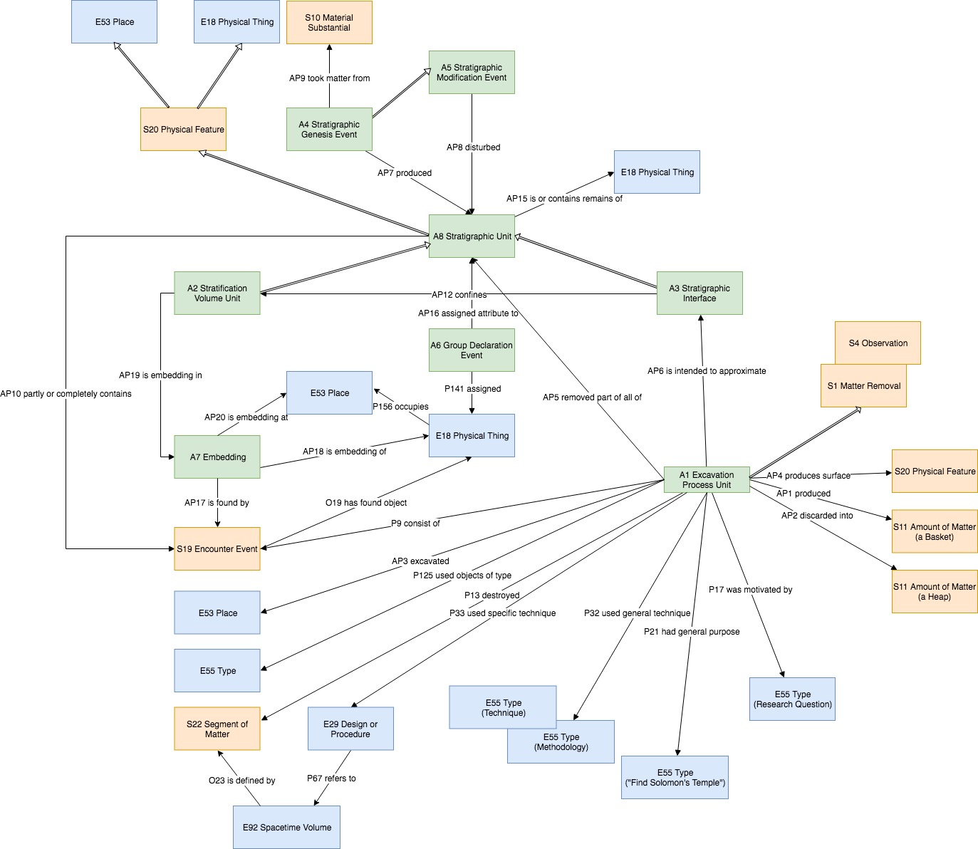

Fig. 1: CRMarchaeo classes and properties with relations to CRM and CRMsci classes
Fig. 2: CRMarchaeo, temporal entities

Fig. 3: Things in CRMarchaeo

1.3.1 Class and property usage examples

The following examples are taken from the English Heritage Recording Manual [Harris 1989] and try to illustrate the use of classes and properties of CRMarchaeo to represent the entities and relations of documentation praxis in relation to the Harris Matrix.
The stratigraphic sequence explains how the site was formed. For this example, we’ll work backwards and explain how the site was formed to make determining the stratigraphic sequence easier. Focussing near the top of Figure 4, the post-hole [3] was dug and the post inserted, the hole was packed (18). Eventually the post rotted away, leaving a post-pipe [19], into which later material accumulated (2) (see Fig. 4).

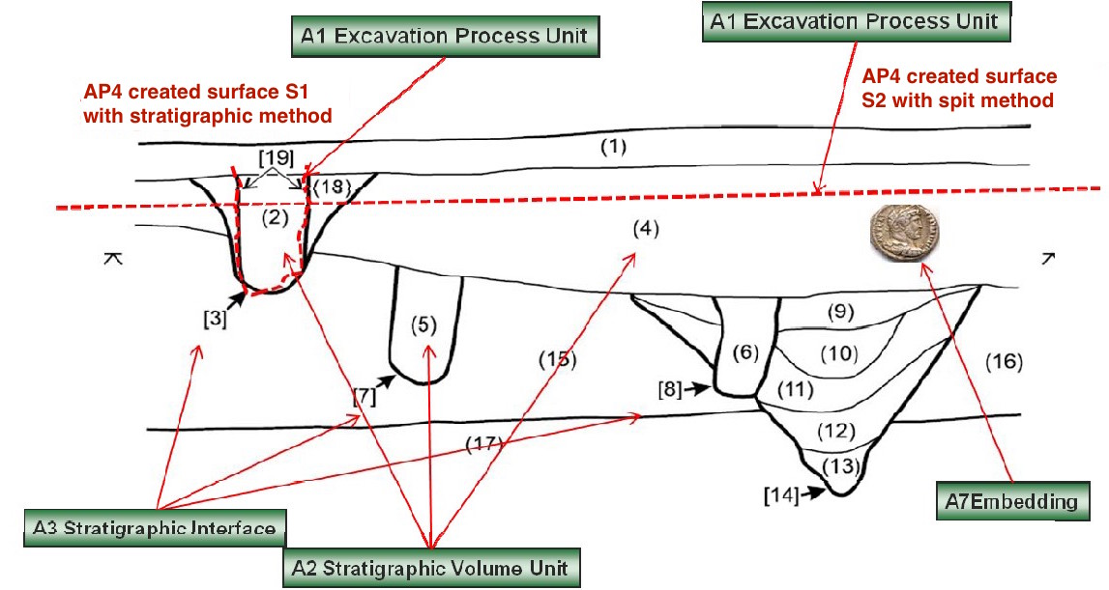

Fig. 4: Section drawing with A3 Stratigraphic Interfaces in square brackets [], A2 Stratigraphic Volume Unit in round brackets (), the surfaces S1 and S2 created through A1 Excavation Process Units using different methodologies and an A7 Embedding of a coin.

Fig. 5: CRMarchaeo conceptualisation to represent stratigraphic relationships contained in Harris Matrix, being justified by physical relationships.

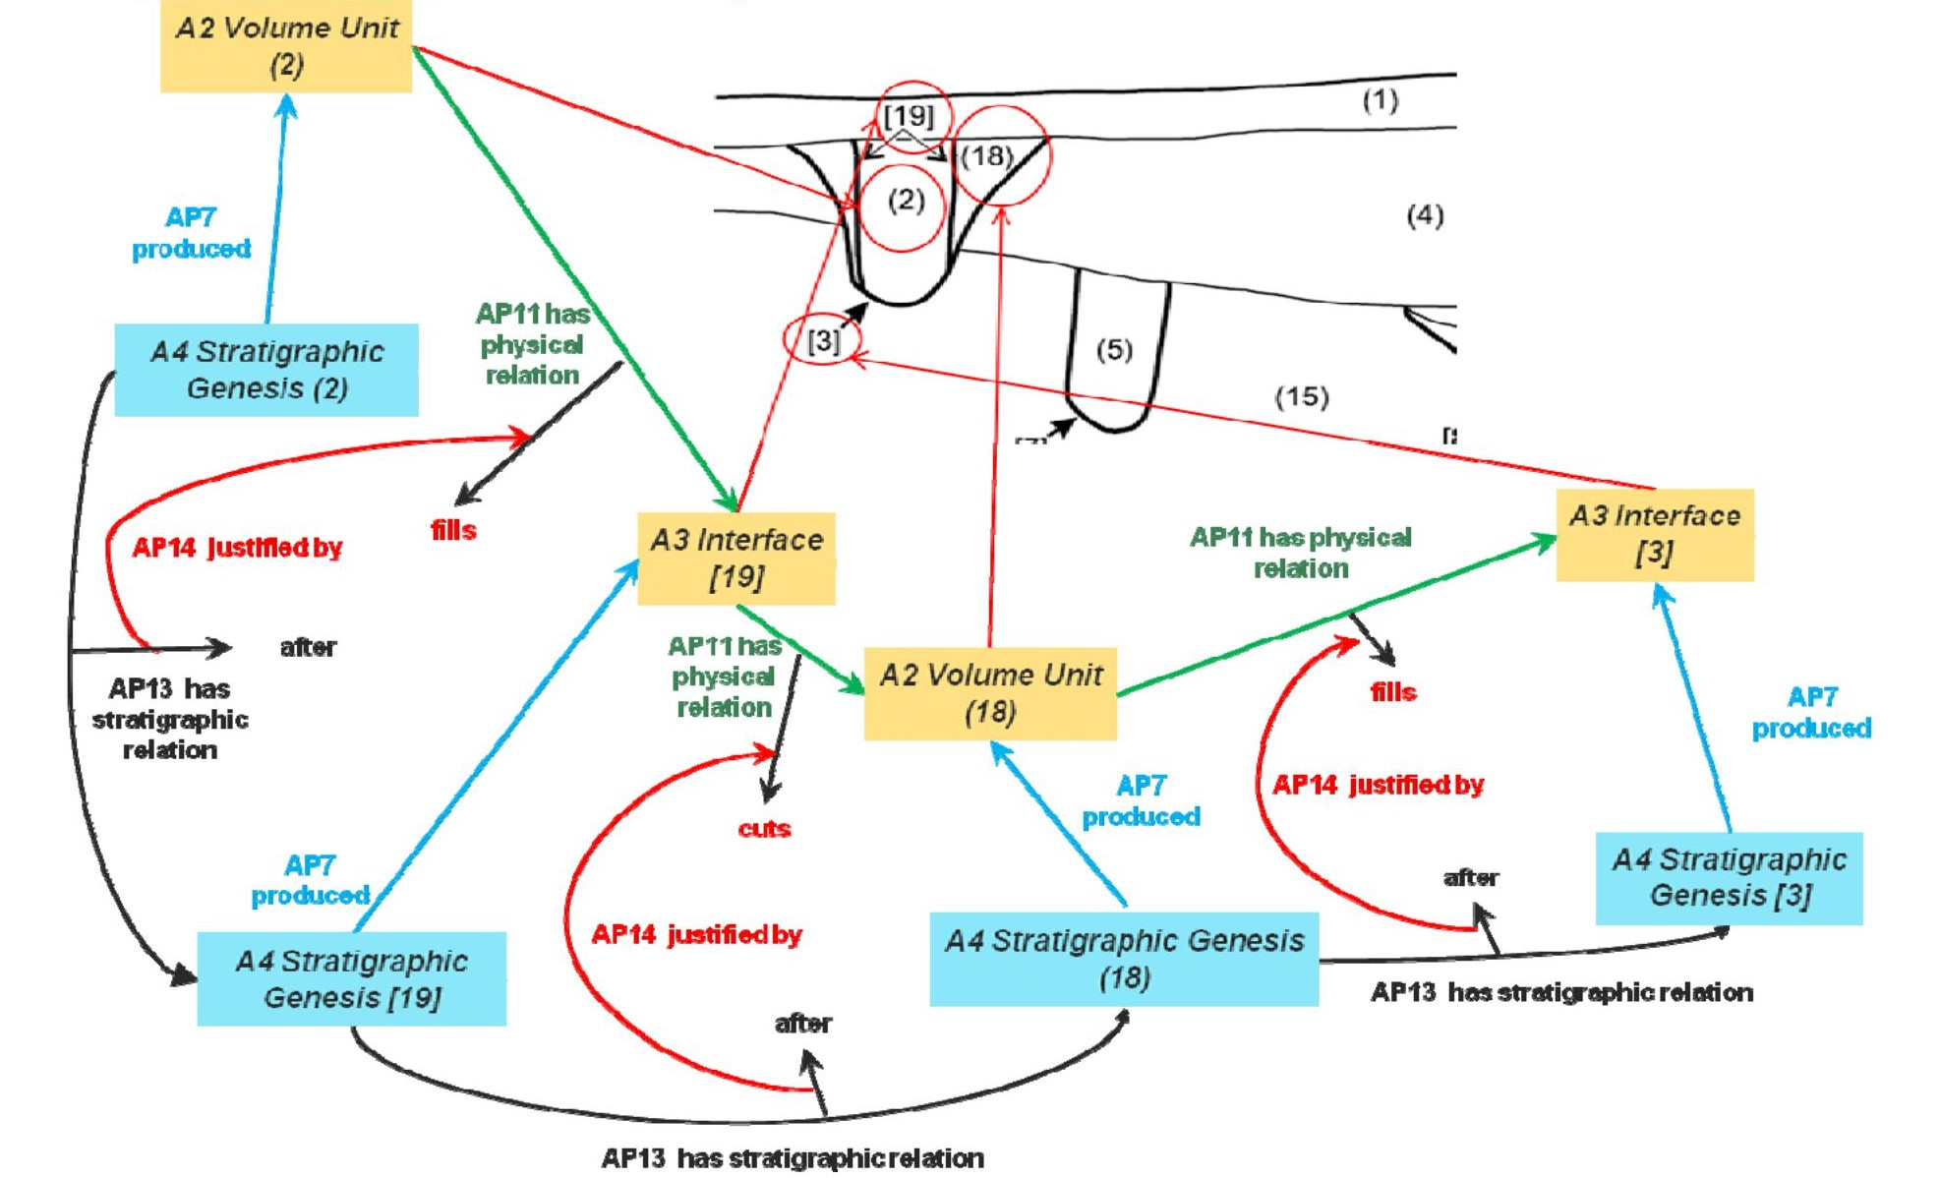

Fig. 6: CRMarchaeo representation of Harris Matrix for post-hole [3] (Figure 4)

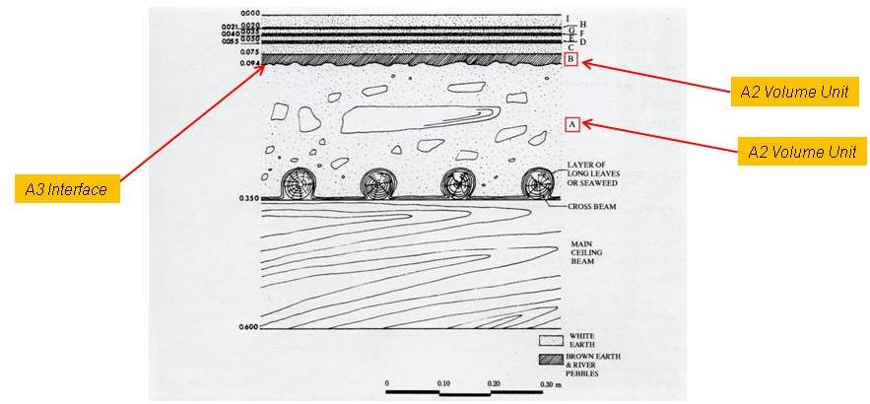

Fig. 7: CRMarchaeo example of A2 and A3 classes (Shaw 1977, ill.1-Michailidou 2001, fig.24)

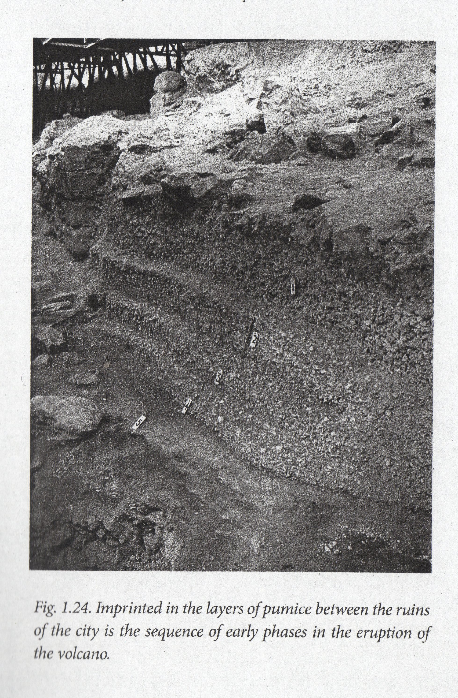

Fig. 8: CRMarchaeo example of A4 and A8 classes (Doumas 2015, fig. 1.24)

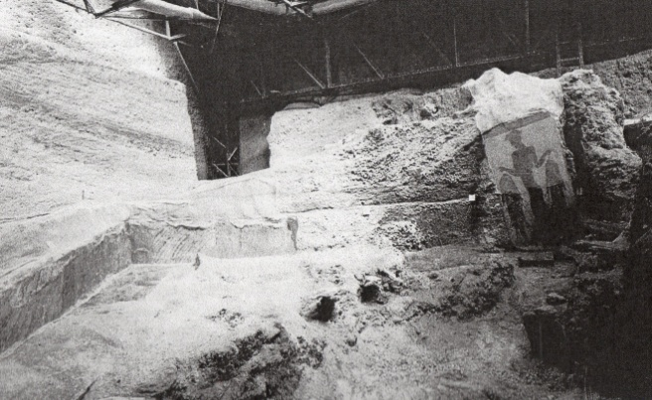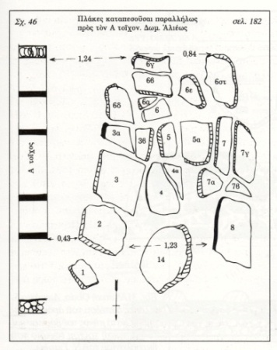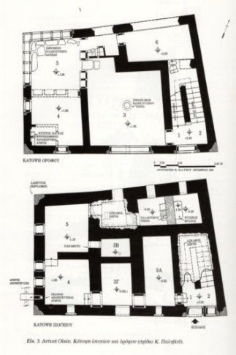

Fig. 9: CRMarchaeo example of A6 class (Marinatos 1974, pl. 38b-Michailidou 2001, Fig.3, 29)

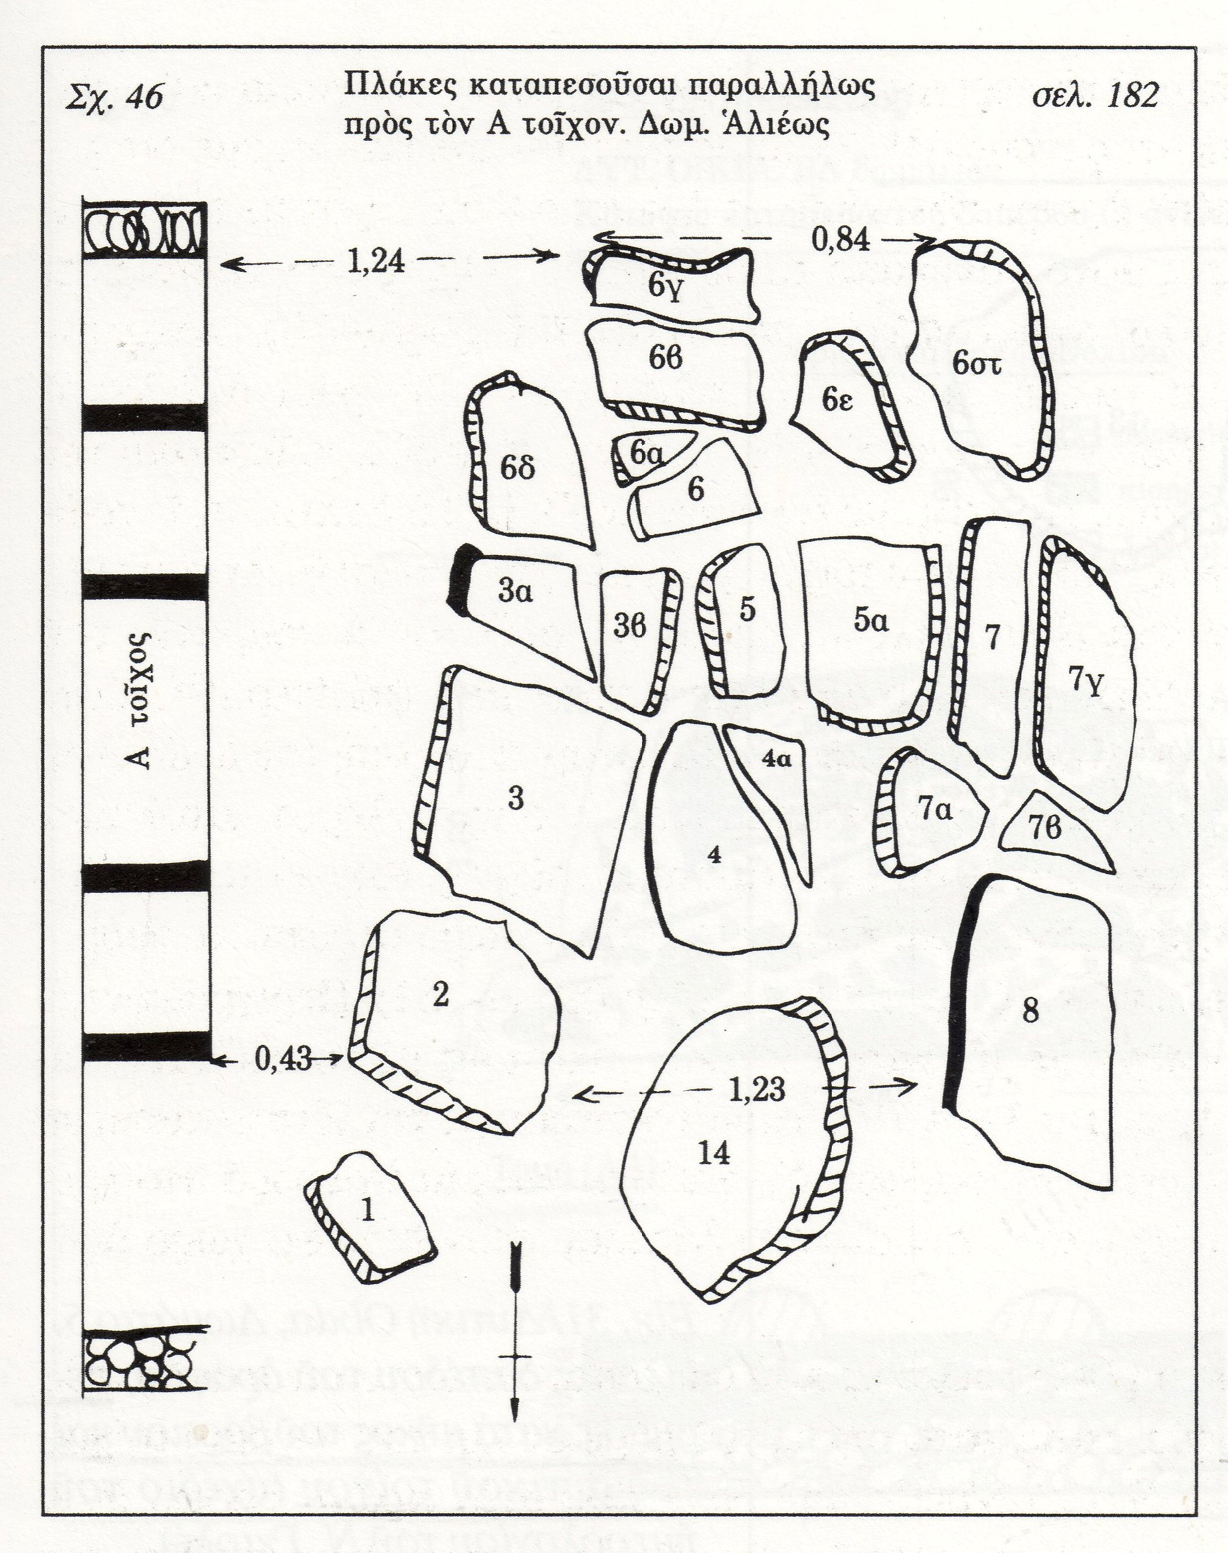
Fig. 10: CRMarchaeo example of A7 class (Michailidou 2001, Fig.29)

1.4 Excavation Model Class Declarations

The classes are comprehensively declared in this section using the following format:

- Class names are presented as headings in bold face, preceded by the class’ unique identifier;
- The line “Subclass of:” declares the superclass of the class from which it inherits properties;
- The line “Superclass of:” is a cross-reference to the subclasses of this class;
- The line “Scope note:” contains the textual definition of the concept the class represents;
- The line “Examples:” contains a bulleted list of examples of instances of this class.
- The line “Properties:” declares the list of the class’s properties;
- Each property is represented by its unique identifier, its forward name and the range class that it links to, separated by colons;
- Inherited properties are not represented;
- Properties of properties, if they exist, are provided indented and in parentheses beneath their respective domain property.

A1 Excavation Process Unit

Subclass of: E6 Destruction
S4 Observation

Scope Note: This class comprises activities of excavating in the sense of archaeology, which are documented as a coherent set of actions of progressively recording and removing matter from a pre-specified location under specific rules. Typically, an excavation process unit would be terminated if significant discontinuities of substance or finds come to light, or if the activity is interrupted due to external factors, such as end of a working day. In other cases, the termination would be based on predefined physical specifications, such as the boundaries of a maximal volume of matter to be excavated in one unit of excavation.
Depending on the methodology, an instance of A1 Excavation Process Unit may intend to remove matter only within the boundaries of a particular stratigraphic unit, or it may follow a pre-declared spatial extent such as a trench. It may only uncover, clean or expose a structure or parts of it.
The process of excavation results in the production of a set of recorded (documentation) data that should be sufficient to provide researchers enough information regarding the consistence and spatial distribution of the excavated Segment of Matter and things and features embedded in it. Some parts or all of the removed physical material (S11 Amount of Matter) may be dispersed, whereas others may be kept in custody in the form of finds or samples, while others (such as parts of walls) may be left at the place of their discovery. The data produced by an instance of excavation process unit should pertain to the material state of matter at excavation time only and should be clearly distinguished from subsequent interpretation about the causes for this state of matter.
Examples:
    - The activity taking place on 21.9.2007 between 12:00 and 13:00 that excavated the Stratigraphic Volume Unit (2) of Figure 4 and created the surface S1
    - The activity that excavated the first 20 cm of a spit excavation on 21.7.2007 created the surface S2 in Figure 4.

In First Order Logic:
A1(x) ⊃ S4(x)
Properties:
AP1 produced (was produced by): S11 Amount of Matter
AP2 discarded into (was discarded by): S11 Amount of Matter
AP4 produced surface (was surface produced by): S20 Rigid Physical Feature
AP5 removed part or all of (was partially or totally removed by): A8 Stratigraphic Unit
AP6 intended to approximate (was approximated by): A3 Stratigraphic Interface
AP10 destroyed (was destroyed by): S22 Segment of Matter (Segment of Matter that happened to be at the Excavated Place)

A2 Stratigraphic Volume Unit

Subclass of: A8 Stratigraphic Unit

Scope Note: This class comprises instances of A8 Stratigraphic Unit which are connected portions of terrain or other solid structures on, in, or under the surface of earth or seafloor exhibiting some homogeneity of structure or substance and which are completely bounded by surfaces or discontinuities in substance or structure with respect to other portions of the terrain or surfaces of objects or finds.
Normally at least one of the surfaces, i.e. instances of A3 Stratigraphic Interface (such as the lower one), from the genesis event of the A2 Stratigraphic Volume Unit will remain during its existence.
An instance of A2 Stratigraphic Volume Unit may contain physical objects

Examples:
The stratigraphic deposit unit number (2) of Figure 5 representing the filling of a post hole.

A collapsed part of the roof of the West House was found in a horizontal position on the first floor during the excavation of Room 3. It is made up of a number of successive layers, the principal ones being the thick layer “A” (A2), consisting of gray soil and small tuff stones, and the thinner layer “B” (A2) consisting of brownish red soil and marine pebbles (Fig. 7). [Μιχαηλίδου 2001, pp.64-65].

Properties: AP21 contains (is contained in): E18 Physical Thing

In First Order Logic:
A8(x) ⊃ A2(x)

A3 Stratigraphic Interface

Subclass of: A8 Stratigraphic Unit

Scope Note: This class comprises instances of A8 Stratigraphic Unit, which are coherent parts of a boundary surface that appear as the result of a stratigraphic genesis event or process. The interface marks the limit of the geometric extent of the effect of a genesis or modification event, and indicates in particular where the effect of this event ended. Each event of creation or destruction of a deposition layer implies the creation of new interfaces. Thus there are two main types of interface: those that are surfaces of strata (that can be directly related to the corresponding stratum via the AP12 confines property), and those that are only surfaces, formed by the removal or destruction of existing stratifications.

Examples:
The Stratigraphic Interface number [19] confines the number (2) Stratigraphic Volume Unit, in Figure 5.

The two layers A and B (A2) are separated by a stratigraphic interface (A3) (Fig.7) [Μιχαηλίδου 2001, pp. 64-645]

Properties:
AP12 confines (is confined by): A2 Stratigraphic Volume Unit

A4 Stratigraphic Genesis

Subclass of: S17 Physical Genesis
A5 Stratigraphic Modification5
Scope Note: This class comprises activities or processes that have produced homogeneous, distinguishable units of stratification that are in a relatively stable form from the time of their genesis until they are observed. Such processes may be the aggregation of cycles of erosion/destruction, deposit/accumulation, or transformation/modification occurring on a particular site throughout a particular period of time. These processes are usually not only due to natural forces (i.e., climate, the impact of flora and fauna, other natural events), but also to human activities, in particular excavation and construction. An event of stratification genesis typically produces two main forms of stratification units, both a deposit and an interface.
Examples:
The cut in the pre-existing strata of the posthole in Figure 8 produced the stratigraphic interface number [3]; the filling of the posthole with detritus or some other matter produced stratigraphic unit number (18).

In the excavation of Akrotiri, Thera, five distinct layers (A2) of pumice create a level (A8), about one metre thick, which covers the ruins caused by the earthquake (A4). Above the pumice, the deposition of successive layers (A2) of volcanic ash created an 8-10 m thick level (A8) (Fig. 5, 8). [Doumas 2015].

At the time of the destruction (A4) of Room 5 of the West House, the upper storey's paved floor collapsed and some of its slabs fell on the ground floor. This event produced two deposit levels (A8) (Fig. 5). [Μιχαηλίδου, Α. 2001, pp. 68-70].

Properties:
AP7 produced (was produced by): A8 Stratigraphic Unit or A3 Stratigraphic Interface
AP9 took matter from (provided matter to): S10 Material Substantial

A5 Stratigraphic Modification

Subclass of: S18 Alteration

Scope Note: This class comprises activities or processes resulting in the modification of Stratigraphic Units after their genesis through A4 Stratigraphic Genesis Events.

Examples:
The Event that eroded the number (1) Stratigraphic Volume Unit in Figure 4 and diminished it to its actual size

During the excavation at Eagle Cave, Texas, archaeologists found many burrows, about 7 cm in diameter on average, deriving from rodents, lizards, and insects, which have disturbed (A5) the intact layers (A8). [Larsen, M. 2015]

At the Dutton Paleo-Indian site, Colorado, involutions (flame-structures) due to aquaturbations, caused deformation (A5) of the saturated soil (A8). [Wood & Johnson 1978, pp. 315-380].

Properties:
AP8 disturbed (was disturbed by): A8 Stratigraphic Unit
AP13 has stratigraphic relation (is stratigraphic relation of): A5 Stratigraphic Modification

A6 Group Declaration Event

Subclass of: E13 Attribute Assignment

Scope Note: This class comprises interpretive activities that lead to the recognition two or more instances of Stratigraphic Units (A8) or other Physical Thing (E18) that simultaneously exist at the time of this activity or at the time of an archaeological observation this activity refers to as source and that are attributed to be the remains of one complete instance of Physical Thing (E18) that had existed at a time of reference in the past. Instances of this class could be, for example: two stratigraphic units (with no evident contact) cut through by a ditch having been segments of the same original stratigraphic unit, two or more surviving parts of a structure having been segments of the same wall (B5), a number of postholes being the indication of a past wooden house or a number of potsherds being segments of the same original artefact.
Examples:
The excavator declared the post holes [7] and [8] in Figure 4 to be part of one building.

During the excavation process of Room 5 (A1) of the West House (E24) a slab surface (E18) was found on deposit (A8) located on the upper storey (E53), as well as several individual slabs (E19) on deposit (A8) located on the ground floor (E53); these were declared, by the excavators, to be parts of the same object, i.e. the original paved floor (E19) of the upper storey (Fig. 9). [Μαρινάτος 1974] [Μιχαηλίδου 2001, pp. 40, 68-70]

Properties:
AP16 assigned attribute to (was attributed by): E18 Physical Thing

A7 Embedding

Subclass of: S16 State
Superclass of:
Scope Note: This class comprises the states of instances of E18 Physical Things of being partially or completely embedded at a particular position with relative stability in one or more A2 Stratigraphic Volume Units. Normally, an embedding is expected to have been stable from the time of generation of the first A2 Stratigraphic Volume Unit that surrounds it. However, it may also be due to later intrusion. As an empirical fact, the expert may only be able to decide that a particular embedding is not recent, i.e. has been persisting for longer than the activity that encountered it. This class can be used to document the fact of embedding generally with respect to the surrounding matter or, more specifically, with respect to a more precise position within this matter. It further allows for specifying temporal bounds for which a particular embedding has existed, as specified by the evidence.
Examples:
The excavator declared the post holes [7] and [8] in Figure 4 to be part of one building.

Τhe individual fallen slabs (E19) that were discovered (S19) during the excavation process of Room 5 (A1) of the West House in Akrotiri, Thera, were embedded (A7) in an almost vertical position (E55) within deposit (A8) on the ground floor (E53) (Fig. 10). [Μιχαηλίδου 2001, pp. 68-70].

Properties:
AP17 is found by (found): S19 Encounter Event
AP18 is embedding of (is embedded): E18 Physical Thing
P19 is embedding in (contains embedding): A2 Stratigraphic Volume Unit
AP20 is embedding at (contains): E53 Place
In First Order Logic:
A7(x) ⊃ S16(x)

A8 Stratigraphic Unit

Subclass of: S20 Rigid Physical Feature

Scope Note: This class comprises instances of S20 Rigid Physical Features which appear as the result of a stratigraphic genesis event or process. The form of an instance of A8 Stratigraphic Unit should be of a kind that can be attributed to a single genesis event or process and has the potential to be observed. One genesis event may have created more than one SU. An instance of A8 Stratigraphic Unit is regarded to exist as long as a part of its matter is still in place with respect to a surrounding reference space, such that its spatial features can be associated with effects of the genesis process of interest.
This also implies that a certain degree of coherent (“conformal”) deformation is tolerable within its time-span of existence. Therefore the place an instance of A8 Stratigraphic Unit occupies can be uniquely identified with respect to the surrounding reference space of archaeological interest
Examples:
The excavator declared the post holes [7] and [8] in Figure 4 to be part of one building.

In the excavation of Akrotiri, Thera, five distinct layers (A2) of pumice create a level (A8) about one metre thick which covers the ruins caused by the earthquake (A4) (Fig. 8) [Doumas 2015].

Properties:
AP11 has physical relation (is physical relation of): A8 Stratigraphic Unit
AP15 is or contains remains of (is or has remains contained in): S10 Material Substantial

A9 Archaeological Excavation

Subclass of: E7 Activity
S4 Observation

Scope Note: This class describes the general concept of archaeological excavation intended as a coordinated set of activities performed on an area considered as part of a broader topographical, rural, urban, or monumental context. An archaeological excavation is usually under the responsibility of a coordinator, officially designated, which is legally and scientifically responsible for all the activities carried out within each of the excavation process units and is also responsible for the documentation of the whole process.
Examples:
The archaeological excavation (A9) of the West House (E24) that took place at the archaeological site of Akrotiri, Thera (E53) during the years (1967-1973) (E52) by the archaeologist Sp. Marinatos (E39). [Μιχαηλίδου 2001, p. 41] [Palyvou 200].

Properties: AP3 investigated (was investigated by): E53 Place

1.4 Excavation Property Declarations

The properties are comprehensively declared in this section using the following format:
• Property names are presented as headings in bold face, preceded by unique property identifiers;
• The line “Domain:” declares the class for which the property is defined;
• The line “Range:” declares the class to which the property points, or that provides the values for the property;
• The line “Superproperty of:” is a cross-reference to any subproperties the property may have;
• The line “Scope note:” contains the textual definition of the concept the property represents;
• The line “Examples:” contains a bulleted list of examples of instances of this property.

AP1 produced (was produced by)

Domain: A1 Excavation Process Unit
Range: S11 Amount of Matter

Quantification: one to many (0,n:0,1)

Scope note: This property identifies the S11 Amount of Matter, e.g. a basket, that is preserved (part or total of) from an A1 Excavation Process Unit for further examination or evidence keeping.

Examples:
- The Excavation Process Unit excavating the Stratigraphic Volume Unit (2) produced an amount of black turf with wood inclusions.

In First Order Logic:
AP1(x,y) ⊃ A1(x)
AP11(x,y) ⊃ S11 (y)
Properties:

AP2 discarded into (was discarded by)

Domain: A1 Excavation Process Unit
Range: S11 Amount of Matter

Quantification: one to many (0,n:0,1)

Scope note: This property identifies the S11 Amount of Matter (e.g. a heap) into which material from an A1 Excavation Process Unit is discarded.
Examples:
The Excavation Process Unit excavating the Stratigraphic Volume Unit (2) discarded an amount of matter into the waste heap of the excavation.

In First Order Logic:
Properties:

AP3 investigated (was investigated by)

Domain: A9 Archaeological Excavation
Range: E53 Place

Quantification: one to many (0,n:0,1)

Scope note: This property identifies the 3D excavated volume instance of E53 Place, i.e., a three- dimensional volume, that was actually excavated during an A1 Excavation Process Unit.
Examples:
The Excavation Process Unit excavating the Stratigraphic Volume Unit (2) excavated the place where the Stratigraphic Volume Unit (2) was.
In First Order Logic:
Properties:

AP4 produced surface (was surface produced by)

Domain: A1 Excavation Process Unit
Range: S20 Rigid Physical Feature

Quantification: one to many (0,n:0,1)

Scope note: This property identifies the instance of S20 Rigid Physical Feature that constitutes the new surface produced during an A1 Excavation Process Unit in the excavated area. Frequently this surface or parts of it are documented through drawing and/or measured by technical means such as photography, tachymetry or laser scanning.
Examples:
The stratigraphic Excavation Process Unit excavating the Stratigraphic Volume Unit (2) produced surface S1.
In First Order Logic:
Properties:

AP5 removed part or all of (was partially or totally removed by)

Domain: A1 Excavation Process Unit
Range: A8 Stratigraphic Unit

Quantification: one to many (0,n:0,1)

Scope note: This property identifies the instance of A8 Stratigraphic Unit that was cut during an A1 Excavation Process Unit.
Examples:
The spit Excavation Process Unit producing surface S2 cut Stratigraphic Units [3],(18),[19],(2) and (4).
In First Order Logic:
Properties:

AP6 intended to approximate (was approximated by)

Domain: A1 Excavation Process Unit
Range: A3 Stratigraphic Interface
Subproperty of: S4 Observation.O8 observed: S15 Observable Entity

Quantification: one to many (0,n:0,1)

Scope note: This property identifies the A3 Stratigraphic Interface that was intended to approximate during an A1 Excavation Process Unit. This property should be assigned when a stratigraphic excavation methodology is used. It enables the linkage of the surface produced by an A1 Excavation Process Unit and an A3 Stratigraphic Interface.
Examples:
The stratigraphic Excavation Process Unit excavating the Stratigraphic Volume Unit (2) intended to approximate Stratigraphic Interface [19].
In First Order Logic:
Properties:

AP7 produced (was produced by)

Domain: A4 Stratigraphic Genesis
Range: A3 Stratigraphic Interface
Subproperty of: S17 Physical Genesis; O17 generated: E18 Physical Thing

Quantification: one to many (0,n:0,1)

Scope note: This property identifies the A8 Stratigraphic Unit that was produced during an A4 Stratigraphic Genesis Event.

Examples:
The stratigraphic Excavation Process Unit excavating the Stratigraphic Volume Unit (2) intended to approximate Stratigraphic Interface [19].
In First Order Logic:
Properties:

AP8 disturbed (was disturbed by)

Domain: A5 Stratigraphic Modification
Range: A8 Stratigraphic Unit

Quantification: one to many (0,n:0,1)

Scope note: This property identifies an A8 Stratigraphic Unit that was disturbed through an A5 Stratigraphic Modification. One A5 Stratigraphic Modification may disturb several A8 Stratigraphic Units.

AP9 took matter from (provided matter to)

Domain: A4 Stratigraphic Genesis
Range: S10 Material Substantial
Quantification: one to many (0,n:0,1)

Scope note: This property identifies the S10 Material Substantial from where matter was taken from during an A4 Stratigraphic Genesis Event.

AP10 destroyed (was destroyed by)

Domain: A1 Excavation Process Unit
Range: S22 Segment of Matter
Subproperty of: E6 Destruction; P13 destroyed (was destroyed by): E18 Physical Thing

Quantification: one to many (0,n:0,1)

AP11 has physical relation (is physical relation of)

Domain: A8 Stratigraphic Unit
Range: A8 Stratigraphic Unit

Quantification: one to many (0,n:0,1)

Scope note: This property identifies the physical relationship between two A8 Stratigraphic Units. The type of physical relationships found between stratigraphic units in archaeological documentation is documented through the property AP 11.1 has type

Properties: AP11.1 has type: E55 Type

AP12 confines (is confined by)

Domain: A3 Stratigraphic Interface
Range: A2 Stratigraphic Volume Unit

Scope note: This property identifies partly or completely the surface (A3 Stratigraphic Interface) of an A2 Stratigraphic Volume Unit. One A3 Stratigraphic Interface may confine two or more A2 Stratigraphic Volume Units.

AP13 has stratigraphic relation (is stratigraphic relation of)

Domain: A5 Stratigraphic Modification
Range: A5 Stratigraphic Modification
Subproperty of:
Superproperty of:
Quantification: one to many (0,n:0,1)

Scope note: This property identifies the stratigraphic relation between two A5 Stratigraphic Modification events. This relation may be inferred from the kind of physical relation that exists between the two AP 8 Stratigraphic Units that have been created or modified during the corresponding A5 Stratigraphic Modification events. The type of stratigraphic relationships in archaeological documentation assigned to two A5 Stratigraphic Modification events is documented through the property AP 13.1 has type.

Properties: AP13.1 has type: E55 Type AP14 justified by: AP11.1 has type (type of physical relation)

AP14 justified by (is justification of)

Domain: AP13.1 has type (type of stratigraphic relation)
Range: AP11.1 has type (type of physical relation)

Quantification: one to many (0,n:0,1)

Scope note: This property identifies the type of physical relation that was used to justify the type of stratigraphic relation assigned to the relation between two A5 Stratigraphic Modification events. Physical relations of “above” or “fills” may justify the stratigraphic relation type “after”. Figure 7 gives a graphical representation and Figure 6 shows an example.

AP15 is or contains remains of (is or has remains contained in)

Domain: A2 Stratigraphic Volume Unit
Range: S10 Material Substantial

Quantification: one to many (0,n:0,1)

Scope note: This property indicates that an instance of A2 Stratigraphic Volume Unit can be the remains of or contain the remains of an instance of S10 Material Substantial.

AP16 assigned attribute to (was attributed by)

Domain: A6 Group Declaration Event
Range: E18 Physical Thing
Subproperties: E13 Attribute Assignment. P140 assigned attribute to (was attributed by): E1 CRM Entity

Quantification: one to many (0,n:0,1)

Scope note: This property indicates an instance of E18 Physical Thing that was assigned by an instance of A6 Group Declaration Event as remains of the target of this instance of A6 Group Declaration Event.

AP17 is found by (found)

Domain: A7 Embedding
Range: S19 Encounter Event

Quantification: one to many (0,n:0,1)

Scope note: This property associates an instance of S19 Encounter Event with an instance of A7 Embedding that has been found during this even.

AP18 is embedding of (is embedded)

Domain: A7 Embedding
Range: E18 Physical Thing

Quantification: one to many (0,n:0,1)
Scope note: This property identifies the E18 Physical Thing that is contained in an A7 Embedding.

AP19 is embedding in (contains embedding)

Domain: A7 Embedding
Range: A2 Stratigraphic Volume Unit

Quantification: one to many (1,1:0,n)

Scope note: This property identifies the instance of A2 Stratigraphic Volume Unit that contains the A7 Embedding. An Embedding may not extend over more than one instance of A2 Stratigraphic Volume Unit.

In First Order Logic:
AP19(x,y) ⊃ A7(x)
AP19(x,y) ⊃ A2(y)

AP20 is embedding at (contains)

Domain: A7 Embedding
Range: E53 Place

Quantification: one to many (1,n:0,n)

Scope note: This property identifies the E53 Place that is documented as the E53 Place of the A7 Embedding. This place must be at rest relative to the instance of A2 Stratigraphic Volume Unit that contains the A7 Embedding.

In First Order Logic:
AP20(x,y) ⊃ A7(x)
AP20(x,y) ⊃ E53(y)
AP20(x,y) ⊃ (∃z)[ A2(z) ∧ AP19(x,z) ∧ P157(y,z)]

AP21 contains (is contained in)

Domain: A2 Stratigraphic Volume Unit
Range: E18 Physical Thing

Quantification: one to many (0,n:0,1)

Scope note: This property associates an E18 Physical Thing that is found within an A2 Stratigraphic Volume Unit with the stratigraphic volume unit. AP21 contains (is contained in) is a shortcut for the more detailed path from E18 Physical Thing through AP18i is embedded, A7 Embedding, AP19 is embedding in, A2 Stratigraphic Volume Unit.

1.5 Referred to CIDOC CRM Classes and properties

Since Excavation Model refers to and reuses, wherever appropriate, large parts of the CIDOC Conceptual Reference Model, this section provides a comprehensive list of all constructs used from CIDOC CRM, together with their definitions following the CIDOC CRM ver6.2, May 2015 maintained by CIDOC CRM - SIG. 1.5.1 CIDOC CRM Classes

1.5.1 CIDOC CRM Classes

E1 CRM Entity
Superclass of: E2 Temporal Entity
E52 Time-Span
E53 Place
E54 Dimension
E77 Persistent Item
E92 Spacetime Volume

Scope note: This class comprises all things in the universe of discourse of the CIDOC Conceptual Reference Model.

It is an abstract concept providing for three general properties:
- Identification by name or appellation, and in particular by a preferred identifier
- Classification by type, allowing further refinement of the specific subclass an instance belongs to
- Attachment of free text for the expression of anything not captured by formal properties

With the exception of E59 Primitive Value, all other classes within the CRM are directly or indirectly specialisations of E1 CRM Entity.

Examples:
- the earthquake in Lisbon 1755 (E5)

In First Order Logic:
E1(x)

Properties:
P1 is identified by (identifies): E41 Appellation
P2 has type (is type of): E55 Type
P3 has note: E62 String
(P3.1 has type: E55 Type)
P48 has preferred identifier (is preferred identifier of): E42 Identifier
P137 exemplifies (is exemplified by): E55 Type
(P137.1 in the taxonomic role: E55 Type)

E6 Destruction
Subclass of: E64 End of Existence

Scope note: This class comprises events that destroy one or more instances of E18 Physical Thing such that they lose their identity as the subjects of documentation.

Some destruction events are intentional, while others are independent of human activity. Intentional destruction may be documented by classifying the event as both an E6 Destruction and E7 Activity.

The decision to document an object as destroyed, transformed or modified is context sensitive:
1. If the matter remaining from the destruction is not documented, the event is modelled solely as E6 Destruction.
2. An event should also be documented using E81 Transformation if it results in the destruction of one or more objects and the simultaneous production of others using parts or material from the original. In this case, the new items have separate identities. Matter is preserved, but identity is not.
3. When the initial identity of the changed instance of E18 Physical Thing is preserved, the event should be documented as E11 Modification.
Examples:
- the destruction of Herculaneum by volcanic eruption in 79 AD
- the destruction of Nineveh (E6, E7)
- the breaking of a champagne glass yesterday by my dog

In First Order Logic:
E6(x) ⊃ E64(x)

Properties:
P13 destroyed (was destroyed by): E18 Physical Thing

E7 Activity
Subclass of: E5 Event
Superclass of: E8 Acquisition
E9 Move
E10 Transfer of Custody
E11 Modification
E13 Attribute Assignment
E65 Creation
E66 Formation
E85 Joining
E86 Leaving
E87 Curation Activity

Scope note: This class comprises actions intentionally carried out by instances of E39 Actor that result in changes of state in the cultural, social, or physical systems documented.

This notion includes complex, composite and long-lasting actions such as the building of a settlement or a war, as well as simple, short-lived actions such as the opening of a door.
Examples:
    - the Battle of Stalingrad
    - the Yalta Conference
    - my birthday celebration 28-6-1995
    - the writing of “Faust” by Goethe (E65)
    - the formation of the Bauhaus 1919 (E66)
    - calling the place identified by TGN ‘7017998’ ‘Quyunjig’ by the people of Iraq
    - Kira Weber working in glass art from 1984 to 1993
    - Kira Weber working in oil and pastel painting from 1993

In First Order Logic:
E7(x) ⊃ E5(x)

Properties:
P14 carried out by (performed): E39 Actor
(P14.1 in the role of: E55 Type)
P15 was influenced by (influenced): E1 CRM Entity
P16 used specific object (was used for): E70 Thing
(P16.1 mode of use: E55 Type)
P17 was motivated by (motivated): E1 CRM Entity
P19 was intended use of (was made for): E71 Man-Made Thing
(P19.1 mode of use: E55 Type)
P20 had specific purpose (was purpose of): E5 Event
P21 had general purpose (was purpose of): E55 Type
P32 used general technique (was technique of): E55 Type
P33 used specific technique (was used by): E29 Design or Procedure
P125 used object of type (was type of object used in): E55 Type
P134 continued (was continued by): E7 Activity

E13 Attribute Assignment
Subclass of: E7 Activity
Superclass of: E14 Condition Assessment
E15 Identifier Assignment
E16 Measurement
E17 Type Assignment

Scope note: This class comprises the actions of making assertions about properties of an object or any relation between two items or concepts.

This class allows the documentation of how the respective assignment came about, and whose opinion it was. All the attributes or properties assigned in such an action can also be seen as directly attached to the respective item or concept, possibly as a collection of contradictory values. All cases of properties in this model that are also described indirectly through an action are characterised as "short cuts" of this action. This redundant modelling of two alternative views is preferred because many implementations may have good reasons to model either the action or the short cut, and the relation between both alternatives can be captured by simple rules.

In particular, the class describes the actions of people making propositions and statements during certain museum procedures, e.g. the person and date when a condition statement was made, an identifier was assigned, the museum object was measured, etc. Which kinds of such assignments and statements need to be documented explicitly in structures of a schema rather than free text, depends on if this information should be accessible by structured queries.
Examples:
- the assessment of the current ownership of Martin Doerr’s silver cup in February 1997

In First Order Logic:
E13(x) ⊃ E7(x)

Properties:
P140 assigned attribute to (was attributed by): E1 CRM Entity
P141 assigned (was assigned by): E1 CRM Entity

E18 Physical Thing
Subclass of: E72 Legal Object
E92 Spacetime Volume
Superclass of: E19 Physical Object
E24 Physical Man-Made Thing
E26 Physical Feature

Scope Note: This class comprises all persistent physical items with a relatively stable form, man-made or natural.

Depending on the existence of natural boundaries of such things, the CRM distinguishes the instances of E19 Physical Object from instances of E26 Physical Feature, such as holes, rivers, pieces of land etc. Most instances of E19 Physical Object can be moved (if not too heavy), whereas features are integral to the surrounding matter.

An instance of E18 Physical Thing occupies not only a particular geometric space, but in the course of its existence it also forms a trajectory through spacetime, which occupies a real, that is phenomenal, volume in spacetime. We include in the occupied space the space filled by the matter of the physical thing and all its inner spaces, such as the interior of a box. Physical things consisting of aggregations of physically unconnected objects, such as a set of chessmen, occupy a number of individually contiguous spacetime volumes equal to the number of unconnected objects that constitute the set.

We model E18 Physical Thing to be a subclass of E72 Legal Object and of E92 Spacetime volume. The latter is intended as a phenomenal spacetime volume as defined in CRMgeo (Doerr and Hiebel 2013). By virtue of this multiple inheritance we can discuss the physical extent of an E18 Physical Thing without representing each instance of it together with an instance of its associated spacetime volume. This model combines two quite different kinds of substance: an instance of E18 Physical Thing is matter while a spacetime volume is an aggregation of points in spacetime. However, the real spatiotemporal extent of an instance of E18 Physical Thing is regarded to be unique to it, due to all its details and fuzziness; its identity and existence depends uniquely on the identity of the instance of E18 Physical Thing. Therefore this multiple inheritance is unambiguous and effective and furthermore corresponds to the intuitions of natural language.

The CIDOC CRM is generally not concerned with amounts of matter in fluid or gaseous states.

Examples:
    - the Cullinan Diamond (E19)
    - the cave “Ideon Andron” in Crete (E26)
    - the Mona Lisa (E22)

In First Order Logic:
E18(x) ⊃ E72(x)
E18(x) ⊃ E92(x)

Properties:
P44 has condition (is condition of): E3 Condition State
P45 consists of (is incorporated in): E57 Material
P46 is composed of (forms part of): E18 Physical Thing
P49 has former or current keeper (is former or current keeper of): E39 Actor
P50 has current keeper (is current keeper of): E39 Actor
P51 has former or current owner (is former or current owner of): E39 Actor
P52 has current owner (is current owner of): E39 Actor
P53 has former or current location (is former or current location of): E53 Place
P58 has section definition (defines section): E46 Section Definition
P59 has section (is located on or within): E53 Place
P128 carries (is carried by): E90 Symbolic Object
P156 occupies (is occupied by): E53 Place

E53 Place
Subclass of: E1 CRM Entity

Scope note: This class comprises extents in space, in particular on the surface of the earth, in the pure sense of physics: independent from temporal phenomena and matter.

The instances of E53 Place are usually determined by reference to the position of “immobile” objects such as buildings, cities, mountains, rivers, or dedicated geodetic marks. A Place can be determined by combining a frame of reference and a location with respect to this frame. It may be identified by one or more instances of E44 Place Appellation.

It is sometimes argued that instances of E53 Place are best identified by global coordinates or absolute reference systems. However, relative references are often more relevant in the context of cultural documentation and tend to be more precise. In particular, we are often interested in position in relation to large, mobile objects, such as ships. For example, the Place at which Nelson died is known with reference to a large mobile object – H.M.S Victory. A resolution of this Place in terms of absolute coordinates would require knowledge of the movements of the vessel and the precise time of death, either of which may be revised, and the result would lack historical and cultural relevance.

Any object can serve as a frame of reference for E53 Place determination. The model foresees the notion of a "section" of an E19 Physical Object as a valid E53 Place determination.
Examples:
- the extent of the UK in the year 2003
- the position of the hallmark on the inside of my wedding ring
- the place referred to in the phrase: “Fish collected at three miles north of the confluence of the Arve and the Rhone”
- here -> <-

In First Order Logic:
E53(x) ⊃ E1(x)

Properties:
P87 is identified by (identifies): E44 Place Appellation
P89 falls within (contains): E53 Place
P121 overlaps with: E53 Place
P122 borders with: E53 Place
P157 is at rest relative to (provides reference space for): E18 Physical Thing
P168 place is defined by (defines place) : E94 Space Primitive
P171 at some place within: E53 Place
P172 contains: E53 Place

E55 Type
Subclass of: E28 Conceptual Object
Superclass of: E56 Language
E57 Material
E58 Measurement Unit

Scope note: This class comprises concepts denoted by terms from thesauri and controlled vocabularies used to characterize and classify instances of CRM classes. Instances of E55 Type represent concepts in contrast to instances of E41 Appellation which are used to name instances of CRM classes.

E55 Type is the CRM’s interface to domain specific ontologies and thesauri. These can be represented in the CRM as subclasses of E55 Type, forming hierarchies of terms, i.e. instances of E55 Type linked via P127 has broader term (has narrower term). Such hierarchies may be extended with additional properties.
Examples:
- weight, length, depth [types of E54]
- portrait, sketch, animation [types of E38]
- French, English, German [E56]
- excellent, good, poor [types of E3]
- Ford Model T, chop stick [types of E22]
- cave, doline, scratch [types of E26]
- poem, short story [types of E33]
- wedding, earthquake, skirmish [types of E5]

In First Order Logic:
E55(x) ⊃ E28(x)

Properties:
P127 has broader term (has narrower term): E55 Type
P150 defines typical parts of (define typical wholes for): E55 Type

1.5.2 CIDOC CRM Properties
This section contains the complete definitions of the properties of the CIDOC CRM Conceptual Reference Model vers. 6.2 May, 2015 referred to by CRMarchaeo model

P9 consists of (forms part of)
Domain: E4 Period
Range: E4 Period
Subproperty of: E92 Spacetime Volume. P10i contains: E92 Spacetime Volume

Quantification: one to many, (0,n:0,1)

Scope note: This property associates an instance of E4 Period with another instance of E4 Period that is defined by a subset of the phenomena that define the former. Therefore the spacetime volume of the latter must fall within the spacetime volume of the former.
This property is transitive.

Examples:
- Cretan Bronze Age (E4) consists of Middle Minoan (E4)

In First Order Logic:
P9(x,y) ⊃ E4(x)
P9(x,y) ⊃ E4(y)
P9(x,y) ⊃ P10(y,x)

P13 destroyed (was destroyed by)
Domain: E6 Destruction
Range: E18 Physical Thing
Subproperty of: E64 End of Existence. P93 took out of existence (was taken out of existence by): E77 Persistent Item
Quantification: one to many, necessary (1,n:0,1)

Scope note: This property allows specific instances of E18 Physical Thing that have been destroyed to be related to a destruction event.
Destruction implies the end of an item’s life as a subject of cultural documentation – the physical matter of which the item was composed may in fact continue to exist. A destruction event may be contiguous with a Production that brings into existence a derived object composed partly of matter from the destroyed object.
Examples:
- the Tay Bridge Disaster (E6) destroyed The Tay Bridge (E22)

In First Order Logic:
P13 (x,y) ⊃ E6 (x)
P13 (x,y) ⊃ E18(y)
P13 (x,y) ⊃ P93(x,y)

P140 assigned attribute to (was attributed by)
Domain: E13 Attribute Assignment
Range: E1 CRM Entity
Superproperty of:E14 Condition Assessment. P34 concerned (was assessed by): E18 Physical Thing
E16 Measurement. P39 measured (was measured by): E70 Thing
E17 Type Assignment. P41 classified (was classified by): E1 CRM Entity
Quantification: many to many (0,n:0,n)

Scope note: This property indicates the item to which an attribute or relation is assigned.
Examples:
- February 1997 Current Ownership Assessment of Martin Doerr’s silver cup (E13) assigned attribute to Martin Doerr’s silver cup (E19)
- 01 June 1997 Identifier Assignment of the silver cup donated by Martin Doerr (E15) assigned attribute to silver cup 232 (E19)

In First Order Logic:
P140(x,y) ⊃ E13(x)
P140(x,y) ⊃ E1(y)

1.6 Referred to Scientific Observation Model Classes and properties

Since CRMarchaeo refers to and reuses, wherever appropriate, large parts of Scientific Observation Model this section provides a comprehensive list of all constructs used from that model, together with their definitions following the CRMsci, together with their definitions following version 1.2 maintained by FORTH.

1.6.1 CRMsci Classes
This section contains the complete definitions of the classes of the Scientific Observation Model referred to by Excavation Model

S4 Observation

Subclass of: E13 Attribute Assignment

Superclass of:
S21 Measurement
S19 Encounter Event
A1 Excavation Process Unit

Scope note:
This class comprises the activity of gaining scientific knowledge about particular states of physical reality gained by empirical evidence, experiments and by measurements. We define observation in the sense of natural sciences, as a kind of human activity: at some Place and within some Time-Span, certain Physical Things and their behavior and interactions are observed, either directly by human sensory impression, or enhanced with tools and measurement devices. The output of the internal processes of measurement devices that do not require additional human interaction are in general regarded as part of the observation and not as additional inference. Manual recordings may serve as additional evidence. Measurements and witnessing of events are special cases of observations. Observations result in a belief about certain propositions. In this model, the degree of confidence in the observed properties is regarded to be “true” per default, but could be described differently by adding a property P3 has note to an instance of S4 Observation, or by reification of the property O16 observed value. Primary data from measurement devices are regarded in this model to be results of observation and can be interpreted as propositions believed to be true within the (known) tolerances and degree of reliability of the device. Observations represent the transition between reality and propositions in the form of instances of a formal ontology, and can be subject to data evaluation from this point on.

Properties:
O8 observed (was observed by): S15 Observable Entity
O9 observed property type (property type was observed by): S9 Property Type
O16 observed value (value was observed by): E1 CRM Entity

S5 Inference Making

Subclass of: E13 Attribute Assignment
Superclass of: S6 Data Evaluation
S7 Simulation or Prediction
S8 Categorical Hypothesis Building

Scope note: This class comprises the action of making propositions and statements about particular states of affairs in reality or in possible realities or categorical descriptions of reality by using inferences from other statements based on hypotheses and any form of formal or informal logic. It includes evaluations, calculations, and interpretations based on mathematical formulations and propositions.

In First Order Logic:
S5(x) ⊃ E13(x)

Properties:

S10 Material Substantial

Subclass of: E70 Thing

Superclass of:
S14 Fluid Body
S11 Amount of Matter
E18 Physical Thing

Scope note:
This class comprises constellations of matter with a relative stability of any form sufficient to associate them with a persistent identity, such as being confined to certain extent, having a relative stability of form or structure, or containing a fixed amount of matter. In particular, it comprises physical things in the narrower sense and fluid bodies. It is an abstraction of physical substance for solid and non-solid things of matter.

Properties:
P44 has condition (is condition of): E3 Condition State
P45 consists of (is incorporated in): E57 Material
P46 is composed of (forms part of): S10 Material Substantial
O15 occupied (was occupied by): E53 Place

S11 Amount of Matter

Subclass of: S10 Material Substantial

Superclass of:
S12 Amount of Fluid
S13 Sample

Scope note:
This class comprises fixed amounts of matter specified as some air, some water, some
soil, etc., defined by the total and integrity of their material content.

S15 Observable Entity
Subclass of: E1 CRM Entity
Superclass of: E2 Temporal Entity
E77 Persistent Item
Scope note:
This class comprises instances of E2 Temporal Entity or E77 Persistent Item, i.e. items or phenomena that can be observed, either directly by human sensory impression, or enhanced with tools and measurement devices, such as physical things, their behavior, states and interactions or events.
Conceptual objects can be present in events by their carriers such as books, digital media, or even human memory. By virtue of this presence, properties of conceptual objects, such as number of words can be observed on their carriers. If the respective properties between carriers differ, either they carry different instances of conceptual objects or the difference can be attributed to accidental deficiencies in one of the carriers. In that sense even immaterial objects are observable. By this model we give credit to the fact that frequently, the actually observed carriers of conceptual objects are not explicitly identified in documentation, i.e., the actual carrier is assumed having existed but is unknown as an individual.

In First Order Logic:
S15(x) ⊃ E1(x)

Properties:
O12 has dimension (is dimension of): E54 Dimension

S16 State

Subclass of: E2 Temporal Entity

Superclass of: E3 Condition State

Scope note:
This class comprises the persistence of a particular value range of the properties of a particular thing or things over a time-span

S17 Physical Genesis

Subclass of:
E63 Beginning of Existence
S18 Alteration

Superclass of:
E12 Production
A4 Stratigraphic Genesis

Scope note:
This class comprises events or processes that result in (generate) physical things, man- made or natural, coming into being in the form by which they are later identified. The creation of a new physical item, at the same time, can be a result of an alteration (modification) – it can become a new thing due to an alteration activity.

Properties:
O17 generated (was generated by): E18 Physical ThingE18 Physical Thing

S18 Alteration
Subclass of: E5 Event
Superclass of: S17 Physical Genesis
E11 Modification

Scope note: This class comprises natural events or man-made processes that create, alter or change physical things, by affecting permanently their form or consistency without changing their identity. Examples include alterations on depositional features-layers by natural factors or disturbance by roots or insects, organic alterations, petrification, etc.
In First Order Logic:
S18(x) ⊃ E5(x)

Properties:
O18 altered (was altered by): E18 Physical Thing

S19 Encounter Event

Subclass of: S4 Observation

Scope note:
This class comprises activities of S4 Observation (substance) where an E39 Actor encounters an instance of E18 Physical Thing of a kind relevant for the mission of the observation or regarded as potentially relevant for some community (identity). This observation produces knowledge about the existence of the respective thing at a particular place in or on surrounding matter. This knowledge may be new to the group of people the actor belongs to. In that case we would talk about a discovery. The observer may recognize or assign an individual identity of the thing encountered or regard only the type as noteworthy in the associated documentation or report.
In archaeology there is a particular interest if an object is found “in situ”, i.e. if its embedding in the surrounding matter supports the assumption that the object was not moved since the archaeologically relevant deposition event. The surrounding matter with the relative position of the object in it as well as the absolute position and time of the observation may be recorded in order to enable inferences about the history of the E18 Physical Thing.
In Biology, additional parameters may be recorded like the kind of ecosystem, if the biological individual survives the observation, what detection or catching devices have been used or if the encounter event supported the detection of a new biological kind (“taxon”).

Properties:
O19 has found object (was object found by): E18 Physical Thing
O21 has found at (witnessed): E53 Place

S20 Rigid Physical Feature
Subclass of: E26 Physical Feature
E53 Place
Superclass of: E27 Site
S22 Segment of Matter

Scope Note: This class comprises physical features with the following characteristics. Any instance of this class is physically attached in an integral way to particular physical object, and has a stability of form in itself and with respect to the physical object bearing it, in such a way that it is sufficient to associate a permanent reference space within which its form is invariant and at rest.
Due to this stability of form, the maximal real volume in space that an instance of S20 Rigid Physical Feature occupies at some time within its existence with respect to the default reference space relative to which the feature is at rest defines uniquely a place for the feature with respect to its surrounding matter.
Therefore we model S20 Rigid Physical Feature as a subclass of E26 Physical Feature and of E53 Place. The latter is intended as a phenomenal place as defined in CRMgeo (Doerr and Hiebel 2013). By virtue of this multiple inheritance we can discuss positions relative to the extent of an instance of S20 Rigid Physical Feature without representing each instance of it together with an instance of its associated place. This model combines two quite different kinds of substance: an instance of E26 Physical Feature and of E53 Place. It is an aggregation of points in a geometric space. However, since the identity and existence of this place depends uniquely on the identity of the instance of S20 Rigid Physical Feature as matter, this multiple inheritance is unambiguous and effective and furthermore corresponds to the intuitions of natural language. It shortcuts an implicit self-referential path from E26 Physical Feature through P156 occupies, E53 Place, P157 is at rest relative to E26 Physical Feature.
In cases of instances of S20 Rigid Physical Feature on or in the surface of earth, the default reference is typically fixed to the closer environment of the tectonic plate or sea floor. In cases of features on mobile objects, the reference space is typically fixed to the geometry of the bearing object. Note that the reference space associated with the instance of S20 Rigid Physical Feature may quite well be deformed over time, as long the continuity of its topology does not become unclear, such as the compression of dinosaur bones in geological layers, or the distortions of the hull of a ship by the waves of the sea. Defined in this way, the reference space can be used as a means to infer from current topological relationships past topological relationships of interest.
Examples:
▪ the temple in Abu Simbel before its removal, which was carved out of solid rock
▪ Albrecht Duerer's signature on his painting of Charles the Great
▪ the damaged nose of the Great Sphinx in Giza
▪ The bones of the Ichtyosaur in Holzmaden, Germany.
▪ The “Schliemann cut” in Troy
In First Order Logic:
S20(x) ⊃ E26(x)
S20(x) ⊃ E53(x)

S22 Segment of Matter
Subclass of: S20 Rigid Physical Feature

Scope Note:
This class comprises physical material in a relative stability of form (substance) within a specific spacetime volume (unity, extend). The spatial extend of a S22 Segment of Matter is defined by humans usually because the constellation is subject to a specific interest for and investigations of the geometric arrangement of physical features or parts of them on or within the specified S22 Segment of Matter. It comes into existence as being an object of discourse through S4 Observation or declaration and is restricted to the time span starting after the last change through an S18 Alteration before the S4 Observation or declaration and ending with the next S18 Alteration Event (identity). A S22 Segment of Matter exists as long as there is no modification of the geometric arrangement of its particles. Therefore the temporal boundaries of the defining Spacetime Volume are given by two S18 Alteration events.
The history of a S22 Segment of Matter started with the first S17 Physical Genesis event that deposited still existing matter within the defined spatial extend. The collection of all S18 Alteration events represent its history. Some of the events will not leave any physical material within the S22 Segment of Matter.
(to be elaborated further)

Properties:
O22 partly or completely contains (is part of): S20 Rigid Physical Feature
O23 is defined by (defines): E92 Spacetime Volume

1.6.2 CRMsci Properties

This section contains the complete definitions of the properties of the Scientific Observation Model referred to by Excavation Model

O8 observed (was observed by)

Domain: S4 Observation
Range: S15 Observable Entity
Subproperty of: E13 Attribute Assignment. P140 assigned attribute to (was attributed by): E1 CRM Entity
Superproperty of: S21 Measurement. O24 measured (was measured by): S15 Observable Entity

Scope note: This property associates an instance of S4 Observation with an instance of S15 Observable Entity that was observed. Specifically it describes that a thing, a feature, a phenomenon or its reaction is observed by an activity of Observation.
In First Order Logic:
O8(x,y) ⊃ S4(x)
O8(x,y) ⊃ S15(y)
O8(x,y) ⊃ P140(x,y)

O17 generated (was generated by)

Domain: S17 Physical Genesis
Range: E18 Physical Thing
Superproperty of: E12 Production. P108 has produced (was produced by): E24 Physical Man-Made Thing

Scope note: This property associates an instance of S17 Physical Genesis event with an instance of E18 Physical Thing that the event generated.

Bibliography

[Μαρινάτος 1974] Μαρινάτος, Σ. 1974 (1972). Ανασκαφαί Θήρας VI. ΒΑΕ 64, πιν.38β. Αθήνα: H Εν Αθήναις Αρχαιολογική Εταιρεία

[Wood & Johnson 1978] Wood, W. R and Johnson, D. L. 1978. ‘A Survey of Disturbance Processes in Archaeological Site Formation’, in Advances in Archaeological Method and Theory. Edited by Michael, B. Schiffer, Vol. 1, pp. 315-380, pl. 9.26. London: Academic Press]

[Harris 1989]: Harris, E.C.: Principles of Archaeological Stratigraphy. Academic
Press, London (1989)

[Μιχαηλίδου 2001] Μιχαηλίδου, Α. 2001. Ακρωτήρι Θήρας. Η μελέτη των ορόφων στα κτήρια του οικισμού. ΒΑΕ 212, Αθήνα: H Εν Αθήναις Αρχαιολογική Εταιρεία

[Palyvou 2005] Palyvou,Cl., 2005. Akrotiri Thera. An Architecture of Affluence 3,500 Years Old. Prehistory Monographs 15, pp. 47. Philadelphia, Pennsylvania: INSTAP

[ARIADNE 2013]: http://www.ariadne-infrastructure.eu/

[Doumas, C. 2015] Doumas, C. 2015. ‘ The Bronze Age on Thera’, in Akrotiri, Thera, 17th century BC, A cosmopolitan harbour town 3,500 years ago, Paris, 30 October 2013. Edited by Society for the promotion of studies on prehistoric Thera, pp. 6-26, pl. 1.24. Athens: Kathimerini S.A

[Larsen 2015] Larsen, M. 2015. ‘Adventures in the Ancient Lost City of the Rodents’. [online] Available at: https://aswtproject.wordpress.com/2015/03/19/adventures-in-the-ancient-lost-city-of-the-rodents/ [Accessed 17 Oct.2017

Amendments 1.4.7

The 36nd joined meeting of the CIDOC CRM SIG and ISO/TC46/SC4/WG9 and the 29th FRBR - CIDOC CRM Harmonization meeting

A1 Excavation Process Unit
The crm-sig resolving the issue 283 changed the supeclasses of A1

FROM:
Subclass of: S1 Matter Removal
S4 Observation
TO:
Subclass of: E6 Destruction
S4 Observation

A2 Stratigraphic Volume Unit

The crm-sig resolving the issue 301 changed the scope note of A2

FROM:

Subclass of: A8 Stratigraphic Unit

Scope Note: This class comprises connected portions of terrain or other solid structure on, in, or under the surface of earth or seafloor exhibiting some homogeneity of structure or substance and completely bounded by surfaces or discontinuities in substance or structure with respect to other portions of the terrain or surfaces of objects/finds.
An instance of A8 Stratigraphic Unit may contain physical objects. The internal continuity and the boundaries of an instance of A8 Stratigraphic Unit should be of a kind that can be attributed to a single genesis event or process and have the potential to be observed.
One genesis event may have created more than one SU. An instance of A8 Stratigraphic Unit is regarded to exist as long as a part of its matter is still in place with respect to a surrounding reference space such that its spatial features can be associated with effects of the genesis process of interest. Normally at least one of the surfaces (such as the lower one) from its genesis event will remain during its existence.
This also implies that a certain degree of coherent (“conformal”) deformation is tolerable within its time-span of existence. Therefore the place an instance of A8 Stratigraphic Unit occupies can be uniquely identified with respect to the surrounding reference space of archaeological interest.
Examples:
The stratigraphic deposit unit number (2) of Figure 5 representing the filling of a post hole
Properties: AP21 contains (is contained in): E18 Physical Thing

TO:
Scope Note: This class comprises instances of A8 Stratigraphic Unit which are connected portions of terrain or other solid structure on, in, or under the surface of earth or seafloor exhibiting some homogeneity of structure or substance and which are completely bounded by surfaces or discontinuities in substance or structure with respect to other portions of the terrain or surfaces of objects or finds.
Normally at least one of the surfaces, i.e. instances of A3 Stratigraphic Interface (such as the lower one), from the genesis event of the A2 Stratigraphic Volume Unit will remain during its existence.
An instance of A2 Stratigraphic Volume Unit may contain physical objects

A8 Stratigraphic Unit
The crm-sig resolving the issue 300 changed the scope note of A8

FROM:
Scope Note: This class comprises S20 Rigid Physical Features that are either A2 Stratigraphic Volume Units or A3 Stratigraphic Interfaces
TO:
Scope Note: This class comprises instances of S20 Rigid Physical Features which appear as the result of a stratigraphic genesis event or process. The form of an instance of A8 Stratigraphic Unit should be of a kind that can be attributed to a single genesis event or process and have the potential to be observed. One genesis event may have created more than one SU. An instance of A8 Stratigraphic Unit is regarded to exist as long as a part of its matter is still in place with respect to a surrounding reference space such that its spatial features can be associated with effects of the genesis process of interest.
This also implies that a certain degree of coherent (“conformal”) deformation is tolerable within its time-span of existence. Therefore the place an instance of A8 Stratigraphic Unit occupies can be uniquely identified with respect to the surrounding reference space of archaeological interest

A9 Archaeological Excavation
The crm-sig resolved the issue 315 and added a new class about archaeological excavation with the following definition

Subclass of: E7 Activity
S4 Observation

Scope Note: This class describes the general concept of archaeological excavation intended as a coordinated set of activities performed on an area considered as part of a broader topographical, rural, urban, or monumental context. An archaeological excavation is usually under the responsibility of a coordinator, officially designated, which is legally and scientifically responsible for all the activities carried out within each of the excavation process units and is also responsible for the documentation of the whole process.

Properties: AP3 investigated (was investigated by): E53 Place
P9 consists of: A1 Excavation Process Unit

AP3 excavated (was excavated by)
The crm-sig resolved the issue 315 and changed the label and the domain of the property AP3

FROM:

AP3 excavated (was excavated by)

Domain: A1 Excavation Process Unit
Range: E53 Place

TO:

AP3 investigated (was investigated by)

Domain: A9 Archaeological Excavation
Range: E53 Place

Quantification: one to many (0,n:0,1)

AP15 is or contains remains of (is or has remains contained in)
The crm-sig resolving the issue 299 changed the range of AP15

FROM:
Domain: A8 Stratigraphic Unit
Range: E18 Physical Thing
TO:
Domain: A2 Stratigraphic Volume Unit
Range: S10 Material Substantial

AP21 contains (is contained in)
The crm-sig resolving the issue 299 added new property AP21 contains with the following definition

Domain: A2 Stratigraphic Volume Unit
Range: E18 Physical Thing

Quantification: one to many (0,n:0,1)

Scope note: This property associates an E18 Physical Thing that is found within an A2 Stratigraphic Volume Unit with the stratigraphic unit. This property is a shortcut for the fully articulated path from E18 Physical Thing through A7 Embedding to A2 Stratigraphic Volume Unit.

37th joined meeting of the CIDOC CRM SIG and ISO/TC46/SC4/WG9 and the 30th FRBR - CIDOC CRM Harmonization meeting

A2 Stratigraphic Volume Unit
The crm-sig resolving the issue 303 added the appropriate FOL expression

In First Order Logic:
A8(x) ⊃ A2(x)

A6 Group Declaration Event
The crm-sig resolving the issue 302 changed the scope note and the properties of A6

FROM:

Scope Note: This class comprises activities resulting in recognising two ore more physical things or stratigraphic units as part of a single physical thing or stratigraphic unit. This may be due to an archaeologists interpretation of many units in the stratigraphic context as being part of the same thing, like postholes being part of one building.
Properties:
AP16 assigned attribute to (was attributed by): E18 Physical Thing
P141 assigned: E18 Physical Thing
TO:
Scope Note: This class comprises interpretive activities that lead to the recognition two or more instances of Stratigraphic Units (A8) or other Physical Thing (E18) that simultaneously exist at the time of this activity or at the time of an archaeological observation this activity refers to as source and that are attributed to be the remains of one complete instance of Physical Thing (E18) that had existed at a time of reference in the past, such as two stratigraphic units (with no evident contact) cut through by a ditch having been segments of the same original stratigraphic unit, two or more surviving parts of a structure having been segments of the same wall (B5), a number of postholes being the indication of a past wooden house or a number of potsherds being segments of the same original artefact
Properties:
AP16 assigned attribute to (was attributed by): E18 Physical Thing

A7 Embedding
The crm-sig resolving the issue 303 added the appropriate FOL expression

In First Order Logic:
A7(x) ⊃ S16(x)

AP15 is or contains remains of (is or has remains contained in)

The crm-sig resolving the issue 299, changed the domain and the scope note of the property AP15

FROM:
Domain: A8 Stratigraphic Unit
Range: S10 Material Substantial

Quantification: one to many (0,n:0,1)

Scope note: This property associates an S10 Material Substantial that is or is contained within an A8 Stratigraphic Unit with the stratigraphic unit.

TO:
Domain: A2 Stratigraphic Volume Unit
Range: S10 Material Substantial

Quantification: one to many (0,n:0,1)

Scope note: This property indicates that an instance of A2 Stratigraphic Volume Unit can be the remains of or contain the remains of an instance of S10 Material Substantial.

AP16 assigned attribute to (was attributed by)
The crm-sig resolving the issue 302 changed the scope note and the range of AP16

FROM:
Domain: A6 Group Declaration Event
Range: A8 Stratigraphic Unit

Scope note: This property indicates the Stratigraphic Unit that was assigned by an A6 Group Declaration Event.

TO:
Domain: A6 Group Declaration Event
Range: E18 Physical Thing

Scope note: This property indicates an instance of E18 Physical Thing that was assigned by an instance of A6 Group Declaration Event as remains of the target of this instance of A6 Group Declaration Event.

AP19 is embedding in (contains embedding)
The crm-sig resolving the issue 303 changed the scope note of AP19, corrected the quantifications and added the appropriate FOL expression

FROM:
Domain: A7 Embedding
Range: A2 Stratigraphic Volume Unit

Quantification: one to many (0,n:0,1)

Scope note: This property identifies the A2 Stratigraphic Volume Unit that contains the A7 Embedding.

TO:

Domain: A7 Embedding
Range: A2 Stratigraphic Volume Unit

Quantification: one to many (1,1:0,n)

Scope note: This property identifies the instance of A2 Stratigraphic Volume Unit that contains the A7 Embedding. An Embedding may not extend over more than one instance of A2 Stratigraphic Volume Unit.
In First Order Logic:
AP19(x,y) ⊃ A7(x)
AP19(x,y) ⊃ A2(y)

AP20 is embedding at (contains)
The crm-sig resolving the issue 303 changed the scope note of AP20, corrected the quantifications and added the appropriate FOL expression

FROM:
Domain: A7 Embedding
Range: E53 Place

Quantification: one to many (0,n:0,1)

Scope note: This property identifies the E53 Place that is documented as the E53 Place of the A7 Embedding.
TO:
Domain: A7 Embedding
Range: E53 Place

Quantification: one to many (1,n:0,n)

Scope note: This property identifies the E53 Place that is documented as the E53 Place of the A7 Embedding. This place must be at rest relative to the instance of A2 Stratigraphic Volume Unit that contains the A7 Embedding.

In First Order Logic:
AP20(x,y) ⊃ A7(x)
AP20(x,y) ⊃ E53(y)
AP20(x,y) ⊃ (∃z)[ A2(z) ∧ AP19(x,z) ∧ P157(y,z)]

AP21 contains (is contained in)
The crm-sig resolving the issue 299, changed the scope note of the property AP21

FROM:

Scope note: This property associates an E18 Physical Thing that is found within an A2 Stratigraphic Volume Unit with the stratigraphic unit. This property is a shortcut for the fully articulated path from E18 Physical Thing through A7 Embedding to A2 Stratigraphic Volume Unit.

TO:

Scope note: This property associates an E18 Physical Thing that is found within an A2 Stratigraphic Volume Unit with the stratigraphic volume unit. AP21 contains (is contained in) is a shortcut for the more detailed path from E18 Physical Thing through P18i is embedded, A7 Embedding,AP19 is embedding in, A2 Stratigraphic Volume Unit.

Proofreading:
The referred classes and properties to CIDOC CRM, CRMsci and CRMinf are updated. Thus :
- E7 Activity is added, E26 Physical Feature is deleted, E29 Design or Procedure is deleted, P19 was intended use of (was made for) is deleted, P20 had specific purpose is deleted, P141 assigned (was assigne by) is deleted.
- The class S20 Physical Feature from CRMsci has been updated to S20 Rigid Physical Feature
- The classes and properties referred to CRMinf (section 1.7) are deleted.

