

Definition of the CRMsci
An Extension of CIDOC-CRM to support scientific observation

Proposal for approval by CIDOC CRM-SIG

Document Type: Current
Editorial Status: In Progress since [13/01/2022]

Version 1.7

May 2022

Currently Maintained by: FORTH

Contributors: Martin Doerr, Athina Kritsotaki, Yannis Rousakis, Gerald Hiebel, Maria Theodoridou and others

Table of Contents

Introduction 4
Scope 4
Status 10
Scientific Observation Model Class Hierarchy aligned with (part of) CIDOC CRM Class Hierarchy 12
Scientific Observation Model PROPERTY Hierarchy 14
Classes 15
S1 Matter Removal 15
S2 Sample Taking 15
S3 Measurement by Sampling 16
S4 Observation 16
S5 Inference Making 17
S6 Data Evaluation 18
S7 Simulation or Prediction 18
S8 Categorical Hypothesis Building 19
S9 Property Type 19
S10 Material Substantial 20
S11 Amount of Matter 20
S12 Amount of Fluid 21
S13 Sample 21
S14 Fluid Body 21
S15 Observable Entity 22
S17 Physical Genesis 23
S18 Alteration 23
S19 Encounter Event 24
S20 Rigid Physical Feature 24
S21 Measurement 25
S22 Segment of Matter 26
S24 Sample Splitting 27
Properties 28
O1 diminished (was diminished by) 28
O2 removed (was removed by) 28
O3 sampled from (was sample by) 28
O4 sampled at (was sampling location of) 29
O5 removed (was removed by) 29
O6 is former or current part of (has former or current part) 30
O7 confines (is confined by) 30
O8 observed (was observed by) 31
O10 assigned dimension (dimension was assigned by) 32
O11 described (was described by) 32
O13 triggers (is triggered by) 33
O15 occupied (was occupied by) 34
O16 observed value (value was observed by) 34
O17 generated (was generated by) 34
O18 altered (was altered by) 35
O19 encountered object (was object encountered through) 35
O20 sampled from type of part (type of part was sampled by) 35
O21 encountered at (witnessed encounter) 36
O23 is defined by (defines) 36
O25 contains (is contained in) 37
O27 split (was source for) 38
O28 is conceptually greater than (is conceptually less than) 38
O29 removed sub-sample (was sub-sample removed by) 38
Referred CIDOC CRM Classes and Properties 39
REFERENCES: 41
Amendments version 1.2.3 44
37th joined meeting of the CIDOC CRM SIG and ISO/TC46/SC4/WG9 and the 30th FRBR - CIDOC CRM Harmonization meeting 44
S20 Physical Feature 44
S20 Physical Feature 44
S20 Rigid Physical Feature 45
S4 Observation 46
Amendments version 1.2.4 - 39th meeting of the CIDOC CRM 47
O22 partly or completely contains (is part of): 47
Quantification of properties has been edited. 47
Amendments version 1.3 - 49th Meeting of the CIDOC CRM 47
The scope note of O19 and O21 has been changed 47
FROM (original) 47
TO (revised) 47
TO (revised) 48
A new property “O28 is conceptually greater than (is conceptually less than)” has been added 48
Amendments version 1.4 - 50th Meeting of the CIDOC CRM 48
Amendments version 1.5 - 51st Meeting of the CIDOC CRM 48
Amendments version 1.6 - 52st Meeting of the CIDOC CRM 49

Introduction

Scope
This text defines the “Scientific Observation Model” (CRMsci), a formal ontology intended to be used as a global schema for integrating metadata about scientific observation, measurements and processed data in descriptive and empirical sciences such as life sciences, geology, geography, archaeology, cultural heritage conservation and others in research IT environments and research data libraries. Its primary purpose is facilitating the management, integration, mediation, interchange and access to research data by describing semantic relationships, in particular causal ones. It is not primarily a model for processing data in order to produce new research results, even though its representations can be used for processing.

The Scientific Observation Model

It uses and extends the CIDOC Conceptual Reference Model (CRM, ISO21127) as a general ontology of human activity, things and events happening in spacetime. It uses the same encoding-neutral formalism of knowledge representation (“data model” in the sense of computer science) as the CIDOC CRM, which can be implemented in RDFS, OWL, on RDBMS and in other forms of encoding. Since the model reuses, wherever appropriate, parts of CIDOC CRM, we provide in this document also a comprehensive list of all constructs used from ISO21127, together with their definitions following the version 6.2 maintained by CIDOC.

The Scientific Observation Model has been developed bottom up from specific metadata examples from life sciences, geology, archeology, cultural heritage conservation and clinical studies, such as water sampling in aquifer systems, earthquake shock recordings, landslides, excavation processes, species occurrence and detection of new species, tissue sampling in cancer research, 3D digitization, based on communication with the domain experts and the implementation and validation in concrete applications. It takes into account relevant standards, such as INSPIRE, OBOE, national archaeological standards for excavation, Digital Provenance models and others. For each application, another set of extensions is needed in order to describe those data at an adequate level of specificity, such as semantics of excavation layers or specimen capture in biology. However, the model presented here describes, together with the CIDOC CRM, a discipline neutral level of genericity, which can be used to implement effective management functions and powerful queries for related data. It aims at providing superclasses and superproperties for any application-specific extension, such that any entity referred to by a compatible extension can be reached with a more general query based on this model.

Besides application-specific extensions, this model is intended to be complemented by CRMgeo, a more detailed model and extension of the CIDOC CRM of generic spatiotemporal topology and geometric description, also currently available in a first stable version [CRMgeo, version 1.0 - Doerr, M. and Hiebel, G. 2013]. Details of spatial properties of observable entities should be modelled in CRMgeo. As CRMgeo links CIDOC CRM to the OGC standard of GeoSPARQL it makes available all constructs of GML of specific spatial and temporal relationships. Still to be developed are models of the structures for describing quantities, such as IHS colors, volumes, velocities etc.

This is an attempt to maintain a modular structure of multiple ontologies related and layered in a specialization – generalization relationship, and into relatively self-contained units with few cross-correlations into other modules, such as describing quantities. This model aims at staying harmonized with the CIDOC CRM, i.e., its maintainers submit proposals for modifying the CIDOC CRM wherever adequate to guarantee the overall consistency, disciplinary adequacy and modularity of CRM-based ontology modules.

Basic concepts
Figure 1 and figure 2 summarise the classes that CRMsci introduces (in red) and their relations with CIDOC CRM classes (in blue).
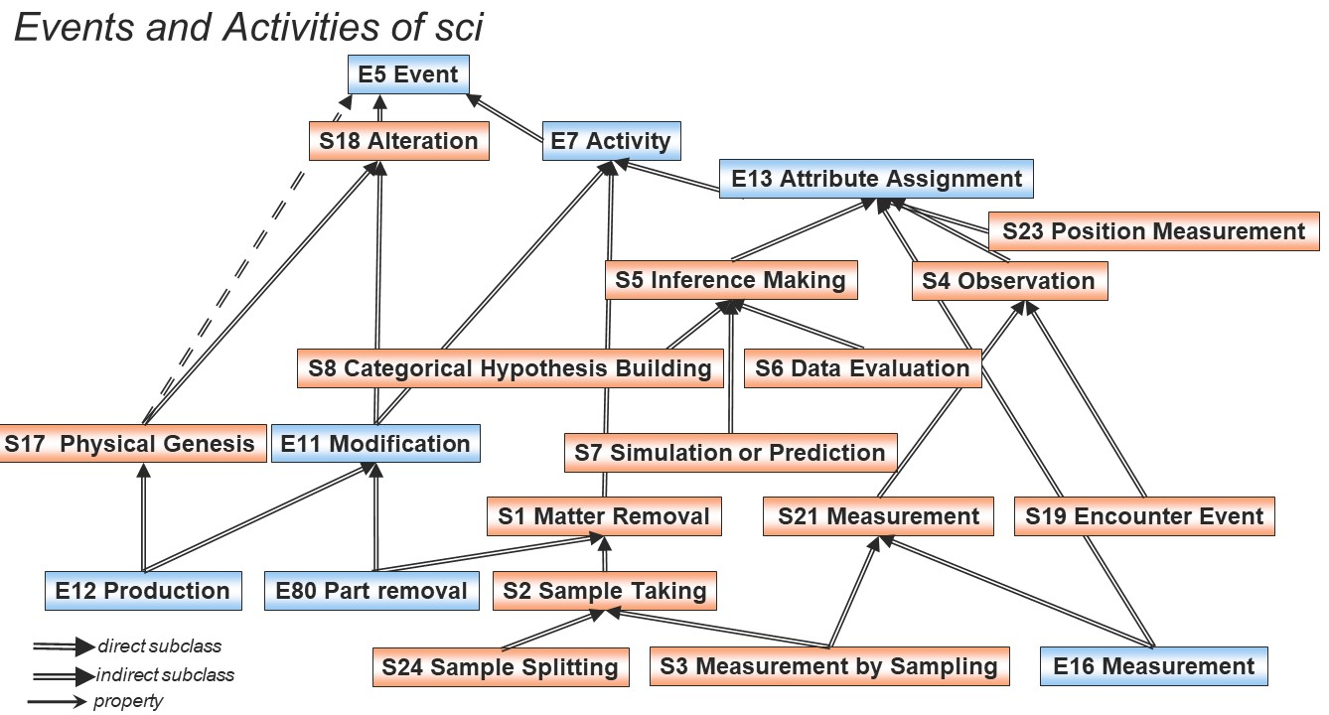
Figure 1: Subclass relations between temporal classes of the CRMsci and the CIDOC CRM.

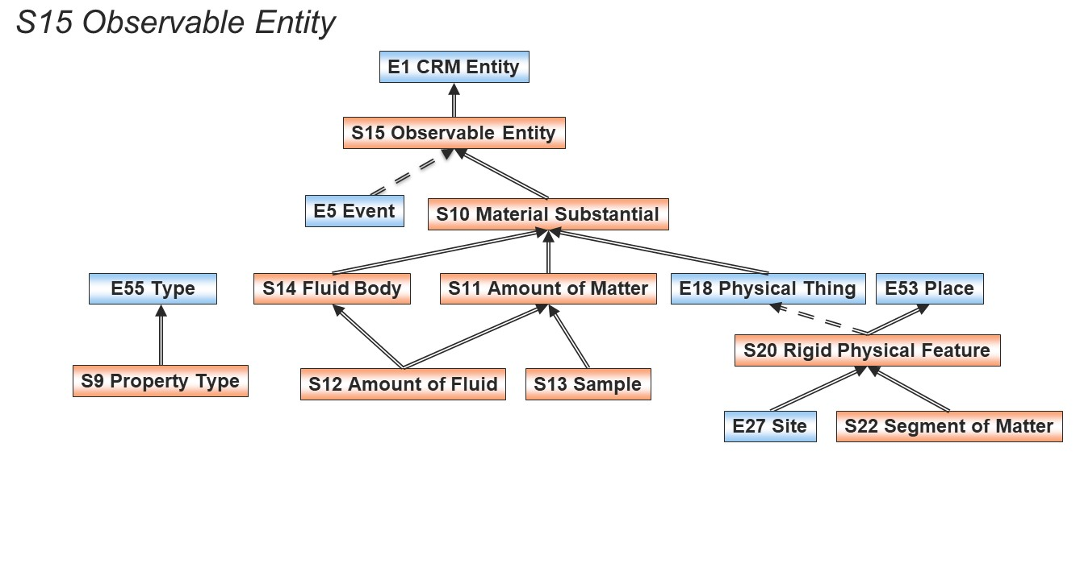
Figure 2: S15 Observable Entity and subclasses describing substance.
The class S10 Material Substantial describes instances of matter which can be identified and therefore recorded. While the material things that the CIDOC CRM describes are primarily considered solid, the CRMsci can also describe material things which are not solid, such as identifiable instances of fluids and piles of earth. The class S10 Material Substantial and its subclasses S14 Fluid Body and S11 Amount of Matter can be used to describe such instances respectively.

Samples
The process of taking a sample can be described by the class S2 Sample Taking, a specialisation of the more general class S1 Matter Removal, as shown in figure 3. The activity of sampling removes matter from something and creates a new identifiable entity which can be described as an instance of the class S13 Sample. This is similar to the CIDOC CRM construct of removing parts from solid things through the class E80 Part Removal. CRMsci generalises this construct allowing sampling of fluids and other non-solid things. During sampling it is important to record the location on the sampled thing from where the sample was taken (e.g. collecting a pigment sample from the area of a canvas where an apple was painted). This can be described using the property O4 sampled at. This is distinct to the location that the sampling activity was taking place in general (e.g. the conservation studio where the sampling was done). Partitive relationships between instances of S10 Material Substantial can be described using the property O25 contains, which generalises the CIDOC CRM property P46 is composed of used for solid things.
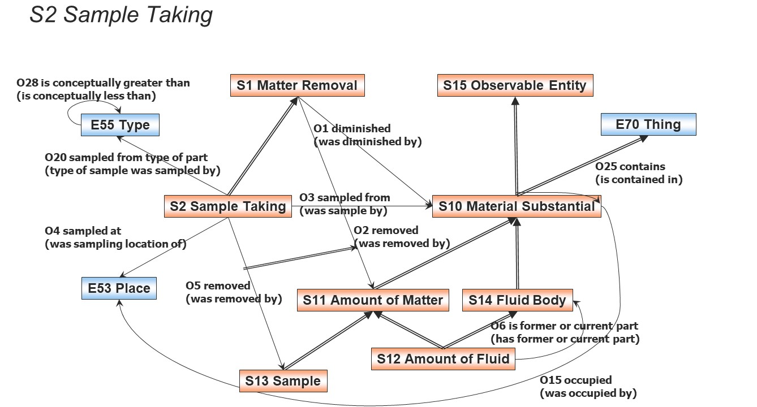
Figure 3: Classes and properties for describing the process of sampling.
A special case of sampling is when a sample is split, for example, when taking a blood sample from a patient and then splitting it to use in different diagnostic tests. This can be considered as a sub-sampling activity and can be described using class S24 Sample Splitting with its subproperties mirroring the main sampling process as shown in figure 4.

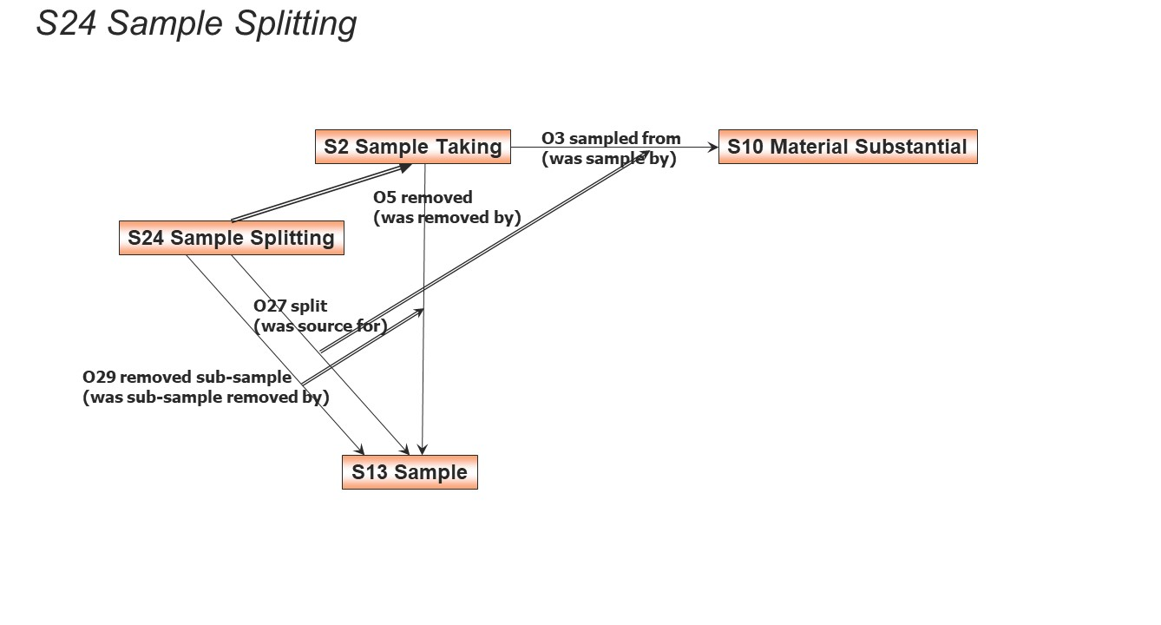
Figure 4: Classes and properties describing sample splitting.
Samples are often preserved after analysis is done. In some cases this is not possible, for example when the sample is destroyed as part of the analysis process. The class S3 Measurement by Sampling can be used to describe such cases. This class is a subclass of both S2 Sample Taking and of S21 Measurement, therefore it inherits the properties and intention of both classes, making this activity of taking a sample also a measurement (figure 5).
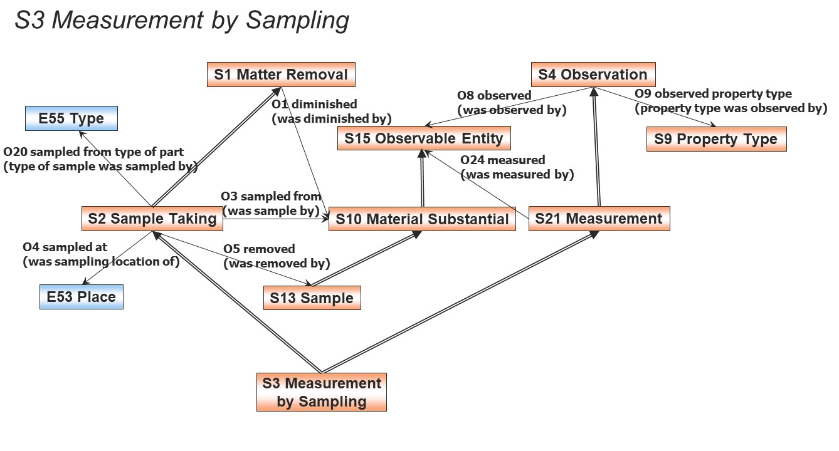

Figure 5: Extending the sampling activity for the special case of samples used solely for measurements.

Alterations
In the CIDOC CRM the making of things is associated with an activity undertaken by an agent as indicated by the construct of the class E12 Production with a) its associated property P108 produced and b) its inherited property P14 carried out. The CRMsci provides classes that describe the making of things without any agents being involved. The class S17 Physical Genesis (figure 6) generalises the class E12 Production for things which materialise through natural processes, such as the making of stalactites. The class S17 Physical Genesis is a subclass of E5 Event but not E7 Activity to make clear that there is no agency associated with the event. The class S18 Alteration (figure 6) is a generalisation of the CIDOC CRM class E11 Modification, therefore it cannot be used for instances of events which generate things but only for instances of events which alter things without agency (e.g. in the case of corrosion layers appearing on a metal surface due to acidic environment).
The CIDOC CRM avoids providing constructs to imply causality of events and instead describes influence and sequence of events. The CRMsci introduces the property O13 triggers (figure 6) which can be used to describe that one event being the cause for another event starting at the given time, i.e. this property should not be used for analysis of social or historical causes of events.
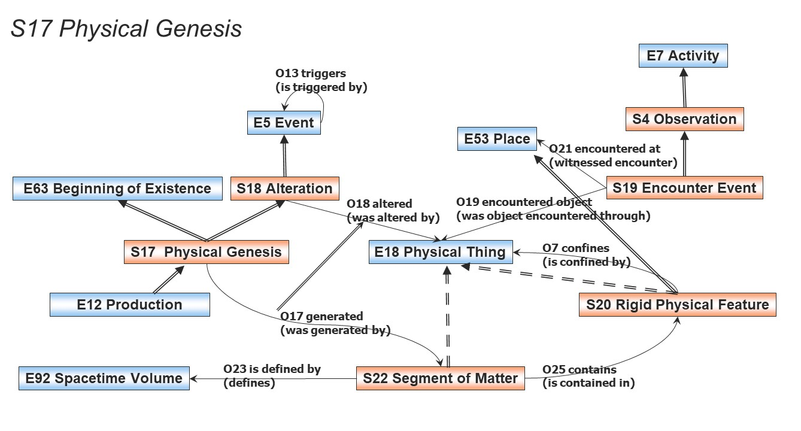

Figure 6: Events generating things without agency and causal relationships of events.

CRMsci offers classes and properties for describing scientific observation (figure 6). Class S4 Observation can be used for all instances of activities which provide additional evidence to add knowledge, regardless of how valuable that is considered. During an instance of S4 Observation an entity is observed and a value is assigned to a type of property that is relevant to the study. This is a specialisation of E13 Attribute Assignment from the CIDOC CRM with a parallel construct which is more generalised. The class S15 Observable Entity is superclass to both E5 Event and S10 Material Substantial to indicate that an instance of S4 Observation can observe both perdurants and endurants with a material substance or interaction.
The class S21 Measurement is a specialisation of S4 Observation and a superclass of CIDOC CRM class E16 Measurement. The class E16 Measurement can be used to measure dimensions of physical things but cannot be used for dimensions of instances of classes such as E5 Event. Class S21 Measurement is broader in scope (also see figure 1) and can be used for other instances than instances of E18 Physical Thing.
Similarly the property O12 has dimension is equivalent to CIDOC CRM property P43 has dimension only when the observed entity is an instance of class E18 Physical Thing.
The class S19 Encounter Event can be used to describe the observation of entities of particular interest relevant to the research study. This can be used in species surveys or finds in archaeological excavations. It serves documenting the fact that someone has seen the entity of interest as existing at the particular place and time.
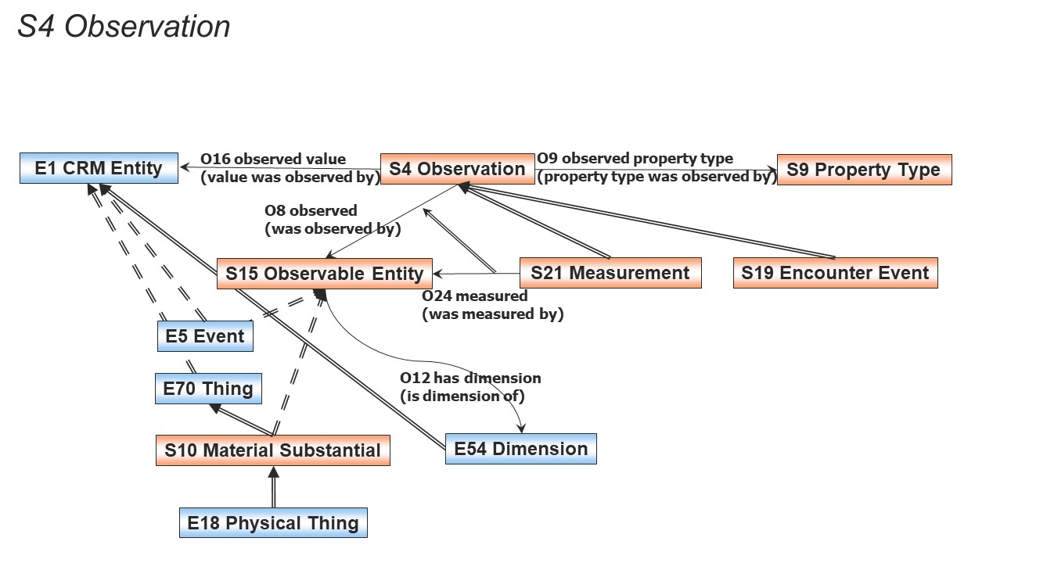
Figure 7: Classes and properties for describing scientific observation.

Inference making
In addition to a model for scientific observation the CRMsci provides classes and properties which allow the description of processing observations to produce new knowledge. This includes inferences made during data analysis, simulation or categorisation with specialised classes as shown in figure 8. Instances of S8 Categorical Hypothesis Building are activities where the definition of categories (similar to instances of CIDOC CRM E55 Type) are created based on the current observations of the instances of these categories (inductive reasoning). Through class S5 Inference Making, it is possible to connect and take advantage of the extended model for argumentation CRMinf, which is currently under development.
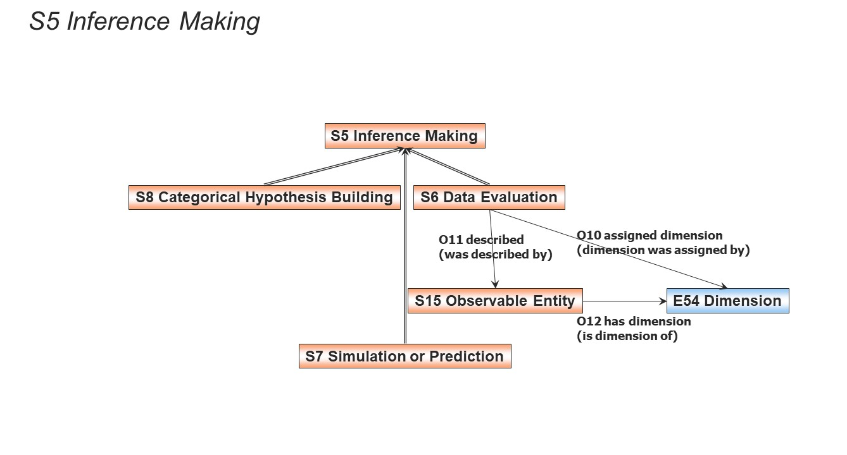

Figure 8: CRMsci classes for inference making.

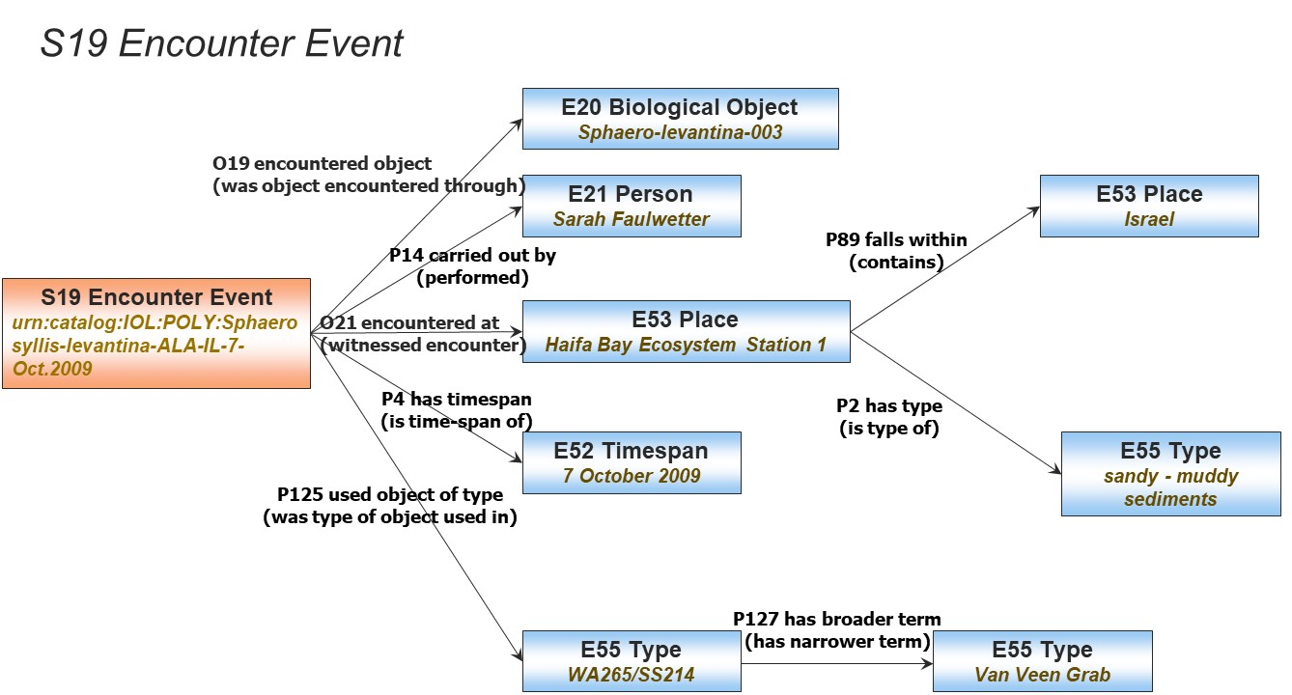

Status

The model presented in this document has been validated in several national and international projects, through implementations of slightly different versions together with application-specific extensions and through mapping to and from related standards. This document describes a consolidated version from this experience, with the aim to present it for review and further adoption. The model is not “finished”, some parts such as the subclasses of inference making are not fully developed in terms of properties, and all constructs and scope notes are open to further elaboration.

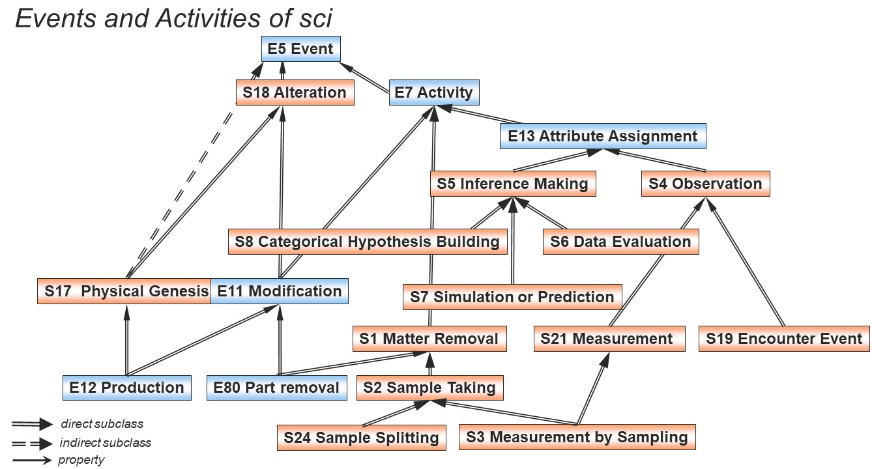

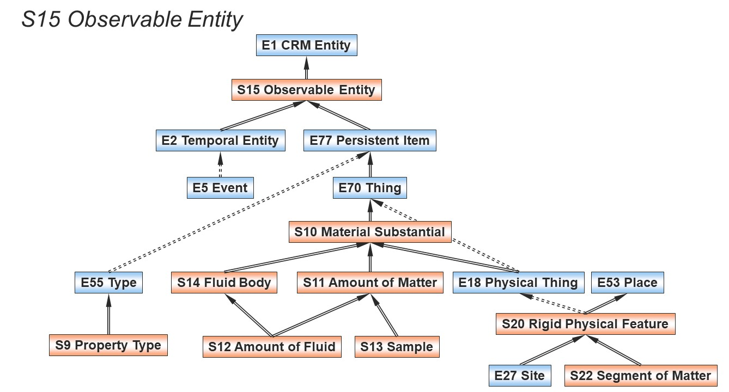

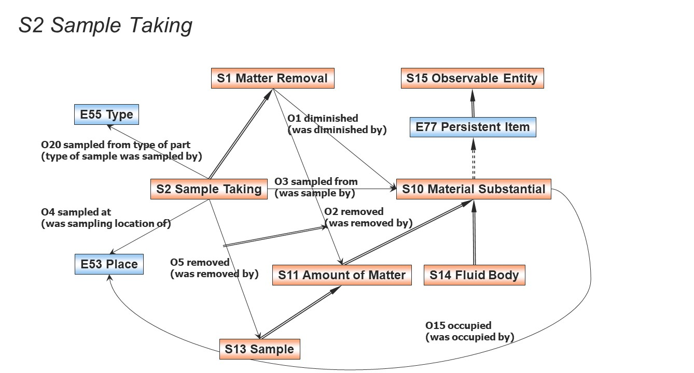

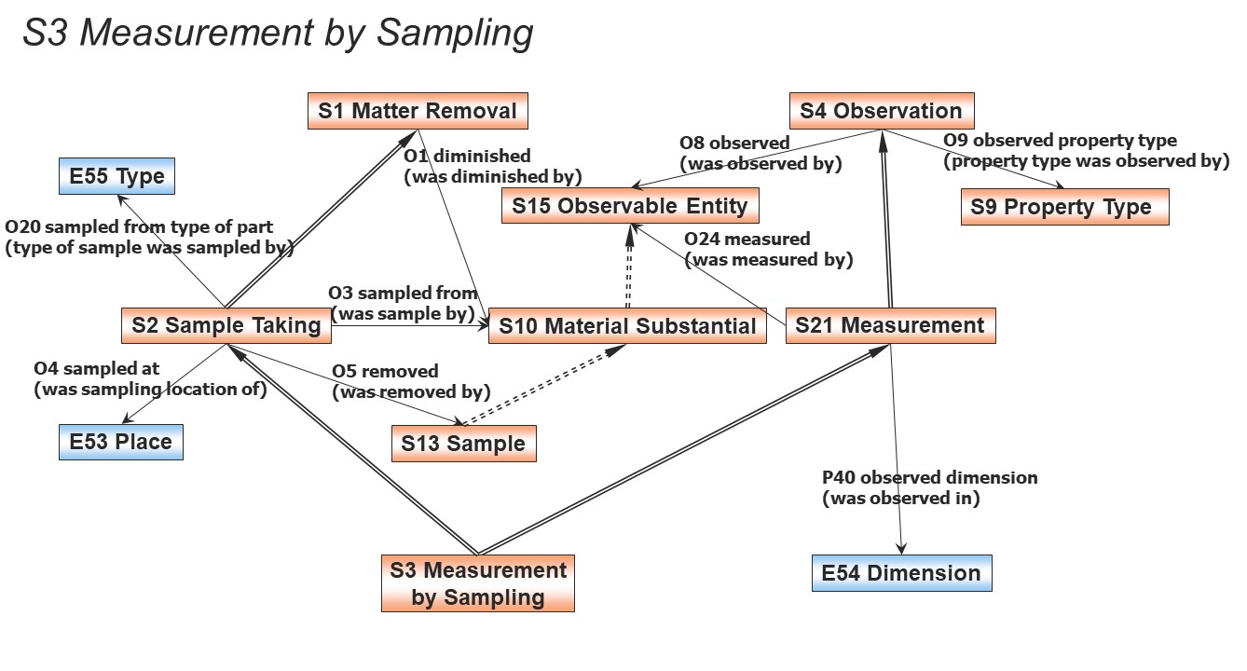
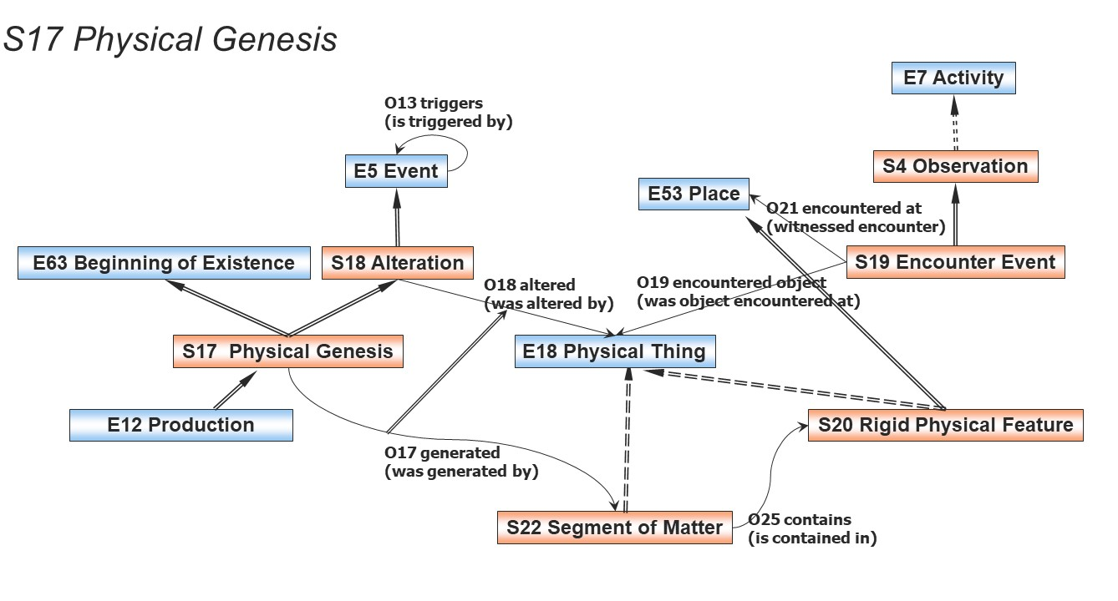

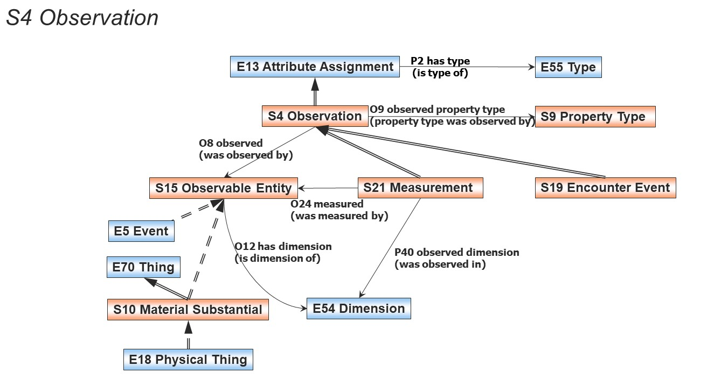

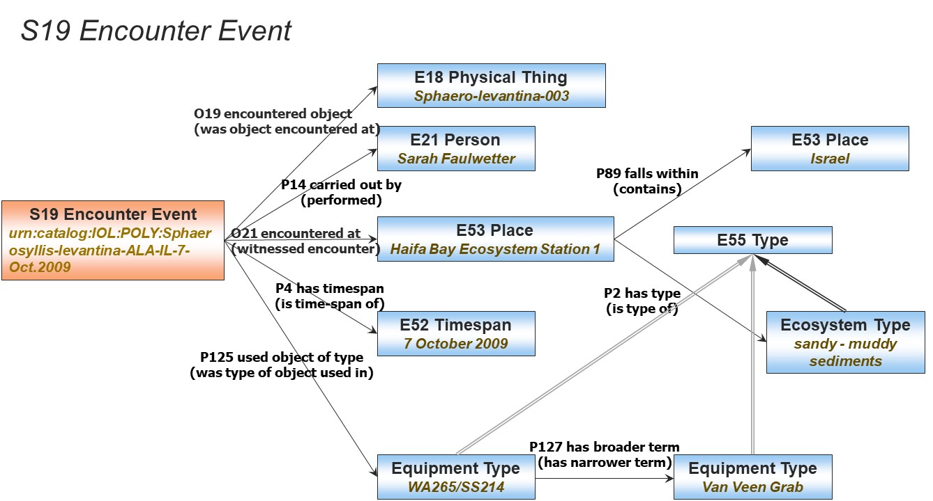
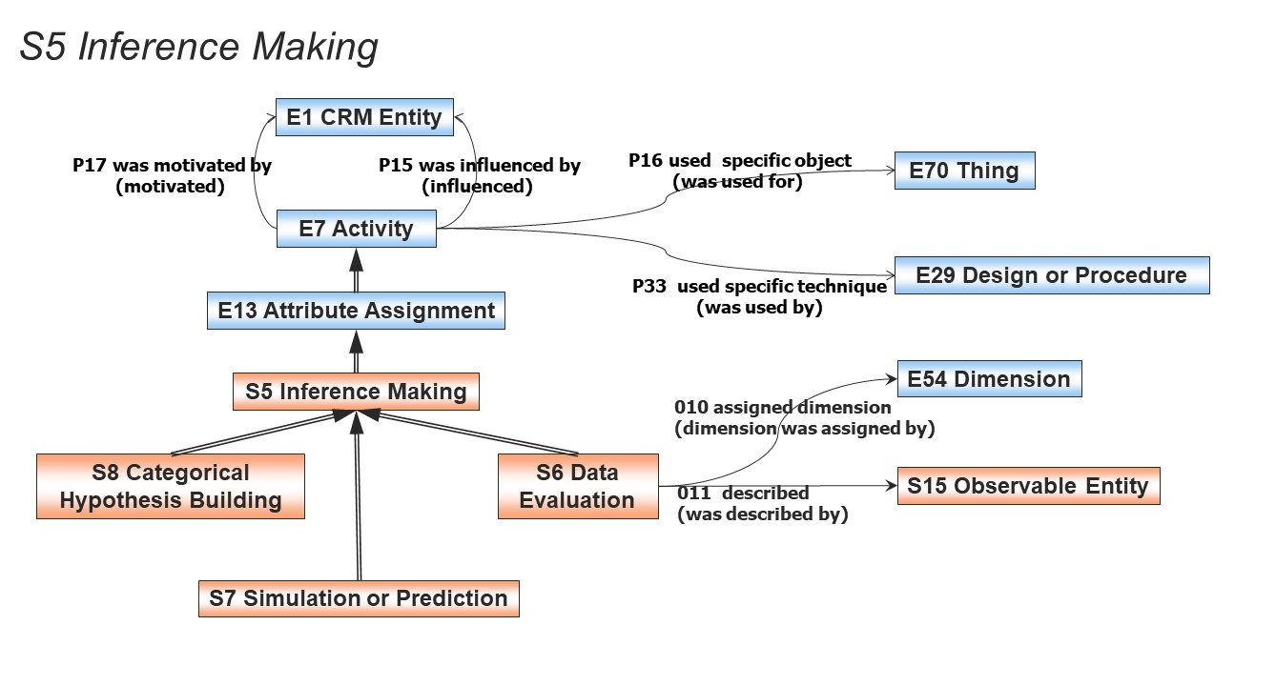

Scientific Observation Model Class Hierarchy aligned with (part of) CIDOC CRM Class Hierarchy
E1 | CRM Entity
S15 | - | Observable Entity
E2 | - | - | Temporal Entity
S16 | - | - | - | State
E3 | - | - | - | - | Condition State
E5 | - | - | - | - | - | Event
E7 | - | - | - | - | - | - | Activity
S1 | - | - | - | - | - | - | - | Matter Removal
E80 | - | - | - | - | - | - | - | - | Part Removal
S2 | - | - | - | - | - | - | - | - | Sample Taking
S3  S24 | - | - | - | - | - | - | - | - | - | Measurement by Sampling  Sample Splitting
E13 | - | - | - | - | - | - | - | Attribute Assignment
S21 | - | - | - | - | - | - | - | - | Measurement
E16 | - | - | - | - | - | - | - | - | - | Measurement
S3 | - | - | - | - | - | - | - | - | - | Measurement by Sampling
S4 | - | - | - | - | - | - | - | - | Observation
S21 | - | - | - | - | - | - | - | - | - | Measurement
S19 | - | - | - | - | - | - | - | - | - | Encounter Event
S5 | - | - | - | - | - | - | - | - | Inference Making
S6 | - | - | - | - | - | - | - | - | - | Data Evaluation
S7 | - | - | - | - | - | - | - | - | - | Simulation or Prediction
S8 | - | - | - | - | - | - | - | - | - | Categorical Hypothesis Building
S18 | - | - | - | - | - | - | Alteration
S17 | - | - | - | - | - | - | - | Physical Genesis
E11 | - | - | - | - | - | - | - | Modification
E63 | - | - | - | - | - | - | Beginning of Existence
S17 | - | - | - | - | - | - | - | Physical Genesis
E12 | - | - | - | - | - | - | - | - | Production
E77 | - | - | Persistent Item
E70 | - | - | - | Thing
S10 | - | - | - | - | Material Substantial
S14 | - | - | - | - | - | Fluid Body
S12 | - | - | - | - | - | - | Amount of Fluid
S11 | - | - | - | - | - | Amount of Matter
S12 | - | - | - | - | - | - | Amount of Fluid
S13 | - | - | - | - | - | - | Sample
E18  E26- | -  - | - | -  - | -  - | -  - | Physical Thing  Physical Feature
S20 | - | - | - | - | - | - | - Rigid Physical Feature
E27 | - | - | - | - | - | - | - | - Site
S22 | - | - | - | - | - | - | - | - Segment of Matter
E28 | - | - | - | - | - | Conceptual Object
E55 | - | - | - | - | - | - | Type
S9 | - | - | - | - | - | - | - | Property Type
E53 | - | Place
S20 | - | - | Rigid Physical Feature

Scientific Observation Model PROPERTY Hierarchy
Property id | Property Name | Entity – Domain | Entity - Range
O1 | diminished (was diminished by) | S1 Matter Removal | S10 Material Substantial
O2 | - removed (was removed by) | S1 Matter Removal | S11 Amount of Matter
O5 | - - removed (was removed by) | S2 Sample Taking | S13 Sample
O29 | - - - removed sub-sample (was sub-sample removed by) | S24 Sample Splitting | S13 Sample
O3  O27 | sampled from (was sample by)  - split (was source for) | S2 Sample Taking  S24 Sample Splitting | S10 Material Substantial  S13 Sample
O4 | sampled at (was sampling location of) | S2 Sample Taking | E53 Place
O7 | confines (is confined by) | S20 Rigid Physical Feature | S10 Material Substantial
O8 | observed (was observed by) | S4 Observation | S15 Observable Entity
O24 | - measured (was measured by) | S21 Measurement | S15 Observable Entity
O9 | observed property type (property type was observed by) | S4 Observation | S9 Property Type
O10 | assigned dimension (dimension was assigned by) | S6 Data Evaluation | E54 Dimension
O11 | described (was described by) | S6 Data Evaluation | S15 Observable Entity
O12 | has dimension (is dimension of) | S15 Observable Entity | E54 Dimension
O13 | triggers (is triggered by) | E5 Event | E5 Event
O15 | occupied (was occupied by) | S10 Material Substantial | E53 Place
O16 | observed value (value was observed by) | S4 Observation | E1 CRM Entity
O18 | altered (was altered by) | S18 Alteration | E18 Physical Thing
O17 | - generated (was generated by) | S17 Physical Genesis | E18 Physical Thing
O19 | encountered object (was object encountered through) | S19 Encounter Event | E18 Physical Thing
O20 | sampled from type of part (type of part was sampled by) | S2 Sample Taking | E55 Type
O21 | encountered at (witnessed encounter) | S19 Encounter Event | E53 Place
O23 | is defined by (defines) | S22 Segment of Matter | E92 Spacetime Volume
O25 | contains (is contained in) | S10 Material Substantial | S10 Material Substantial
O6 | - is former or current part of (has former or current part) | S12 Amount of Fluid | S14 Fluid Body
O28 | is conceptually greater than (is conceptually less than) | E55 Type | E55 Type

Classes

S1 Matter Removal

Subclass of: E7 Activity
Superclass of: E80 Part Removal
S2 Sample Taking

Scope note: This class comprises the activities that result in an instance of S10 Material Substantial being decreased by the removal of an amount of matter.

Typical scenarios include the removal of a component or piece of a physical object, removal of an archaeological or geological layer, taking a tissue sample from a body or a sample of fluid from a body of water. The removed matter may acquire a persistent identity of different nature beyond the act of its removal, such as becoming a physical object in the narrower sense. Such cases should be modeled by using multiple instantiation with adequate concepts of creating the respective items.

Examples:
- The removal of the layer of black overpainting that covered the background of "La Gioconda of the Prado" between 2011 and 2012 by the Prado Museum in Madrid (Museo del Prado, 2012).

In First Order Logic:
S1(x) ⊃ E7(x)
Properties:
O1 diminished (was diminished by): S10 Material Substantial
O2 removed (was removed by): S11 Amount of Matter

S2 Sample Taking

Subclass of: S1 Matter Removal
Superclass of S3 Measurement by Sampling
S24 Sample Splitting

Scope note: This class comprises the activity that results in taking an amount of matter as sample for further analysis from a material substantial such as a body of water, a geological formation or an archaeological object. The removed matter may acquire a persistent identity of different nature beyond the act of its removal, such as becoming a physical object in the narrower sense. The sample is typically removed from a physical feature which is used as a frame of reference, the place of sampling. In case of non-rigid Material Substantials, the source of sampling may regarded not to be modified by the activity of sample taking.

Examples:
- The water sampling (S2) carried out by IGME, sampled from borehole 10/G5 at 419058.03, 4506565 , 95.7 Mygdonia basin on 28/6/2005 (InGeoCloudS - INspiredGEOdata CLOUD Services D2.2 2012;D2.3 2013)The collection (S2) of specimen “FHO – Benth. - 1055” (S13) from a plant (E20) of the species “spiciformis” (E55) in Zambia by Bullock, A.A. in 1939.
- The collection (S2) of micro-sample 7 (S13), from the paint layer (S10) on the area of the apple (E53, E25) shown on the painting (E22) “Cupid complaining to Venus” (Cranach) by Joyce Plesters in June 1963 (Cranach Digital Archive, http://lucascranach.org/UK_NGL_6344).
In First Order Logic:
S1(x) ⊃ S3(x)

Properties:
O3 sampled from (was sample by): S10 Material Substantial
O4 sampled at (was sampling location of): E53 Place
O5 removed (was removed by): S13 Sample
O20 sampled from type of part (type of part was sampled by): E55 Type

S3 Measurement by Sampling

Subclass of: S2 Sample Taking
S21 Measurement

Scope note: This class comprises activities of taking a sample and measuring or analyzing it as one unit of activity, in which the sample is typically not identified and preserved beyond the context of this activity. Instances of this class describe the taking of one or more samples regardless whether they are explicitly identified in documentation or preserved beyond this activity. The dimensions observed by the respective measurement of this particular sample are regarded as dimensions of the instance of S10 Material Substantial at the place from which the samples were taken. Therefore, the class S3 Measurement by Sampling inherits the properties of S2 Sample Taking. O3 sampled from: S10 Material Substantial and O4 sampled at: E53 Place, and the properties of S21(E16) Measurement. P40 observed dimension: E54 Dimension, due to multiple inheritance. It needs not instantiate the properties O5 removed: S13 Sample and O24 measured: S15 Observable Entity, if the sample is not documented beyond the context of the activity.

Examples:
- The chemical Analysis 1 on 20/4/2004 sampled from layer 50501 and observed 70 mg of Ca (InGeoCloudS - INspiredGEOdata CLOUD Services D2.2 2012;D2.3 2013)The Sphaerosyllislevantina specimen length measurement on 12/3/1999 (Bekiari et al., 2014)Measurement (S3) of retention times during Gas Chromatography analysis of a paint sample “mid-blue paint for the sky” (S13) which identified Linseed oil as the paint medium (Foister, S, 2015).

In First Order Logic:
S3(x) ⊃ S2(x)
S3(x) ⊃ S21(x)

S4 Observation

Subclass of: E13 Attribute Assignment
Superclass of: S21 Measurement
S19 Encounter Event

Scope note: This class comprises the activity of gaining scientific knowledge about particular states of physical reality through empirical evidence, experiments and measurements.

We define observation in the sense of natural sciences, as a kind of human activity: at some place and within some time-span, certain physical things and their behavior and interactions are observed by human sensory impression, and often enhanced by tools and measurement devices.

Observed situations or dimensions may pertain to properties confined to a single instance of S15 Observable Entity or pertain to constellations of multiple instances and relations between them, in particular distances between them.

The output of the internal processes of measurement devices that do not require additional human interaction are in general regarded as part of the observation and not as additional inference. Primary data from measurement devices are regarded in this model to be results of observation and can be interpreted as propositions believed to be true within the (known) tolerances and degree of reliability of the device.

Measurements and witnessing of events are special cases of observations. Observations result in a belief that certain propositions held at a time within the time-span of the observation. In this model, the degree of confidence in the observed properties is regarded to be “true” by default, but could be described differently by adding a property P3 has note to an instance of S4 Observation

Examples:
The excavation (S4) in the NE section of the central court of the Knossos palace by the Ephorate of Antiquities of Heraklion in 1997 (Κνωσός , Συντήρηση, Στερέωση και Ανάδειξη του ανακτόρου και του αρχ/κού χώρου 2008)
The observation (S4) of the density (S9) of the X-Ray image of cupid's head from the painting “Cupid complaining to Venus” (S15) as “high density” (E1), on the 19th of March 1963 (Cranach Digital Archive, http://lucascranach.org/UK_NGL_6344).
The observation (S4) of visible light absorption (S9) of the painting “Cupid complaining to Venus” (S15) as “having red pigment”, in 2015 (Foister, S., 2015)

In First Order Logic:
S4(x) ⊃ E13(x)

Properties: O8 observed (was observed by): S15 Observable Entity
O9 observed property type (property type was observed by): S9 Property Type
O16 observed value (value was observed by): E1 CRM Entity
O? observed: Situation?

S5 Inference Making

Subclass of: E13 Attribute Assignment
Superclass of: S6 Data Evaluation
S7 Simulation or Prediction
S8 Categorical Hypothesis Building

Scope note: This class comprises the action of making propositions and statements about particular states of affairs in reality or in possible realities or categorical descriptions of reality by using inferences from other statements based on hypotheses and any form of formal or informal logic. It includes evaluations, calculations, and interpretations based on mathematical formulations and propositions.

Examples:
- The inference made by Sakellarakis in 1980 about the sacrifice of a young man (E7) in the Minoan temple of Anemospilia based on the skeleton found (and 2 more) in the west room of the temple and the ritual bronze knife (E22) on it and the hypothesis that he died from loss of blood (the evidence was that his bones (E20) remained white in contrast to the others). The inference that the underdrawing (E25) of the painting “Cupid complaining to Venus” (E22) was done with red pigment (E57), based on the observation (S4) that red pigment lines appear under the top paint layers (Foister, S., 2015).
- In First Order Logic:
S5(x) ⊃ E13(x)

Properties:

S6 Data Evaluation

Subclass of: S5 Inference Making

Scope note: This class comprises the action of concluding propositions on a respective reality from observational data by making evaluations based on mathematical inference rules and calculations using established hypotheses, such as the calculation of an earthquake epicenter. S6 Data Evaluation is not defined as S21/E16 Measurement; Secondary derivations of dimensions of an object from data measured by different processes are regarded as S6 Data Evaluation and not determining instances of Measurement in its own right. For instance, the volume of a statue concluded from a 3D model is an instance of S6 Data Evaluation and not of Measurement.

Examples:
- The calculation of the earthquake epicenter of Lokris area in 1989 by IGME (Ganas et al., 2006)The calculation of the intensity distance and assignment of PGA_N using the gcf2sac software from the EPPO shock wave recording of 2/2/1990 in Athens (S4) (InGeoCloudS - INspiredGEOdata CLOUD Services D2.2 2012;D2.3 2013)The calculation of the overall height (E54) of the statue of Hercules (S15) in the Temple of Hercules in Amman from the measurement of the size of the fragment of the fingers [https://en.wikipedia.org/w/index.php?title=Temple_of_Hercules_(Amman)&oldid=827687597].

In First Order Logic:
S6(x) ⊃ S5(x)

Properties:
O10 assigned dimension (dimension was assigned by): E54 Dimension
O11 described (was described by): S15 Observable Entity

S7 Simulation or Prediction
Subclass of: S5 Inference Making

Scope note: This class comprises activities of executing algorithms or software for simulating the behavior and the properties of a system of interacting components that form part of reality or not by using a mathematical model of the respective interactions. In particular it implies making predictions about the future behaviors of a system of interacting components of reality by starting simulation from an actually observed state, such as weather forecasts. Simulations may also be used to understand the effects of a theory, to compare theoretical predictions with reality, or to show differences with another theory.

Examples:
- The forecasting of the imminent flooding of Venice in November 2012 by the Hellenic Centre for Marine Research using the Poseidon Sea Level Forecast System, (72 hours before its actual occurrence) (Poseidon System
(http://poseidon.hcmr.gr/article_view.php?id=147&cid=28&bc=28)Predicting the required temperature to maintain a target RH(%) of 50 based on monthly average temperature and RH in Birmingham, UK using the “Calculator for conservation heating” hostead at: http://www.conservationphysics.org/atmcalc/consheatcalc.php.
In First Order Logic:
S7(x) ⊃ S5(x)

Properties:

S8 Categorical Hypothesis Building

Subclass of: S5 Inference Making

Scope note: This class comprises the action of making categorical hypotheses based on inference rules and theories; By categorical hypotheses we mean assumptions about the kinds of interactions and related kinds of structures of a domain that have the character of “laws” of nature or human behavior, be it necessary or probabilistic. Categorical hypotheses are developed by “induction” from finite numbers of observation and the absence of observations of particular kinds. As such, categorical hypotheses are always subject to falsification by new evidence. Instances of S8 Categorical Hypothesis Building include making and questioning categorical hypotheses.

Examples:
- Hypothessizing that “no binding before the 9th century is made with spine supports” documented in section 7.1 and 7.2 of “The Archaeology of Medieval bookbinding” by Szirmai (Szirmai, J.A. 1999)

In First Order Logic:
S8(x) ⊃ S5(x)
Properties:

S9 Property Type

Subclass of: E55 Type

Scope note: This class comprises types of properties. Typically, instances of S9 Property Type would be taken from an ontology or terminological system. In particular, instances of this class can be used to describe in a parametric way what kind of properties the values in scientific data sets are about. By virtue of such descriptions, numeric data can be interpreted as sets of propositions in terms of a formal ontology, such as “concentration of nitrate”, observed in the ground water from a certain borehole.

Examples:
- The velocity (S9) (of a station that is observed, meaning a share-wave velocity over the first 30 m).) (InGeoCloudS - INspiredGEOdata CLOUD Services D2.2 2012;D2.3 2013)Retention time (S9) (in gas chromatography, meaning the time it takes for a component to pass through the chromatographer's column) (https://en.wikipedia.org/w/index.php?title=Gas_chromatography&oldid=828895011).
- In First Order Logic:
S9(x) ⊃ E55(x)
Properties:

S10 Material Substantial

Subclass of: E70 Thing
S15 Observable Entity
Superclass of: S14 Fluid Body
S11 Amount of Matter
E18 Physical Thing

Scope note: This class comprises constellations of matter with a relative stability of any form sufficient to associate them with a persistent identity, such as being confined to certain extent, having a relative stability of form or structure, or containing a fixed amount of matter. In particular, it comprises physical things in the narrower sense and fluid bodies. It is an abstraction of physical substance for solid and non-solid things of matter.

Examples:
- The groundwater of the 5-22 basin of Central Macedonia ((InGeoCloudS - INspiredGEOdata CLOUD Services D2.2 2012;D2.3 2013).The Mesozoic carbonate sequence with flysch (S10) extracted from the area of Nafplion that was mapped and studied by Tattaris in 1970 (Photiades, 2010).Parnassos, the limestone mountain (Strid, 1986)
- In First Order Logic:
S10(x) ⊃ E70(x)
Properties:
O25 contains (is contained in): S10 Material Substantial
O15 occupied (was occupied by): E53 Place

S11 Amount of Matter

Subclass of: S10 Material Substantial
Superclass of: S12 Amount of Fluid
S13 Sample

Scope note: This class comprises fixed amounts of matter specified as some air, some water, some soil, etc., defined by the total and integrity of their material content. In order to be able to identify and recognize in practice one instance of S11 Amount of Matter, some sort of confinement is needed that serves as a constraint for the enclosed matter and the integrity of the content, such as a bottle. In contrast to instances of E18 Physical Thing, no stability of form is required. The content may be put into another bottle without losing its identity. Subclasses may define very different identity conditions for the integrity of the content, such as chemical composition, or the sequence of layers of a bore core. Whereas an instance of E18 Physical Thing may gradually change form and chemical composition while preserving its identity, such as living beings, an instance of S11 Amount of Matter may lose its identifying features by such processes. What matters for the identity of an instance of S1 Amount of Matter is the preservation of a relevant composition from the initial state of definition onwards.
Examples:
- The mass of soil (S11) that was removed from sections 1, 2, 3 and 4 of the central building of Zominthos in order to be sieved, during the excavation in 2006 (Field Notes, 2006). The amount of natural cement (S11) that was added in a proportion of 5% in 2016 for the development of the sample of mortar in the laboratory of Ceramic, in Boumerdes University (Kelouaz khaled et al., 2016).

In First Order Logic:
S11(x) ⊃ S10(x)

S12 Amount of Fluid

Subclass of: S11 Amount of Matter
S14 Fluid Body

Scope note: This class comprises fixed amounts of fluid (be they gas or liquid) defined by the total of its material content, typically molecules. They frequently acquire identity in laboratory practice by the fact of being kept or handled together within some adequate containers.

Examples:
- J.K.’s blood sample 0019FCF5 for the measurement of the cholesterol blood level
- In First Order Logic:
S12(x) ⊃ S11(x)
S12(x) ⊃ S14(x)

Properties:
O6 is former or current part (has former or current part ): S14 Fluid Body

S13 Sample

Subclass of: S11 Amount of Matter

Scope note: This class comprises instances of S11 Amount of Matter taken from some instance of S10 Material Substantial with the intention to be representative for some material qualities of the instance of S10 Material Substantial or part of it was taken for further analysis. We typically regard a sample as ceasing to exist when the respective representative qualities become corrupted, such as the purity of a water sample or the layering of a bore core.

Examples:
- The ground water sample with ID 105293 that was extracted from the top level of the intake No32 under terrain (S13, S12). (InGeoCloudS - INspiredGEOdata CLOUD Services D2.2 2012;D2.3 2013)The micro-sample 7, taken from the painting (S10) “Cupid complaining to Venus” (Cranach) by Joyce Plesters in June, 1963 (http://lucascranach.org/UK_NGL_6344).

In First Order Logic:
S13(x) ⊃ S11(x)

S14 Fluid Body

Subclass of: S10 Material Substantial
Superclass of: S12 Amount of Fluid

Scope note: This class comprises a mass of matter in fluid form environmentally constraint in some persistent form allowing for identifying it for the management or research of material phenomena, such as a part of the sea, a river, the atmosphere or the milk in a bottle. Fluids are generally defined by the continuity criterion which is characteristic of their substance: their amorphous matter is continuous and tends to flow. Therefore, contiguous amounts of matter within a fluid body may stay contiguous or at least be locally spatially confined for a sufficiently long time in order to be temporarily identified and traced. This is a much weaker concept of stability of form than the one we would apply to what one would call a physical object. In general, an instance of Fluid Body may gain or lose matter over time through so-called sources or sinks in its surface, in contrast to physical things, which may lose or gain matter by exchange of pieces such as spare parts or corrosion.
Examples:

- The Rhine River

In First Order Logic:
S14(x) ⊃ S10(x)

S15 Observable Entity
Subclass of: E1 CRM Entity
Superclass of: E2 Temporal Entity
S10 Material Substantial
Scope note:
This class comprises instances of E2 Temporal Entity or O10 Material Substantial (i.e. items or phenomena, such as physical things, their behavior, states and interactions or events), that can be observed by measurement or detection devices or by human sensory impression including when enhanced by tools.

In order to be observable, instances of E5 Event must consist of some interaction or action of material substance. In some cases, the spatiotemporal confinement of the event itself, such as a flash, a car stopping etc. marks the limits of a documented observation of an event. In other cases, such as the situation of a car passing by a certain object, the spatiotemporal limits of the event of observing itself, as well as the direction of attention or the orientation of used instruments, may constrain the observed detail of a larger process, e.g., noticing the sight of a car passing by; a light emission, etc.

Conceptual objects manifest through their carriers such as books, digital media, or even human memory. Attributes of conceptual objects, such as number of words, can be observed on their carriers. If the respective properties between carriers differ, either they carry different instances of conceptual objects or the difference can be attributed to accidental deficiencies in one of the carriers. In that sense, even immaterial objects are observable. By this model we address the fact that frequently, the actually observed carriers of conceptual objects are not explicitly identified in documentation, i.e., they are assumed to have existed but they are unknown as individuals

Examples:
- The domestic goose from Guangdong/1/1996 (H5N1) (S15) that was identified in 1996 in farmed geese in southern China as circulating highly pathogenic H5N1 (Wan, 2012).
- The crow flight he observed over the waters of Minamkeak Lake during the summer of 2015
- The eruption of Krakatoa volcano at Indonesia in 1883 (F.A.R., Archibald and Whipple, 1888). The density of the cupid head area in the X-Ray of the painting “Cupid complaining to Venus” (http://lucascranach.org/UK_NGL_6344)

In First Order Logic:
S15(x) ⊃ E1(x)

Properties:
O12 has dimension (is dimension of): E54 Dimension

S17 Physical Genesis

Subclass of: E63 Beginning of Existence
S18 Alteration
Superclass of: E12 Production

Scope note: This class comprises events or processes that result in (generate) physical things, man-made or natural, coming into being in the form by which they are later identified. The creation of a new physical item, at the same time, can be a result of an alteration (modification) – it can become a new thing due to an alteration activity.

Examples:
- The desertification process that resulted in the spatial distribution of ‘tiger bush’ pattern on the gradually sloped terrain in Western Africa, as it was studied in 1994.(Thiery et al., 1995)
- The corrosion process affecting my copper samples (S13) in the artificial aging salt-spray apparatus after 10 cycles which produced layers (E25) of cuprite and malachite. (E12)

In First Order Logic:
S17(x) ⊃ E63(x)
S17(x) ⊃ S18(x)

Properties:
O17 generated (was generated by): E18 Physical Thing

S18 Alteration
Subclass of: E5 Event
Superclass of: S17 Physical Genesis
E11 Modification

Scope note: This class comprises natural events or man-made processes that create, alter or change physical things, by affecting permanently their form or consistency without changing their identity. Examples include alterations on depositional features-layers by natural factors or disturbance by roots or insects, organic alterations, petrification, etc.

Examples:
- The petrification process of the Lesvos forest related to the intense volcanic activity in Lesvos island during late Oligocene - middle Miocene period (Marinos and Greek National Group of IAEG, 1997).The flattening of the Lanhydrock Pedigree parchment (E18) after humidification (Pickwoad, N., 2016).
- In First Order Logic:
S18(x) ⊃ E5(x)

Properties:
O18 altered (was altered by): E18 Physical Thing

S19 Encounter Event
Subclass of: S4 Observation

Scope note: This class comprises activities of S4 Observation (substance) where an E39 Actor encounters an instance of E18 Physical Thing of a kind relevant for the mission of the observation or regarded as potentially relevant for some community (identity). This observation produces knowledge about the existence of the respective thing at a particular place in or on surrounding matter. This knowledge may be new to the group of people the actor belongs to. In that case we would talk about a discovery. The observer may recognize or assign an individual identity of the thing encountered or regard only the type as noteworthy in the associated documentation or report.

In archaeology there is a particular interest if an object is found “in situ”, i.e. if its embedding in the surrounding matter supports the assumption that the object was not moved since the archaeologically relevant deposition event. The surrounding matter with the relative position of the object in it as well as the absolute position and time of the observation may be recorded in order to enable inferences about the history of the object.

In Biology, additional parameters may be recorded like the kind of ecosystem, if the biological individual survives the observation, what detection or catching devices have been used or if the encounter event supported the detection of a new biological kind (“taxon”).

Examples:
- The finding, by Prof. Stampolidis, of a complete skeleton, in situ, at the site of Eleutherna during the archaeological excavation carried out by the University of Crete in 2007 (Bonn-Muller, 2010).The detection of lagocephalos_Sceleratus was carried out with the trawler 419in the Mediteranean sea, during the first week of August 2014
(Bekiari et al., 2014)
- .
- In First Order Logic:
S19(x) ⊃ S4(x)

Properties:
O19 encountered object (was object encountered through): E18 Physical Thing
O21 encountered at (witnessed encounter): E53 Place

S20 Rigid Physical Feature
Subclass of: E26 Physical Feature
E53 Place
Superclass of: E27 Site
S22 Segment of Matter
Scope Note: Any instance of this class is a physical feature with sufficient stability of form in itself and with respect to the physical object bearing it in order to associate a permanent reference space within which its form is invariant and at rest. The maximum volume in space that an instance of S20 Rigid Physical Feature occupies defines uniquely a place for the feature with respect to its surrounding matter.
Therefore we model S20 Rigid Physical Feature as a subclass of E26 Physical Feature and of E53 Place. The latter is intended as a phenomenal place as defined in CRMgeo (Doerr and Hiebel 2013). By virtue of this multiple inheritance we can discuss positions relative to the extent of an instance of S20 Rigid Physical Feature without representing each instance of it together with an instance of its associated place. However, since the identity and existence of this place depends uniquely on the identity of the instance of S20 Rigid Physical Feature as matter, this multiple inheritance is unambiguous and effective and furthermore corresponds to the intuitions of natural language. It shortcuts an implicit self-referential path from E26 Physical Feature through P156 occupies, E53 Place, P157 is at rest relative to E26 Physical Feature.
In cases of instances of S20 Rigid Physical Feature on or in the surface of earth, the default reference is typically fixed to the closer environment of the tectonic plate or sea floor. In cases of features on mobile objects, the reference space is typically fixed to the geometry of the bearing object. Note that the reference space associated with the instance of S20 Rigid Physical Feature may quite well be deformed over time, as long the continuity of its topology does not become unclear, such as the compression of dinosaur bones in geological layers, or the distortions of the hull of a ship by the waves of the sea. Defined in this way, the reference space can be used as a means to infer from current topological relationships past topological relationships of interest

Examples:
- The temple in Abu Simbel before its removal, which was carved out of solid rock
- Albrecht Duerer's signature on his painting of Charles the Great
- The damaged form of the nose of the Great Sphinx in Giza
- The “Central Orygma” (pit-house) which dominates the central part of the excavated area of the settlement of Mavropigi, representing phases I-III. (Karamitrou-Mentessidi et al., 2015)
- The surface Surf313 (created by the excavation process on 3/3/2003).

In First Order Logic:
S20(x) ⊃ E18(x)
S20(x) ⊃ E53(x)

Properties:
O7 confines (is confined by) :S10 Material Substantial

S21 Measurement

Subclass of: S4 Observation

Superclass of: S3 Measurement by Sampling
E16 Measurement

Scope note: This class comprises actions measuring instances of S15 Observable Entity, properties of physical things, or phenomena, states and interactions or events, that can be determined by a systematic procedure. Primary data from measurement devices are regarded to be results of an observation process .

Examples:
• The magnitude measurement of the earthquake of Mexico city in 2017. (S21) [It had the magnitude 6.2 Richter] (Mindock, 2017 (http://www.independent.co.uk/news/world/americas/mexico-earthquaketoday-latest-mexico-city-magnitude-6-tremor-damage-a7963211.html ).
• The sensor measurement by IGME in 1999 which measured the landslide displacement in the area of Parnitha, Greece. (S21) (InGeoCloudS - INspiredGEOdata CLOUD Services D2.2 2012;D2.3 2013)
In First Order Logic:
S21(x) ⊃ S4(x)

Properties:
O24 measured (was measured by): S15 Observable Entity

S22 Segment of Matter
Subclass of: S20 Rigid Physical Feature

Scope Note: This class comprises physical features with relative stability of form and structure within a declared spatial volume of interest. The spatial extent of an instance of S22 Segment of Matter may be declared or defined by a researcher or observer usually because the arrangement and composition of substance is characteristic for the surrounding matter or can be interpreted as traces of its genesis and subsequent internal and external processes it was exposed to. The defining spatial extent is typically declared on a continuous matter by means of geometric determination without observable boundaries on all sides or any side. It may however be extracted at some point in time along the declared boundaries.
An instance of S22 Segment of Matter is regarded to be existing from the time on it completely solidified with a structure that is still preserved in a recognizable way at the time of its spatial definition. Its existence is regarded to end when its respective integrity is partially or completely corrupted. Uncorrupted subsections of an instance of S22 Segment of Matter may continue to exist as segments of matter in their own right beyond the existence of the containing instance, and may have solidified before it.
Typical examples are segments of archaeological or geological layers. They are regarded as uncorrupted even if they have undergone conformal deformations, such as compressions or shifts, as long as the effects of these deformations do not destroy the relevant structures of interest. This means that the defining spatial volume may be only geometrically valid for an instant of time for which it was declared, and undergo before and after deformations. In some cases, it may be possible to calculate the initial volume at the time of solidification, for instance for petrified bones compressed in Jurassic layers.

Examples:

In First Order Logic:
S22(x) ⊃ S20(x)

Properties:
O23 is defined by (defines): E92 Spacetime Volume

S23 Position Measurement

Subclass of: E13 Attribute Assignment

Scope note: .

Properties:

Oxx1 determined position (was determined by): E94 Space Primitive

Oxx2 covered thing: E18 Physical Thing

Oxx3 covered event: E4 Period

Oxx4 fell within thing: E18 Physical Thing

Oxx5 fell within event: E4 Period

S24 Sample Splitting

Subclass of: S2 Sample Taking

Scope note: This class comprises the activity of dividing an instance of S13 Sample into new instances of S13 Sample. This activity describes cases of sub-sampling where the resulting instance maintains the characteristic qualities of the original instance. Any observations of these qualities made on the new instance also apply to the original one. This class should be used to model cases of splitting a homogenous sample into multiple ones.

Examples:
- . the activity of removing a part from the sample, which was originally taken from the tusk fragment GT993 by Godfrey et al. in 2000, in order to analyse it through ICP-AES analysis to reveal the composition of the original sample.
[A sample from a section of the tusk fragment GT993 which was originally found in the ship-wreck of Vergulde Draeck in Western Australia was taken. This sample was homogenous (ground to fine powder). Part of the sample was then removed for elemental analysis using inductively coupled plasma atomic emission spectrometry (ICP-AES). Another part was removed for carbon/nitrogen analysis using a LECO analyser.] (Godfrey et al., 2002)

In First Order Logic: S24(x) ⇒ S2(x)

Properties:

O27 split (was source for): S13 Sample
O29 removed sub-sample (was sub-sample removed by): S13 Sample

Properties

O1 diminished (was diminished by)

Domain: S1 Matter Removal
Range: S10 Material Substantial
Superproperty of: E80 Part Removal: P112 diminished (was diminished by): E24 Physical Human-Made Thing
Quantification: many to many, necessary (1,n:0,n)

Scope note: This property associates an instance of S1 Matter Removal with the instance of S10 Material Substantial that this activity diminished.
Although an instance of S1 Matter Removal activity normally concerns only one item of S10 Material Substantial, it is possible to imagine circumstances under which more than one item might be diminished by a single Matter Removal activity.
An instance S1 Matter Removal activity requires to diminish at least one item of S10 Material Substantial. This may be realized by any of the subproperties of O1 diminished. Therefore the instantiation of a particular subproperty of O1 diminished is not necessary.
Examples:
The removal of the fill from the interior of the “tomb of Lagadas” at Derveni Thessaloniki by the excavators in 1995 (S1) diminished the width of the cross-section of the burial chamber and the fill of the façade. (S10).) (Papasotiriou, A., Athanasiou, F., Malama, V., Miza, M., Sarantidou, M, 2010).
In First Order Logic:
O1(x,y) ⊃ S1(x)
O1(x,y) ⊃ S10(y)

O2 removed (was removed by)

Domain: S1 Matter Removal
Range: S11 Amount of Matter
Subproperty of:
Superproperty of: S2 Sample Taking: O5 removed (was removed by): S13 Sample
Quantification: many to many (0,n:0,n)

Scope note: This property associates an instance of S1 Matter Removal with the instance of S11 Amount of Matter that it has removed.

Examples:
- The "La Gioconda of the Prado” layer removal by the conservators of Prado Museum in Madrid (S1) removed the layer of black overpainting (S11) that covered the background of it (Museo del Prado, 2012)

In First Order Logic:
O2(x,y) ⊃ S1(x)
O2(x,y) ⊃ S11(y)
O2(x,y) ⊃ O1(x,y)

O3 sampled from (was sample by)

Domain: S2 Sample Taking
Range: S10 Material Substantial
Subproperty of:
Superproperty of: S24 Sample Splitting: O27 split (was source for): S13 Sample
Quantification: many to many, necessary (1,n:0,n)

Scope note: This property associates an instance of S2 Sample Taking with the instance S10 Material Substantial from which a sample was taken. In particular, it may be a feature or a fluid body from which a sample was removed.

Examples:
Water Sample Taking 74001 sampled from the acquifer that overlaps with borehole 10/G5 (InGeoCloudS - INspiredGEOdata CLOUD Services D2.2 2012;D2.3 2013)
The collection (S2) of micro-sample 7, sampled from the painting (S10) “Cupid complaining to Venus” (Cranach) by Joyce Plesters in June 1963 (http://lucascranach.org/UK_NGL_6344).
In First Order Logic:
O3(x,y) ⊃ S2(x)
O3(x,y) ⊃ S10(y)
O3(x,y) ⊃ O2(x,y)

O4 sampled at (was sampling location of)

Domain: S2 Sample Taking
Range: E53 Place
Quantification: necessary one to many (1,1:0,n)

Scope note: This property associates an instance of S2 Sample Taking with the instance of E53 Place ("spot") at which this activity sampled. It identifies the narrowest relevant area on the material substantial from which the sample was taken. This may be known or given in absolute terms or relative to an instance of the material substantial from which it was taken. If samples are taken from more than one spot, the sample taking activity must be documented by separate instances for each spot.
The property P7 took place at, inherited from E4 Period, describes the position of the area in which the sampling activity occurred; this latter comprises the space within which operators and instruments were contained during the activity, and the sample taking spot.

Examples:
- Water Sample Taking 74001 sampled at borehole 10/G5 at depth 0 which falls within the water district 10/G5 in Central Macedonia (InGeoCloudS - INspiredGEOdata CLOUD Services D2.2 2012;D2.3 2013)
- The collection (S2) of micro-sample 7 (S13) sampled at the area of the apple (E53) shown on the painting “Cupid complaining to Venus” (Cranach) (http://lucascranach.org/UK_NGL_6344)

In First Order Logic:
O4(x,y) ⊃ S2(x)
O4(x,y) ⊃ E53(y)

O5 removed (was removed by)

Domain: S2 Sample Taking
Range: S13 Sample
Subproperty of: S1 Matter Removal. O2 removed (was removed by): S11 Amount of Matter
Superproperty of: S24 Sample Splitting: O29 removed sub-sample (was sub-sample removed by): S13 Sample

Quantification: many to many, necessary (1,n:0,n)
Scope note: This property associates an instance of S2 Sample Taking with the instance of S13 Sample that was taken during this activity.

Examples:
- Lithology Sample Taking 201 removed sample 2B (S13) (InGeoCloudS - INspiredGEOdata CLOUD Services D2.2 2012;D2.3 2013)
- The sampling (S2) undertaken by Joyce Plesters in June 1963 while she was working on the painting “Cupid complaining to Venus” (Cranach), removed micro-sample 7 (S13) (http://lucascranach.org/UK_NGL_6344).

In First Order Logic:
O5(x,y) ⊃ S2(x)
O5(x,y) ⊃ S13(y)
O5(x,y) ⊃ O2(x,y)

O6 is former or current part of (has former or current part)

Domain: S12 Amount of Fluid
Range: S14 Fluid Body
Subproperty of: S10 Material Substantial: O25 contains (is contained in): S10 Material Substantial
Quantification: many to many (0,n:0,n)

Scope note: This property associates an instance of S12 Amount of Fluid with an instance of S14 Fluid Body which formed or forms part of it. It allows instances of S14 Fluid Body to be analyzed into elements of S12 Amount of Fluid.

Examples:
- J.K.’s blood sample 0019FCF5 (S12) is former or current part of J.K.’s blood (S14)

In First Order Logic:
O6(x,y) ⊃ S12(x)
O6(x,y) ⊃ S14(y)

O7 confines (is confined by)

Domain: S20 Rigid Physical Feature
Range: S10 Material Substantial
Quantification: many to many (0,n:0,n)

Scope note: This property associates an instance of S20 Rigid Physical Feature with an instance of S10 Material Substantial that it partially or completely confines. It describes cases in which rigid features such as stratigraphic layers, walls, dams, riverbeds, etc. form the boundaries of some item such as another stratigraphic layer or the waters of a river.

In First Order Logic:
O7(x,y) ⊃ S20(x)
O7(x,y) ⊃ S10(y)

Examples:
The Stavros – Farsala artesian acquifer (S20) confined the overexploited groundwater of the area (S10) (Rozos et al., 2017)
The posthole (S20) confined the organic material (S10) identified in the 1997 analysis of the post holes of the structure 2 in the Tutu archaeological village site (Righter, 2002)
Borehole No1234 confines intake No5 (InGeoCloudS - INspiredGEOdata CLOUD Services D2.2 2012;D2.3 2013)

O8 observed (was observed by)

Domain: S4 Observation
Range: S15 Observable Entity
Subproperty of: E13 Attribute Assignment. P140 assigned attribute to (was attributed by): E1 CRM Entity
Superproperty of: S21 Measurement. O24 measured (was measured by): S15 Observable Entity
Quantification: many to one, necessary (1,1:0,n)

Scope note: This property associates an instance of S4 Observation with an instance of S15 Observable Entity that was observed. Specifically it describes that a thing, a feature, a phenomenon or its reaction is observed by an activity of Observation.

Examples:
- This document is about the rotational landslide that was observed by engineers on the slope of Panagopoula coastal site, near Patras, on the 25th–26th April 1971 and the 3rd May 1971 (Tavoularis et al., 2017).
- The survey (S4) of Sinai MS GREEK 418 observed a detached triple-braided clasp strap (S15). (Honey, A. and Pickwoad, N., 2010)
In First Order Logic:
O8(x,y) ⊃ S4(x)
O8(x,y) ⊃ S15(y)
O8(x,y) ⊃ P140(x,y)

O9 observed property type (property type was observed by)

Domain: S4 Observation
Range: S9 Property Type
Subproperty of: E13 Attribute Assignment. P177 assigned property type: E55 Type
Quantification: one to one (1,1:0,n)

Scope note: This property associates an instance of S4 Observation with the instance of S9 Property Type for which the observation provides a value or evidence, such as “concentration of nitrate” observed in the water from a particular borehole. Encoding the observed property by type, observed entity and value (properties O9, O10, O16) is a method to circumscribe the reification of the observed property by the respective instance of S4 Observation.

In an RDFS encoding, this circumscription can be transformed into an explicit representation of the observed property in terms of a formal ontology either by use of a reification construct or by the use of a Named Graph containing the observed property. The latter representation allows for more formal reasoning with the model, the former is more flexible about the kinds of observations.
Examples:
- The seismic hazard analysis and recording by EPPO in 1990 (S4), in the area of Attiki observed and recorded property type share wave velocity (S9) (InGeoCloudS - INspiredGEOdata CLOUD Services D2.2 2012;D2.3 2013)
- The Gas Chromatography analysis (S4) of the sample “mid-blue paint from the sky” observed property type retention time (S9). (Foister, S. 2015)
In First Order Logic:
O9(x,y) ⊃ S4(x)
O9(x,y) ⊃ S9(y)
O9(x,y) ⊃ P177(x,y)

O10 assigned dimension (dimension was assigned by)

Domain: S6 Data Evaluation
Range: E54 Dimension
Subproperty of: E13 Attribute Assignment. P141 assigned (was assigned by): E1 CRM Entity
Quantification: many to many, necessary (1,n:0,n)
Scope note: This property associates an instance of S6 Data Evaluation with an instance of E54 Dimension that a data evaluation activity has assigned. In that case, dimensions may be determined by making evaluations on observational data based on mathematical inference rules and calculations.

Examples:
- The shock wave recording carried out by EPPO in 1999 assigned PSA_10 with value 0.0008..(InGeoCloudS - INspiredGEOdata CLOUD Services D2.2 2012;D2.3 2013)

In First Order Logic:
O10(x,y) ⊃ S6(x)
O10(x,y) ⊃ E54(y)
Must be connected to CRMInf and CRMDig. Issue 293

O11 described (was described by)

Domain: S6 Data Evaluation
Range: S15 Observable Entity
Quantification: many to many, necessary (1,n:0,n)

Scope note: This property associates an instance of S6 Data Evaluation with an instance of S15 Observable Entity for which a data evaluation activity provides a description. This description of any Observable Entity is based on data evaluations.

Examples:
The quantitative analysis of Munsell color data carried out by by C.TBrown in 1999 (S6) described the slipped sherds of Mayapan period ceramics (S15) in Yukatan, Mexico (Ruck and Brown, 2015).
The linear extrapolation of overall figure height from the size of the fingers (S6) described the statue of Hercules (S15) in Amman [https://en.wikipedia.org/w/index.php?title=Temple_of_Hercules_(Amman)&oldid=827687597].
In First Order Logic:
O11(x,y) ⊃ S6(x)
O11(x,y) ⊃ S15(y)

O12 has dimension (is dimension of)

Domain: S15 Observable Entity
Range: E54 Dimension
Quantification: one to many, dependent (0,n:1,1)

Scope note: .This property associates an instance of S15 Observable Entity with an instance of E54 Dimension that the observable entity has. It offers no information about how and when an E54 Dimension was established. In case the instance of S15 Observable Entity is more specifically an instance of E18 Physical Thing, using the property O12 has dimension (is dimension of) is equivalent to using the property P43 has dimension (is dimension of). In other words, using the one implies the other.

Examples:
- The earthquake of Mexico city in 2017 (E7) has dimension magnitude 6.2 Richter (Mindock, 2017, http://www.independent.co.uk/news/world/americas/mexico-earthquake-today-latest-mexico-city-magnitude-6-tremordamage-a7963211.html).
- The landslide that was activated in Parnitha in 1999 after the earthquake (E26), has dimension crest length > 70 (InGeoCloudS - INspiredGEOdata CLOUD Services D2.2 2012; D2.3 2013)

In First Order Logic:
O12(x,y) ⊃ S15(x)
O12(x,y) ⊃ E54(y)
[O12(x,y) ∧ E18(x)] ⇒ P43(x,y)
[P43(x,y) ∧ E18(x)] ⇒ O12(x,y)

O13 triggers (is triggered by)

Domain: E5 Event
Range: E5 Event
Quantification: many to many (0,n:0,n)

Scope note: This property associates an instance of E5 Event that triggers another instance of E5 Event with the latter. It identifies the interaction between events: an event can activate (trigger) other events in a target system that is in a situation of sustained tension, such as a trap or an unstable mountain slope giving way to a land slide after a rain or earthquake. In that sense the triggering event it is interpreted as a cause.

Examples:
- The earthquake of Parnitha in 1999 triggered the rotational landslide that was observed along the road on the same day.
- The explosion at the Montserrat massif in 2007 (near Barcelona, Spain) triggered the rock fall event happened on 14 February 2007 (Vilajosana et al., 2008).
- The 1966 flood in Florence triggered mould growth on books stored in flooded library rooms.(Rubinstein, N., 1966)

In First Order Logic:
O13(x,y) ⊃ E5(x)
O13(x,y) ⊃ E5(y)

O15 occupied (was occupied by)

Domain: S10 Material Substantial
Range: E53 Place
Equivalent to: E18 Physical Thing. P156 occupies (is occupied by): E53 Place

Scope note: This property associates an instance of S10 Material Substantial with the instance of E53 Place that this substance occupied. It describes the space filled (occupied) by a physical matter. This property is the development of the shortcut expressed in the proposition of classification: “S20 Physical Feature” isA “E53 Place”

Examples:
- AThe layer of pink plaster that occupied/covered the block 30 floor of the area X. on 3/2/2009.

In First Order Logic:
O15(x,y) ⊃ S10(x)
O15(x,y) ⊃ E53(y)

O16 observed value (value was observed by)

Domain: S4 Observation
Range: E1 CRM Entity
Subproperty of: E13 Attribute Assignment. P141 assigned (was assigned by): E1 CRM Entity
Superproperty of: E16 Measurement. P40 observed dimension (was observed in): E54 Dimension
Quantification: many to one, necessary (1,1:0,n)

Scope note: This property associates a value assigned to an entity observed by S4 Observation.

Examples:
- The surface survey at the bronze age site of Mitrou in east Lokris carried out by Cornell University in 1989 observed value 600 (of sherds).) (Kramer-Hajos and O’Neill , 2008).

In First Order Logic:
O16(x,y) ⊃ S4(x)
O16(x,y) ⊃ E1(y)
O16(x,y) ⊃ P141(x,y)

O17 generated (was generated by)

Domain: S17 Physical Genesis
Range: E18 Physical Thing
Subproperty of: S18 Alteration. O18 altered (was altered by): E18 Physical Thing
Superproperty of: E12 Production. P108 has produced (was produced by): E24 Physical Human-Made Thing
Quantification: one to many, necessary (1,n:0,1)

Scope note: This property associates an instance of S17 Physical Genesis event with an instance of E18 Physical Thing that the event generated.

Examples:
- The landslide of Parnitha in 1999 generated the head of the landslide feature.
- The mud flow in the western region of Thessaly million years ago generated the deposits of solidified mud with irregular surface in the area.
- The introduction of my copper samples in the salt-spray apparatus (S17) generated new corrosion layers of cuprite and malachite (E18).

O18 altered (was altered by)

Domain: S18 Alteration
Range: E18 Physical Thing
Superproperty of: E11 Modification. P31 has modified (was modified by): E24 Physical Human-Made Thing
S17 Physical Genesis. O17 generated (was generated by): E18 Physical Thing
Quantification: many to many, necessary (1,n:0,n)

Scope note: This property associates an instance of S18 Alteration process with an instance of E18 Physical Thing which was altered by this activity.
Examples:
- The alteration by the invasion of the beetles in 1995 (S18) which killed the trees, altered the forest (E18) in the areas of Brazil (Paine, 2008)\.
- The application of tension (S18) altered the humidified parchment of the Lanhydrock Pedigree (E18) (Pickwoad, N., 2010).
In First Order Logic:
O18(x,y) ⊃ S18(x)
O18(x,y) ⊃ E18(y)

O19 encountered object (was object encountered through)

Domain: S19 Encounter Event
Range: E18 Physical Thing
Quantification: many to many, necessary (1,n:0,n)

Scope note: This property associates an instance of S19 Encounter Event with an instance of E18 Physical Thing that was encountered or observed as present during the event.
Examples:
- The preservation followed the in situ finding (S19) that encountered object18 arrowheads (E18) from Lerna in Argolis in 1994.

In First Order Logic:
O19(x,y) ⊃ S19(x)
O19(x,y) ⊃ E18(y)
O19(x,y) ⇒ (∃z)[ E53(z) ∧ O21(x,z)]

O20 sampled from type of part (type of part was sampled by)

Domain: S2 Sample Taking
Range: E55 Type
Quantification: many to many (0,n:0,n)

Scope note: This property associates the activity of a Sample Taking with the type of the location part from which a sample was taken. It is a shortcut of the property O4 sampled at, and it is used as an alternative property, identifying features and material substantial as types of parts of sampling positions.

In First Order Logic:
O20(x,y) ⊃ S2(x)
O20(x,y) ⊃ E55(y)

Examples:
- A tissue taken from molar tooth for DNA analysis
- A sample taken from a hand/head
- The sampling (S2) undertaken by Joyce Plesters in June 1963 while she was working on the painting “Cupid complaining to Venus” (Cranach), sampled from type of part paint (E55). (http://lucascranach.org/UK_NGL_6344)

O21 encountered at (witnessed encounter)

Domain: S19 Encounter Event
Range: E53 Place
Quantification: many to many, necessary (1,n:0,n)
If more than one place is given they should contain each other.

Scope note: This property associates an instance of S19 Encounter Event with an instance of E53 Place at which the things, which were encountered, were observed to be present. This may be given in absolute terms or in terms relative to the observed thing. The associated place must be within the boundaries of the E53 Place at which the S19 Encounter Event took place, if that has been given. Note, that the encountered object may be larger and extend beyond the place of encounter, such as a corner of a building being excavated.
Examples:
- The “urn:catalog:IOL:POLY:Sphaerosyllis-levantina-ALA-IL-7-Oct.2009” (S19) encounteredat Haifa Bay (E53).

In First Order Logic:
O21(x,y) ⊃ S19(x)
O21(x,y) ⊃ E53(y)
O21(x,y) ⇒ (∃z)[ E53(z) ∧ P161(x,z) ∧ P89(y,z)]
O21(x,y) ⇒ (∃z,v,w)[ E93(w) ∧ E18(z) ∧ E52(v) ∧ O19(x,z) ∧ P195(w,z) ∧ P4(x,v) ∧ P164(w,v) ∧ P197(w,y)]

In words:
There exists a place z which is the spatial projection P161 of the encounter event S19, and contains P89i the place of encounter.
The presence E93 of P195 the encountered object O19 at the time E52 of P4 the encounter P197 covered parts of (or P167 was within) the place of encounter.

O23 is defined by (defines)

Domain: S22 Segment of Matter
Range: E92 Spacetime Volume
Quantification: many to one, necessary (1,1:0,n)
Scope note:
This property identifies the E92 Spacetime Volume that defines a S22 Segment of Matter. The spatial boundaries of the E92 Spacetime Volume are defined through S4 Observation or declaration while the temporal boundaries are confined by S18 Alteration events.

Examples:
This google earth image marks in red the accumulation zone (S22) of the landslide which is defined by the evolution (E92) of the landslide of Santomerion village in 2008 (Litoseliti et al., 2014).

In First Order Logic:
O23(x,y) ⊃ S22(x)
O23(x,y) ⊃ E92(y)

O24 measured (was measured by)

Domain: S21 Measurement
Range: S15 Observable Entity
Subproperty of: S4 Observation. O8 observed (was observed by): S15 Observable Entity
Superproperty of: E16 Measurement. P39 measured (was measured by): E18 Physical Thing

Quantification: many to one, necessary (1,1:0,n)

Scope note: This property associates an instance of S21 Measurement with the instance of S15 Observable
Entity to which it applied. An instance of S15 Observable Entity may be measured more than
once. Material and immaterial things and processes may be measured, e.g. the number of words in a text, or the duration of an event.

Examples:
• The sensor measurement by IGME in 1999 (S21) measured the landslide displacement (S15) in the area of Parnitha.(InGeoCloudS - INspiredGEOdata CLOUD Services D2.2 2012;D2.3 2013)

In First Order Logic:
O24(x,y) ⊃ S21(x)
O24(x,y) ⊃ S15(y)
O24(x,y) ⊃ O8(x,y)

O25 contains (is contained in)

Domain: S10 Material Substantial
Range: S10 Material Substantial
Superproperty of:E18 Physical Thing. P46 is composed of (forms part of): E18 Physical Thing

Quantification: many to many (0,n:0,n)

Scope note: This property describes that an instance of S10 Material Substantial was or is contained in another instance of S10 Material Substantial regardless of if the identity of the involved instances is based on the persistence of the form of material or on material substance that may change form.
Examples:

In First Order Logic:
O25(x,y) ⊃ E18(x)
O25(x,y) ⊃ E18(y)

O27 split (was source for)

Domain: S24 Sample Splitting
Range: S13 Sample
Subproperty of: S2 Sample Taking: O3 sampled from (was sample by): S10 Material Substantial
Quantification: many to many (0,n:0,n)

Scope note: This property associates an instance of S24 Sample Splitting with the instance of S13 Sample which is the original sample being split.
Examples:
: ♣ The subsampling activity by Godfrey et al. in 2000 (S24) split the homogenous
sample(S13). [Part of the finely ground sample from fragment GT993 was taken to be used in
ICP-AES analysis.] (Godfrey et al., 2002)

In First Order Logic:
O27(x,y) ⇒ S24(x)
O27(x,y) ⇒ S13(y)

O28 is conceptually greater than (is conceptually less than)

Domain: E55 Type
Range: E55 Type
Subproperty of:
Quantification:

Scope note: This property allows an instance of E55 Type from a particular concept scheme or vocabulary to be declared as having an order relative to other instances of E55 Type in the same or other concept schemes, without necessarily having a specific value associated with either instance. This allows, for example, for an E55 Type instance representing the concept of "good" in a conservation report vocabulary to be greater than the E55 Type instance representing the concept of "average" in the same vocabulary. This property is transitive, and thus if "average" is greater than "poor", then "good" is also greater than "poor". In the domain of statistics, types that participate in this kind of relationship are called "Ordinal Variables"; as opposed to those without order which are called "Nominal Variables". This property allows for queries that select based on the relative position of participating E55 Types..
Examples:

O29 removed sub-sample (was sub-sample removed by)

Domain: S24 Sample Splitting
Range: S13 Sample
Subproperty of: S2 Sample Taking: O5 removed (was removed by): S13 Sample
Quantification: many to many (0,n:0,n)

Scope note: This property associates an instance of S24 Sample Splitting with the resulting instance of S13 Sample that has been removed from the original sample. The new sample (i.e. the sub-sample) maintains the characteristic qualities of the original.

Examples: ♣ The subsampling activity by Godfrey et al. in 2000 (S24) removed sub-sample the ICP-AES subsample (S13). [This sub-sample was used for elemental analysis using inductively coupled plasma atomic emission spectrometry (ICP-AES) to reveal the composition of the original sample.] (Godfrey et al., 2002)

In First Order Logic:
O29(x,y) ⇒ S24(x)
O29(x,y) ⇒ S13(y)

Referred CIDOC CRM Classes and Properties
This model refers to and reuses parts of ISO21127, the CIDOC Conceptual Reference Model. The complete definition of the CIDOC Conceptual Reference Model can be found in its official site: http://www.cidoc-crm.org/official_release_cidoc.html.

REFERENCES:

Bekiari, Chr., Doerr,M, Allocca, C., Barde, J., Minadakis, N. (2014) MarineTLO-iMarine - Data e Infrastructure Initiative for Fisheries Management and Conservation of Marine Living Resources, Version 4.0,
January 2014

Bonn-Muller,E (2010), Dynasty of Priestesses - Archaeology Magazine Archive,
available at: https://archive.archaeology.org/online/features/eleutherna/

Clausen, J.P., (1976). Circulatory adjustments to dynamic exercise and effect of physical training in normal
subjects and in patients with coronary artery disease. Prog Cardiovasc Dis 18, 459–495.

Committee, R.S. (Great B.K., Symons, G.J., Judd, J.W., Strachey, S.R., Wharton, W.J.L., Evans, F.J., Russell,
F.A.R., Archibald, D., Whipple, G.M., (1888). The Eruption of Krakatoa: And Subsequent Phenomena. Trübner
& Company.

Doerr, M. and Hiebel, G. (2013). CRMgeo : Linking the CIDOC CRM to GeoSPARQL through a Spatiotemporal Refinement. Heraklion.

Field Notes 2006 « Interactive Dig Crete – Zominthos Project, available at:
https://interactive.archaeology.org/zominthos/2006/08/field-notes-2006/

Foister, S. (2015). LUCAS CRANACH THE ELDER Cupid Complaining to Venus, National Gallery Catalogues The German Paintings before 1800, London: National Gallery Company Limited. available at: https://www.nationalgallery.org.uk/media/16340/cranach-catalogue-cupid-complaining-to-venus.pdf

Ganas, A., Sokos, E., Agalos, A., Leontakianakos, G., Pavlides, S. (2006). Coulomb stress triggering of
earthquakes along the Atalanti Fault, central Greece: Two April 1894 M6+ events and stress change patterns.
Tectonophysics 420, 357–369.

Honey, A., & Pickwoad, N. (2010). Learning from the past: using original techniques to conserve a twelfth-century illuminated manuscript and its sixteenth-century Greek-style binding at the Monastery of St Catherine, Sinai. In C. Rozeik, A. Roy, & D. Saunders (Eds.) (pp. 56–61). International Institute for Conservation of Historic and Artistic Works.

InGeoCloudS - INspiredGEOdata CLOUD Services. Deliverable D2.2: Interface of Web Services and models of data (D2.2), December 2012.
InGeoCloudS - INspiredGEOdata CLOUD Services. Deliverable D.2.3:InGeoCloudS Web Services covering Use Cases (D2.3), July 2013.Available at: https://www.ingeoclouds.eu/

Karamitrou-Mentessidi, G., Efstratiou, N., Kaczanowska, M., Koz\lowski, J.K., Karamitrou-Mentessidi, G.,
Efstratiou, N. (2015). Early neolithic settlement of mavropigi in western greek Macedonia. Eurasian Prehistory
12, 47–116.

Kelouaz khaled , Guebboub lakhdar salim , Deloum said , Hamiene Massouad, (2016) Mortar of lime and
natural cement for the restoration of built cultural heritage, IJOER, Vol-2, Issue- 1, January- 2016

Κνωσός , Συντήρηση, Στερέωση και Ανάδειξη του ανακτόρου και του αρχ / κού χώρου (2008), Ηράκλειο, ΥΠΠΟ, ΤΔΠΕΑΕ, Επιστημονική Επιτροπή Κνωσού
.
Kramer-Hajos, M., O’Neill, K. (2008). The Bronze Age site of Mitrou in East Lokris: Finds from the 1988-1989
surface survey. Hesperia 163–250.

Le Boeuf, P., Doerr,M.,Ore,CE. and Stead,S. (current main editors).(20015)Definition of the CIDOC Conceptual Reference Model version 6.2 May 2015

Litoseliti, A., Koukouvelas, I., Nikolakopoulos, K. (2014). Hazard due to earthquake-induced rock falls: The use
of remote sensing data and field mapping in the case of Skolis Mountain, NW Peloponnese. Bulletin of the
Geological Society of Greece 48, 4–26.

Marinos, P.G., Greek National Group of IAEG (Eds.), (1997). Engineering geology and the environment:
proceedings, International Symposium on Engineering Geology and the Environment ; Athens, Greece, 23-27
June 1997. A.A. Balkema, Rotterdam ; Brookfield.

Mindock,C (2017),Mexico earthquake: Strong 6.2-magnitude earthquake hits Mexico City, monitor says |
The Independent (online), available at:
http://www.independent.co.uk/news/world/americas/mexico-earthquake-today-latest-mexico-city-magnitude-6-tremor-damage-a7963211.html

Museo del Prado (2012) El Museo del Prado presenta las conclusiones del estudio técnico y restauración de su
Gioconda available at:
https://www.fundacioniberdrolaespana.org/webfund/gc/prod/es_ES/contenidos/docs/120221
NP_Gioconda.pdf

Paine, T.D. (Ed.), (2008). Invasive forest insects, introduced forest trees, and altered ecosystems: ecological pest
management in global forests of a changing world. Springer, Dordrecht, the Netherlands.

Papasotiriou, A., Athanasiou, F., Malama, V., Miza, M., Sarantidou, M, (2010). Damage assessment to the
Macedonian “Tomb of Macridy Bey” at Derveni, Thessaloniki. Presented at the 8o International Symposium of
the Conservation of the Monuments in the Mediterranean Basin, Patra.

Photiades, A., (2010). GEOLOGICAL CONTRIBUTION TO THE TECTONO-STRATIGRAPHY OF THE
NAFPLION AREA (NW ARGOLIS, GREECE). Bulletin of the Geological Society of Greece 43, 1495–1507.

Pickwoad, N. (2016) ‘The Lanhydrock Pedigree: Mounting and framing an oversize parchment document’, in Driscoll, M. J. (ed.) Care and Conservation of Manuscripts. Copenhagen: Museum Tusculanum Press, University of Copenhagen, pp. 233–248.

Poseidon System available at: http://poseidon.hcmr.gr/article_view.php?id=147&cid=28&bc=28 (accessed
3.16.18).

Righter, E. (2002). The Tutu archaeological village site: a multidisciplinary case study in human adaptation.
Psychology Press.

Rozos, D., Sideri, D., Loupasakis, C., Apostolidis, E. (2017). LAND SUBSIDENCE DUE TO EXCESSIVE
GROUND WATER WITHDRAWAL. A CASE STUDY FROM STAVROS - FARSALA SITE, WEST
THESSALY GREECE. Bulletin of the Geological Society of Greece 43, 1850.

Rubinstein, Nicolai (1 December 1966). "Libraries and Archives of Florence". Times Literary Supplement: 1133.

Ruck, L., Brown, C.T., (2015). Quantitative analysis of Munsell color data from archeological ceramics. Journal
of Archaeological Science: Reports 3, 549–557.

Sakellarakis, Y., Sapouna-Sakellaraki, E. (1981). Drama of death in a Minoan temple. National Geographic 159,
205–222.

Strid, A. (1986). Mountain Flora of Greece. Vol. 1.

Szirmai, J. A. (1999) The archaeology of medieval bookbinding. Aldershot, Hants.; Brookfield, Vt.: Ashgate.

Tavoularis, N., Koumantakis, I., Rozos, D., Koukis, G. (2017). The Contribution of Landslide Susceptibility
Factors Through the Use of Rock Engineering System (RES) to the Prognosis of Slope Failures: An Application
in Panagopoula and Malakasa Landslide Areas in Greece. Geotechnical and Geological Engineering.

Thiery, J.M., D’Herbes, J.-M., Valentin, C. (1995). A Model Simulating the Genesis of Banded Vegetation
Patterns in Niger. The Journal of Ecology 83, 497.

Vilajosana, I., Suriñach, E., Abellán, A., Khazaradze, G., Garcia, D., Llosa, J. (2008). Rockfall induced seismic
signals: case study in Montserrat, Catalonia. Natural Hazards and Earth System Science 8, 805–812.

Wan, X.F. ( 2012). Lessons from Emergence of A/Goose/Guangdong/1996-Like H5N1 Highly Pathogenic
Avian Influenza Viruses and Recent Influenza Surveillance Efforts in Southern China: Lessons from Gs/Gd/96
like H5N1 HPAIVs. Zoonoses and Public Health 59, 32–42

Amendments version 1.2.3

37th joined meeting of the CIDOC CRM SIG and ISO/TC46/SC4/WG9 and the 30th FRBR - CIDOC CRM Harmonization meeting

S20 Physical Feature
The crm-sig resolving the issue 311 changed the label, the scope note and the superclasses of S20

FROM:

S20 Physical Feature
Subclass of: E18 Physical Thing
E53 Place
Superclass of: E25 Man-Made Feature
E27 Site
S22 Segment of Matter

Equivalent to: E26 Physical Feature (CIDOC-CRM)

Scope Note: This class comprises identifiable features that are physically attached in an integral way to particular physical objects. An instance of S20 Physical Feature also represents the place it occupies with respect to the surrounding matter. More precisely, it is the maximal real volume in space that an instance of S20 Physical Feature is occupying during its lifetime with respect to the default reference space relative to which the feature is at rest. In cases of features on or in the surface of earth, the default reference is typically fixed to the closer environment of the tectonic plate or sea floor. In cases of features on mobile objects, the reference space is typically fixed to the geometry of the bearing object.

Instances of E26 Physical Feature share many of the attributes of instances of E19 Physical Object. They may have a one-, two- or three-dimensional geometric extent, but there are no natural borders that separate them completely in an objective way from the carrier objects. For example, a doorway is a feature but the door itself, being attached by hinges, is not.

Instances of E26 Physical Feature can be features in a narrower sense, such as scratches, holes, reliefs, surface colors, reflection zones in an opal crystal or a density change in a piece of wood. In the wider sense, they are portions of particular objects with partially imaginary borders, such as the core of the Earth, an area of property on the surface of the Earth, a landscape or the head of a contiguous marble statue. They can be measured and dated, and it is sometimes possible to state who or what is or was responsible for them. They cannot be separated from the carrier object, but a segment of the carrier object may be identified (or sometimes removed) carrying the complete feature.

This definition coincides with the definition of "fiat objects" (Smith &Varzi, 2000, pp.401-420), with the exception of aggregates of “bona fide objects”.
Examples:
- the temple in Abu Simbel before its removal, which was carved out of solid rock
- Albrecht Duerer's signature on his painting of Charles the Great
- the damage to the nose of the Great Sphinx in Giza
- Michael Jackson’s nose prior to plastic surgery

In First Order Logic:
S20(x) ⊃ E18(x)
S20(x) ⊃ E53(x)

TO:

S20 Rigid Physical Feature
Subclass of: E26 Physical Feature
E53 Place
Superclass of: E27 Site
S22 Segment of Matter
Scope Note: This class comprises physical features with the following characteristics. Any instance of this class is physically attached in an integral way to particular physical object, and has a stability of form in itself and with respect to the physical object bearing it, in such a way that it is sufficient to associate a permanent reference space within which its form is invariant and at rest.
Due to this stability of form, the maximal real volume in space that an instance of S20 Rigid Physical Feature occupies at sometime within its existence with respect to the default reference space relative to which the feature is at rest defines uniquely a place for the feature with respect to its surrounding matter.
Therefore we model S20 Rigid Physical Feature as a subclass of E26 Physical Feature and of E53 Place. The latter is intended as a phenomenal place as defined in CRMgeo (Doerr and Hiebel 2013). By virtue of this multiple inheritance we can discuss positions relative to the extent of an instance of S20 Rigid Physical Feature without representing each instance of it together with an instance of its associated place. This model combines two quite different kinds of substance: an instance of E26 Physical Feature and of E53 Place. It is an aggregation of points in a geometric space. However, since the identity and existence of this place depends uniquely on the identity of the instance of S20 Rigid Physical Feature as matter, this multiple inheritance is unambiguous and effective and furthermore corresponds to the intuitions of natural language. It shortcuts an implicit self-referential path from E26 Physical Feature through P156 occupies, E53 Place, P157 is at rest relative to E26 Physical Feature.
In cases of instances of S20 Rigid Physical Feature on or in the surface of earth, the default reference is typically fixed to the closer environment of the tectonic plate or sea floor. In cases of features on mobile objects, the reference space is typically fixed to the geometry of the bearing object. Note that the reference space associated with the instance of S20 Rigid Physical Feature may quite well be deformed over time, as long the continuity of its topology does not become unclear, such as the compression of dinosaur bones in geological layers, or the distortions of the hull of a ship by the waves of the sea. Defined in this way, the reference space can be used as a means to infer from current topological relationships past topological relationships of interest.
Examples:
▪ the temple in Abu Simbel before its removal, which was carved out of solid rock
▪ Albrecht Duerer's signature on his painting of Charles the Great
▪ the damaged nose of the Great Sphinx in Giza
▪ The bones of the Ichtyosaur in Holzmaden, Germany.
▪ The “Schliemann cut” in Troy

S4 Observation
The crm-sig resolving the issue 308 changed the scope note of S4

FROM:

Scope note: This class comprises the activity of gaining scientific knowledge about particular states of physical reality gained by empirical evidence, experiments and by measurements. We define observation in the sense of natural sciences, as a kind of human activity: at some Place and within some Time-Span, certain Physical Things and their behavior and interactions are observed, either directly by human sensory impression, or enhanced with tools and measurement devices. The output of the internal processes of measurement devices that do not require additional human interaction are in general regarded as part of the observation and not as additional inference. Manual recordings may serve as additional evidence. Measurements and witnessing of events are special cases of observations. Observations result in a belief about certain propositions. In this model, the degree of confidence in the observed properties is regarded to be “true” per default, but could be described differently by adding a property P3 has note to an instance of S4 Observation, or by reification of the property O16 observed value. Primary data from measurement devices are regarded in this model to be results of observation and can be interpreted as propositions believed to be true within the (known) tolerances and degree of reliability of the device. Observations represent the transition between reality and propositions in the form of instances of a formal ontology, and can be subject to data evaluation from this point on..
In First Order Logic:
S4(x) ⊃ E13(x)

Properties:
O8 observed (was observed by): S15 Observable Entity
O9 observed property type (property type was observed by): S9 Property Type
O16 observed value (value was observed by): E1 CRM Entity

TO:

Scope note: This class comprises the activity of gaining scientific knowledge about particular states of physical reality gained by empirical evidence, experiments and by measurements.
We define observation in the sense of natural sciences, as a kind of human activity: at some place and within some time-span, certain physical things and their behavior and interactions are observed, either directly by human sensory impression, or enhanced with tools and measurement devices.
The output of the internal processes of measurement devices that do not require additional human interaction are in general regarded as part of the observation and not as additional inference. Manual recordings may serve as additional evidence. Measurements and witnessing of events are special cases of observations. Observations result in a belief about certain propositions. In this model, the degree of confidence in the observed properties is regarded to be “true” by default, but could be described differently by adding a property P3 has note to an instance of S4 Observation, or by reification of the property O16 observed value.
Primary data from measurement devices are regarded in this model to be results of observation and can be interpreted as propositions believed to be true within the (known) tolerances and degree of reliability of the device.
Observations represent the transition between reality and propositions in the form of instances of a formal ontology, and can be subject to data evaluation from this point on. For instance, detecting an archaeological site on satellite images is not regarded as an instance of S4 Observation, but as an instance of S6 Data Evaluation. Rather, only the production of the images is regarded as an instance of S4 Observation.

Amendments version 1.2.4 - 39th meeting of the CIDOC CRM

O22 partly or completely contains (is part of):
is deleted because it is covered by the property O25 contains.

O25 contains:
is a superproperty of P46 is composed of
Examples are updated and added:

Specifically, the example of O8 observed was changed and time was added.

BEFORE:
The field examination by IGME institute observed a rotational landslide in the area of Attiki

AFTER:
A rotational landslide was observed by engineers on the slope of Panagopoula coastal site, near Patras on the 25th–26th April 1971 and the 3rd May 1971.

An event instance was added in the example of S10 Material Substantial:

BEFORE:
Mesozoic carbonate sequence with flysch (S10) extracted from the area of Nafplion

AFTER:
Mesozoic carbonate sequence with flysch (S10) extracted from the area of Nafplion was mapped and studied by Tattaris in 1970.

Most of the examples now have references in footnotes.

Quantification of properties has been edited.
State is deleted from CRM sci and should be part of CRM inf.

Amendments version 1.3 - 49th Meeting of the CIDOC CRM

The scope note of O19 and O21 has been changed

FROM (original)
O19 encountered object (was object encountered at)

Scope note: This property associates an instance of S19 Encounter Event with an instance of E18 Physical
Thing that has been found.

TO (revised)
O19 encountered object (was object encountered at)

Scope note: This property associates an instance of S19 Encounter Event with an instance of E18 Physical Thing that was encountered or observed as present during the event.

The scope note of O21 encountered at (witnessed encounter) changed
From :

Scope note: This property associates an instance of S19 Encounter Event with an instance of E53 Place at which an encounter event found things. It identifies the narrower spatial location in which a thing was found at. This maybe known or given in absolute terms or relative to the thing found. It describes a position within the area in which the instance of the encounter event occurred and found something.

TO (revised)

Scope note: This property associates an instance of S19 Encounter Event with an instance of E53 Place at which the things, which were encountered, were observed to be present. This may be given in absolute terms or in terms relative to the observed thing. The associated place must be within the boundaries of the E53 Place at which the S19 Encounter Event took place, if that has been given.

A new property “O28 is conceptually greater than (is conceptually less than)” has been added

The following relationships have been deleted: O2 removed [D: S1 Matter Removal, R: S11 Amount of Matter] from the list of subproperties of O1 diminished [D: S1 Matter Removal, R: S10 Material Substantial] AND
O1 diminished [D: S1 Matter Removal, R: S10 Material Substantial] from the list of superproperties of O2 removed [D: S1 Matter Removal, R: S11 Amount of Matter]

Amendments version 1.4 - 50th Meeting of the CIDOC CRM

The scope note and examples for S24 Sample Splitting have been modified.
The scope note for “O27 split (was source for)” to reflect change in the domain was redrafted
A new property “O29 removed sub-sample(was removed by)” was defined for S24 Sample Splitting.
The definition of S21 Measurement changed.
The definition of “O16 observed value”, “O24 measured”, “O12 has dimension”, “O9 observed property type” have been also changed.

Amendments version 1.5 - 51st Meeting of the CIDOC CRM

Addition of the axiom to the FOL section of the property O12 has dimension - expression
of the equivalence axioms
Update and inclusion of graphs for the introduction.
Update of the FOL statements and the supplementary text for O21 encountered at and O19 encountered object.
The definition of S4 Observation has been updated as proposed.
The definition of S15 Observable Entity has been updated.

Amendments version 1.6 - 52st Meeting of the CIDOC CRM

The scope note of O12 has been updated, based on the axiom of equivalence.
The inverse property label O19i changed from “encountered at” to “encountered through”.
The labels of the examples of the properties O19, O21 have been changed.
New example for S4 has been added (replacing a fictitious one).
A few editorial changes have been made.

InGeoCloudS - Inspired GEOdata CLOUD Services 01/02/2012 - 31/07/2014 EU FP7 – PSP, ARIADNE - Advanced Research Infrastructure for Archaeological Dataset Networking in Europe 01/02/2013 - 31/01/2017 EU FP7-INFRASTRUCTURES-2012-1, Geosemantics for Cultural Heritage Documentation – Domain specific ontological modelling and implementation of a Cultural Geosemantic Information System based on ISO specifications 01/09/2012 - 31/08/2014 European Commission / FP7-PEOPLE-2011-IEF, iMarine - Data e-Infrastructure Initiative for Fisheries Management and Conservation of Marine Living Resources 01/11/2011 - 30/04/2014 EU - FP7 - CP & CSA, Standards for cultural documentation and support technologies for the integration of digital cultural repositories and systems interoperability: Studies, Prototypes and Best-practices guides 14/2/2004 - 15/3/2005 EU - Op. Pr. Information Society
InGeoCloudS - Inspired GEOdata CLOUD Services 01/02/2012 - 31/07/2014 EU FP7 – PSP, ARIADNE - Advanced Research Infrastructure for Archaeological Dataset Networking in Europe 01/02/2013 - 31/01/2017 EU FP7-INFRASTRUCTURES-2012-1, Geosemantics for Cultural Heritage Documentation – Domain specific ontological modelling and implementation of a Cultural Geosemantic Information System based on ISO specifications 01/09/2012 - 31/08/2014 European Commission / FP7-PEOPLE-2011-IEF, iMarine - Data e-Infrastructure Initiative for Fisheries Management and Conservation of Marine Living Resources 01/11/2011 - 30/04/2014 EU - FP7 - CP & CSA, Standards for cultural documentation and support technologies for the integration of digital cultural repositories and systems interoperability: Studies, Prototypes and Best-practices guides 14/2/2004 - 15/3/2005 EU - Op. Pr. Information Society
Fake example (fictitious)
Sakellarakis Y, Sapouna-Sakellaraki E .1981. Drama of death in a Minoan temple. Natl Geogr 159, pp 205–222
Fake example (fictitious)
Fake example (fictitious)
Fake example (fictitious)
5 Early Neolithic settlement of Mavropigi in western Greek Macedonia, Eurasian Prehistory 12 (1-2) (2015): 47-116
Fake example (fictitious)
Fake example (fictitious)
Fake example (fictitious)
Fake example (fictitious)
Fake example (fictitious)
Fake example (fictitious)
Fake example (fictitious)
Fake example (fictitious)

