Conceptual model logically integrating reification under sets of propositions.
Conceptual Modelling Study
Martin Doerr
Honorary Head,
Center for Cultural Informatics

October 15, 2024

Rationale:
Even though a comprehensive logical theory is lacking, the representation of statements about statements is an absolute practical necessity for knowledge management. Prominent use cases are (1) provenance of knowledge, for instance in the classical “data warehouse update problem”, (2) encoding of facts observed together as one unit, and (3) representation of argumentation, possibly resulting in different belief values for the same facts.

There are two competing encoding paradigms, both supported by current KR platforms and serializations: reification and Named Graphs. Reification can refer only to one proposition. It is easy to understand, but lacks a built-in notion of referred facts belonging together and it does not scale well on current platforms. The referred propositions are not per default recognized as facts by reasoners on the same platform. Named Graphs can refer to any set of propositions belonging together. Unrestricted, they can create undecidable models, but the actual implementations (out of necessity) on popular KR platforms are decidable and very efficient. The facts in Named Graphs are recognized per default as part of the overall knowledge base.

General observation models, such as the European standard INSPIRE, use reification-like constructs to connect an observation event to the observed fact. The CRM compatible model “CRMsci” developed by CCI together with CIDOC, generalizing about such models, still uses the same logic, as well as the CRM itself. All these models cannot represent multiple facts observed together, nor can they constrain certain types of observations to types of facts they can observe.

On the other side, the model “CRMinf”, which was largely based on my paper “Factual Argumentation” from 2011 and was initially developed by CCI together with CIDOC with the intention of being CRM-compatible, makes use of “Proposition Sets”, that are compatible to a certain degree with Named Graphs, for the representation of argumentation and observation. This makes the latter model partially incompatible with the CRM and CRMsci, but it is superior in expressive power, due to the use of sets of facts and by representing belief values for sets of facts explicitly.
This work resolves the current incompatibility between CIDOC CRM, CRMsci and CRMinf, and the incompatibility between reification constructs and Named Graphs. The elaboration and clarification of the relationship of reification-like constructs and Named Graphs, as described above, is innovative, in particular for modeling observations, and can solve a major dispute in the IT community. It aims at approval by the CIDOC CRM Special Interest Group as an international recommendation and should be published as a full academic paper together with colleagues of CCI.

Introduction
In the following, we are not interested in variants of encoding and serialization. Since the conception of the CIDOC CRM, several KR encoding paradigms have become prominent or attempted to become standard, such as TELOS, KIF, DAML, DAML-OIL, RDFS, OWL, OWL II. Nothing has changed in substance, and the aim our work is to provide conceptual models that will be still valid when new encoding schemes appear. Therefore, we use only a high-level notion of First Order predicate logic, and but will talk for convenience of “classes” instead of unary predicates, and “properties” instead of n-ary predicates as in RDFS and OWL, in accordance with the formalization of the CIDOC CRM data model, as described in (Meghini and Doerr 2018).

The presented model has parts which are strictly ontological, i.e. class instances are regarded to be identifiable individuals and relations between them in the real world of reference, such as me, Martin, author of this document, and parts which are epistemological, i.e., expressions of knowledge, potential states of affairs and beliefs, as evident from adequate documents and again individually identifiable (see Doerr at al. 2011). The problem we address in this study is the connection of scientific and scholarly statements with the “historical” facts of their utterance and provenance, be it following observation, inference making, or adoption of beliefs from identifiable sources in the same knowledge graph. As “beliefs”, we deal only with the convictions documented by authors, taken to be honest, and not with potentially different inner mental states.

We will not deal with the logical foundations of using an n-ary predicate instance as argument in another one, nor a set of n-ary predicate instance as argument. Instead, we rely on the well-established implementation structures of so-called Quad-Stores, which assign a referrable internal identifier to all instances of predicates maintain store all references to predicates explicitly.

Under “reification”, we understand in this study the logical-structural construct to refer to an instance of a binary property within the same knowledge graph from an instance of a class, specific to such a construct, via three properties, one pointing to the domain instance, one pointing to the range instance and one to the type of the connecting property. By this triple reference, the identity of the referred property instance is given. We do not further restrict the semantics of such a class. It could be an observation event, simply a scholarly statement of the referred property, or an intermediate node for such a reference in the knowledge graph. We are not interested in encoding variants.

Under a “Named Graph”, we understand in this study the logical-structural construct to assign an identifier to a whole set of class and n-ary property instances that appear within the same knowledge graph regardless of their collective identification, as in the case of reification, but which can be referred to by any class instance. We do not accept any schema-level statements in such a “Named Graph”, thereby avoiding the well-known decidability issues, that seem having effectively prevented the development of a logical theory for these simpler applications. We do however allow to take the Named Graph to be instance of classes with further semantics, both of reference and content restrictions. Even though we do not consider encoding, the proposed model can be populated, e.g., by RDF TRIG, which allows for specifying the content of a Named Graph. We formulate content restrictions for Named Graphs as distinct properties of Named Graphs. In the following, the reader should carefully pay attention to the differentiation of a set of KR statements contained in a Named Graph in a document, such as a TRIG file, to the set appearing in a knowledge base that represents the maintainers’ beliefs about a reality, such as in a museum documentation system, or in a database of biodiversity observations. Since Quad Stores offer query languages that allow for querying the content of Named Graphs in a populated Knowledge Base, the reasoning about their content and enforcing constraints notated in properties as foreseen by the proposed model can be implemented by adequate S/W without need for further formalization.

The background of this work is the current state of CRMsci version 2.1 from March 2024, an extension of the CIDOC CRM used in various projects, the current state of CRMinf version 1.0 from October 2023, and the latest official version of the CIDOC CRM, i.e., version 7.1.3 from February 2024 (in the following “CRMbase”). This work also includes material the author has proposed to CRM-SIG in the past for working stepwise towards a solution to the above mentioned incompatibilities and that have partially been approved by CRM-SIG already.

In the following graphics, we use fat black or double arrows for IsA (“has superclass”), thin arrows for properties, dotted arrows for property IsA (“has superproperty”), and horizontal curly bracket with dotted arrows at each end for a deduction (“shortcut”).

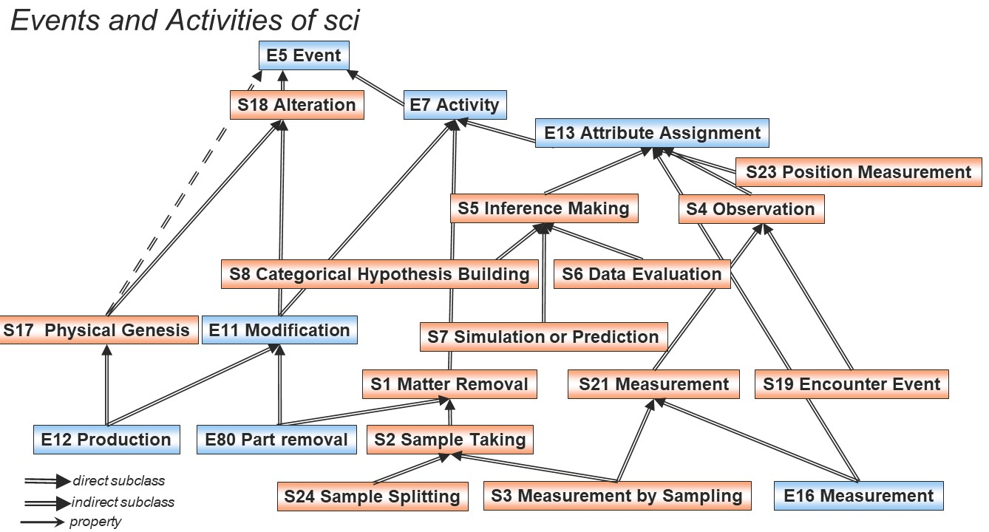
Figure 1: Subclass relations between temporal classes of the CRMsci and the CIDOC CRM (from CRMsci version 2.1).

Problem Statement
The problem in CRMbase is the following:

The only top-level epistemological class in CRMbase is E13 Attribute Assignment, a reification-type model describing the activity of assigning only one proposition via 3 properties: P141 assigned, P140 assigned to and P177 assigned property of type. The actual quantifiers of these properties are however still not constrained in CRMbase, so that any use of more than one instance of P140 and P141 per instance of E13 makes it ambiguous to which combination the instance of P177 will pertain. The respective change of these quantifiers to (1,1:0,n) is a pending issue. E13 is superclass of E14 Condition Assessment, E15 Identifier Assignment, E16 Measurement and E17 Type Assignment, which all inherit the single-proposition constraint. This is sufficient for describing simple cases, as in museum conservation reports, biodiversity collections etc. and connecting these activities to tools and sources used for the assignment.

There is no class for observation. The property P43 has dimension is restricted to be used for one identifiable item only, material or immaterial (an instance of E70 Thing). There is no intention to change this, because CRMbase must stay simple enough for a wide range of users to comprehend and use it. However, it is insufficient for describing complex scientific tasks, such as archaeological excavations and geodetic measurements, historical witnesses, such as from battles, and scholarly or scientific reasoning. However, the class E54 Dimension itself should be kept as top-level concept for the intended extensions. That requires minor adjustments.

CRMsci and CRMinf are the extensions of CRMbase to address these problems.

The problem in CRMsci is the following:
The CRMsci version 2.1 has formally been made CIDOC CRM compatible by declaring its epistemological classes as subclasses of E13 Attribute Assignment. The class S5 Inference Making and all its subclasses in CRMsci repeat I5 Inference Making from CRMinf, in a preliminary attempt to justify E13 as superclass, but no properties have been developed for these classes, and that of E13 are not adequate. This work will not address this problem (yet).

The class S21 Measurement generalizes the concept of what can be measured from physical things in CRMbase to material items and events (S15 Observable Entity). However, distance and angle measurements and others require multiple objects to pertain to the measurement, which is incompatible with E13, and currently not allowed in CRMsci. Consequently, neither can the measurements necessary for an instance of S23 Position Determination be described, nor the measurement of instances of S25 Relative Dimension.

The problem in CRMinf is the following:
The only top-level epistemological class in CRMinf is I1 Argumentation, a subclass of E7 Activity. The result of an argumentation is a belief (I2 Belief), modified by a belief value (I6 Belief Value) in an instance of I4 Proposition Set, subclass of E73 Information Object, which contains the propositions believed together following the argumentation by those that carried it out. In comparison, the result of an E13 Attribute Assignment is one proposition held to be true by those that carried it out.

The challenge is to relate the latter consistently to a whole set of propositions and varied beliefs, so that querying the one paradigm will return the results of the other as well. The current declaration of I5 Inference Making as subclass of E13 has no logical foundation. Similarly, there were inconsistent attempts to declare I1 Argumentation subclass of E13. Another practical problem is the complexity of documenting premises and conclusions of arguments in full detail with belief values and sets of formal propositions. Often premises cannot even be documented with the used schema, but rather with clear language, unambiguous according to scientific and scholarly practice. In most cases, the belief value is simply “TRUE”. Therefore, a set of properties is needed that simplify the documentation of premises and conclusions, implying adequate defaults.

Further, declaring S4 Observation from CRMsci a subclass of I1 Argumenation does not represent the outcome of an (S4) observation in the sense of CRMsci as an outcome of an (I1) argumentation in the sense of CRMinf.

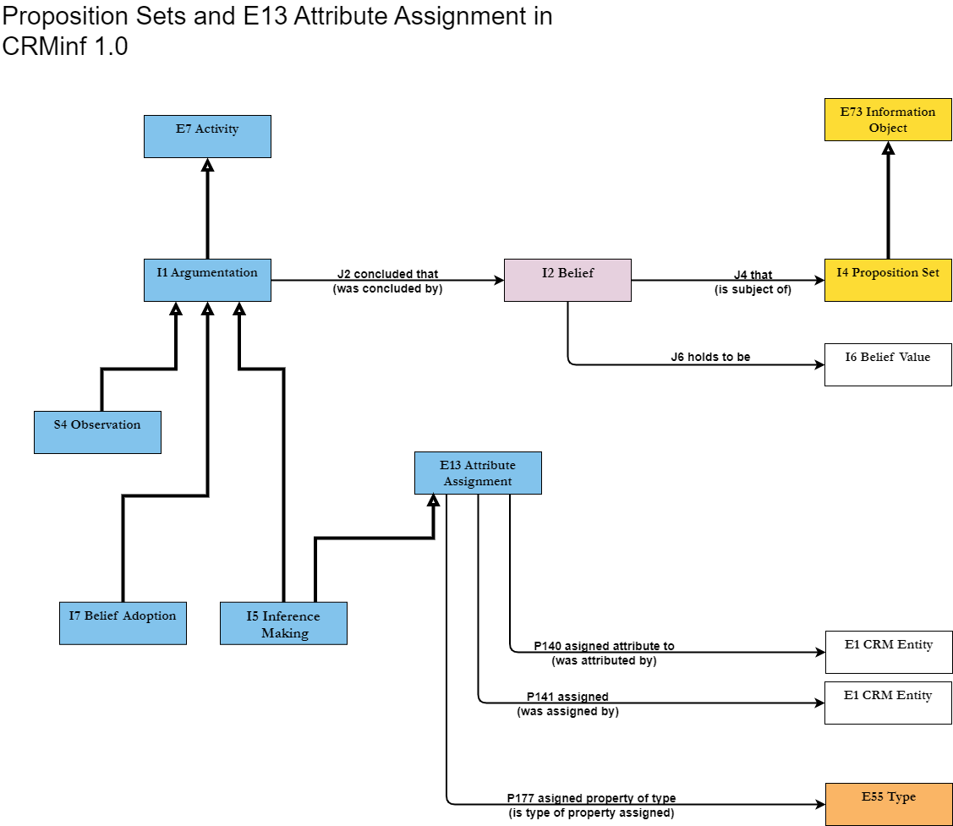
Figure 2: Argumentation, E13 Attribute Assignment and Proposition Sets in CRMinf version 1.0.

Finally, the epistemological status and nature of an instance of I4 Proposition Set is confusing. On one side, as convenience to refer its context as a text, it is subclass of E73 Information Object. But this conflicts with the encoding-independent nature of a proposition in the mind and in actual RDF-OWL instances in current knowledge bases, including Named Graph implementations. It confuses, if the propositions are regarded being (1) representations only, as believed statements about (2) a given reality or about (3) a possible world. For the latter distinctions, see also the section “Reality, Knowledge Bases and CIDOC CRM” in the Definition of the CIDOC CRM, see (Meghini & Doerr 2018), and the concept of “propositional attitudes” in (Levesque & Lakemeyer 2001), or even (Wittgenstein 1984).

Solution
In this text, the solution will be motivated, going from the redefinition of I4 Proposition Set, to the new integration of E13 Attribute Assignment in CRMinf, until the redefinition and restructuring of Observation in CRMsci. The complete definitions and graphics are provided in separate files.

The presented solution is not completely specific to the CIDOC CRM model environment. It provides a general pattern how to relate references to sets of propositions to reification patterns. It must be understood that the semantics of referring to a set of propositions is more expressive than referring to the contained propositions one by one: The set forms a sort of semantic context. E.g., if we have two reports that the same person at the same time was at different places, we would disbelieve the whole set, but not its elements.

Redefinition of I4 Proposition Set:

I4 Proposition Set becomes subclass of E89 Propositional Object only. I.e., its identity is given by the meaning (referents) of its elements, as commonly understood by some maintainers of a knowledge base or a wider audience, and not by encoding and URIs. The new definition is (see attached file CRMinf_revision.docx):
This class comprises sets of unambiguous propositions that are or could, in principle be, encoded in a knowledge representation language. These propositions should be factual, i.e., each proposition should pertain to at least one particular item, in contrast to universals, such as instances of E55 Type. The identity of an instance of I4 Proposition Set is given by the total of its content, regardless equivalent encodings.
An instance of I4 Proposition Set should be regarded per se to be neutral to its relationship to reality. The relationship to reality is determined by the link using the proposition set:
If an instance of I2 Belief refers to an instance of I4 Proposition Set, the belief value of "TRUE" will mean that the propositions are believed to correspond to reality, if the propositions can be related to reality (i.e., are about real-world items, in contrast to, e.g., mathematical statements). "FALSE" would mean that at least one of the propositions in the set is regarded to not correspond to reality. Belief values expressing possibility or probability will mean "possibly real" if the propositions can be related to reality.
Some properties associating an activity with an instance of I4 Proposition Set may imply the belief of the Actor carrying out the activity that the propositions are true. This should be expressed in the respective scope notes.
In a Knowledge Base implementation, an instance of I4 Proposition Set may be represented by the URI of a Named Graph, but only if the propositions are encoded in the data model of the Knowledge Base and held to be true by the maintainers of a Knowledge Base because they become part of the stated knowledge. In this case, the platform-internal relation between the URI and its content are regarded as equivalent to the property J25 is encoded by. Proposition Sets held to be possibly true by the maintainers of a Knowledge Base may also be introduced as Named Graphs, if the operation of the Knowledge Base foresees filtering by provenance and likelihood. In this case, Named Graphs are particularly effective.
The trick is to introduce a subclass of I4, an “I17 One-Proposition Set”:

This class comprises proposition sets containing exactly one binary proposition which is or could, in principle be, encoded in a knowledge representation language. The identity of an instance of I17 One-Proposition Set is given by the total of its content, regardless equivalent encodings.
An instance of I17 One-Proposition Set in a Knowledge Base may alternatively be implemented by a “reification” construct, and is regarded as logically equivalent in this model. Similarly, all triples of properties declared for one class to denote the domain, type and range of another property, such as the properties of E13 Attribute Assignment and its subclasses, can be interpreted as shortcuts to an instance of I17 One-Proposition Set and its properties J30 has domain (is domain of), J31 has range (is range of), J32 has property type (is property type of), or as a “reification” implicit to the declaring class.
As such, the class I17 One-Proposition Set plays the role of an important logical interface between different ways to document a discourse about propositions within a Knowledge Base in different ways. It is particularly relevant for implementing effective queries. For documentation, the use of simpler shortcut properties will, typically, be the preferred approach.
Consequently, E13 Attribute Assignment can be declared as subclass of I1 Argumentation, as shown in the following figure 3. Adequate properties for I17 One-Proposition Set are taken as constraints, in case of a Named Graph implementation, or as constituents of a reification construct. The properties of E13 are first interpreted as strong shortcuts (equivalent deductions) of J33 assigned proposition, the new, necessary, many-to-one property of E13, to an intermediate I17 One-Proposition Set with properties (J30,J31,J32) equivalent to that of E13, and in turn J33 assigned proposition is defined to be a shortcut over J2 concluded that and I2 Belief to I17, with belief value fixed to be true. Further, the use of the property J2 for an instance of E13 is restricted to the subproperty J33, so that no other use can be made from E13 of this superproperty it inherits that would violate the definition in CRMbase. In FOL:
J33(x,y) ⇒ E13(x)
J33(x,y) ⇒ I17(y)
J33(x,y) ⇒ P140(x,u) ˄ J30(y,u) ˄ P141(x,v) ˄ J31(y,v) ˄ P177(w) ˄ J32(y,w)
J33(x,y) ⇒ (∃u) [I2(u) ˄ J2(x,u) ˄ J4(u,y) ˄ J5(u,’TRUE’)] believed to be true!
E13(x) ⇒ (∃uvw) [E1(u) ˄ P140(x,u) ˄ E1(v) ˄ P141(x,v) ˄ E55(w) ˄ P177(x,w)]
P140(x,y) ⇒ (∃u) [I17(u) ˄ J33(x,u) ˄ J30(u,y)]
P141(x,y) ⇒ (∃u) [I17(u) ˄ J33(x,u) ˄ J31(u,y)]
P177(x,y) ⇒ (∃u) [I17(u) ˄ J33(x,u) ˄ J32(u,y)]
J2(x,y) ˄ E13(x) ⇒ J33(x,y)

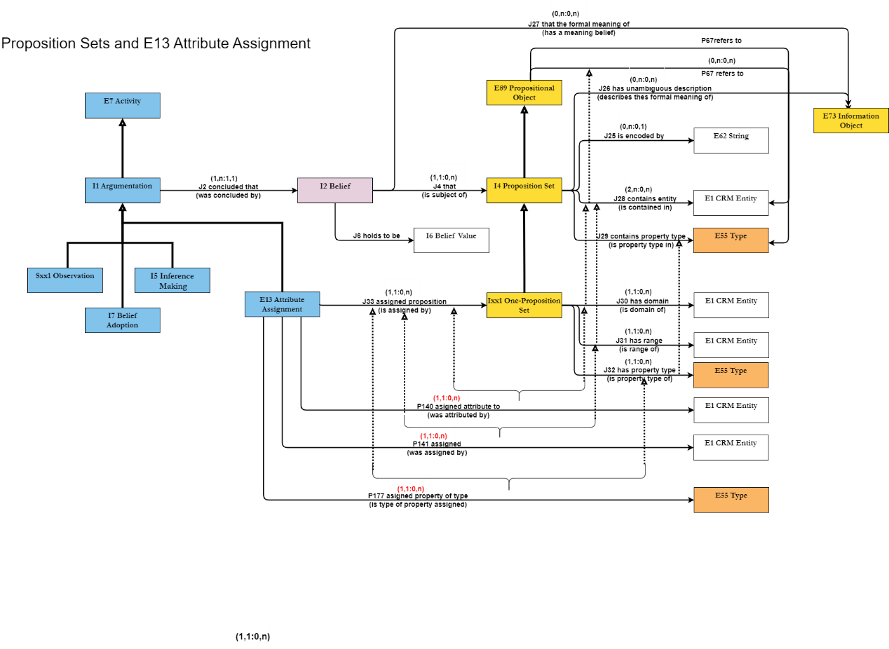
Figure 3: Proposed model for E13 Attribute Assignment and Proposition Sets in CRMinf.

New content properties for I4 Proposition Set:

The new properties for I4 Proposition Set, J28 contains entity reference and J29 contains property type reference serve for specifying some important content elements, in particular for constraints in subclasses of I4. The property J25 is encoded by is foreseen for a complete serialization of its content, such as the part in “{}” brackets in an RDF TRIG file.

In cases such a serialization is not available or possible or not necessary, the content can be specified by a natural language text, via J26 has unambiguous description, or, omitting a formal instance of I4, by J27 that the formal meaning of from I2 Belief directly. The latter two must only be used, if in the given context of a knowledge base, domain experts will regard the respective texts as unambiguous. In particular premises of scientific arguments may not be required to be represented explicitly by KR expressions in a knowledge base.

The proposed model looks fairly much more complicated, but for practical use, it is easier and clearer than before, because (1) it makes clear where the content of an instance of I4 goes to; because (2) the properties J28,J29,J30,J31,J32 and J33 are typically only internally needed for querying across the different paradigms and all subclasses of E13 in CRMbase and CRMsci; and (3) because J27 can simplify a lot of use cases of property J2 concluded that and J1 used as premise. This model now also opens the solution for the observation model in CRMsci.

Revision of the observation model in CRMsci:

CRMbase, as stated above, does not have a class “observation”, but it has the top-level class E54 Dimension, which stand for any quantifiable property, the real, particular phenomenon, and not the numerical approximation, as already defined and argued for by Thomas Gruber. In CRMbase, an instance of E54 Dimension can only be specific to one item, an instance of E70 Thing, E97 Monetary Amount, or being the duration of a E52 Time-Span, and E16 Measurement is restricted to physical things. E.g., one physical object can have a current length of approximately 11.5 cm etc.

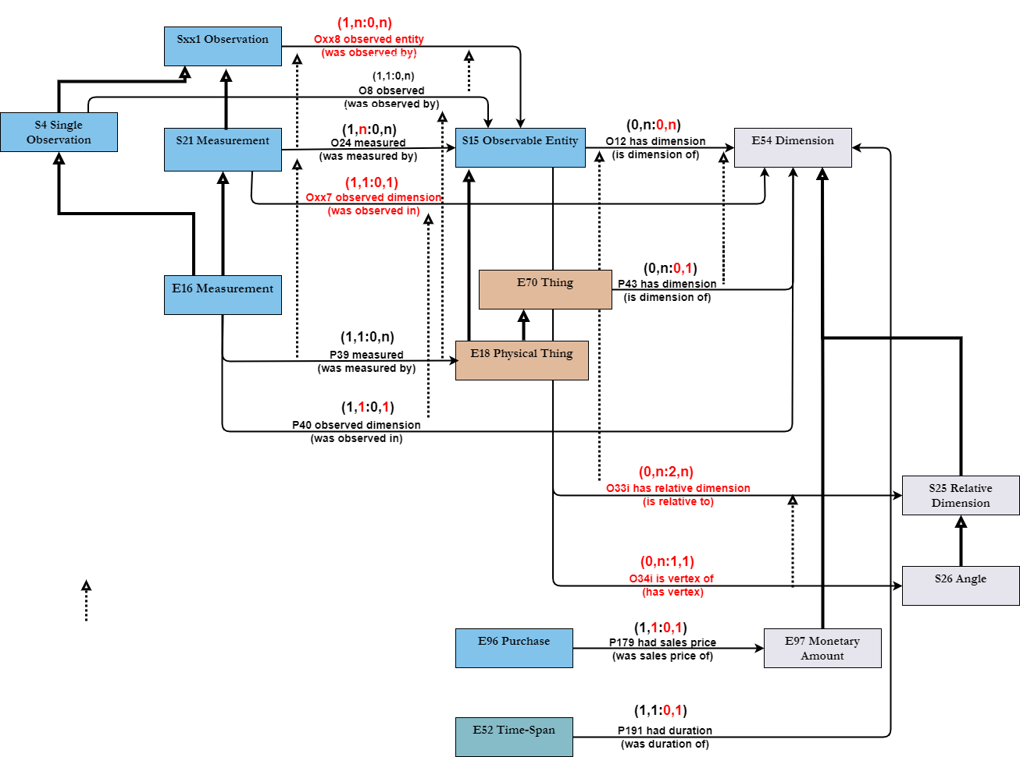
Figure 4: Proposed adaptation of CRMsci to measuring and observing multiple items

In CRMsci, S21 Measurement was introduced to generalize E16 to observable entities (S5 Observable Entity), i.e., anything material and events, but now we need to generalize to measure quantifiable properties holding between individual things (instances of S25 Relative Dimension), without giving up the specificity of an instance of E54 Dimension to such a combination. Further, we do not want to complicate CRMbase by more subclasses or superclasses of E54 Dimension.

The solution results in a revision of eight property quantifiers in CRMsci and in CRMbase. In order to keep backwards compatibility in CRMsci (and compatibility with many other observation models), we keep the class S4 as is, but rename the label to “S4 Single Observation”. Instead, we introduce a new, generic class “S27 Observation” and generalize the property O8 observed of S4 Single Observation, to O35 observed entity for S27 Observation to allow for observing multiple items. In order to keep instances of S21 Measurement specific to one instance of E54 Dimension measured, we introduce a new property O39 observed dimension for S21 Measurement. The latter now is allowed to measure multiple items (O24 measured), but is now subclass of S27 Observation instead of S4 Single Observation. These changes are depicted in figure 4, and explicitly defined in the attached file CRMsci_revision.docx.

However, the relaxation of the quantifier of O12 has dimension to (0,n:0,n) would allow for unintended models, assigning the same dimension to multiple items, rather to a property between them only, in CRMbase and CRMsci. This has been addressed by the following addition in the scope note for O12 has dimension:

“Most instances of E54 Dimension pertain to one item only. An instance of E54 Dimension referred to by more than one item via this property or a specialization of it is more specifically an instance of S25 Relative Dimension, such as a distance between two physical objects. Referring to an instance of E54 Dimension by this property is mutually exclusive to using either property P191 had duration (was duration of) or P179 had sales price (was sales price).”

Further, a fairly complicated set of FOL rules have been defined to enforce the above, easy-to-read paragraph (see also CRMsci_revision.docx):

O12(x,y) ⇒ S15(x)
O12(x,y) ⇒ E54(y)
[P43(x,y) ∧ E18(x)] ⇒ O12(x,y)
[O12(x,y) ⋀ O12(z,y) ) ⋀ (x ≠ z)] ⇒ S25(y)
O12(x,y) ⇐ (∃z) [S21(z) ∧ O24(z,x) ∧ Oxx7(z,y)]

Exclusion statements in CRMsci :

O12(x,y) ) ⇒ ¬(∃z) [E54(z) ⋀ 191(x,z)]
O12(x,y) ⇒ ¬(∃z) [E54(z) ⋀ P179(x,z)]
[P43(x,y) ⋀ ¬E18(x)] ⇒ ¬(∃z) [E54(z) ⋀ O12(x,z)]
P191(x,y) ⇒ ¬(∃z) [E54(z) ⋀ O12(x,z)]
P179(x,y) ⇒ ¬(∃z) [E54(z) ⋀ O12(x,z)]

Exclusion statements for CRMbase:

P43(z,y) ⇒ ¬(∃z) [E54(z) ⋀ 191(x,z)]
P43(z,y) ⇒ ¬(∃z) [E54(z) ⋀ 179(x,z)]
P179(x,y) ⇒ ¬(∃z) [E54(z) ⋀ P43(x,z)]
P179(x,y) ⇒ ¬(∃z) [E54(z) ⋀ P191(x,z)]

And by deduction,
P40(x,y) ⇒ P39(x,z) ⇒ P43(z,y) ⇒ ¬(∃z) [E54(z) ⋀ 191(x,z)]
Oxx7(x,y) ) ⇒ O24(x,z) ⇒ O12(z,y) ⇒ ¬(∃z) [E54(z) ⋀ 191(x,z)]
Oxx7(x,y) ) ⇒ O24(x,z) ⇒ O12(z,y) ⇒ ¬(∃z) [E54(z) ⋀ 179(x,z)]

Integrating the observation model in CRMsci with CRMinf:

Whereas S4 Single Observation remains a valid subclass of E13 Attribute Assignment, S27 Observation does not. We use for S27 Observation the current scope note of S4 Observation, which already foresaw:
“We define observation in the sense of natural sciences, as a kind of human activity: at some place and within some time-span, certain physical things and their behaviour and interactions are observed by human sensory impression, and often enhanced by tools and measurement devices.
Observed situations or dimensions may pertain to properties confined to a single instance of S15 Observable Entity or pertain to constellations of multiple instances and relations between them, in particular distances between them. “
However, this was not implemented in terms of properties. The scope note of S4 Single Observation is now reduced as subclass of S27 Observation, in agreement with its actual properties, to:
“This class comprises the activity of gaining scientific knowledge about particular states of physical reality through empirical evidence, experiments or measurements, for cases in which the observed knowledge can be described by a single binary proposition relating one instance of O15 Observable Entity to some instance of E1 CRM Entity.”
CRMinf already has foreseen the class I11 Situation as subclass of I4 Proposition Set. Since many properties in the CRM and in other models using KR languages such as RDF are indefinite in time, restricted only by the existence of the domain and range instance, the property J24 held at least for allows for specifying a least period of validity for all propositions in the set. However, observations cannot verify all kinds of properties. E.g., being married is verified by documents, and not by observing a couple. Propositions themselves cannot be observed, only their fitting to a material state of affairs.
Therefore, we introduce in CRMsci a new class S28 Observable Situation, which necessarily J28 contains entity reference (is referred to in) to at least one observable entity:
S28(x) ⇒ (∃y) [S15(y) ∧ J28(x,y)]

We connect now Sxx1 Observation directly to CRMinf, I1 Argumentation, and no more to E13 Attribute Assignment, and describe the most generic observation as “O36 expressed the observed as (was the expression of): S28 Observable Situation. This property implies the default assumption that results of observations are taken to be true by the observers. It is therefore defined as a strong shortcut over J2 concluded that: I2 Belief, J4 that: S28 Observable Situation and J5 holds to be “TRUE”:

O36(x,y) ⇔ (∃u) [I2(u) ˄ J2(x,u) ˄ J4(u,y) ˄ J5(u,’TRUE’)]

Note, that instances of S28 Observable Situation may also pertain to the absence of affairs, such as “no foe had entered the city at that time”, or be used epistemologically in questions if a situation has ever occurred. By these definitions, S27 Observation becomes a valid subclass of I1 Argumentation, and hence CRMinf and CRMbase compatible at that level of the model. Future attention is still needed to achieve compatibility with S6 Data Evaluation, S7 Simulation or Prediction and S8 Categorical Hypothesis Building, which is not part of this work.

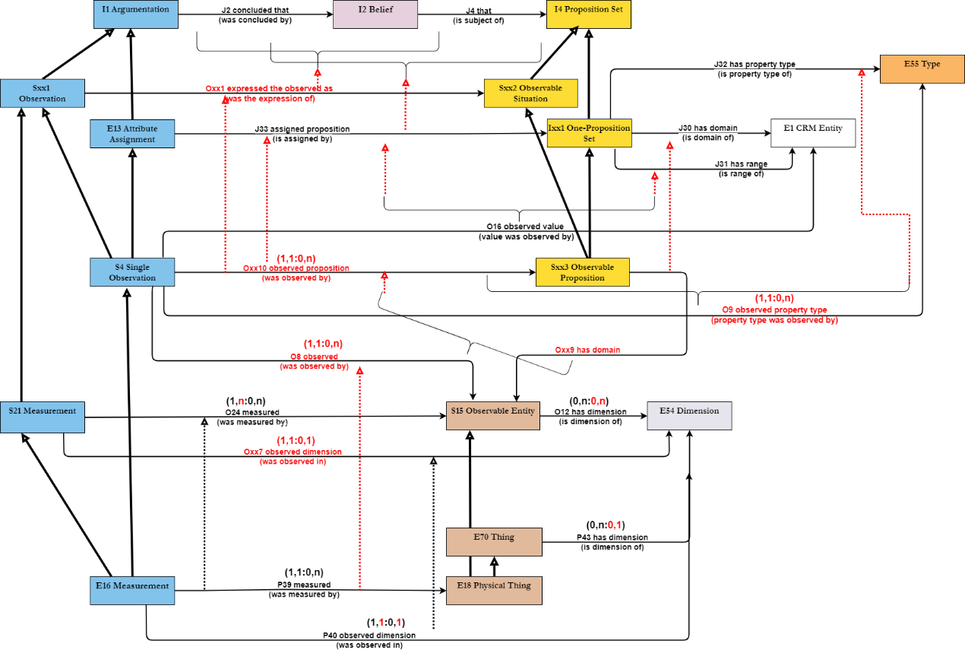

Figure 5: Proposed extension of CRMsci to observing multiple propositions

What follows is a fairly complicated looking specialization of the modeling pattern from CRMinf for I17 One-Proposition Set and E13 Attribute Assignment propagating two interconnected specialization paths for multi-property observations and single property observations, as well for observable situations and observable properties. The proposed model looks fairly much more complicated, but for practical use, it is consistent and clearer than before. The respective changes are depicted in figure 5, and explicitly defined in the attached file CRMsci_revision.docx.

Conclusion
As a result of the presented model, statements whatever provenance about propositions sets and single propositions via reification patterns can be made in the same knowledge base. Queries to all such statements about proposition sets, including multi-property observations and measurements, will also retrieve all statements about single-property instances in CRMsci, CRMinf and CRMbase, and the proposedchanges are backwards compatible with the current editions. The model is also innovative, so far, to our knowledge, no observation model consistently based on a situation concept and compatible with the widely used reification pattern has been proposed. This model aims at being approved by CRM-SIG as international recommendation.

My particular gratitude to Gerald Hiebel University of Innsbruck, for discussing applications of Named Graphs; to Christian-Emil Ore, University of Norway, for discussing First Order Logic statements and quantification; and in particular Pavlos Fafalios, for discussing the representation of scholarly inferences and logical parts of this model; and Eleni Tsouloucha and Athina Kritsotaki for reviewing and preparing presentations of parts of this model to CRM-SIG for feedback from an international audience.

References
Martin Doerr, Athina Kritsotaki and Katerina Boutsika. 2011. Factual argumentation - a core model for assertions making. Journal on Computing and Cultural Heritage (JOCCH), 3(3), 34, New York, NY, USA : ACM
Carlo Meghini and Martin Doerr. 2018. A first-order logic expression of the CIDOC conceptual reference model. International Journal of Metadata Semantics and Ontologies, 13(2), 131-149.
Levesque, H.J. and Lakemeyer, G. (2001) The Logic of Knowledge Bases, The MIT Press, MA, USA.
C. Masolo, S. Borgo, A. Gangemi, N. Guarino and A. Oltramari, Won-derWeb deliverable D18 ontology library (final), Laboratory for Applied Ontology, Trento, 2003
Ludwig Wittgenstein. 1984. Tractatus Logico-Philosophicus, Tagebücher 1915-1916. Philosophische Untersuchungen. Suhrkamp, Frankfurt, ISBN 3-518-28101-1.

Thomas Gruber in (https://tomgruber.org/writing/onto-design.pdf): "We now focus on the representation of physical quantities in engineering models. Engineers often use the word “quantity” to refer to both the thing-in-the-world, such as the length of some segment of railway track (about 3 meters), and the thing-in-the- equation, such as the parameter X in an equation model denoting the position of a car along the track. In the engineering ontologies, we distinguish these two notions. A physical-quantity is the extent of some property in the world independent of how it is represented or measured (e.g., the length that is 3 meters long). The symbol X is an expression that denotes a physical quantity. A representation of X is at the metalinguistic level, where parameters and equations in an engineering model are treated as special cases of terms and sentences in the logic. The treatment of the metalinguistic level is beyond the scope of this paper, so we will concentrate on the object level representation of physical-quantity."
This is similar to the concept of situation in (Masolo et al. 2003).

