Financial transactions

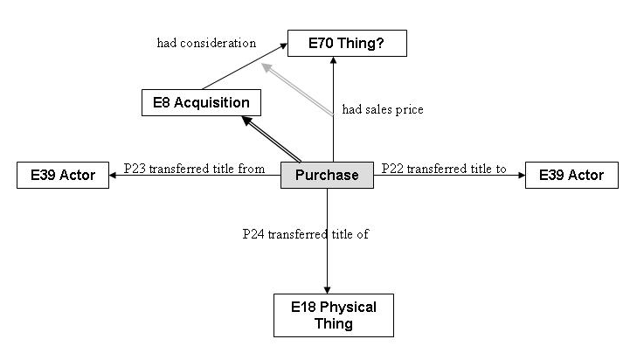

Class Declaration

E96 Purchase

Subclass of: E8 Acquisition
Superclass of:

Scope note: This class comprises transfers of legal ownership from one or more instances of E39 Actor to one or more different instances of E39 Actor, where the transferring party is completely compensated by the payment of a monetary amount. In more detail, a purchase agreement establishes a fixed monetary obligation at its initialization on the receiving party, to the giving party. An instance of E96 Purchase begins with the contract or equivalent agreement and ends with the fulfilment of all contractual obligations. In the case that the activity is abandoned before both parties have fulfilled these obligations, the activity is not regarded as an instance of E96 Purchase.
This class is a very specific case of the much more complex social business practices of exchange of goods and the creation and satisfaction of related social obligations. Purchase activities which define individual sales prices per object can be modelled by instantiating E96 Purchase for each object individually and as part of an overall E96 Purchase transaction.
Properties:
P173 had sales price (was sales price of)): E97 Monetary Amount
Decision: agreed

E97 Monetary Amount

Subclass of: E54 Dimension

Scope note: This class comprises quantities of monetary possessions or obligations in terms of their nominal value with respect to a particular currency. These quantities may be abstract accounting units, the nominal value of a heap of coins or bank notes at the time of validity of the respective currency, the nominal value of a bill of exchange or other documents expressing monetary claims or obligations. It specifically excludes amounts expressed in terms of weights of valuable items, like gold and diamonds, and quantities of other non-currency items, like goats or stocks and bonds.

Properties:
P174 has currency (was currency of): E98 Currency
P175 has amount: E60 Number
Decision: general happiness = agreed

E98 Currency
Subclass of: E55 Type
Scope note: This class comprises the units in which a monetary system, supported by an administrational authority or other community, quantifies and arithmetically compares all monetary amounts declared in this unit. The unit of a monetary system must describe a nominal value which is kept constant by its authority and an associated banking system, and not by market value. For instance, one may pay with grams of gold, but the respective monetary amount may be agreed on as the gold price in US dollars the day of the payment. Under this definition, British Pounds, U.S. Dollars, and European Euros are examples of currency, but “grams of gold” are not. One monetary system has only one currency. Instances of this class must not be confused with coin denominations, such as “Dime” or “Sestertius”. Non-monetary exchange of values in terms of quantities of a particular type of goods, such as cows, do not constitute a currency.

Examples: “As” (Roman mid republic), “Euro”, “US Dollar”

Property Declaration

P179 had sales price (was sales price of)

Domain: E96 Purchase
Range: E97 Monetary Amount
Subproperty of: E8 Acquisition: P?? had consideration (): E70 Thing

Scope note: This property establishes the relationship between an instance of E96 Purchase and the instance of E97 Monetary Amount that forms the compensation for the transaction.

Examples:
- The sale of Vincent van Gogh’s “Vase with Fifteen Sunflowers” on 1987/03/30 (E96) had sales price Christies’ hammer price for “Vase with Fifteen Sunflowers” (E97)

Decision: agreed on substance, issue of its superproperty not yet decided

P180 has currency (is currency of)

Domain: E97 Monetary Amount
Range: E98 Currency
Subproperty of: P91 has unit (is unit of)
Superproperty of:
Scope note: This property establishes the relationship between an instance of E97 Monetary Amount and the currency that it is measured in.

Examples:
- Christies’ hammer price for “Vase with Fifteen Sunflowers” (E97) has currency British Pounds (E98)

Decision: agreed on substance, and repeat example in dimension and in E97

P181 has amount

Domain: E97 Monetary Amount
Range: E60 Number
Subproperty of: P90 has value

Scope note: This property establishes the relationship between an instance of E97 Monetary Amount and the amount of currency that it consists of.

Examples:
- Christies hammer price for “Vase with Fifteen Sunflowers” (E97) has amount 24,750,000 (E60)

Decision: agreed

