Issue 627: explicitly document cross-references btw family models
Etz gave an update on the HW (tasks completed, and tasks that he would like the SIG’s opinion on).
The HW can be found below. The decisions and some discussion points can be found below.

Decisions: The SIG agreed
- to include <owl:versionIRI> statements in in the rdf encoding of CRMbase and extensions (point a1)
- for family models, mint versioned IRIs following the practices of CRMbase (point a2).
- to use <owl:imports> statements to reference external ontologies (point a3).
- to replace <rdf:Description> and <rdf:type> statements in CRM extension serializations with <rdfs:Class|Property>, to match CRMbase syntax (point B)
- to include FOL and examples in the <rdfs:comment> statements (previously only used for scope notes) both for CRMbase and extensions (point C).
  - N.b.: this has been implemented for Erlangen CRM, and it works well. It is always possible that some characters are not recognized by a system, but it has worked well for them.
- to reuse the main classes and properties needed for implementing the PC module (PC01, P01, P01i, P02, P02i, P03, P04) (point e1)
  - Reification properties specific to CRM extensions will be defined using the prefix denoting the properties of the given extension (APC11_has_Physical_relation_to for PCs, AP11.1_has_type for properties of properties) (points e2, e3, respectively)
- to not disallow rdf uri resolution for draft versions of CRMbase and extensions, but to flag said models as draft (make a note that they should not be used for implementations)
N.b. Point D has been resolved by means of resolving points (a1 through a3)

WD for 627 60th SIG meeting April 2025
Issue link: https://cidoc-crm.org/Issue/ID-627-explicitly-document-cross-references-btw-family-models
Related issues: 678 Towards CRM OWL, 460 URI Management
The latest note of issue 627 has been recorded after the 58th CIDOC CRM and 51st FRBR/LRMoo SIG meeting. This note ended up with a promise that Etz will be implementing the proposed & agreed changes, and the issue will close.
In short, the proposed & agreed changes included the following:
- External references must point to the corresponding version of the referenced ontology
- PC Properties module needs to be implemented
- Regarding draft implementations - make obvious the note – do not use for implementation
- Change label more in Encodings column to gitlab
The updates on the agreed changes are presented later in this document. Some of them also depend some additional proposals that occured in the context of 627 which will be discussed first in Session 1.3 of the 60th CIDOC & 53rd FRBR/LRMoo SIG Meeting and are somehow relevant to issues 460 URI Management and 678 Towards CRM OWL

Additional Proposals
The additional proposals (a1, a2, a3, b, c) are:

owl:versionIRI & owl:import

(a1) Include an owl:versionIRI statement in both CRMbase and FM encodings.
e.g. change the following
<rdf:Description rdf:about="http://www.cidoc-crm.org/cidoc-crm/">
<rdf:type rdf:resource="http://www.w3.org/2002/07/owl#Ontology" />
<owl:versionInfo>RDFs Implementation (February 2024) of CIDOC-CRM 7.1.3</owl:versionInfo>
to the following
<owl:Ontology rdf:about="http://www.cidoc-crm.org/cidoc-crm/">
<owl:versionInfo>RDFs Implementation (February 2024) of CIDOC-CRM 7.1.3</owl:versionInfo>
<owl:versionIRI rdf:resource="http://www.cidoc-crm.org/cidoc-crm/7.1.2/" />
...

Relevant links :
https://www.w3.org/TR/owl2-syntax/#Versioning_of_OWL_2_Ontologies
https://protege.stanford.edu/ontologies/pizza/pizza.owl

(a2) support versioned uri resolution for FMs similarly to the CRMbase versioned uri resolution decision in 460 URI Management.
Currently owl:versionIRI for FMs would be supported through the following statement
<owl:versionIRI rdf:resource="https://cidoc-crm.org/extensions/crmsci/rdfs/2.0/CRMsci_v2.0.rdf“ />

The proposal is to make the required changes so that it follows CRMbase implementation so that owl:versionIRI will be supported by:
<owl:versionIRI rdf:resource="https://cidoc-crm.org/extensions/crmsci//2.0/“ />

a3) In FM rdf and owl use owl:import statements with the owl:versionIRI or the external reference ontology
e.g. change
<rdf:Description rdf:about="http://www.cidoc-crm.org/extensions/crmsci/">
<rdf:type rdf:resource="http://www.w3.org/2002/07/owl#Ontology"/>
<owl:versionInfo xml:lang="en">CRMsci Ontology 2.0 (March, 2023) including references to CIDOC-CRM 7.1.2</owl:versionInfo>
…

To
<owl:Ontology rdf:about="http://www.cidoc-crm.org/extensions/crmsci/">
<owl:imports rdf:resource="http://www.cidoc-crm.org/cidoc-crm/7.1.2/"/>
<owl:versionInfo xml:lang="en">CRMsci Ontology 2.0 (March, 2023) including references to CIDOC-CRM 7.1.2</owl:versionInfo>

a3) In FM rdf and own use owl:versionIRI for owl:import statements

Adjust the FM rdf serialization syntax to the CRMbase rdf serialization syntax.
More specifically replace the following example rdf statements
<rdf:Description rdf:about="http://www.cidoc-crm.org/extensions/crmarchaeo/A1_Excavation_Processing_Unit">
<rdf:type rdf:resource="http://www.w3.org/2000/01/rdf-schema#Class"/>
…

<rdf:Description rdf:about="http://www.cidoc-crm.org/extensions/crmarchaeo/AP1_produced">
<rdf:type rdf:resource="http://www.w3.org/1999/02/22-rdf-syntax-ns#Property"/>
…

With the following:

<rdfs:Class rdf:about="A1_Excavation_Processing_Unit">
…
<rdf:Property rdf:about="AP1_produced">
…

Include all declaration info (examples quantification etc) in the rdfs:comment/scope note of the CRMBase and FM rdf encodings

Change the CRMBase and FM rdfs:comment/scope note patterns. One of the decisions of 678 Towards CRM OWL included the synchronization of CRM owl rdfs:comment/scope note pattern with the pattern followed in Erlangen CRM. It basically includes all relevant declaration information for classes and properties (including examples, quantifications, etc.).

The proposal is to use the same rdfs:comment/scope note pattern for both CRMbase rdf serialization and all FM rdf serializations.

Updates on the agreed changes

The updates on the proposed & agreed statements are the following (d1,d2, e1, e2, e3, f, g)

FM External References
External references must point to the corresponding version of the referenced ontology
- For HTML it is already there – DONE e.g. http://www.cidoc-crm.org/extensions/crmarchaeo/A1_Excavation_Processing_Unit
- For RDF currently no change as no action had been decided. Next step depends on the approval of owl:versionIRI & owl:import usage

FM PC module implementation
Implement PC Properties module whenever required (See example CRMarchaero PC module proposal file)
- The main classes and properties needed for implementing are already defined in CRMbase, but they are not resolvable.
  - PC0_Typed_CRM_Property
  - P01_has_domain
  - P02_has_range
  - P02i_is_range_of
  - P03_has_range_literal
  - P04_represents

Question e1)
Reuse the unresolvable CRMbase PC module references or reimplement these (e.g with a different prefix) so that the PC module is not depending in unresolvable references?
- Regarding Property Classes (e.g. like PC3_has_note, PC14_carried_out_by from CRMbase PC module).

Question e2)
should we keep the same prefix PC or perhaps define another one (e.g. PC11_has_physical_relation_to or APC11_has_physical_relation_to)?
- The FM base uri will be different so there is no chance of conflicting uris. I would propose APC11_has_physical_relation_to so that it seems more compatible to the prefixes used in the base model that it refers to

- Similarly regarding .1 property names (e.g. like P3.1_has_type from CRMbase PC module).

Question e3) should we keep the same prefix P or perhaps define another one (e.g. P11.1_has_type" or AP11.1_has_type)?

Uri Resolution for Draft FMs
Regarding the existing draft implementations of FMs and the uri resolution mechanism for these extensions, it should be made obvious that they must not be used for implementation
- Encodings for Draft or obsolete versions have been removed.
- HTML uri resolution has been updated so that each resolvable link is obviously not meant to be used for implementations e.g. https://cidoc-crm.org/extensions/crminf/I1_Argumentation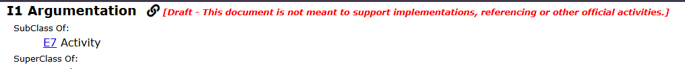
- RDF uri resolution currently enabled – the only draft indication message is included just the at the owl:versionInfo text of the ontology
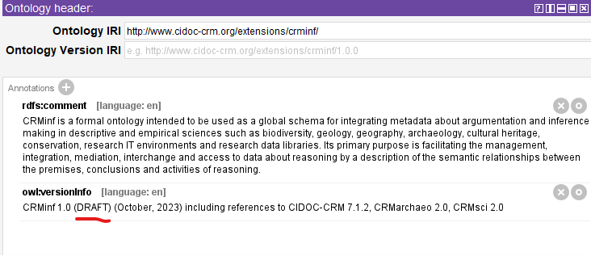

Change label more in Encodings column to gitlab
DONE

