Issue 646:

Scope of CRMinf
Scope
CRMinf regards as “knowledge” anything someone says and can justify as “I know that X”, regardless of whether X is regarded to be true, false, probable, etc., whereas X itself is regarded as information or “data”. In this sense, knowledge resides in humans, who relate the symbols in information to states of affairs in current or past reality. “Knowledge representation” is regarded as a particular form of encoded information, for instance a CRM-compatible form. CRMinf aims at connecting the people who know something to the information representing their knowledge, and its justification. The model supposes scientific ethics and is not concerned with beliefs of people using CRMinf differently from what they state, but it can quite well be used to reason about deliberately false statements in historical sources.
The disciplines addressed by CRMinf are what (Turner, 2012) calls “historical sciences”, i.e., cultural heritage studies, human and natural history, archaeology, but also descriptive empirical sciences, such as biodiversity, ethnology, geology, cultural heritage conservation, even clinical studies, etc., in their focus on documenting particular states of affairs now and in the past.
CRMinf is inspired by the IAM model in Doerr, Kritsotaki and Boutsika (2011), which in turn draws on a background of other argumentation models under the aspect of application to knowledge about the past, among them being the “logicist” approach (Gardin, 2003), (Gardin & Roux, 2004) in use in France for archaeological data. Like the IAM, CRMinf deals with the sources of knowledge for facts stated in explicit propositions. It simplifies IAM by making the general theories used for inferences (such as a mathematical proof, universal properties etc.) and the belief in their correct application an implicit part of an argumentation event (possibly represented in a text). CRMinf is also less formal than IAM with respect to inference chains (i.e., using conclusions as premises for the next inference) of different granularity. As in IAM, a documented chain of inferences represents a state of knowledge at a point in time, and not the historical order of finding its elements. The latter is given explicitly by the time of argument making, which is taken to be a historical fact.
CRMinf makes a basic distinction between three kinds of sources of knowledge because of the way it can be acquired, justified or falsified. These are (1) observation, (2) belief adoption and (3) inference making.
Observation results in knowledge acquired by human senses or by technical devices at a particular place and time. Verification or falsification may re-examine the same environment or things, if sufficiently unaltered, examine observation protocols and the functionality of employed devices and compare with independent observations. Observation is the ultimate primary source of such historical scientific knowledge. The complexity of observation processes, in particular with calibrated means, lies outside the scope of CRMinf, which is primarily concerned with the origin and further history of the observation results, thus providing a common generalization for other CRM extensions, notably CRMsci. In particular, the generic class for observation itself is declared as “S27 Observation” in CRMsci, making use of all constructs of CRMinf for argument making in general, and the class I11 Situation defined in CRMinf.
Belief adoption is used in CRMinf as a term for the use of information someone has heard, read or seen presented in symbolic form and accepts as their own knowledge. It is the major source of all our communicated knowledge, including reports from observations. It is supported or questioned by assessing the provenance of the source and trust in its credibility. In case of inconsistencies between reported facts, a trust argument may be used to decide on the one or the other. Therefore, CRMinf has developed the concept of Belief Adoption into much more detail than IAM, and created an “articulation” (ontological connection) to the deciphering and reading of original texts addressed by the CRM extension CRMtex, in order to be able to represent critical methods in historical research. Subsequent activities of belief adoption form endless networks of information transfer, which are of great importance for historical research.
Inference making, the third kind of acquiring knowledge, means that one concludes from the belief in the truth or likelihood of one or more propositions, the premises, that other propositions are true or likely, using background theories, such as common logic, laws of nature or assumptions about general human behaviour. The peculiarity of this knowledge is that it is relative to the truth of the premise. Therefore, it may be verified or falsified by revising the truth of the premises and the validity of the background assumptions for the given context and the correct application of the background theory, such as the common errors in applying logic. Note that an inference may conclude that at least one of the premises must be wrong. In IAM it is described as “recursive inference”, but for reasons of simplicity not distinguished in CRMinf.
The knowledge itself is represented by an instance of I2 Belief, which relates an E39 Actor to a set of propositions (I4 Proposition Set) believed forming one context and holding the same truth value (I6 Belief Value) as explicitly stated by the Actor. It comes into existence as the conclusion of an instance of I1 Argumentation (through one of its sub-classes, S27 Observation, I5 Inference Making, or I7 Belief Adoption), and ends with any modification of its truth value or propositions. Only one E39 Actor may hold a particular instance of I2 Belief, though the E39 Actor may, of course, be an instance of E74 Group. Such an instance of E74 Group may lose or gain members (via one or more instances of E85 Joining or E86 Leaving) without affecting the belief the group representatively maintains. The members supporting the common belief may not necessarily be individually convinced of it. This does not invalidate the (explicitly stated) belief of the Group as expressed, for instance, in a joint publication.
A classical definition of knowledge is that someone believes and can justify it, and it is true. Since to be actually true would require an absolute authority, documented knowledge by CRMinf constructs is regarded as something someone believes (I2 Belief) and can justify – by experience, inference or justified trust in the source. Therefore, a documented belief value, i.e., instance of I6 Belief Value, such as “TRUE”, does neither mean that a set of propositions is globally true in the sense of logic, nor that the documenting user believes that they are true. Instead, it means that the documenting user believes that the actor, documented for the respective belief expressed, in its turn, in some explicit form, takes certain propositions to be true “to the best of their knowledge”, as is the common scholarly assumption for all scientific publications. This sense of truth corresponds to “inference to the best explanation (IBE)” (Ladyman, 2002) and does not exclude revision when better evidence arrives. In cases where the underlying honesty of expressions by some actors cannot be assumed, it is recommended to document their statements more generally as products of E65 Creation, which applies to all propositions, and not as instances of I2 Belief. Otherwise, using CRMinf for documenting the progress of a serious scientific discourse would be compromised. Notwithstanding, opinions about specific propositional content can analytically be documented by instances of I16 Meaning Comprehension and I7 Belief Adoption. However, documentation would equally be compromised by an unreflected global questioning of trustworthiness of any source, whereas occasional cases of “lies” in generally trusted sources can effectively be dealt with as exceptions when detected and as knowledge revisions by the documentalist about the source. In general, it is recommended to use a richer vocabulary of belief values, at least including “UNKNOWN”. CRMinf does not further prescribe such a vocabulary.
If scientists and scholars, and in particular curators, documented the provenance of the immediate sources for each information source in publicly accessible systems, this partial knowledge of provenance could be “stitched together” to more and more complete networks of provenance, similar to the way these days citations in scientific publications are processed. This is one major motivation for CRMinf; the other is to make transparent how knowledge was acquired for enabling the justification of future revisions, and for documenting who is supporting contested propositions.

Class and property usage examples
Class and property usage examples
The first running example is about an important archaeological discovery, initially announced in the press, and subsequently in proper scientific archaeological publications (Mandolesi, 2013). It covers two simple events of observation (S27 Observation), a simple example of an inference (I5 Inference Making) based on a legitimate plausibility argument, and a rare published example of knowledge revision (I5 Inference Making) by the same author.
The skeleton found on the left bench of Tomb 6423, nicknamed Tomba dell’Aryballos sospeso, in the Doganaccia necropolis of the Etruscan city of Tarquinia, Tuscany, by Alessandro Mandolesi on the 21th of September 2013, was initially estimated by Mandolesi to be the remains of a male person, due to the spear found next to it, and was published in the press as such. Soon after, osteological analysis carried out by the team revealed that it belonged to a female person, as published in the official academic papers afterwards. This is a good example for a simple inference and scientific knowledge revision. We refer to this skeleton in the examples found throughout the text as “The skeleton on the left bench in La Tomba dell’Aryballos sospeso”, and to the burial arrangement as “The burial arrangement on the left bench in La Tomba dell’Aryballos sospeso”, respectively.
We continue this example further: Critical to this example is the archaeological context. When opening the tomb, Mandolesi observed that it had been untouched since the time of the last burial it contained, a very rare fact. Therefore, the arrangement found was interpreted to be the one intended by the people who had carried out the burial.
The interpretation of this example in terms of formal propositions is graphically shown in Figure 4, below; it can also be found in the examples for individual concepts throughout the class and property declarations.
The second running example is the blog post by Francesca Bologna concerning Nero, and, in particular, his whereabouts during the Great Fire of Rome (Bologna, 2021). It demonstrates a case of understanding and citing two contradictory historical sources (I10 Provenance Statement), without explicitly believing them (I13 Intended Meaning Belief). Bologna proceeds with making a scholarly argument for trusting the one (I7 Belief Adoption) over the other, which she disbelieves (I5 Inference Making). The argument she makes is based on plausibility, the provenance of the information that the author of each source had, and an assumed bias on the part of one of the sources, which she contextually justifies.
Here are the relevant citations from Bologna (2021):
On 19 July AD 64, a fire started close to the Circus Maximus. The flames soon encompassed the entire city of Rome and the fire raged for nine days. Only four of the fourteen districts of the capital were spared, while three were completely destroyed.
Later historians blamed Nero for the event, claiming that he set the capital ablaze in order to clear land for the construction of a vast new palace. According to Suetonius and Cassius Dio, Nero took in the view of the burning city from the imperial residence while playing the lyre and singing about the fall of Troy. This story, however, is fictional.
Most of what we know about Nero comes from the surviving works of three historians –Tacitus, Suetonius, and Cassius Dio. All written decades after Nero’s death, their accounts have long shaped our understanding of this emperor’s rule. However, far from being impartial narrators presenting objective accounts of past events, these authors and their sources wrote with a very clear agenda in mind. Nero’s demise brought forward a period of chaos and civil war –one that ended only when a new dynasty seized power, the Flavians. Authors writing under the Flavians had all an interest in legitimizing the new ruling family by portraying the Julio-Claudians in the worst possible light, turning history into propaganda. These accounts became the ‘historical’ sources used by later historians, therefore perpetuating a fabricated image of Nero, which has survived all the way to the present.
The interpretation of this example in terms of formal propositions is graphically shown in Figure 5, below; it can also be found in the examples for individual concepts throughout the class and property declarations.

Diagram depicting a knowledge revision process by A. Mandolesi
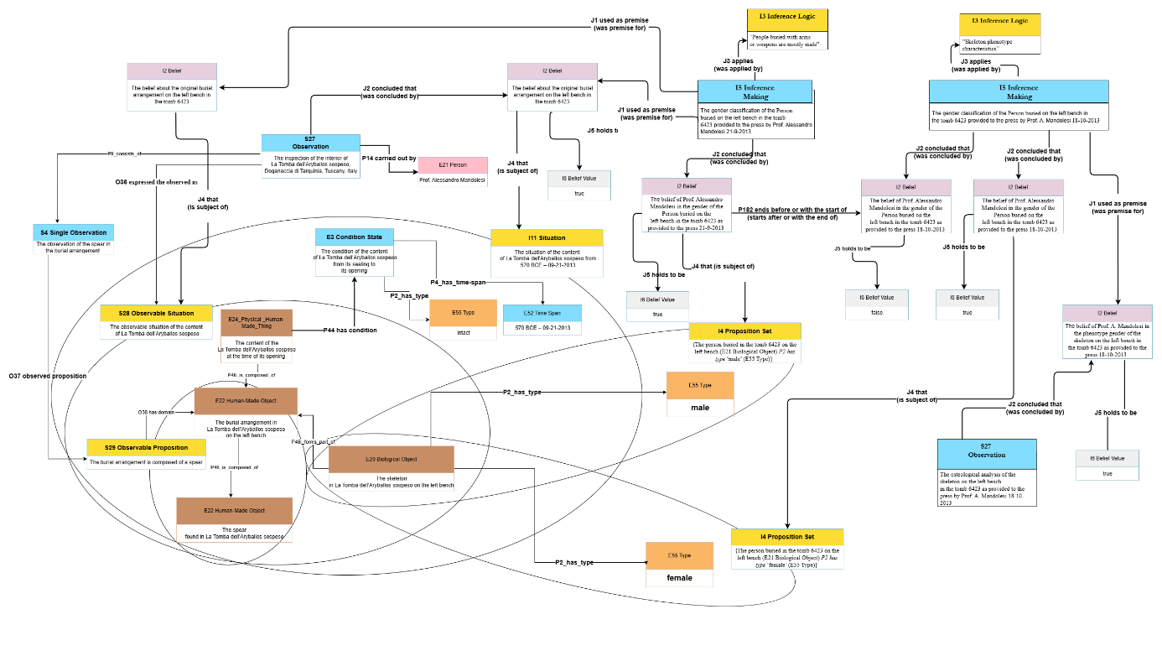

Figure 1: La Tomba dell'Aryballos sospeso; a case of knowledge revision

Diagram depicting a belief adoption by F. Bologna

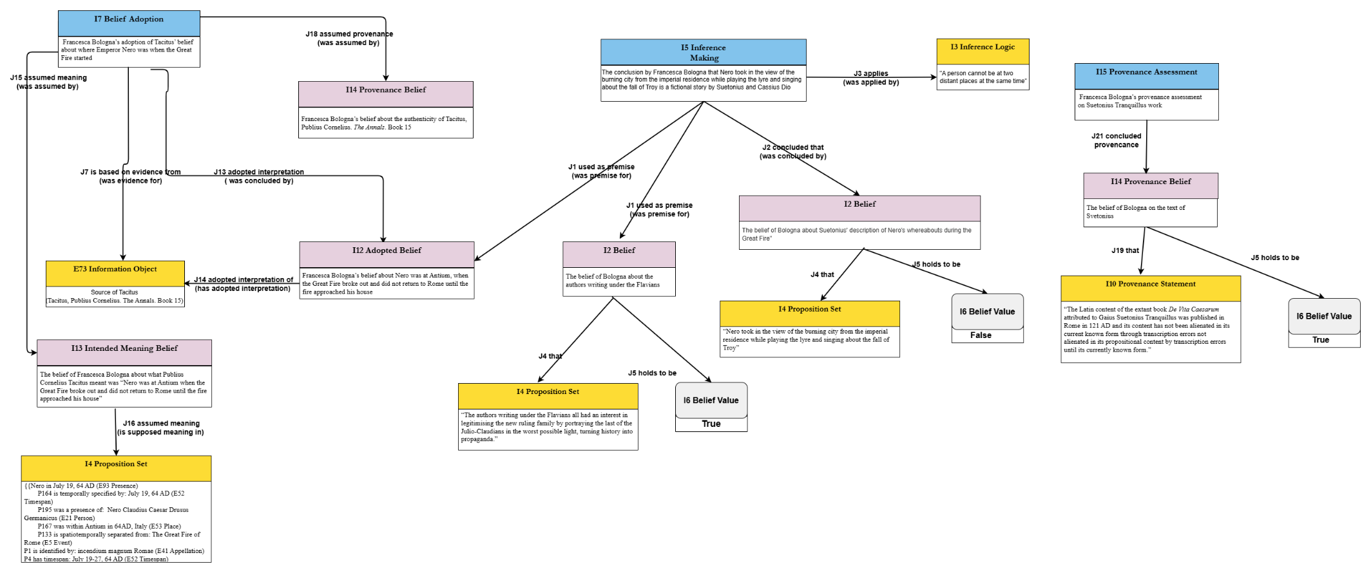
Figure 2: A scholarly argument concerning Nero's whereabouts during the Great Fire of Rome

