Issue 628: Update the modelling constructs found under The Model\Use&Learn\Functional Overview
Decisions per diagram –details in the appendix

Taxonomic Discourse diagram
The diagram documents how types are created in order to classify things
The following things need editing:
- Add P136.1 in the taxonomic role to P136 was based on (supported type creation)

Subject Information
- Substitute E21 Person for E39 Actor (could be a picture of E74 Group f.i.)
- Add the indirect IsA to E5 Event in the list of subclasses of E1.
- Change the label to “Subject Information” rather than “Subject Depicted Information” –it’s not limited to visual information (at least not in terms of what appears on the diagram)

Time-Span Information
- Do not disengage P10 falls within (contains) from E4 Period, but make sure to mark the property with a dashed line (as it is inherited from E92 Spacetime Volume). E92 Spacetime Volume is not critical information for this particular diagram.

Spatial-Temporal Relations
- The updated diagram looks very dense; it encodes too much information, unsure whether it’s extremely commonsensical.
  - There should be some textual description attached to it, to ensure that the information therein can be easily unpacked. We need to appoint someone to do that.
  - Especially in view of the fact that the website does not mention any STV-related pedagogical information.
- The diagram has been implemented with the previous (not universally agreed upon) version of the CHIN library. It needs to be updated.
- The information around E2 Temporal Entity could be split from the STV diagram and should probably get linked to “time-related” notions. Maybe reference some bits across diagrams. Or just create smaller bits for Temporal Entities and for Places and give a general overview for the STVs in this diagram.
  - HW: WS to do just that.

Reproduction Rights Information
- Change the label to “Rights Information” –it’s not only about reproduction rights.
- The following nodes are intended to document that one can always classify a right, and also add a textual description to it (of a particular type). It is one of the things where a short description of what the diagram is about and what the modeling is supposed to be doing can prove helpful.
  - P2 has type: E55 Type, and
  - P3 has note: E62 String (P3.1 has type: E55 Type):
- Add subclasses of E72 Legal Object that can be subject to a Right (E18 Physical Thing and E28 Conceptual Object).
- Delete P129 is about (is subject of)
- Delete E70 Thing

Reference Information
- E24 Physical Human-Made Thing. P62 depicts (is depicted by): E1 CRM Entity
  - The left-hand side should be aligned under E28/E89/E31, in the sense that it, too, is a class that can refer (in one way or another) to E1 CRM Entity.

Planned Actitivity (design, purpose, use) 1
- The diagram lacks a clear-cut purpose.
- If anything, the diagram should be relabeled “Intentional Activities” –its current name means that it’s future oriented.
- Mark the IsA between P33 used specific technique (was used by) and P16 used specific object (was used for)
- Delete the occurrence of E7 Activity at the bottom right corner of the diagram (done).
- Add P134 continued (was continued by) on E7 Activity.

Planned Activity (design, purpose, use) 2
- Rename the diagram “Intentional Activities 2”.
- Lose E1 CRM Entity. P2 has type (is type of): E55 Type link, to avoid duplicating the class in the diagram. Since the indirect ISA to E1 CRM Entity has been declared (through E70 Thing and E7 Activity), we assume that all relevant classes inherit P2.
- Use ETs copy of the slide, it only references E55 Type once, and the ISA relations show alright. The link between E1 CRM Entity and E55 Type remains implicit, but it can be inferred.

Recorder Information
- Make sure that P67 refers to (is referred to by) and P70 documents (is documented in) point to the E1 CRM Entity box on the top of the diagram.
- Add P177 assigned property of type (is type of property assigned) to the diagram.

Person Nationality Information
Discussion points:
- The diagram needs massive reorganization. The connection between E21 Person and an E74 Group is not particularly convincing, in the sense that not all national subjects of a given state act collectively or in a similar way. The information could be relayed through a
  - P2 has type. E55 Type {“a given nationality”} on E21 Person
  - P98i was born (brought into life): E67 Birth. P7 took place at (witnessed). E53 Place
- The P10 falls within (contains) property to be replaced by P9 consists of (forms part of): E4 Period
- E41 Appellation should be used for E21 Person, E74 Group, E53 Place, E4 Period as well –although maybe geospatial data can serve as what used to be Place Appellations, if that’s considered useful.
  - Alternatively, P172 contains or P168 place is defined by (defines place) could be used for E53 Place in particular.
These points should be part of the textual description of the diagram
HW: GB to do that.

Part and component information
Discussion points:
- Proposal to add P110 augmented (was augmented by), P112 diminished (was diminished by)
- Consider adding the superproperty of P110 and P112 (namely P31 has modified (was modified by) –Domain: E11 Modification, Range: E18 Physical Thing.

How to proceed:
- HW: ETz to check all the diagrams for mislabeled things, other kinds of typos etc.
- HW: GB, CEO, PM & WS to continue working on the diagrams.
This group will be working offline to edit the diagrams or generate new ones and will present them at the next SIG meeting (when they will be incorporated in the Functional Overview section of the website).

The SIG voted for the diagrams that have already been revised to be uploaded on the site -with a disclaimer that only a subset is revised (it’s going to be a work in progress).
Decisions applying to all diagrams:
- We try to keep the subproperty/subclass relation pointing upwards, where possible, but in cases where they become over encumbered, we don’t have to worry too much about it.
- The indirect IsA for classes does not really show the dashed line –needs to change so that readers can easily identify the specified kind of relation
- Take out the dashed lines surrounding the main class represented in a diagram, it’s underinformative and possibly creates ambiguities
- Come back to representing the E55 Type for .1 properties. They will appear more often, and should not mess up the diagrams completely. Maybe standardize a different representation for them. Maybe a smaller box, or different colour…
- Start a new issue about adding short descriptions to each diagram explaining what they are about etc.
Overall comment:
- Pointers from diagram to diagram in order to enhance the available information. Maybe instead of using draw.io, we could use Criteria diagrams.

Issue 628:

Taxonomic Discourse
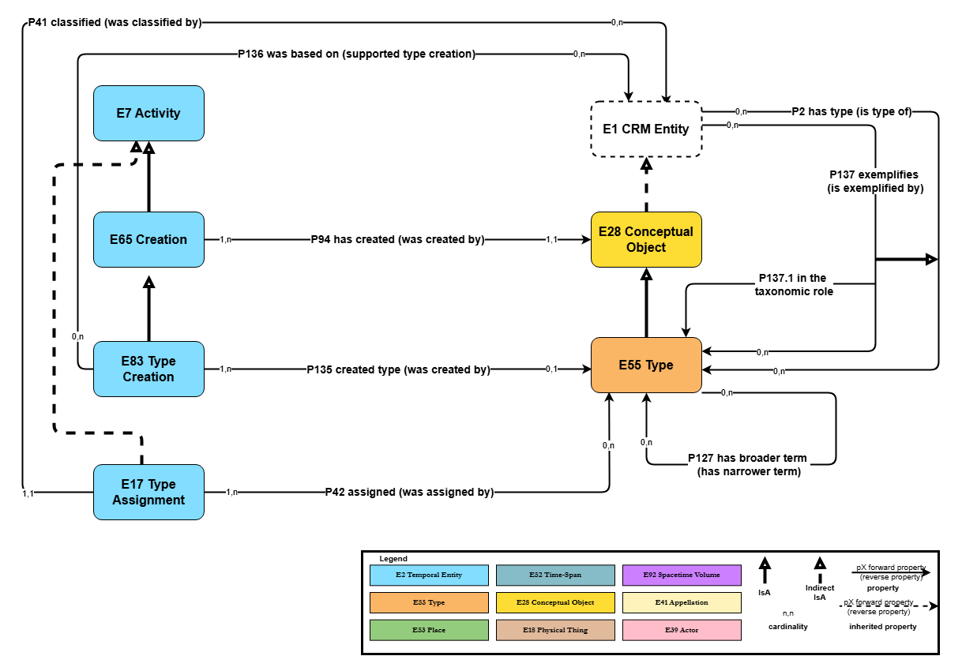

Subject Information
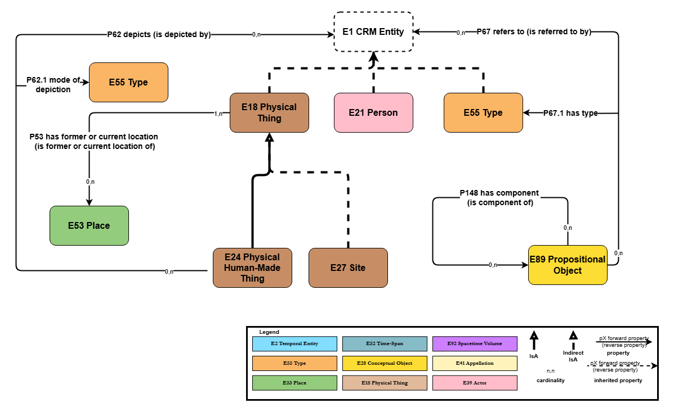

Time-Span Information
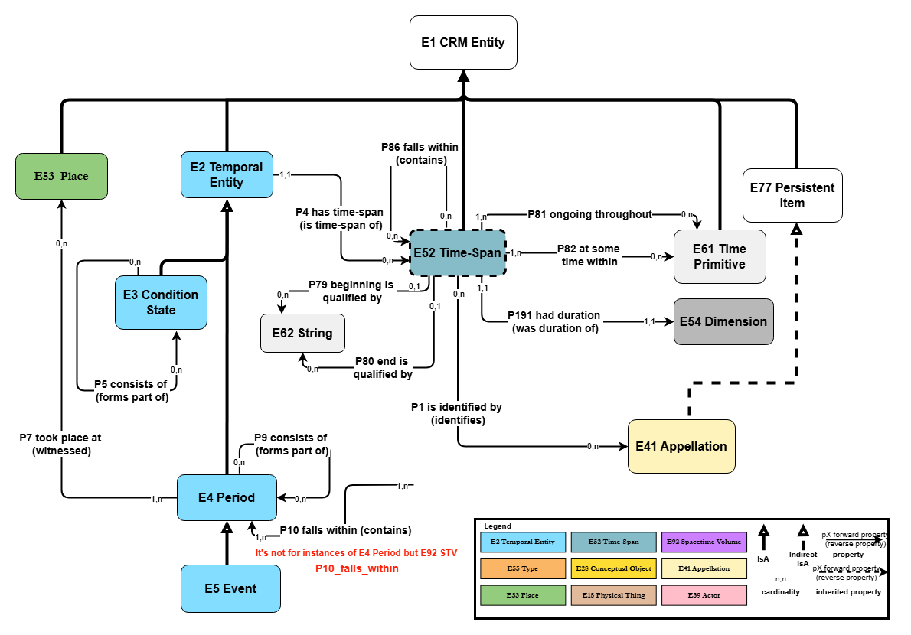

Spatial-Temporal Relations
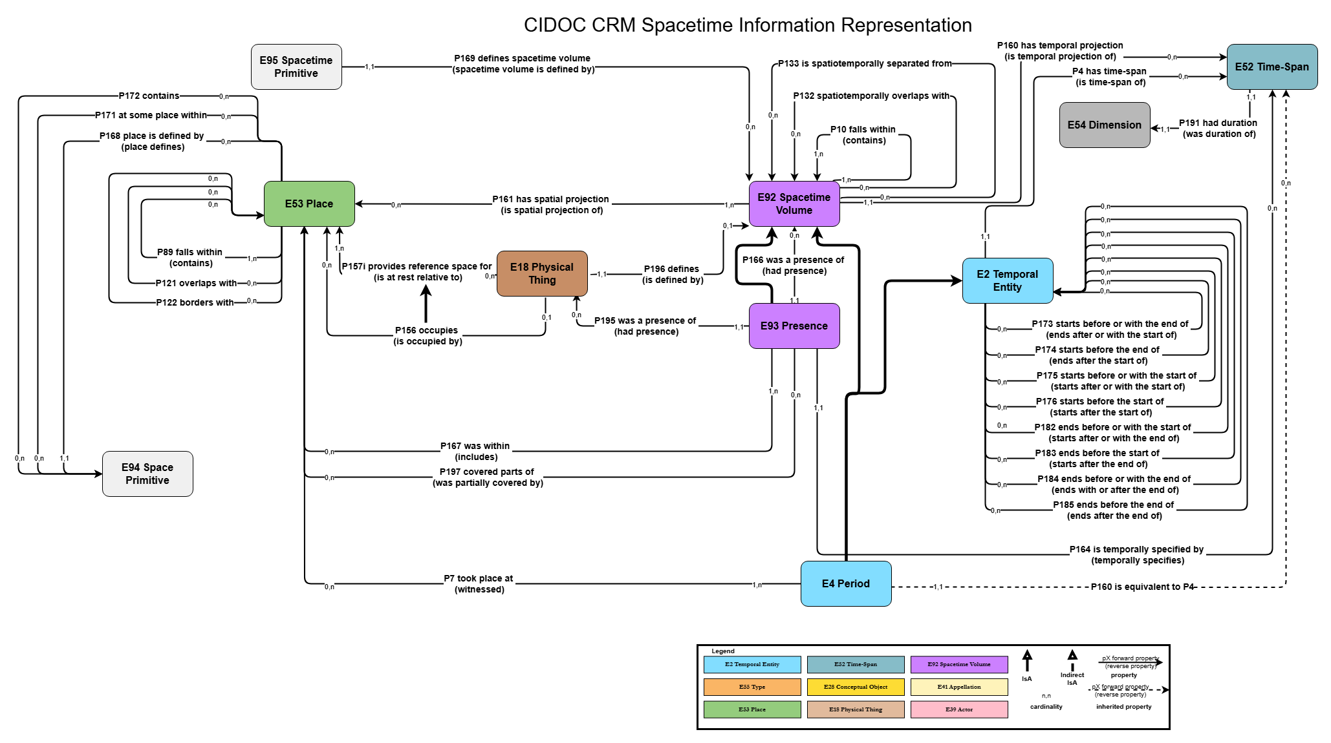

Reproduction Rights
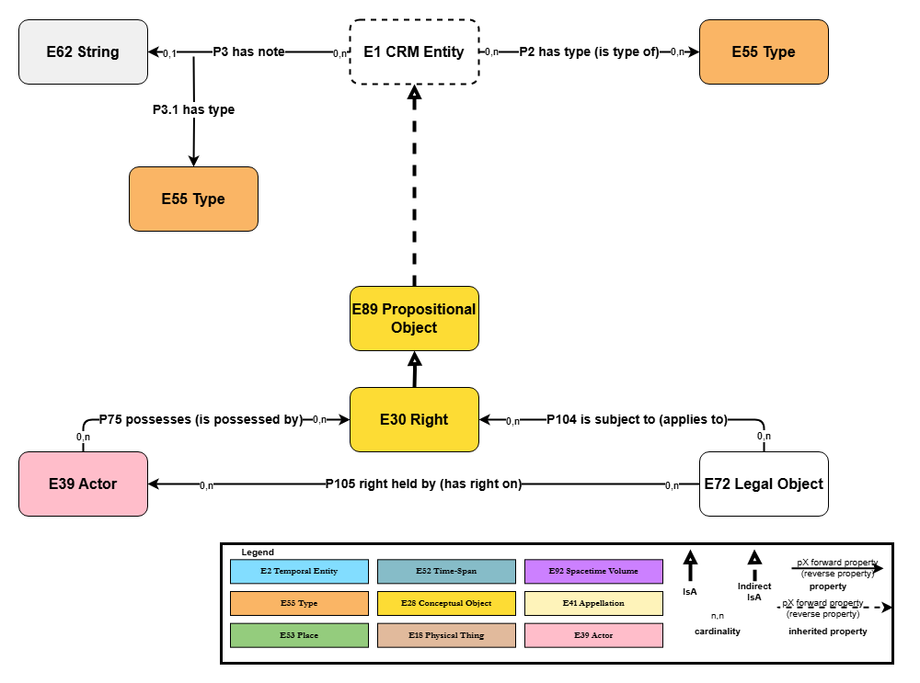

Reference Information
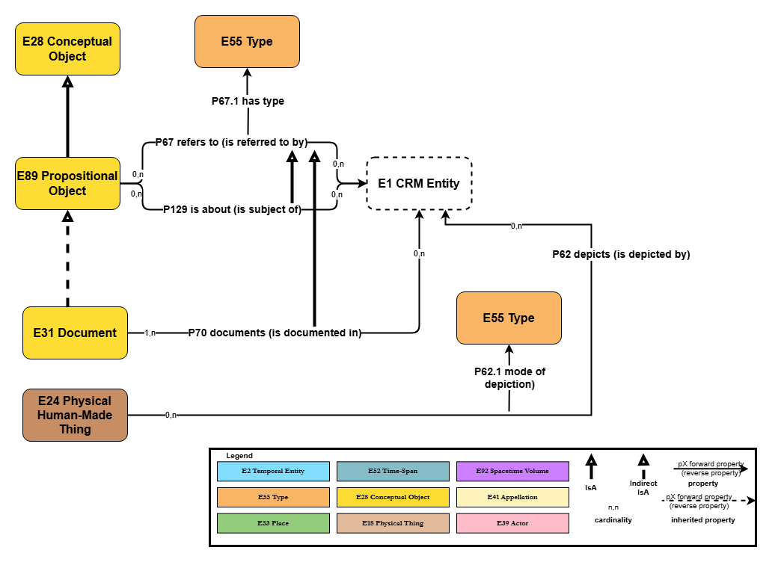

Planned Activities (design, purpose, use) 1
Nb. The diagram will be renamed “Intentional Activities 1”
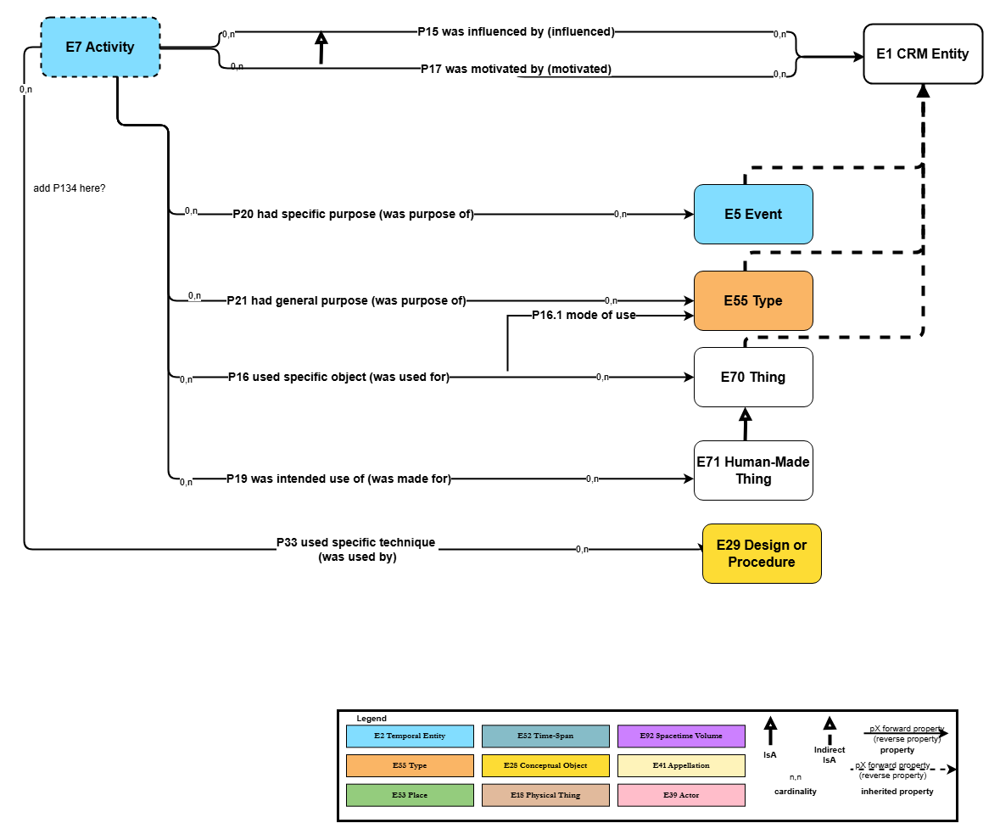

Planned Activities (design, purpose, use) 2
Nb. The diagram to be renamed “Intentional Activities 2”.
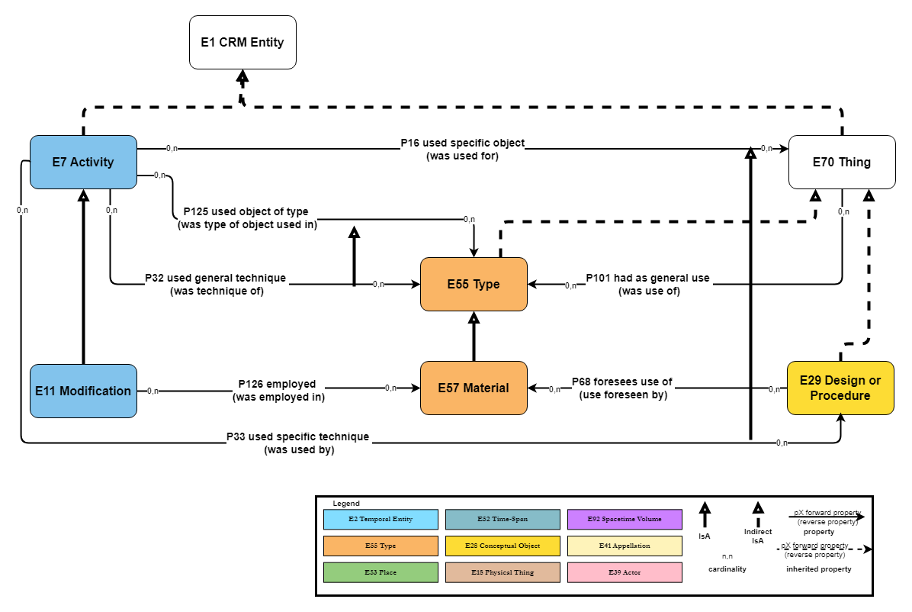

Recorder Information
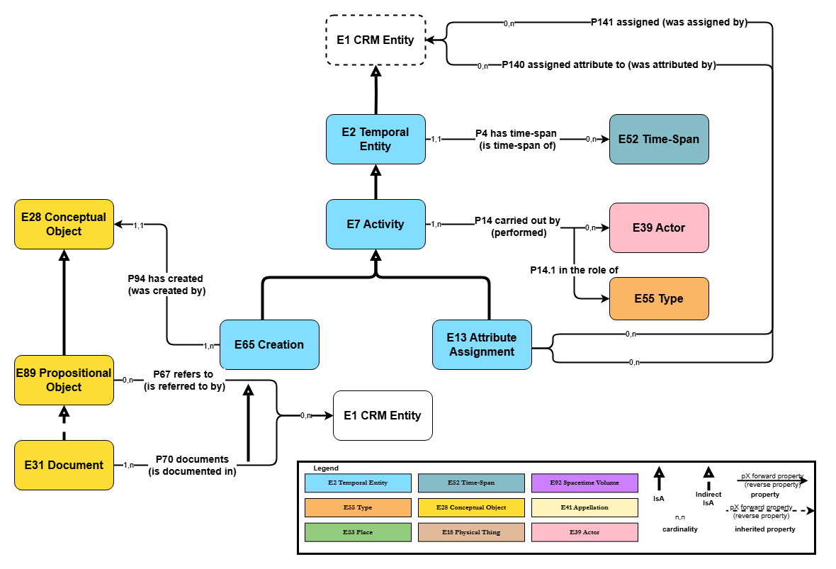

Person Nationality Information
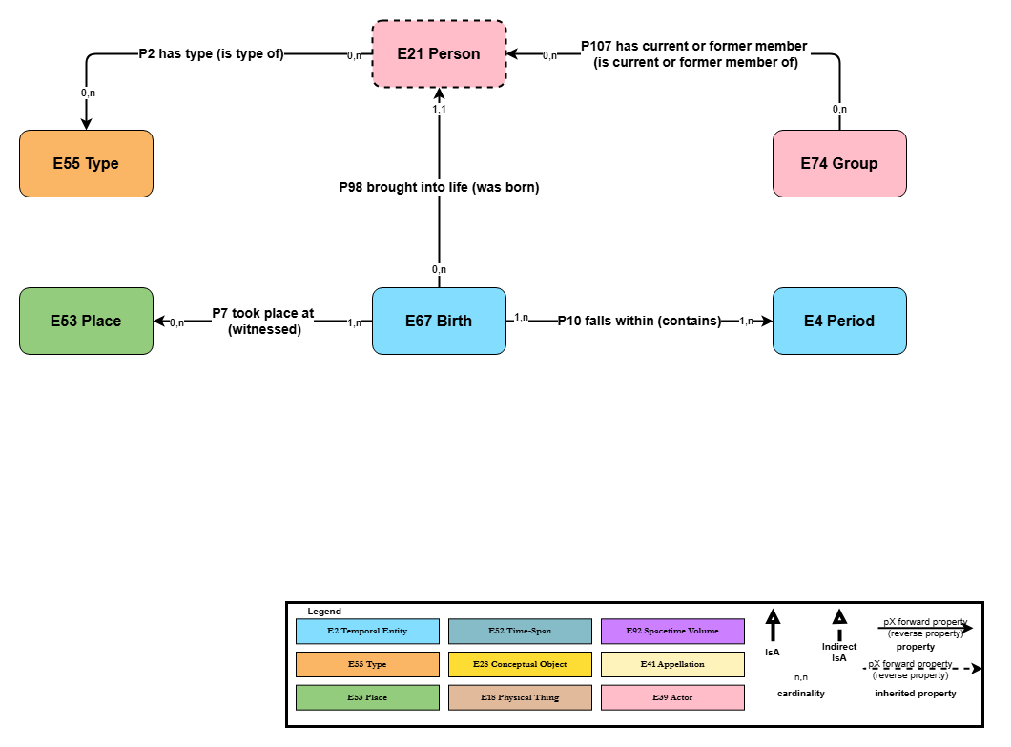

Part and Component Information
