The 37nd joined meeting of the CIDOC CRM SIG and ISO/TC46/SC4/WG9 and the 30th FRBR - CIDOC CRM Harmonization meeting
7-9 December 2016
Deutsches Archäologisches Institut(DAI)
Lepsius Kolleg,
Im Dol 2-6, Berlin-Dahlem

Chryssoula Bekiari (ICS-FORTH, GR), Francesco Beretta (Laboratoire de Recherche Historique Rhône-Alpes), George Bruseker (ICS-FORTH, GR), Pierre Choffé (BnF, FR), Martin Doerr (ICS-FORTH, GR), Øyvind Eide (Universität Passau, DE), Mark Fichtner, (GNM, DE), Günther Görz (FAU-DE), Sabine de Günther (Humboldt Universität, DE), Peter Haase (Metafacts, DE), Thomas Hänsli (ETHZ, CH), Gerald Hiebel (University of Innsbruck, AT), Florian Kräutli (Max Plank Institute for History and Science), Marco Klindt(ZIB, DE), Michael Müller (FU, Berlin), Dominic Oldman(British Museum, UK), Christian Emil Ore (Unviversity of Olso, NO), Stephen Stead (Paveprime Ltd, UK), Wolfgang Schmidle (DAI,DE), Leo Zorc (ETHZ, CH)

Wednesday 7 December

ISSUE 309
The crm-sig went over the text provided by MD and made the following comments:
(i) reedit the text
(ii) changed the notation of A^{s} and A^{e} to A^{start} and A^{end}
(iii) asked MD/Lida to correct the direction of the last two properties.
(iv) asked MD/Lida to add the appropriate super/sub relationships to the Allen properties – check which Allen relations should be deprecated
(v) asked Francesco Berretta and Wolfgang to add examples
The new revised text is attached in the appendix of these minutes. Also the crm-sig decided the following:
(a) make a new section in the introduction of the CIDOC CRM text with title “Specific Modelling Constructs” and
(i) move the already existed paragraph “About Types” there
(ii) add the introduction of the above text there
(iii) Enumerate the topological relations i.e. spatial and temporal and write an introduction for them. This is assigned to MD GH
(b) Consider the semantic grouping of relations/classes for providing a digital index to tools and for being used in educational materials. This is assigned as HW to GB. Sources for this assignment will be of Martin’s presentations on how to organize classes and relations according to topics.

ISSUE 326
The crm-sig found that setting E2 isA E52 and E92 isA E52 is not causing any syntactic problems in the model(tested by Chryssoula),but it causes a conceptual inconsistency since the Spacetime Volume could be either phenomenal or declarative but ‘time span’ is definitively phenomenal in the model at present.
Martin designed the following figure on the blackboard
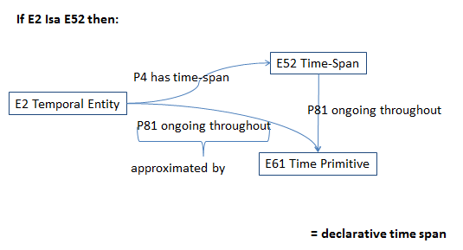
Figure 1
Then the crm-sig made a list of problems/realizations needed to be discussed more. The list includes the following:
- E52 is phenomenal
- E52 cardinality constraint was wrong between E2 and E52 in P4 must be 1:1
- Either E52 or E2 is redundant
- temporal relationships are already attached to E2
- E4 being isA E2, isA E92 causes the properties P4 and P160 to be competitive
- There should be one P4 & P160, there should be one domain
- No concept of declarative time span exist
Regarding the question if we can really abstract the phenomenal from declarative, Martin drew on the board the following figure
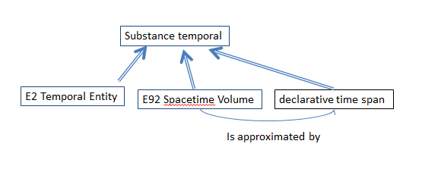
Figure 2
Finally the crm-sig concluded that next steps should be:
- To find examples of E2 that are not spacetime volumes (ie non spatial)
- To find examples of declarative time spans and places
- To prepare a practice guide experience (decision from CRMgeo) where to use declarative place
Homework for the next meeting is assigned to GB, who is to write a text about this situation and then this text should be reviewed by Wolfgang and CEO

ISSUE 312
The sig reviewed proposals from previous meeting about E4 Period and assigned Gerald and Wolfgang to revise the scope note of E4 Period considering that the period maybe a geopolitical unit: a real phenomenon, Claim of power / jurisdictional area
Also, crm-sig asked Dominic to provide examples about modern and ancient periods.
Subsequently, the crm-sig discussed about the declarative vs phenomenal nature of the geopolitical unit and commented that this is should be under consideration.
They agreed that ontologically the geopolitical unit may be an extent like (a) a settlement (b) physical feature (c) an area where population is living.
Finally it is assigned to Chistian Emil to provide examples from Norway / Sweden
Also the crm-sig reviewed and accepted the examples about fictitious persons and places proposed by Oyvind to E89 Propositional object.

ISSUE 275
The crm-sig discussed this issue and made the following proposals and decisions:
(a) GB should improve his proposal about the scope note of E61 according to the following recommendations:
- check the consistency of the proposed scope note (2nd paragraph with the properties P81 and P82, and if they can be referenced to.
- check the third paragraph (instances of E61) against E59 Primitive Value and if this is not expressed there, this should be moved here.
- To consider if E61 is a declarative time – span (Linked to the overall issues of E52 either an approximation or declarative in sense of plan)
(b) the reference note in the scope note of P169 defines spacetime volume (spacetime volume is defined by) should be removed. There is a problem with making references to an extension from core. The improvement of the scope note is postponed since there is a general consideration of phenomenal vs declarative spacetime
(c) approved the changes in the scope note of P171, P172
(d) since in common documentation practice it might be needed to express a place that is indefinitely related (P171, P172), it is assigned to Gerald to formulate a question/issue about this in order to be discussed in the next meeting.

ISSUE 288
The crm-sig discussed the proposal of Christian - Emil and decided that this issue cannot be solved without addressing the overall issue discussed in issue 309. To contribute to / consider within that overall discussion it should be decided how time primitives relate to E2 instances. A Potential solution is to identify these constructs with declarative time spans. It seems that a generalization of phenomenal vs declarative properties is required.
This issue remains pending.

ISSUE 234
The sig reviewed and accepted the proposed changes to the scope note of P7 made by Christian Emil for expressing in words the FOL representation. It is assigned to MD and GB to find the representative date for ‘Britain’ in order to complete the scope note of P7.
The crm-sig reviewed and accepted the proposed changes to the scope notes of P132 and P133 made by MD, for expressing in words the restriction in FOL representation of these properties.
The example in P121 proposed by MD was accepted.
The examples proposed in P132 and P133 were accepted, but references are required. It is assign a task to Lida to find references for all the examples in the text of CRM.

ISSUE 276
Martin should ask Carlo on formal properties, no action

ISSUE 318
The crm-sig discussed the proposal about the examples made by Velios and changed the examples of E3 Condition State.
Also a new issue emerged about the identity conditions for states in S16 Sate in CRMsci. Martin proposed to check the ABC model for materials (George ?)

ISSUE 306
No discussion, no HW it is still pending

ISSUE 302
The crm-sig reviewed the proposal made by Martin about A6 Group Declaration Event and assigned to GB and Steve to check the syntax considering the follow comments
- At the time of reference of being destroyed and time of reference in the past the two things shared complete identity.
- B5 should be removed.
- To investigate if we should restrict to man-made objects. (See Martin’s comment about the stone in the image and imagine the stone, without the stand, dispersed in the remains of a burned-down temple!)
- Think about a constraint in first order logic that the STV of the target thing has to be "before" the activity.
Then the crm – sig reviewed and made changes to the proposal made by Achilles about AP16. They decided that P141 cannot be used here since the range has been restricted. Need to declare a subclass and assigned to homework to GB to make the scope more comprehensible
The revision of the examples of A7 and A8 is still pending.

ISSUE 303
The CRM-SIG accepted Martin’s proposal about FOL expressions to A2, A7, AP19, AP20, about quantification and scope note of AP19, AP20. The changes should be incorporated in the “current” version 1.4,3 with editorial status Under Revision , January 2017. The issue is closed

ISSUE 299
The crm-sig reviewed the proposals made by Lida and Achille and changed the scope notes of AP15 and AP21. Also considering that there are non-stratigraphic style archaeological methods, the sig asked Gerald Hiebel to generalize these scope notes.

ISSUE 315
The crm-sig discussed about planned activities, considering George' s proposal, and asked him to continue working on this taking into account the following comments:
- An activity pattern is needed giving permissions
-this would only cover activities that actually did take place

Thursday 8 December

Presentations
We started with presentations
(1) “on new Semantic Web database building system” by Dominic Oldman, Peter Haase
(2) "Sacrobosco’s Sphaera – Mapping Knowledge Networks” by Florian Kräutli from MPI

Discussion
After the second presentations, the sig discussed the problems encountered by Florian Kräutli.
a) What we can avoid on modelling individual work: Martin proposed that if there is 1:1 relation between expression and work, we can make a query that may reproduce the relation between individual work and expression. It might be a good practice on implementation. He drew the following figure on the board
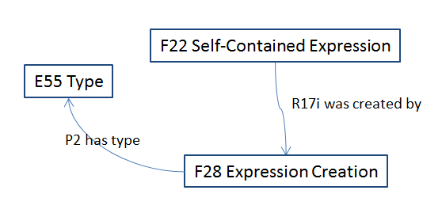
Figure 3
b) What we can avoid on modelling individual work: it is proposed to investigate the “work limits” Pierre Choffe, Dominic, Florian, Geronimo??, Christian Emil will work on this.
c) about modelling parts of publications: to check 3D co form rdf data types
d) about addressing location in media: a good practice is:
to investigate METS <area> construct and extended to 3D
to make use rdf literal which then encodes such a structure
e) about origin and composition of publications:
to make use of named graph, there is an open annotation OAM as a standard, it was developed simultaneously with the named graph
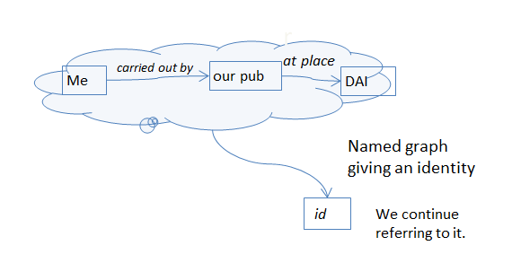
Figure 4
It is proposed to create a text that connects a named graph with the belief adoption of CRMinf (SS, Francesco, CEO, MD, Dominic, George will work on this)
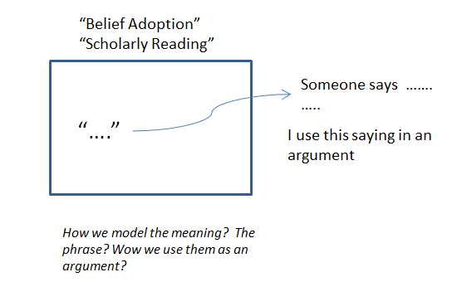
Figure 5

Presentations continue
(4) Presentation of IT department of DAI by Prof. Dr. Reinhard Förtsch
(5) “The DOREMUS model, a FRBRoo extension for complex music” by Pierre Choffe
(6) “Is FRBRoo complex ? Experience, Feedback, Proposals” by Pierre Choffe
(7) “Parthenos Architecture” by Martin Doerr
(8) “long term archiving of 50 years of archaeological documentation” by Gerald Hiebel
(9) “integrate mining archaeology resources” by Gerald Hiebel
(10) “ semantics into a corpus of alpine literature” by Gerald Hiebel

ISSUE 287
The crm-sig discussed about Regina’s post and suggested that a CIDOC CRM extension into the world of artistic printing might be interesting. Subsequently reviewed Pat's proposal and decided that Modification would not be strong enough, since in modification the physical thing’s identity doesn’t change, there is nothing new. The sig proposes to Pat to make use of transformation (with implied destruction) instead of modification. If Pat accept and the notion of transformation is correctly interpreted, then the FAQ answer can be accepted, otherwise the issue should be discussed.
Martin drew on the board the following figure
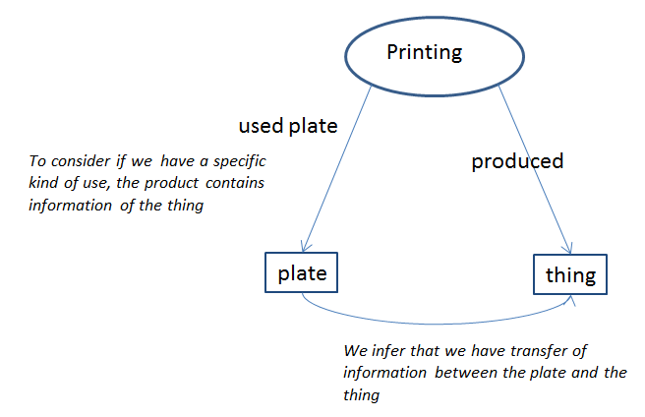
Figure 6:Visual Work printing process
Also a related issue has been raised about a specific type of ‘used’ relation in a production that would allow tracking of transfer of information.

ISSUE 278-268
The crm-sig discussed these two issues together, since both are about mass production. The crm-sig reviewed the proposed new classes and properties and concluded to the following:
a) homework: The sig assigned to Steve and George to elaborate the scope note of Exx Product Type with the aim to express the identity given by a company and taking into account the practice in ancient times. The accepted scope note follows. About the label of class, it should be sent an email to see if there are better options, otherwise stay with the proposed ones: (i) batch product type or (ii) mass product type or (iii) industrial product type.

Exx Product Type: (proposed by MD)
Scope note: This class comprises types that characterize instances of E22 Man-Made Object that are the result of production activities that
- use the same plans and
- are intended to result in one or more series of functionally and aesthetically identical and interchangeable items.
A notable case is component parts which are typically replaceable pieces of a larger assembly. Instances of this class would, for example, capture the characteristic type of the series of objects that share a manufacturer’s model number.
Frequently this uniform production is achieved by creating individual tools, such as moulds or printing plates, that are themselves carriers of the design of the product type. Modern tools may use the flexibility of electronically controlled devices to achieve such functionally and aesthetically identical products without themselves being specific to the created product. The product type itself, i.e., the potentially unlimited series of aesthetically equivalent items, may be the result of an artistic design process, in contrast to the design of an individual object.
In extreme cases, only one instance of a product type may have been produced, such as in a "print on demand" process. However, this case should not be confused with industrial prototypes, such as car prototypes, which are produced prior to the production line being set up, or to test the production line itself.
Examples: Volkswagen Type 11 (Beetle)
Dragendorff 54 samian vessel
1937 Edward VIII brass threepenny bit
Qin Crossbow trigger un-notched Part B (Bg2u)
Nokia Cityman 1320 (The first Nokia mobile phone)
Proposed properties: A unique plan, a required, unique tool.

b) the proposed property has been accepted with the following definition

Px1 produced thing of product type (is produced by)
Domain: E12 Production
Range: Ex Product Type
Quantification: many to many (0,n:0,n)

Scope note: This property associates an instance of E12 Production with the instance of Ex Production Type, that is, the type of the things it produces.
Examples: The production activity of the Volkswagen factory during 1949-1953 (E12) Px produced thing of product type Volkswagen Type 11 (Beetle) (Exx).

c) the proposed property ‘Px2 is example of (has example)’ has not been accepted
d) the proposal to set R7 is example of sub property of Px1 produced thing of product type has not been accepted since Px1 links event to type and not thing and type
e) the proposal to set R26 produced things of type sub property of Px2 is example of has not been accepted because of (c)
f) add cardinality to the plan property (plan is necessary) and decide if there are any further properties of relevance. It is assigned to MD to continue working on the property declarations for plans and specific tools, categorical properties for items produced and used by activities that produce things of this product type considering as a generalization of what is found in FRBRoo

ISSUE 312
Oyvind’s HW and Martin’s revision accepted. It should be added with the proper punctuation and the relevant class numbers. No need for an issue.

ISSUE 307
The sig reviewed and accepted the proposed scope note of E16 Measurement which includes the recommendations of previous meeting and asked Oyvind to provide examples for image and symbolic object e.g. word count of the crm based on the pdf of CRM 5.0

ISSUE 227
The sig reviewed Steve’s and Oyvind’s proposal about P165 incorporates and decided that the yellow and blue paragraphs need to be criticized, elaborated and revised by MD so that it will become a more general paragraph about feature transfer.

ISSUE 296
It should be discussed together with Carlo, no action

Friday, 9 December

ISSUE 321
Trying to describe the fact that two rooms may be connected through a door or through a corridor, the following properties are defined in the new version CRMba 1.4
BP11 is connected to
Domain: B2 Morphological Building Section
Range: B2 Morphological Building Section
Quantification: one to many (0,n:0,1)
Scope note: This property identifies the instance of B2 Morphological Building Section which is connected to another instance of B2 Morphological Building Section. The instance of E24 Physical Man Made Thing through which the connection between the two instances of B2 Morphological Building Section is made, can be recorded using the property BP11.2 is connected through.
Examples: The great hall (B2) is connected to the sacristy (B2).
Properties: BP11.1 in the mode of: E55 Type
BP11.2 is connected through
Domain: BP11 is connected to
Range: E24 Physical Man Made Thing
Quantification: one to many (0,n:0,1)
Scope note: This property identifies the instance of E24 Physical Man Made Thing through which the connection between the two instances of B2 Morphological Building Section is made.
Examples: The great hall (B2) is connected to (B11) the sacristy (B2) is connected through the corridor (E24).
any comments or suggestions?
After discussion the crm-sig decided that the relations are useful, but the scope note should make clear the type of connection. It would seem that the connection intended is to pass through. If this is the intention, then the domain/range specification should be changed. It is only empty sections that are connected (you can’t walk through a wall).
Also the connectivity for liquid/air/water/sound/light/smell should be investigated since it could be an issue for modelling in future
About 11.2: It should be clarified whether this property employs transitivity, if yes then the 11.2 should be replaced by transitivity rules. To resolve this it might be needed to consider how to model openings? Door as opening, corridor as empty space e.g. Room A connected to Corridor B connected to Room C
The crm-sig assigned to George to talk to Paola in order to reformulate it.

ISSUE 316
The crm-sig discussed about what is a reasonable formulation in describing a co reference statement with CRMinf
Martin drew on the board the following figure

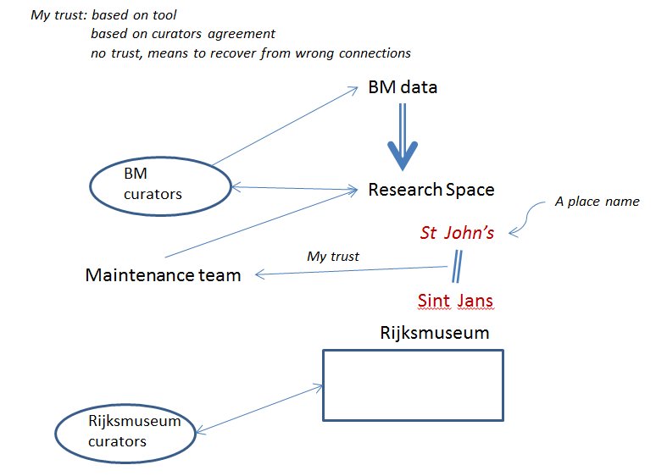
Figure 7
It is agreed that we should look at belief states implied in describing a co-reference statement (and disbelief). Oyvind, Dominic and MD will make a proposal about this by to the end of January (related to Research Space implementation of CRMinf).
The idea is to describe a use case of an instance matching process of an aggregator with provider’s data

ISSUE 320
Trying to apply CRMinf in a real example of an archaeological excavation, it is noted that the quantification of the properties is missing.
Steve’s proposed to relate belief adoption and manifestation product type. Martin drew the following figure in the board
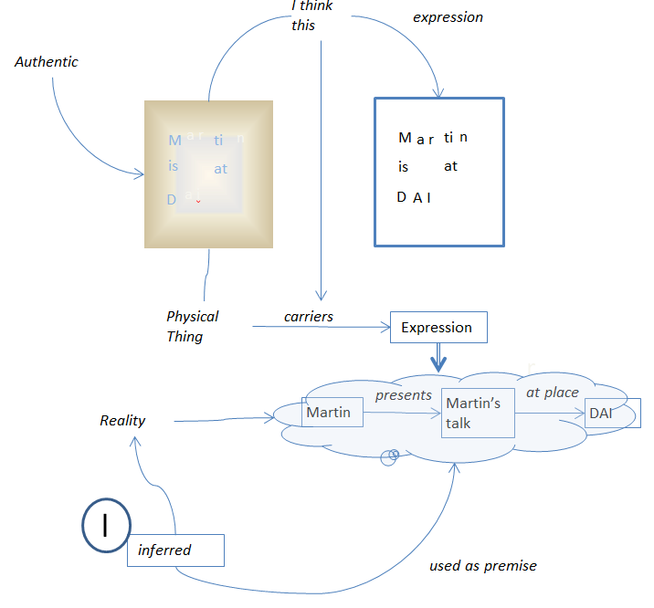
Figure 8
Comments to the above figure were: the point is not to ignore any step of this process. The problem is the complexity of this process. Can we describe in CRMinf a link in the model that someone uses the link to see the beliefs that someone did?
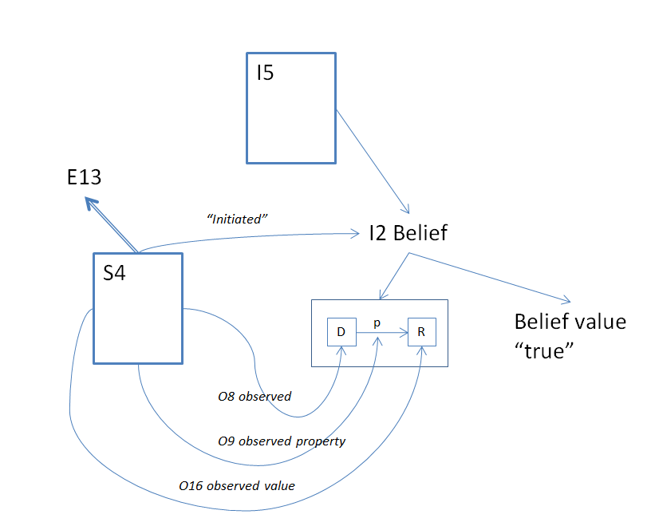
Figure 9
The crm-sig assigned to Steve, CEO and Wolfgang to specify the quantifications and the temporal constraints. Also they should take into account the new temporal properties.

ISSUE 250
The crm-sig discussed how to proceed with mapping between TGN and CRMgeo. It is decided to form a CRMgeo team which should investigate the mapping with other known in use gazetteers. Finally the sig proposed
(a) Wolfgang will investigate, if possible, the mappings to the gazetteers of DAI
(b) Francesco Beretta the mapping to the gazetteers from LARHRA
(c) Max Planck the mapping to the Chinese local gazetteers
(d) Wolfgang to discuss it with the people at Pleiades meeting

ISSUE 291
The crm-sig text slightly edited the text proposed by GH and accepted for publishing on site.

ISSUE 293
The crm-sig accepted the examples provided by GB. The homework assignment of MD, CEO, Oyvind about transferring S15 Observable entity to CIDOC CRM remains open.

ISSUE 311
The crm-sig accepted the change of the label of S20 Physical Feature to S20 Rigid Physical Feature and made changes to the definition of the class. HW is assigned to SS and MD to rework the syntax and consistency.

ISSUE 322
It was assigned to Christian -Emil to analyse and see if FOL representation is possible between the E13 Attribute Assignment and S4 Observation with the named graph construction of I1 Argumentation and also it was noted that a link is needed between the temporal constraint belief and the argumentation that motivated it.
Also the crm-sig decided to open a new issue about the missing quantifications of CRMsci

ISSUE 308
The sig reviewed and accepted the proposed changes in scope note of S4 Observation of CRMsci version 1.2.3. The issue is closed.

ISSUE 273
The crm-sig discussed the pending issues in
P179 : decided that the proposed super property was incorrect due to range conflict and there is no super property appropriate for this property
E98: made minor changes in the scope note
The issue is closed.

ISSUE 203-205 (new issue 325)
Discussing the remark of the outcome of the issues 203-205, about the revision of P138, the crm-sig made the following comments:
- with regards to digitization and the question if the 3d object or other digitization ‘incorporate’ the information that was carried by the painting, the scope note of P138 is complete.
- On the one hand, a digitization might be done in a way that only captures some attributes which could not be said to carry the information that the object was meant to convey.
- Also if we take an accurate image of the object, then in a sense we could say that the resultant digital product has indeed incorporated the information carried by the original.
- From the above it seems that there is also the question of what tolerance one holds towards loss of information within the transfer from analogue to digital.
- This requires a deeper investigation since if information content of physical thing is of symbolic nature then there is a resolution at which we could certainly say that the digitization will carry the symbolic content of the original. (properly digitized texts, where symbols are properly captured)
Finally the crm-sig assigned to MD, Oyvind and (possibly with the help of Max Plank’s people)to write a guideline under which conditions it can be said that a digitization of a physical object incorporates an information object that the physical object that was digitized carries

ISSUE 260
The crm-sig reviewed the proposals made by Oyvind and proposed the following:
E41: Added a paragraph to the scope note
E35: Accepted the comment made by Oyvind that the scope note of E35 Title is misleading, since it refers to something functioning a title, not having the form of a title, it is decided to keep the Title, to update scope note. This HW is assigned to Oyvind
E42 Identifier: keep and fix scope note
E44 Place Appellation: Keep
E49 Time Appellation: keep but it should be merged with Date and it should be decided if they keep the same name (Oyvind)
E51 Contact Point: Keep and harmonize with Parthenos and relate to services (GB)
E75 Conceptual Object Appellation: delete
E82 Actor Appellation: delete
E46 Section definition: delete
Also the crm-sig decided that when a property or a class is deleted then its definition should be removed from the text, (sub classes, scope note and examples) and leaves a note saying ‘deprecated’ use X instead. The properties of the deprecated class will either be deleted or changed domain.

ISSUE 304
The crm-sig decided to merge this issue with the issue 260. The E51 Contact Point should be harmonized with Parthenos. GB will elaborate the proposal. The outcome will be presented in the issue 260. This issue is closed

ISSUE 305
The crm-sig, resolving the issue 260, decided to delete the class E82 Actor Appellation. The issue is closed.

ISSUE 290
The crm-sig, resolving the issue 260, decided to delete the class E75 Conceptual Object Appellation. The issue is closed.

ISSUE 317
The crm-sig reviewed this issue together with the issue 260.Thus, the sig proposed the following for the classes referred to this issue:
E45 Address – it remains
E46 Section Definition – it is deleted
E47 Spatial Coordinates - it remains
E48 Place Name - it remains
E49 Time Appellation - it remains, to be merged with E50 Date (Oyvind)
E50 Date - it remains, to be merged with E49 Time Appellation. (Oyvind)
E75 Conceptual Object Appellation - it is deleted
E82 Actor Appellation - it is deleted
E51 Contact Point - it remains, to be harmonized with Parthenos (GB)
E35 Title - it remains, the scope should be updated (Oyvind)
It is decided to report to all concerned and who gave advice on this issue of the final decisions.
It is assigned to SS to rework overall remaining scope notes.

ISSUE 319
The sig resolved this issue and corrected the quantifiers of P96 by mother (gave birth) and P97 from father (was father for), the issue is closed.

Appendix A.: Temporal Relation Primitives based on fuzzy boundaries

Introduction
It is characteristic for sciences dealing with the past, such as history, archaeology or geology, to derive temporal topological relations from stratigraphic and other observations and from considerations of causality between events. For this reason the CIDOC CRM introduced in version 3.3 the whole set of temporal relationships of Allen’s temporal logic (properties P114 to P120). It was regarded at that time as a well-justified, exhaustive and sufficient theory to deal with temporal topological relationships of spatiotemporal phenomena relevant to cultural historical discourse. Allen’s temporal logic is based on the assumption of known, exact endpoints of time intervals (time-spans), described by an exhaustive set of mutually exclusive relationships.
Since many temporal relations can be inferred from facts causal to them, e.g., a birth necessarily occurring before any intentional interaction of a person with other individuals, or from observations of material evidence without knowing the absolute time, the temporal relationships pertain in the CIDOC CRM to E2 Temporal Entities, and not their Time-Spans, which require knowledge of absolute time. If absolute times are known, deduction of Allen’s relation is a simple question of automated calculus and not the kind of primary scientific insight the CRM, as a core model, is interested in. However, their application turned out to be problematic in practice for two reasons:
Firstly, facts causal to temporal relationships result in expressions that often require a disjunction (logical OR condition) of Allen’s relationships. For instance, a child may be stillborn. Ignoring states at pregnancy as it is usual in older historical sources, birth may be equal to death, meet with death or be before death. The knowledge representation formalism chosen for the CRM however does not allow for specifying disjunctions, except within queries. Consequently, simple properties of the CRM that imply a temporal order, such as P134 continued, cannot be declared as subproperties of the temporal relationship they do imply, which would be, in this case: “before, meets, overlaps, starts, started-by, contains, finishes, finished-by, equals, during or overlapped by” (see P174 starts before the end of).

Secondly, nature does not allow us to observe equality of points in time. There are three possible interpretations of this impossibility to observe these equality of points.Common to all three interpretations is that they can be described in terms of fuzzy boundaries. The model proposed here is consistent with all three of these interpretations.
- Any observable phenomenon that can be dated has a natural temporal extent with fuzzy boundaries of gradual transition from not existing to definitely existing and then to no longer existing.
- These fuzzy boundaries can also be interpreted as the time intervals about which experts, even with a complete knowledge of the described phenomenon, may not agree as to whether this phenomenon is already ongoing or not, or still ongoing or not.
- Under a third interpretation, the fact that an instance of E2 Temporal Entity is ongoing is not observable within the fuzzy boundaries.

Consider, for instance, a birth. Extending over a limited and non-negligible duration in the scale of hours it begins and ends gradually (1), but can be given alternative scientific definitions of start and end points (2), and neither of these can be determined with a precision much smaller than on a scale of minutes (3). The fuzzy boundaries do not describe the relation of incomplete or imprecise knowledge to reality. Assuming a lowest granularity in time is an approach which does not help, because the relevant extent of fuzziness varies at a huge scale even in cultural reasoning, depending on the type of phenomena considered. The only exact match is between arbitrarily declared time intervals, such as the end of a year being equal to the beginning of the next year, or that “Early Minoan” ends exactly when “Middle Minoan” starts, whenever that might have been.
Consequently, we introduce here a new set of “temporal relation primitives” with the following characteristics:
- It is a minimal set of properties that allows for specifying all possible relations between two time intervals given by their start and end points, either directly, or by conjunction (logical AND condition) of the latter.
- Start and end points are interpreted as “thick” fuzzy boundaries as described above.
- Conditions of equality of end points are relaxed to the condition that the fuzzy boundaries overlap. Therefore knowledge of the shape of the fuzzy function is not needed.
- All of Allen’s relationships can be expressed either directly or by conjunctions of these properties.
- In case of time intervals without or with negligibly short fuzzy boundaries, all of Allen’s relationships can exactly be described by adequate conjunctions of these properties.
- No relationship is equal to the inverse of another. Inverses are specified by exchanging the roles of domain and range.

Notation
We use the following notation:
Comparing two instances of E2 Temporal Entity, we denote one with capital letter A, its (fuzzy) starting time with A^{start} and its (fuzzy) ending time with A^{end}, such that A = [A^{start},A^{end}]; we denote the other with capital letter B, its (fuzzy) starting time with B^{start} and its (fuzzy) ending time with B^{end}, such that B = [B^{start},B^{end}].
We identify a temporal relation with a predicate name (label) and define it by one or more (in)equality expressions between its end points, such as:
A starts before the end of B if and only if (≡) A^{start} < B^{end}
We visualize a temporal relation symbolizing the temporal extents of two instances A and B of E2 Temporal Entity as horizontal bars, considered to be on an horizontal time-line proceeding from left to right. The fuzzy boundary areas are symbolized by an increasing/decreasing color gradient. The different choices of relative arrangement the relationship allows for are symbolized by two extreme allowed positions of instance A with respect to instance B connected by arrows. The reader may imagine it as the relative positions of a train A approaching a station B. If the relative length of A compared to B matters, two diagrams are provided.

Overview of Temporal Relation Primitives
The final set of temporal relation primitives can be separated into two groups:
1) Those based on improper inequalities, such as A^{start} ≤ B^{end} (odd number items in the list below- table 1)
2) Those based on proper inequalities, such as A^{start} < B^{end} (even number items in the list below- table 1).
Improper inequalities with fuzzy boundaries are understood as extending into situations in which the fuzzy boundaries of the respective endpoints may overlap. In other words, they include situations in which it cannot be decided when one interval has ended and when the other started, but there is no knowledge of a definite gap between these endpoints. In a proper inequality with fuzzy boundaries, the fuzzy boundaries of the respective endpoints must not overlap, i.e., there is knowledge of a definite gap between these endpoints, for instance, a discontinuity between settlement phases based on the observation of archaeological layers.

1. P173 starts before or with the end of (ends with or after the start of)
2. P174 starts before the end of (ends after the start of)
3. P175 starts before or with the start of (starts with or after the start of)
4. P176 starts before the start of (starts after the start of)
5. P182 ends before or with the start of (starts with or after the end of)
6. P183 ends before the start of (starts after the end of)
7. P184 ends before or with the end of (ends with or after the end of)
8. P185 ends before the end of (ends after the end of)
Table 1, temporal relation primitives

Scope notes

P173 starts before or at the end of (ends with or after the start of)
Domain: E2 Temporal Entity
Range: E2 Temporal Entity
Subproperty of:
Superproperty of: E2 Temporal Entity. P174 starts before the end of (ends after the start of):
E2 Temporal Entity
E2 Temporal Entity. P119i is met in time by: E2 Temporal Entity
Quantification: many to many (0,n:0,n)

Scope note:
This property specifies that the temporal extent of the domain instance A of E2 Temporal Entity starts before or simultaneously with the end of the temporal extent of the range instance B of E2 Temporal Entity.
In other words, if A = [A^{start}, A^{end}] and B = [B^{start}, B^{end}], we mean A^{start} ≤ B^{end} is true.

This property is part of the set of temporal primitives P173 – P176, P182 – P185.

This property corresponds to the disjunction (logical OR) of the following Allen temporal relations [Allen, 1983]: {before, meets, met-by, overlaps, starts, started-by, contains, finishes, finished-by, equals, during, overlapped by}

P174 starts before the end of (ends after the start of)

Domain: E2 Temporal Entity
Range: E2 Temporal Entity
Subproperty of:E2 Temporal Entity. P173 starts before or at the end of (ends after or with the start of): E2 Temporal Entity
Superproperty of: E2 Temporal Entity. P175 starts before or with the start of (starts after or with the start of):E2 Temporal Entity
E2 Temporal Entity. P184 ends before or with the end of (ends with or after the end of): E2 Temporal Entity
E7 Activity. P134 continued (was continued by): E7 Activity
E2 Temporal Entity. P118i is overlapped in time by: E2 Temporal Entity
Quantification: many to many (0,n:0,n)

Scope note:
This property specifies that the temporal extent of the domain instance A of E2 Temporal Entity starts definitely before the end of the temporal extent of the range instance B of E2 Temporal Entity.
In other words, if A = [A^{start}, A^{end}] and B = [B^{start}, B^{end}], we mean A^{start} < B^{end} is true.

This property is part of the set of temporal primitives P173 – P176, P182 – P185.

This property corresponds to a disjunction (logical OR) of the following Allen temporal relations [Allen, 1983] :{before, meets, overlaps, starts, started-by, contains, finishes, finished-by, equals, during, overlapped by}

Typically, this property is a consequence of a known influence of some event on another event or activity, such as a novel written by someone being continued by someone else, or the knowledge of a defeat on a distant battlefield causing people to end their ongoing activities

P175 starts before or with the start of (starts with or after the start of)
Domain: E2 Temporal Entity
Range: E2 Temporal Entity
Subproperty of: E2 Temporal Entity. P174 starts before the end of (ends after the start of):
E2 Temporal Entity
Superproperty of:
E2 Temporal Entity. P176 starts before the start of (starts after the start of): E2 Temporal Entity
E2 Temporal Entity. P116 starts (is started by): E2 Temporal Entity
E2 Temporal Entity. P116i is started by: E2 Temporal Entity
E2 Temporal Entity. P114 is equal in time to: E2 Temporal Entity
Quantification: many to many (0,n:0,n)

Scope note:
This property specifies that the temporal extent of the domain instance A of E2 Temporal Entity starts before or simultaneously with the start of the temporal extent of the range instance B of E2 Temporal Entity.
In other words, if A = [A^{start}, A^{end}] and B = [B^{start}, B^{end}], we mean A^{start} ≤ B^{start} is true.

This property is part of the set of temporal primitives P173 – P176, P182 – P185.

This property corresponds to a disjunction (logical OR) of the following Allen temporal relations [Allen, 1983]: {before, meets, overlaps, starts, started-by, contains, finished-by, equals}

P176 starts before the start of (starts after the start of)
Domain: E2 Temporal Entity
Range: E2 Temporal Entity
Subproperty of: E2 Temporal Entity. P175 starts before or with the start of (starts after or with the start of):E2 Temporal Entity
Superproperty of: E2 Temporal Entity. P182 ends before or at the start of (starts after or with the end of): E2 Temporal Entity
E2 Temporal Entity. P118 overlaps in time with (is overlapped in time by): E2 Temporal Entity
E2 Temporal Entity. P115i is finished by: E2 Temporal Entity
E2 Temporal Entity. P117i includes: E2 Temporal Entity
Quantification: many to many (0,n:0,n)

Scope note:
This property specifies that the temporal extent of the domain instance A of E2 Temporal Entity starts definitely before the start of the temporal extent of the range instance B of E2 Temporal Entity.
In other words, if A = [A^{start}, A^{end}] and B = [B^{start}, B^{end}], we mean A^{start} < B^{start} is true.

This property is part of the set of temporal primitives P173 – P176, P182 – P185.

This property corresponds to a disjunction (logical OR) of the following Allen temporal relations [Allen, 1983]: {before, meets, overlaps, contains, finished-by}

P182 ends before or at the start of (starts with or after the end of)
Domain: E2 Temporal Entity
Range: E2 Temporal Entity
Subproperty of: E2 Temporal Entity .P176 starts before the start of (starts before or with the end of): E2 Temporal Entity
E2 Temporal Entity. P185 ends before the end of (ends after the end of): E2 Temporal Entity
Superproperty of: E2 Temporal Entity. P183 ends before the start of (starts after the end of): E2 Temporal Entity
E2 Temporal Entity. P119 meets in time with (is met in time by): E2 Temporal Entity
Quantification: many to many (0,n:0,n)

Scope note:
This property specifies that the temporal extent of the domain instance A of E2 Temporal Entity ends before or simultaneously with the start of the temporal extent of the range instance B of E2 Temporal Entity.
In other words, if A = [A^{start}, A^{end}] and B = [B^{start}, B^{end}], we mean A^{end} ≤ B^{start} is true.

This property is part of the set of temporal primitives P173 – P176, P182 – P185.

This property corresponds to a disjunction (logical OR) of the following Allen temporal relations [Allen, 1983]: {before, meets}

P183 ends before the start of (starts after the end of)
Domain: E2 Temporal Entity
Range: E2 Temporal Entity
Subproperty of: E2 Temporal Entity. P182 ends before or at the start of (starts after or with the end of): E2 Temporal Entity
Superproperty of: E2 Temporal Entity. P120 occurs before (occurs after): E2 Temporal Entity

Quantification: many to many (0,n:0,n)

Scope note:
This property specifies that the temporal extent of the domain instance A of E2 Temporal Entity ends definitely before the start of the temporal extent of the range instance B of E2 Temporal Entity.
In other words, if A = [A^{start}, A^{end}] and B = [B^{start}, B^{end}], we mean A^{end} < B^{start} is true.

This property is part of the set of temporal primitives P173 – P176, P182 – P185.

This property corresponds to a disjunction (logical OR) of the following Allen temporal relations [Allen, 1983]: {before}

P184 ends before or with the end of (ends with or after the end of)
Domain: E2 Temporal Entity
Range: E2 Temporal Entity
Subproperty of: E2 Temporal Entity.P174 starts before the end of (ends after the start of): E2 Temporal Entity
Superproperty of: E2 Temporal Entity. P185 ends before the end of (ends after the end of): E2 Temporal Entity
E2 Temporal Entity. P114 is equal in time to: E2 Temporal Entity
E2 Temporal Entity. P115 finishes (is finished by): E2 Temporal Entity
E2 Temporal Entity. P115i is finished by: E2 Temporal Entity

Quantification: many to many (0,n:0,n)

Scope note:
This property specifies that the temporal extent of the domain instance A of E2 Temporal Entity ends before or simultaneously with the end of the temporal extent of the range instance B of E2 Temporal Entity.
In other words, if A = [A^{start}, A^{end}] and B = [B^{start}, B^{end}], we mean A^{end} ≤ B^{end} is true.

This property is part of the set of temporal primitives P173 – P176, P182 – P185.

This property corresponds to a disjunction (logical OR) of the following Allen temporal relations [Allen, 1983]: {before, meets, overlaps, finished by, start, equals, during, finishes}

P185 ends before the end of (ends after the end of)
Domain: E2 Temporal Entity
Range: E2 Temporal Entity
Subproperty of: E2 Temporal Entity. P184 ends before or with the end of (ends with or after the end of): E2 Temporal Entity
Superproperty of:
E2 Temporal Entity.P182 ends before or at the start of (starts after or with the end of): E2 Temporal Entity
E2 Temporal Entity.P116 starts (is started by): E2 Temporal Entity
E2 Temporal Entity.P117 occurs during (includes): E2 Temporal Entity
E2 Temporal Entity.P118 overlaps in time with (is overlapped in time by): E2 Temporal Entity
Quantification: many to many (0,n:0,n)

Scope note:
This property specifies that the temporal extent of the domain instance A of E2 Temporal Entity ends definitely before the end of the temporal extent of the range instance B of E2 Temporal Entity.
In other words, if A = [A^{start}, A^{end}] and B = [B^{start}, B^{end}], we mean A^{end} < B^{end} is true.

This property is part of the set of temporal primitives P173 – P176, P182 – P185.

This property corresponds to a disjunction (logical OR) of the following Allen temporal relations [Allen, 1983]: {before, meets, overlaps, starts, during}

